Supplementary Figures
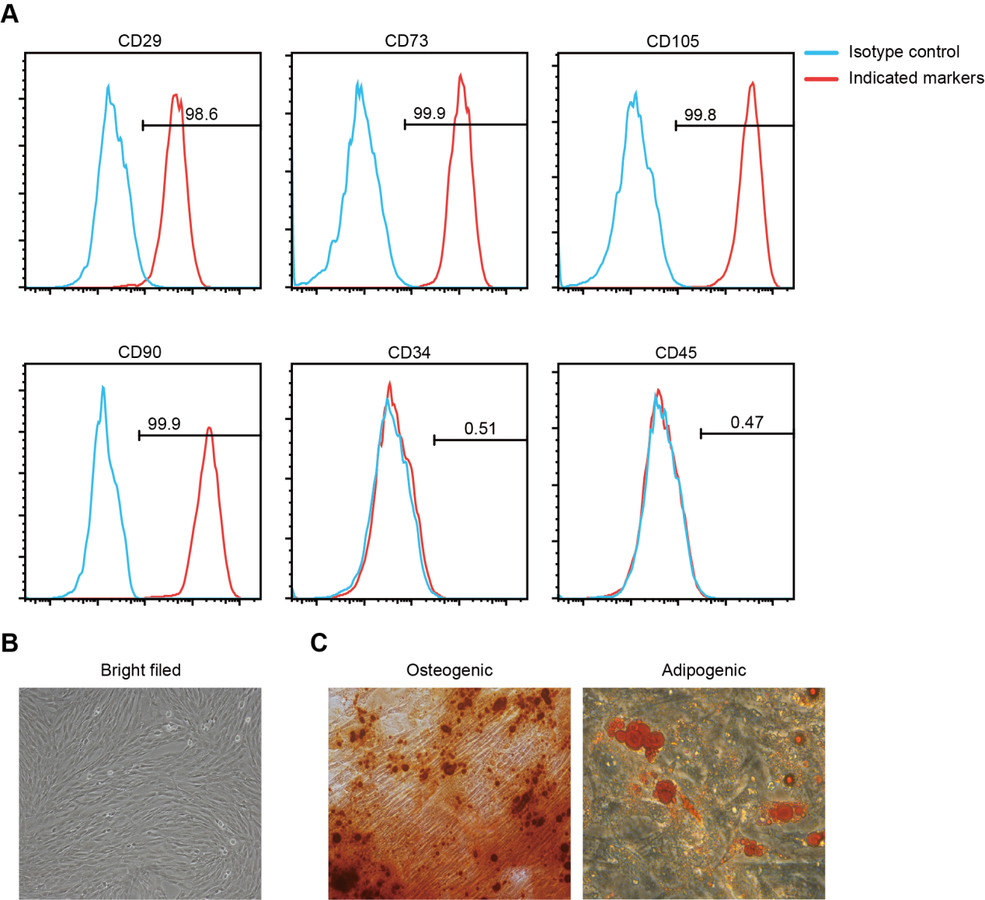
Supplementary Figure 1. Characterization of hUC-MSCs
(A) Representative FACS plots showing hUC-MSCs were strongly positive for CD29, CD73, CD105 and CD90, whereas negative for hematopoietic stem cell markers such as CD34 and CD45. (B) Representative morphological observation of hUC-MSCs. (C) Representative Alizarin red and Oil red O staining for assessing the differentiation potential of hUC-MSCs to osteoblasts and adipocytes, respectively. Magnification for (B & C) was 100*.

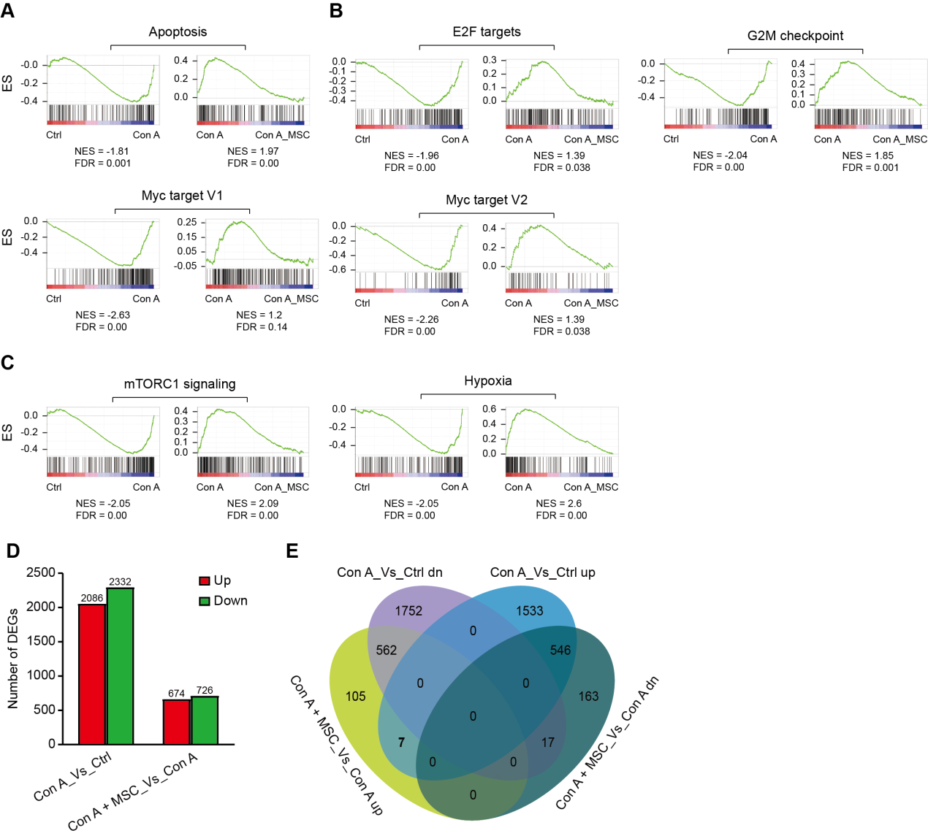
Supplementary Figure 2. RNA-sequencing of liver tissues showing alleviation of Con A-induced mouse liver injury by hUC-MSCs
(A) GSEA showing that apoptosis pathway was enriched in Con A + PBS group and repressed in Con A + hUC-MSCs group. (B) GSEA showing that cell cycle-related pathways (including E2F targets, G2M checkpoints, and Myc targets) were enriched in Con A + PBS group and repressed in Con A + hUC-MSCs group. (C) GSEA showing that mTORC1 signalling and hypoxia pathways were enriched in Con A + PBS group and repressed in Con A + hUC-MSCs group. (D) Number of differentially expressed genes of Con A versus Control group and Con A +MSC versus Con A group. (E) Venn diagrams showing the number of DEGs between the Con A versus Control group and Con A +MSC versus Con A group. NES, normalized enrichment score; FDR, false discovery rate; KEGG, Kyoto Encyclopaedia of genes and genomes.

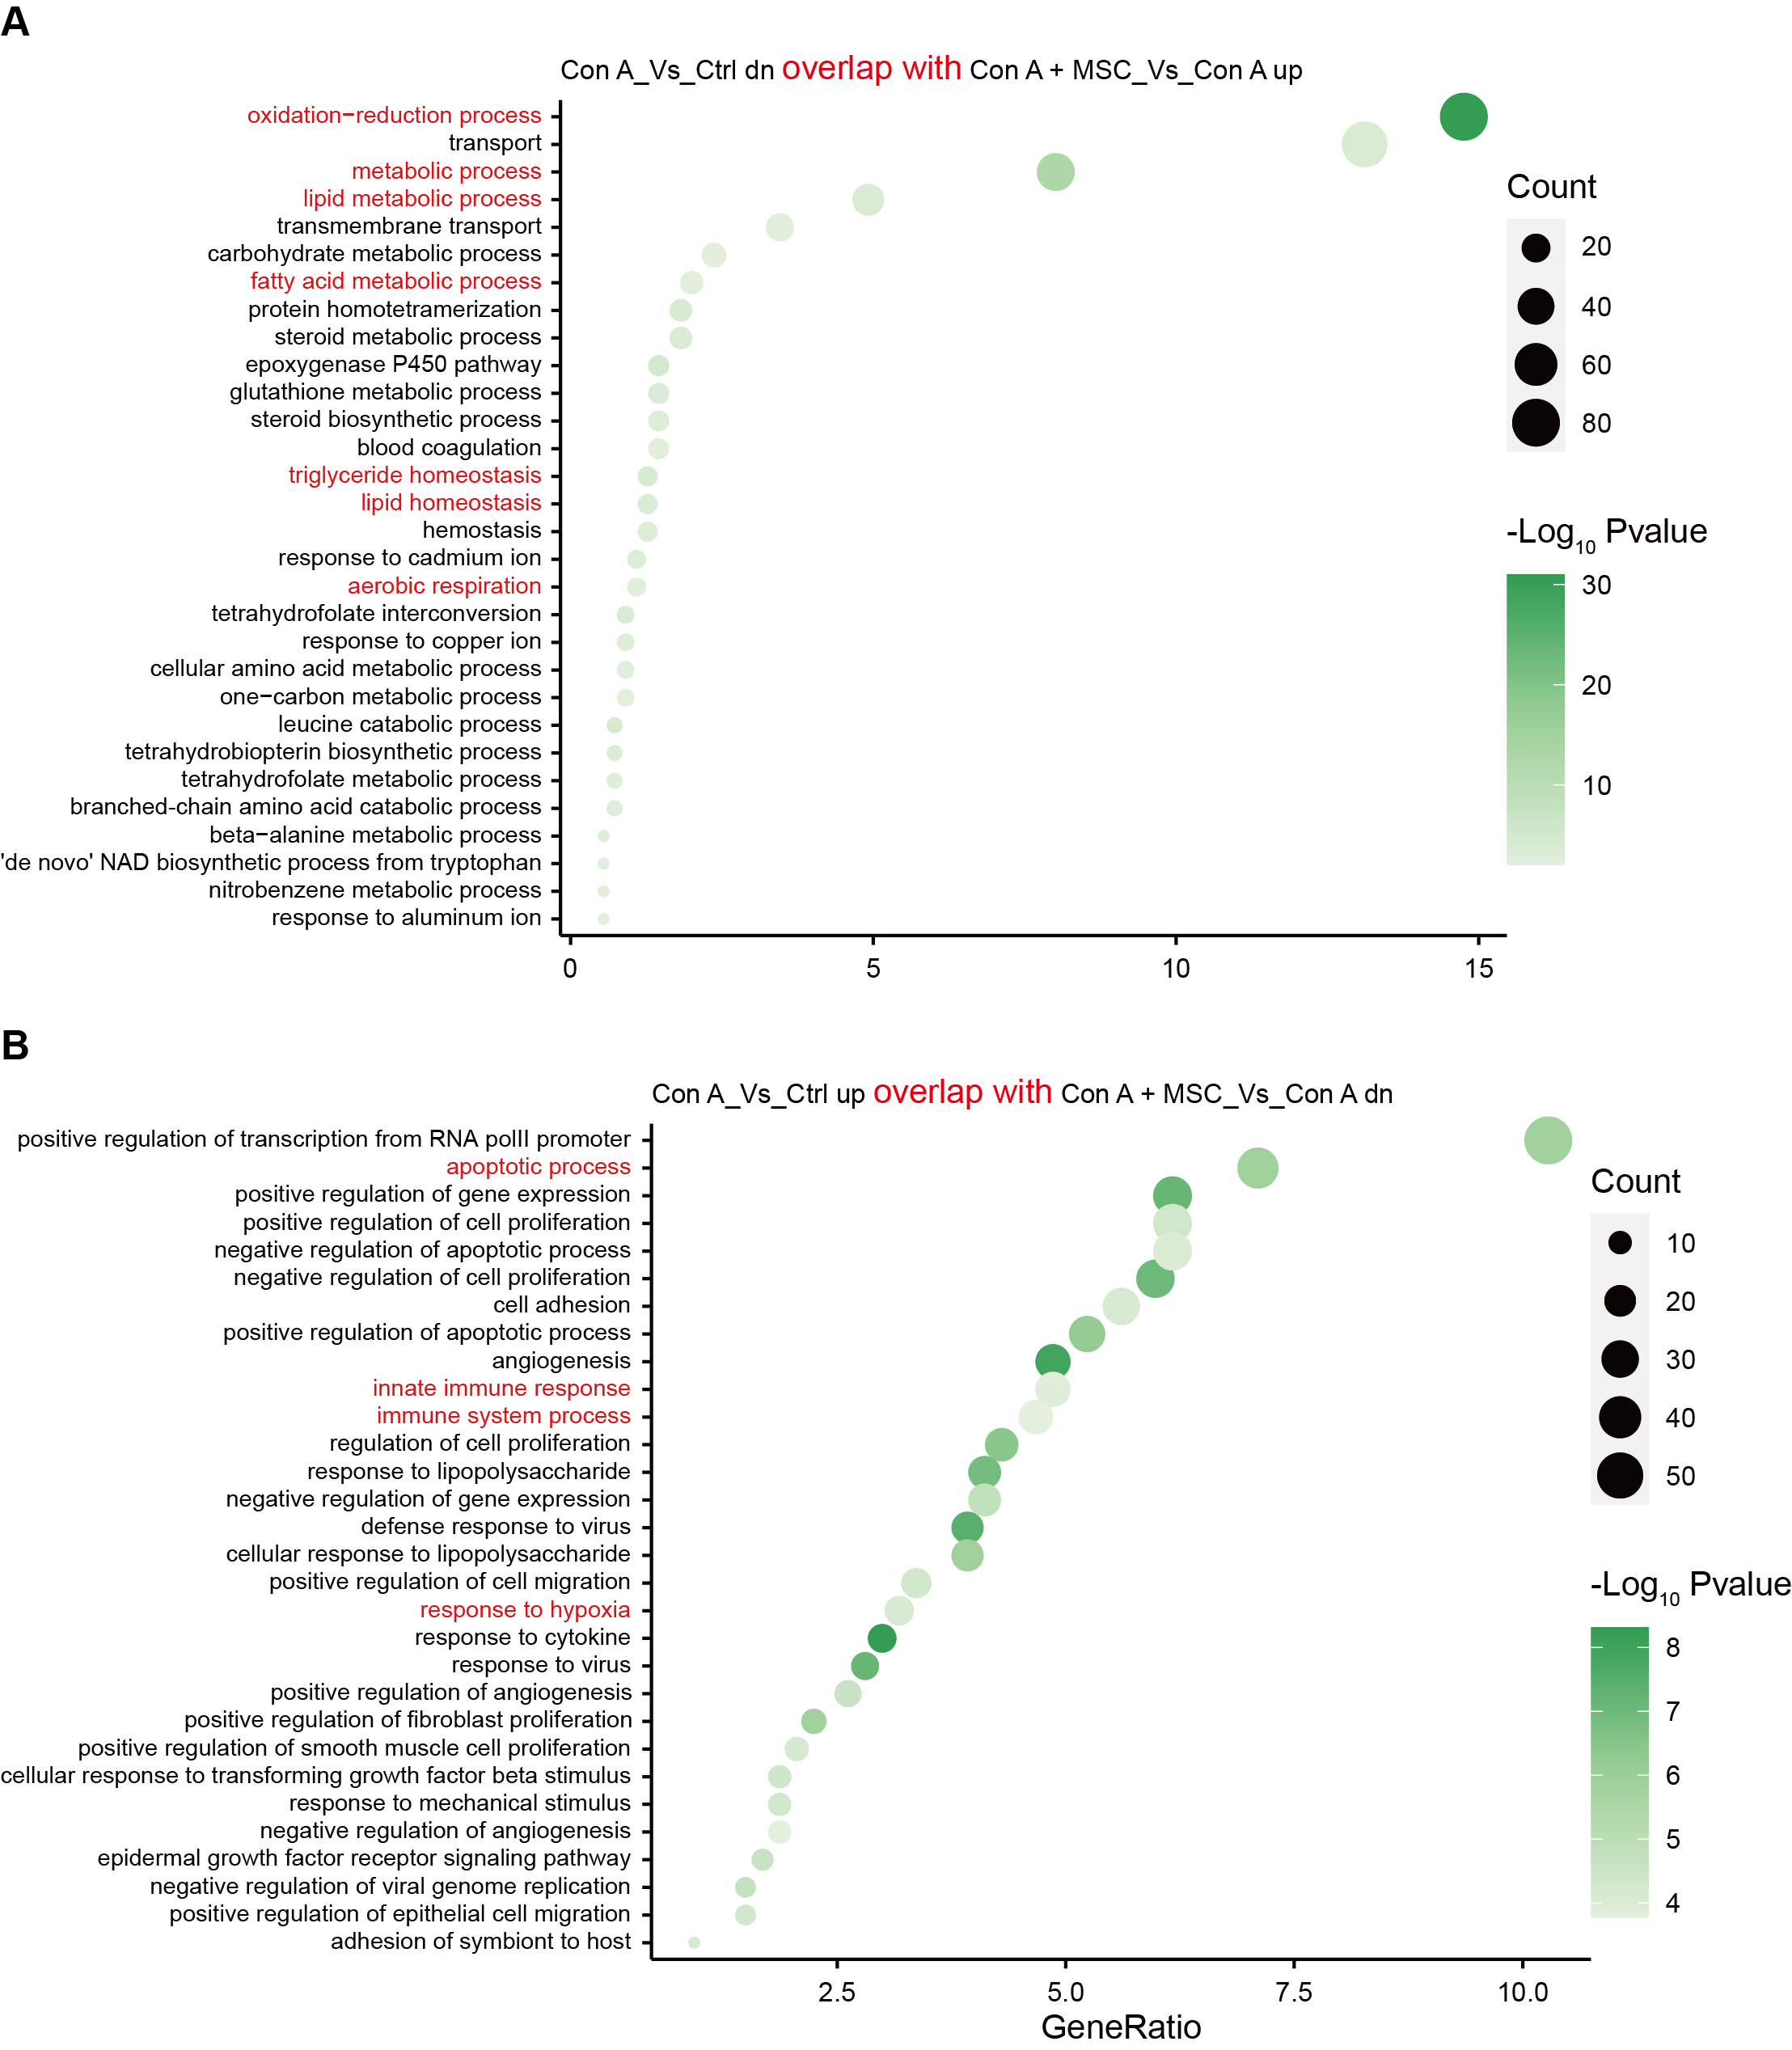
Supplementary Figure 3. KEGG pathway analysis for mouse liver tissues of Con A-induced fulminant hepatitis with hUC-MSC treatment
(A) KEGG pathway analysis of genes downregulated in Con A versus Ctrl overlapping with upregulated in Con A+MSC versus Con A. The y-axis shows significantly enriched pathways. (B) KEGG pathway analysis of genes upregulated in Con A versus Ctrl group overlapping with downregulated in Con A + MSC versus Con A. The y-axis shows significantly enriched pathways.

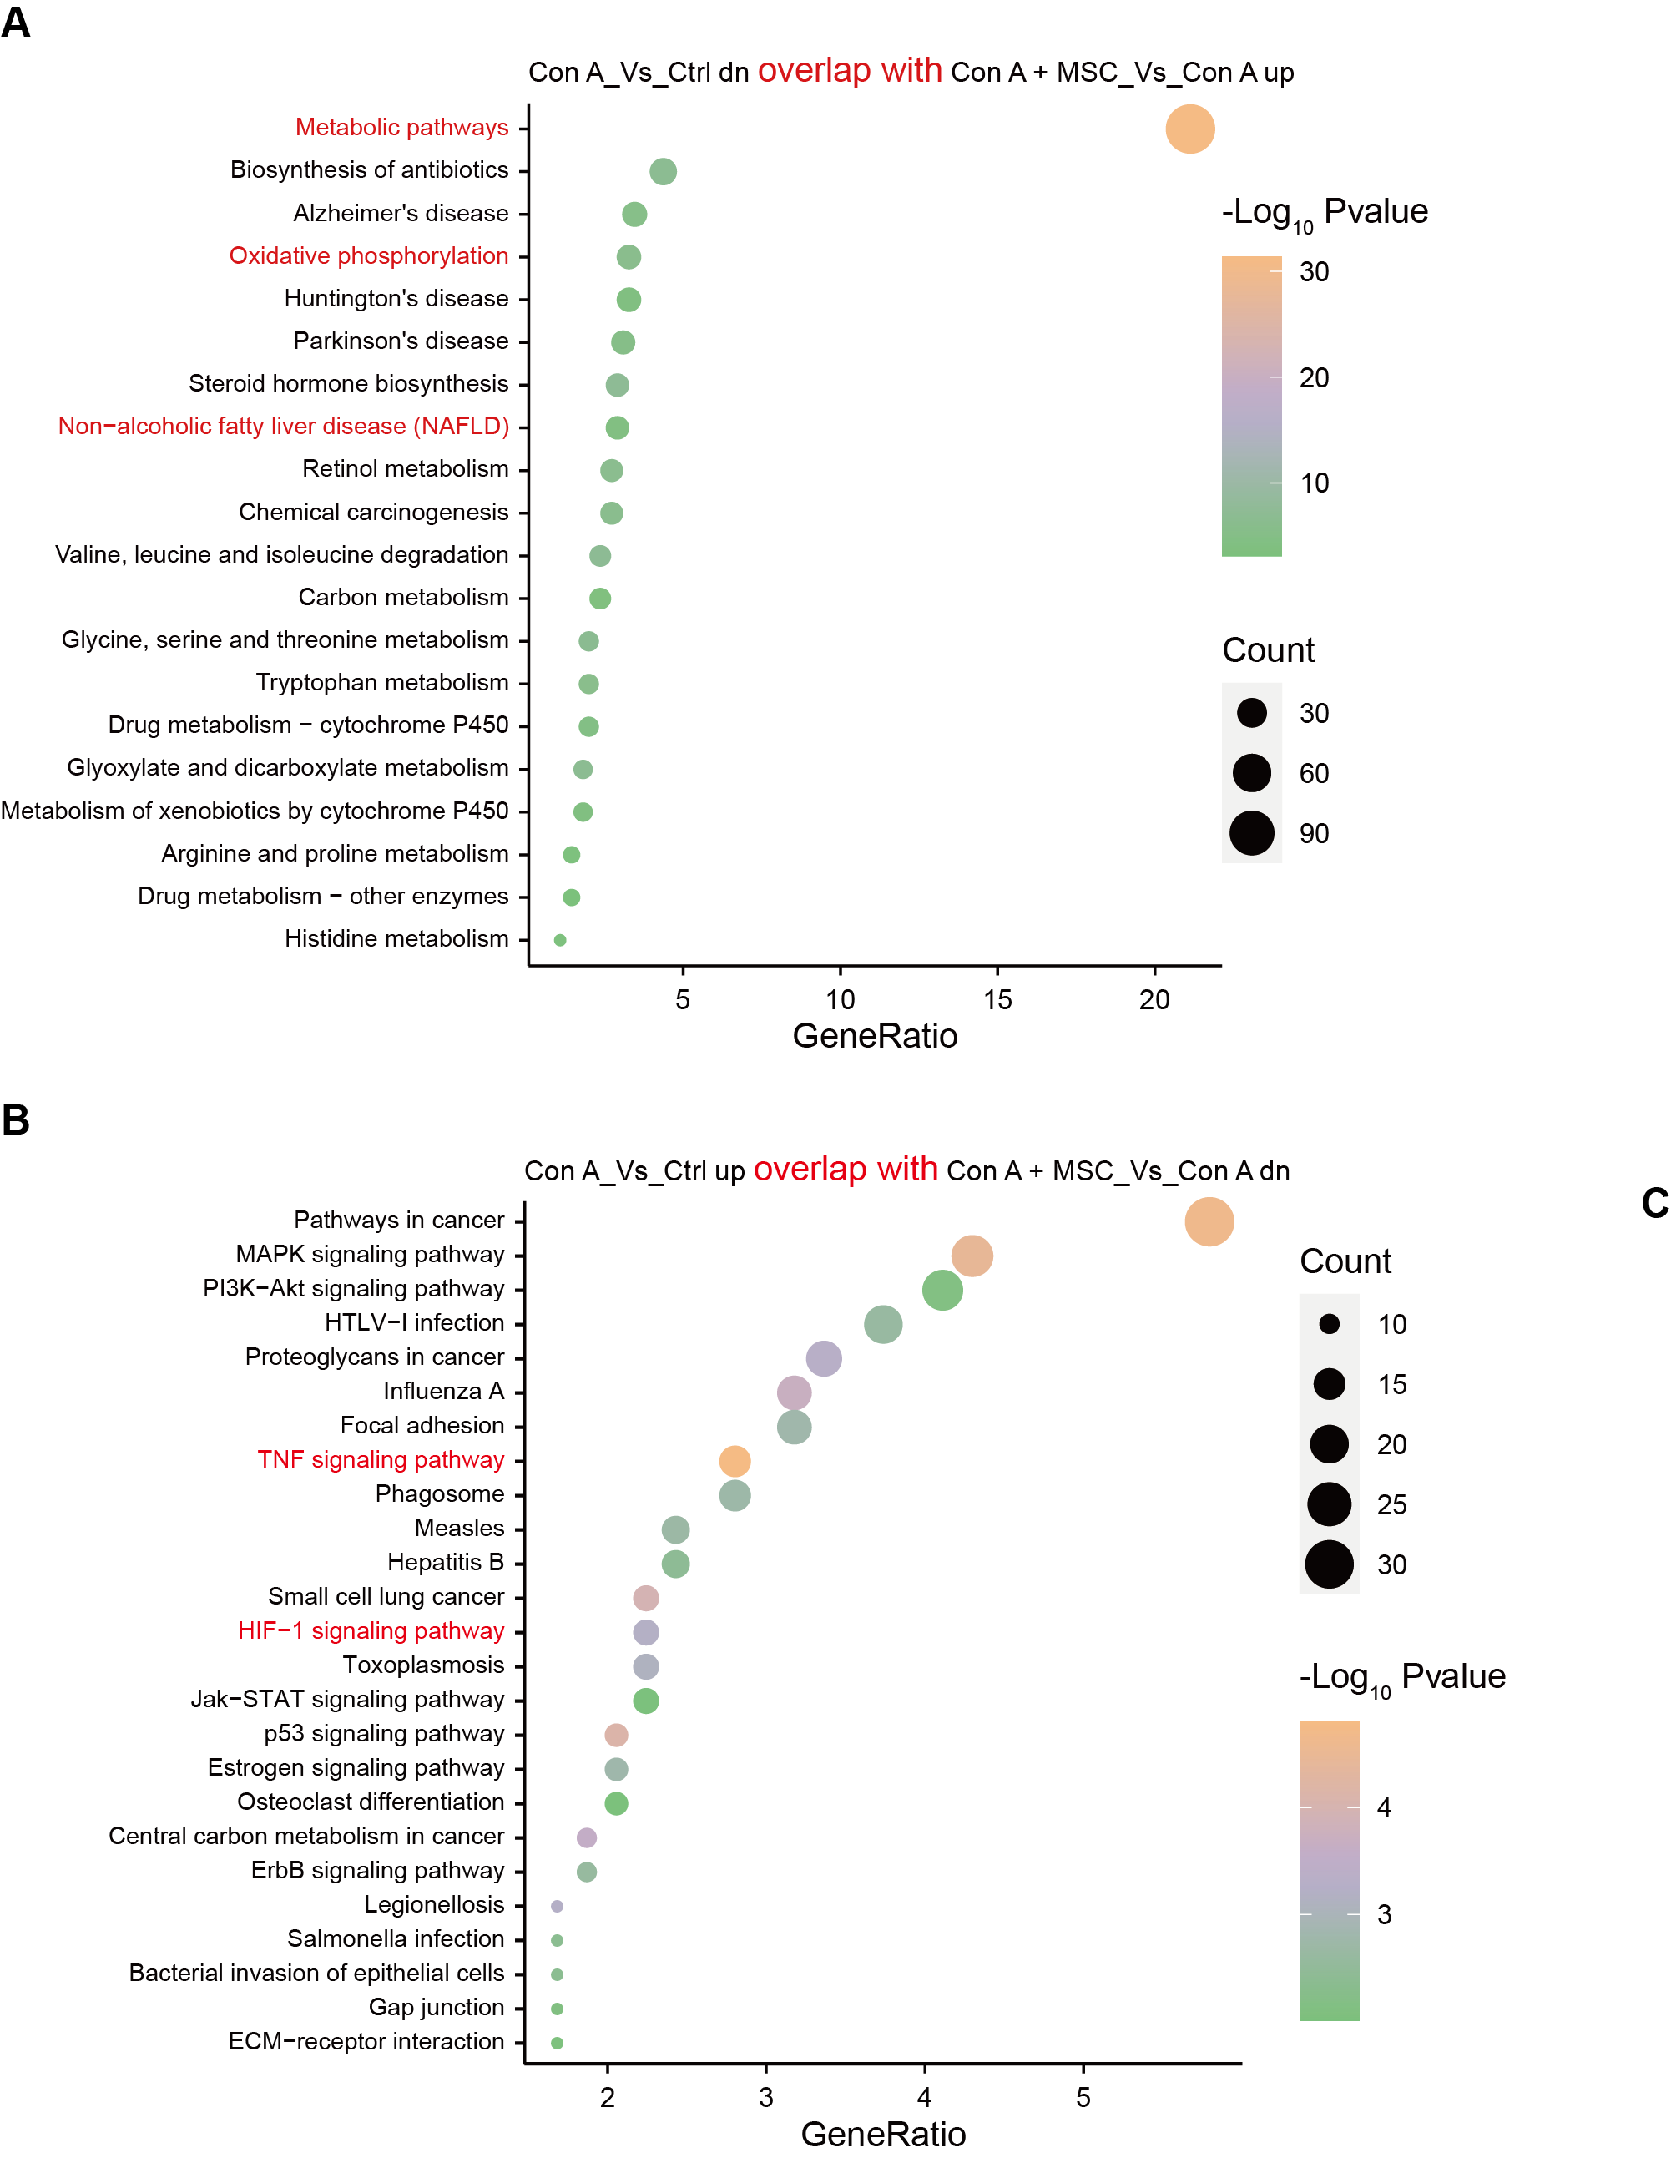
Supplementary Figure 4. GO analysis for mouse liver tissues of Con A-induced fulminant hepatitis with hUC-MSC treatment
(A) GO analysis of genes downregulated in Con A versus Ctrl overlapping with upregulated in Con A+MSC versus Con A. The y-axis shows significantly enriched pathways. (B) GO enrichment analysis of genes upregulated in Con A versus Ctrl group overlapping with downregulated in Con A + MSC versus Con A. The y-axis shows significantly enriched pathways.

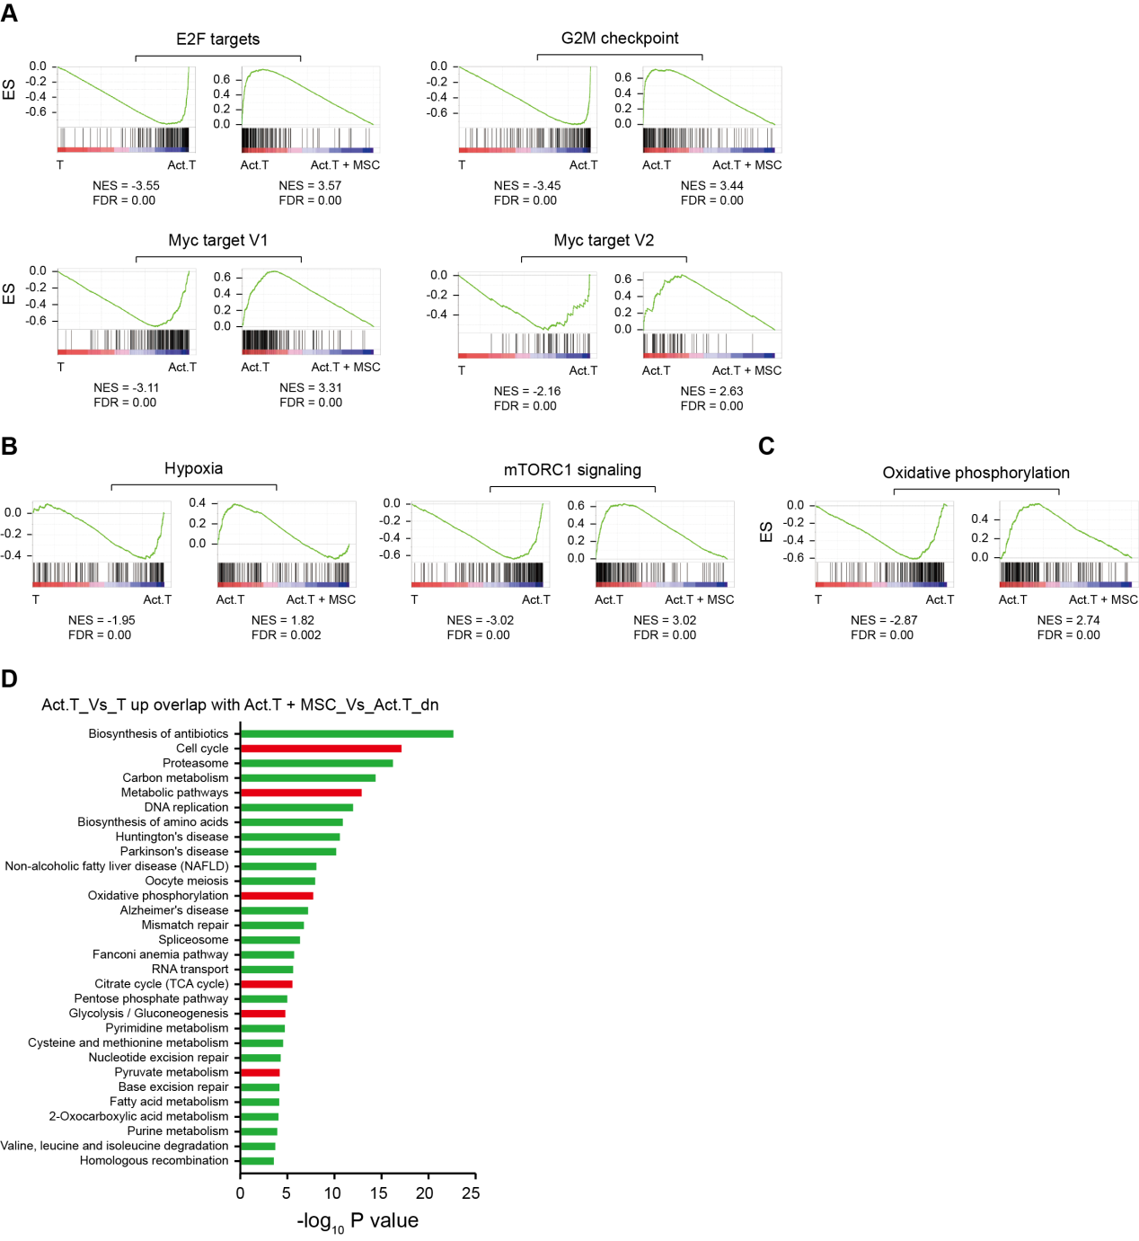
Supplementary Figure 5. RNA-sequencing of human CD3⁺ T cells showing inhibition of T cell immunity by hUC-MSCs in vitro
(A) GSEA showing that cell cycle-related pathways (including E2F targets, G2M checkpoints, and Myc targets) were enriched in activated T cells versus naïve T cells, whereas recovered in activated T cells co-culture with hUC-MSCs. (B) GSEA showing the enrichment of hypoxia and mTORC1 signalling in indicated groups. (C) GSEA showing the enrichment of oxidative phosphorylation in indicated groups. (D) KEGG pathway analysis of the DEGs upregualted in Act.T versus T overlapping with downregulated in Act.T + MSC versus Act.T group.

