Supplementary marerial
Supplement material in this article is as following:
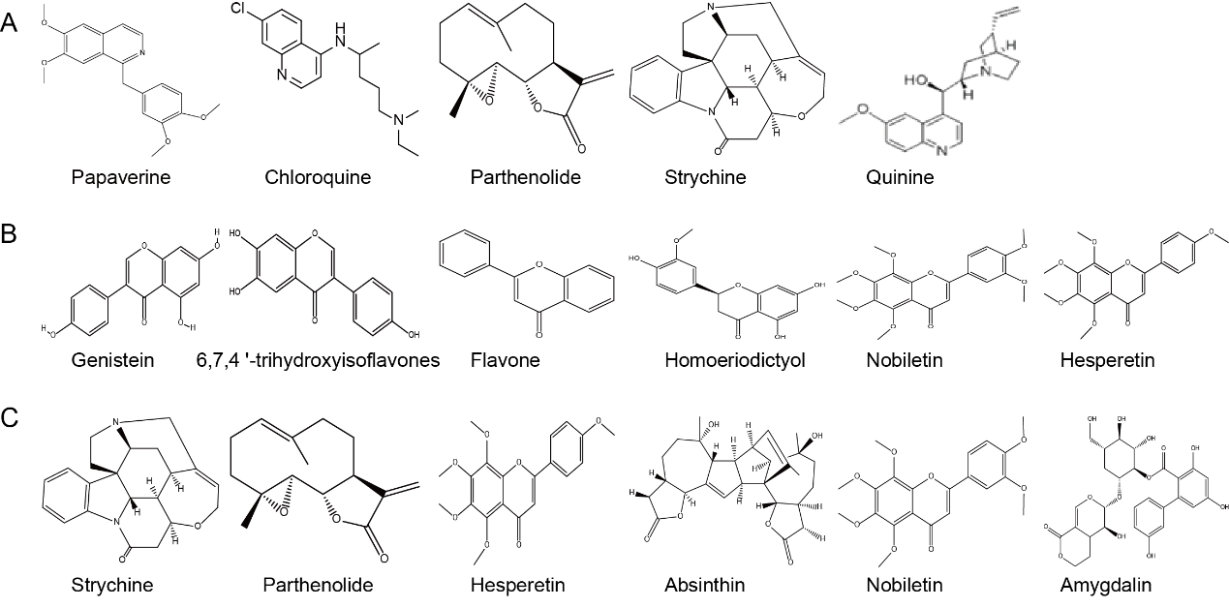
Fig.S.1 The structure of compounds in training set, A shows the structure of compounds in training set of Tas2r10, B shows the structure of compounds in training set of Tas2r14, C shows the structure of compounds in training set of Tas2r46.

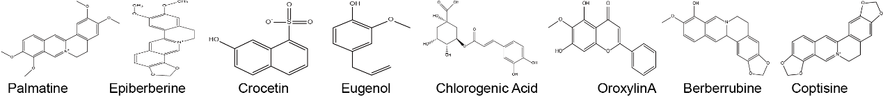
Fig.S.2 The structure of compounds in the test set

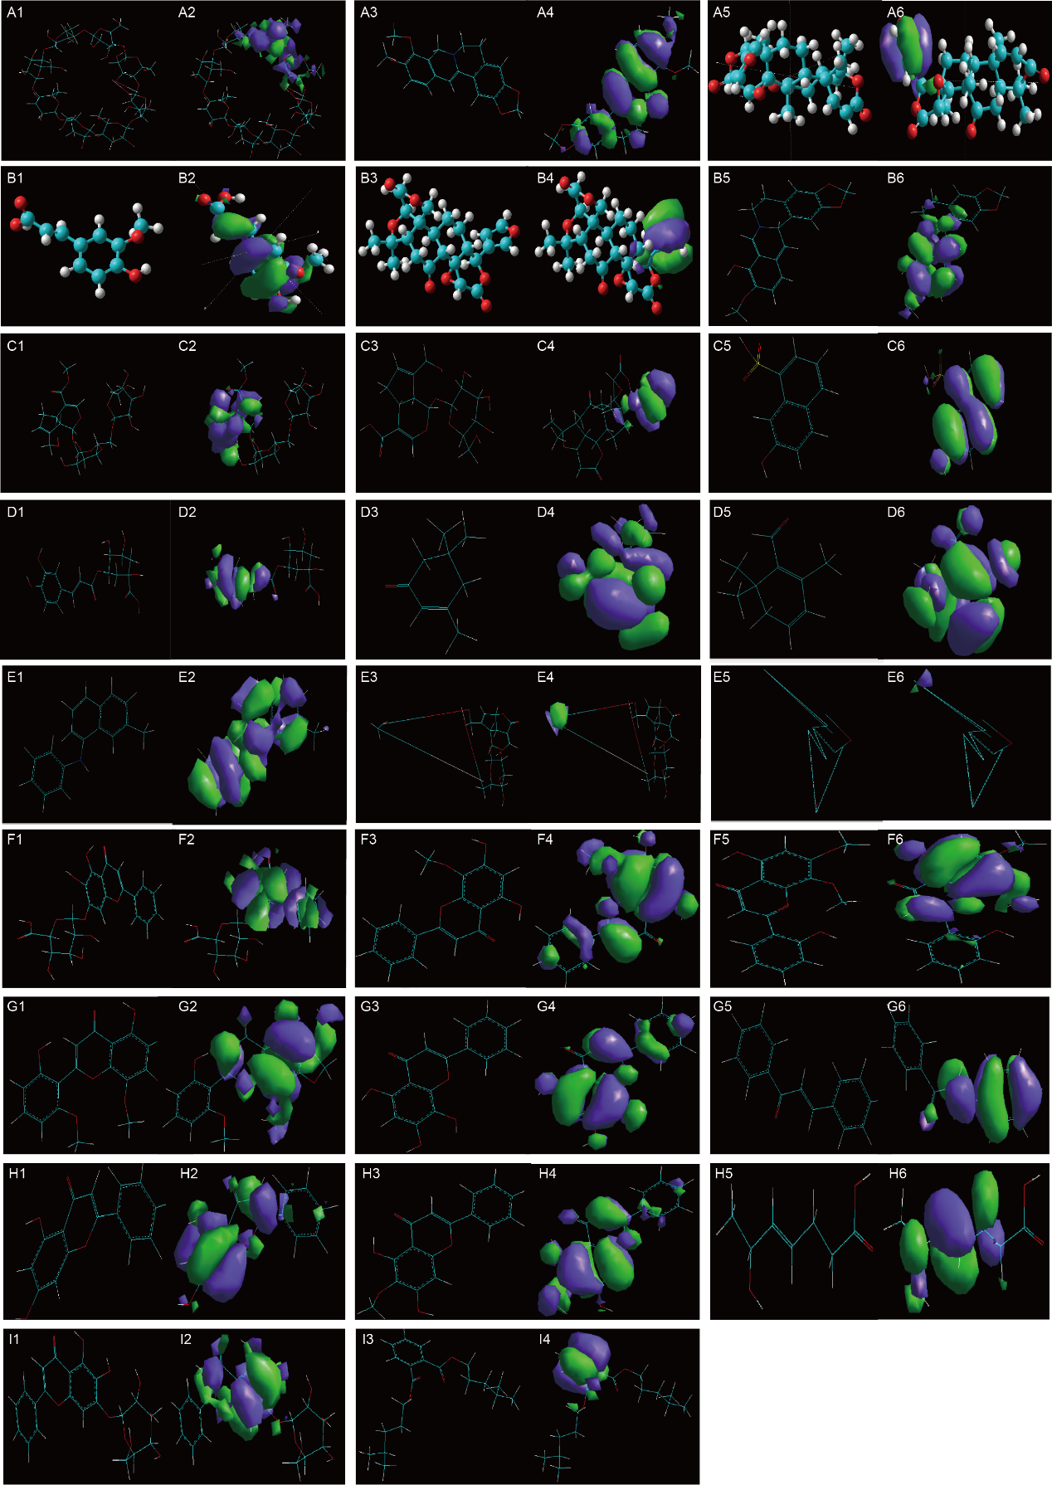
Fig.S.3 Optimized molecular structure and binding sites. A1 shows structure of γ-CD. A2 shows binding site of γ-CD. A3 shows structure of berberine. A4 shows binding site of berberine. A5 shows structure of obacunone. A6 shows binding site of obacunone. B1 shows structure of limonin. B2 shows binding site of limonin. B3 shows structure of ferulic acid. A4 shows binding site of ferulic acid. B5 shows structure of coptisine. B6 shows binding site of coptisine. C1 shows structure of berberrubine. C2 shows binding site of berberrubine. C3 shows structure of geniposide. C4 shows binding site of geniposide. C5 shows structure of chlorogenic acid. C6 shows binding site of chlorogenic acid. D1 shows structure of geniposidic acid. D2 shows binding site of geniposidic acid. D3 shows structure of crocetin. D4 shows binding site of crocetin. D5 shows structure of genipin-1-β-gentiobioside. D6 shows binding site of genipin-1-β-gentiobioside. E1 shows structure of eugenol. E2 shows binding site of eugenol. E3 shows structure of baicalin. E4 shows binding site of baicalin. E5 shows structure of scutellarin. E6 shows binding site of scutellarin. F1 shows structure of wogonoside. F2 shows binding site of wogonoside. F3 shows structure of wogonin. F4 shows binding site of wogonin. F5 shows structure of skullcapflavone Ⅰ. F6 shows binding site of skullcapflavone Ⅰ. G1 shows structure of skullcapflavone Ⅱ. G2 shows binding site of skullcapflavone Ⅱ. G3 shows structure of norwogonin. G4 shows binding site of norwogonin. G5 shows structure of dihydrolignin A. G6 shows binding site of dihydrolignin A. H1 shows structure of viscidulin Ⅱ. H2 shows binding site of viscidulin Ⅱ. H3 shows structure of viscidulin Ⅲ norwogonin. H4 shows binding site of viscidulin Ⅲ. H5 shows structure of dihydrolignin A. H6 shows binding site of dihydrolignin A. I1 shows structure of baicalein -7-O-D-glucoside. I2 shows structure of baicalein -7-O-D-glucoside. I3 shows structure of DIHP. I4 shows structure of DIHP.
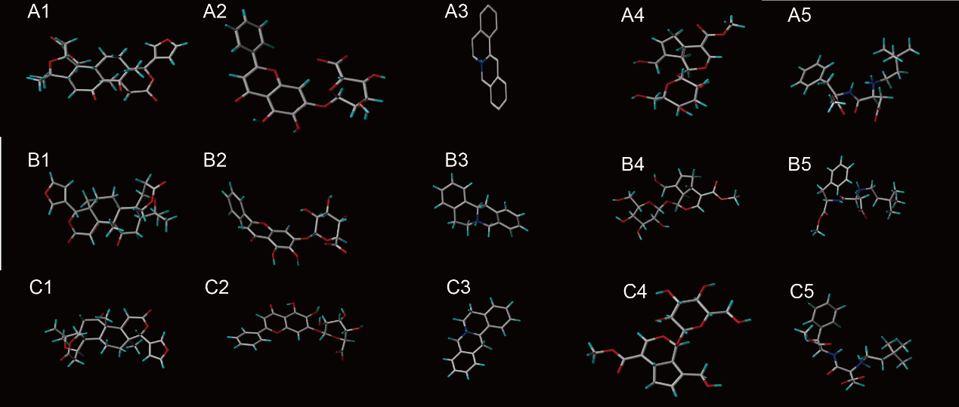
Fig.S.4 3D picture of the best conformation of compound. A shows the best conformation of compound when binding with Tas2r10, B shows the best conformation of compound when binding with Tas2r14, C shows the best conformation of compound when binding with Tas2r46. 1 is limonin, 2 is baicalin, 3 is epiberberine, 4 is geniposide, 5 is neotame.

Table S.1 EC₅₀ of compounds and bitter receptor in training set
Bitter taste receptor | EC₅₀ (μM)
Tas2r10 | Chloroquine | Parthenolide | Strychnine | Papaverine | Quinine
 | 10000.00 | 30.00 | 21.80 | 10.00 | 10.00
Tas2r14 | 6,7,4 '-trihydroxyisoflavones | Homoeriodictyol | Genistein | Flavone | Nobiletin | Hesperetin
 | 378.00 | 63.90 | 28.90 | 20.50 | 2.41 | 0.33
Tas2r46 | Parthenolide | Absinthin | Hesperetin | Nobiletin | Amygdalin | Strychnine
 | 1.00 | 9.90 | 4.53 | 3.81 | 65.00 | 0.43

Table S.1 The binding properties of compounds to bitter taste receptors from BitterX website
BTRs | Epiberberine | Crocetin | Coptisine | Berberrubine | Eugenol | OroxylinA | chlorogenic acid | Palmatine
Tas2r10 | 0 | 0 | 0 | 0 | 66.71 | 57.97 | 0 | 76.38
Tas2r14 | 0 | 0 | 0 | 0 | 65.66 | 76.11 | 60.61 | 70.94
Tas2r46 | 0 | 0 | 0 | 0 | 51.86 | 62.85 | 0 | 75.91

The ligands of bitter receptors Tas2r10 and Tas2r46 both take hydrophobic center (H) and hydrogen bond receptor (A) as the basic pharmacophore elements, and the ligands of Tas2r14 take aromatic ring center (R) and A as the basic pharmacophore element. Among them, H and A are the common features of the three bitter receptor pharmacophores, and correspond to the core of the training set compound of the three receptors.
Table S.3 Pharmacophore modeling results
苦味受体 | 药效团 | Features | Rank | Direct Hit | Partial Hit | Max Fit
Tas2r10 | 01 | HHHA | 34.627 | 1111 | 10000 | 4
 | 02 | HHAA | 34.434 | 11110 | 1 | 4
 | 03 | HHAA | 34.319 | 11110 | 1 | 4
 | 04 | HHAA | 34.199 | 11110 | 1 | 4
 | 05 | HHHA | 33.833 | 1111 | 10000 | 4
 | 06 | HHHA | 33.712 | 1111 | 10000 | 4
 | 07 | HHAA | 33.366 | 11110 | 1 | 4
 | 08 | HHHA | 33.348 | 1111 | 10000 | 4
 | 09 | HHAA | 33.275 | 11110 | 1 | 4
 | 10 | HHHA | 33.015 | 1111 | 10000 | 4
Tas2r14 | 01 | RHA | 37.932 | 111111 | 0 | 3
 | 02 | RHA | 37.790 | 111111 | 0 | 3
 | 03 | RHA | 34.604 | 111111 | 0 | 3
 | 04 | RHA | 34.604 | 111111 | 0 | 3
 | 05 | RRA | 33.592 | 111111 | 0 | 3
 | 06 | RRA | 33.592 | 111111 | 0 | 3
 | 07 | RRA | 33.592 | 111111 | 0 | 3
 | 08 | RRA | 33.312 | 111111 | 0 | 3
 | 09 | RRA | 33.298 | 111111 | 0 | 3
 | 10 | RHA | 31.192 | 111111 | 0 | 3
Tas2r46 | 01 | HHHAA | 54.491 | 111101 | 10 | 5
 | 02 | HHHAA | 51.501 | 111101 | 10 | 5
 | 03 | HHAA | 50.377 | 111111 | 0 | 4
 | 04 | HHAA | 50.320 | 111111 | 0 | 4
 | 05 | HHHAA | 50.019 | 111101 | 10 | 5
 | 06 | HHAA | 47.784 | 111111 | 0 | 4
 | 07 | HHAA | 47.784 | 111111 | 0 | 4
 | 08 | HHAA | 47.310 | 111101 | 10 | 4
 | 09 | HHAA | 46.946 | 111111 | 0 | 4
 | 10 | HHAA | 46.250 | 111111 | 0 | 4

Table S.4 The matching value/binding rate of each compound and bitter taste receptor
BTR |  | Geniposide | Phellodendrine | Epiberberine | Baicalin | Chlorogenic Acid
Tas2r10 | Pharmacophore matching values | 0 | 2.5021 | 0 | 3.3634 | 0
 | Predicted value of Bitter X /% | 0 | 84.03 | 0 | 0 | 0
Tas2r14 | Pharmacophore matching values | 0 | 2.6330 | 0 | 2.1538 | 0
 | Predicted value of Bitter X /% | 0 | 71.91 | 0 | 72.91 | 60.61
Tas2r46 | Pharmacophore matching values | 0 | 2.2969 | 0 | 3.7969 | 0
 | Predicted value of Bitter X /% | 0 | 82.16 | 0 | 70.18 | 0

