Appendix A. Supplementary data
Supplementary Figures and Tables Captions
Supplementary Table S1. Summary of reads quality control.
Sample | Raw Data Read | Valid Data Read | Q20% | Q30%
WFB1YE1 | 58067824 | 51827564 | 99.97 | 96.90
WFB1YE2 | 55856602 | 50440052 | 99.97 | 96.42
WFB1YE3 | 49093548 | 44323472 | 99.97 | 96.93
WFB10YE1 | 55154582 | 48373938 | 99.97 | 96.89
WFB10YE2 | 32577058 | 29566054 | 99.97 | 97.09
WFB10YE3 | 57707296 | 53939666 | 99.97 | 96.82
CH1YE1 | 47223226 | 43972676 | 99.97 | 96.90
CH1YE2 | 50148850 | 47276426 | 99.97 | 96.38
CH1YE3 | 59521130 | 56657380 | 99.97 | 96.43
CH10YE1 | 49924152 | 47693980 | 99.96 | 95.71
CH10YE2 | 56697348 | 53102578 | 99.96 | 96.23
CH10YE3 | 51910576 | 49064482 | 99.96 | 96.10
WFY1YE1 | 42521008 | 39987756 | 99.97 | 96.29
WFY1YE2 | 42407886 | 38573182 | 99.97 | 95.61
WFY1YE3 | 49399744 | 44670540 | 99.97 | 95.66
WFY10YE1 | 59642288 | 54054670 | 99.96 | 96.48
WFY10YE2 | 58586170 | 53489318 | 99.96 | 96.37
WFY10YE3 | 59388316 | 57894440 | 99.95 | 95.66
WFB1YM1 | 41877940 | 37466360 | 99.96 | 95.28
WFB1YM2 | 37675788 | 34596514 | 99.96 | 95.32
WFB1YM3 | 43931940 | 40412444 | 99.96 | 95.25
WFB10YM1 | 55179068 | 48185880 | 99.96 | 96.55
WFB10YM2 | 37529196 | 33435912 | 99.97 | 96.20
WFB10YM3 | 36929212 | 32208332 | 99.96 | 95.35
CH1YM1 | 37453408 | 31809752 | 99.96 | 95.95
CH1YM2 | 49902748 | 44269166 | 99.96 | 96.03
CH1YM3 | 39974474 | 34311360 | 99.96 | 95.72
CH10YM1 | 42010238 | 36958032 | 99.97 | 95.77
CH10YM2 | 48782678 | 43370946 | 99.96 | 96.03
CH10YM3 | 49215802 | 43682886 | 99.96 | 96.08
WFY1YM1 | 58915542 | 52942812 | 99.96 | 96.32
WFY1YM2 | 35801982 | 31728748 | 99.96 | 95.16
WFY1YM3 | 38811202 | 32672228 | 99.96 | 95.73
WFY10YM1 | 45758222 | 39934752 | 99.96 | 95.85
WFY10YM2 | 49112104 | 40312014 | 99.96 | 95.47
WFY10YM3 | 41302046 | 36012804 | 99.96 | 95.36

Supplementary Table S2. Primers used in this study.
Gene ID | Forward primer | Reverse primer
OS09G0555500 | GCAATCTGGGCGATATACGTGTG | TGTACCTCGACTTCGTTAGGTC
OS04G0578400 | TGCCGATGACCGAGATGTTT | CATGCCGAACAGCGTAATCC
OS03G0592500 | TATGGACCTGACCGTCCCAA | CTTCACCCCGTTCTTGGACA
OS03G0856700 | CGGCTTCTTCCTGGTGGTTA | GTCGTTGCGCTGGAAGAATC
OS04G0611800 | TACAAGAGGATTCGGCGTGG | CATCCCCATGGCAAGGCTAA
OS01G0580500 | GGAGGTGAAGAGCTTCGTGT | AGTAGGTGGCCTCCCAGTC
OS01G0656200 | CAGCAGGTGGCAGGGTTATC | GATACCACATCCCACAGCCC
OS01G0841600 | CCTTCACTGGCGAGATCAGT | GGTCTCACCAATGCAAGCAA
OS02G0171100 | TCGAGTGGCGAGAAGACAAA | CCCCAAGGAATATCTGCTGGA
Os11g0171300 | TCCTTGCCATGGATGAGTCG | GAGACCTTGGCACCATGACT
Os06g0133800 | GACGAGGTCATGCGGTACAA | GATGGCCTGGAGTCTTGCTT
Os08g0434300 | AATTGCTGCCGAGGTTCTGA | CATGACCACCGACAACTGGA
Supplementary Fig. S1 Comparison of the log2 (FC) of 12 randomly selected transcripts using RNA-Seq and qRT-PCR. A-C: In the early rice environment, compare one day and ten days after flowering about CHT025, WFB and WFYT025, respectively. D-F: In the middle rice environment, compare one day and ten days after flowering about CHT025, WFB and WFYT025, respectively.

A.

B

C

D

E

F

Supplementary Fig. S2 Gene ontology (GO) enrichment analysis of DEGs(A) GO enrichment analysis of DEGs on the first day and the tenth days under the environment of early rice in WFYT025. (B) GO enrichment analysis of DEGs on the first day and the tenth days under the environment of middle rice in CHT025. (C) GO enrichment analysis of DEGs on the first day and the tenth days under the environment of middle rice in WFB. (D) GO enrichment analysis of DEGs on the first day and the tenth days under the environment of middle rice in WFYT025.
A. 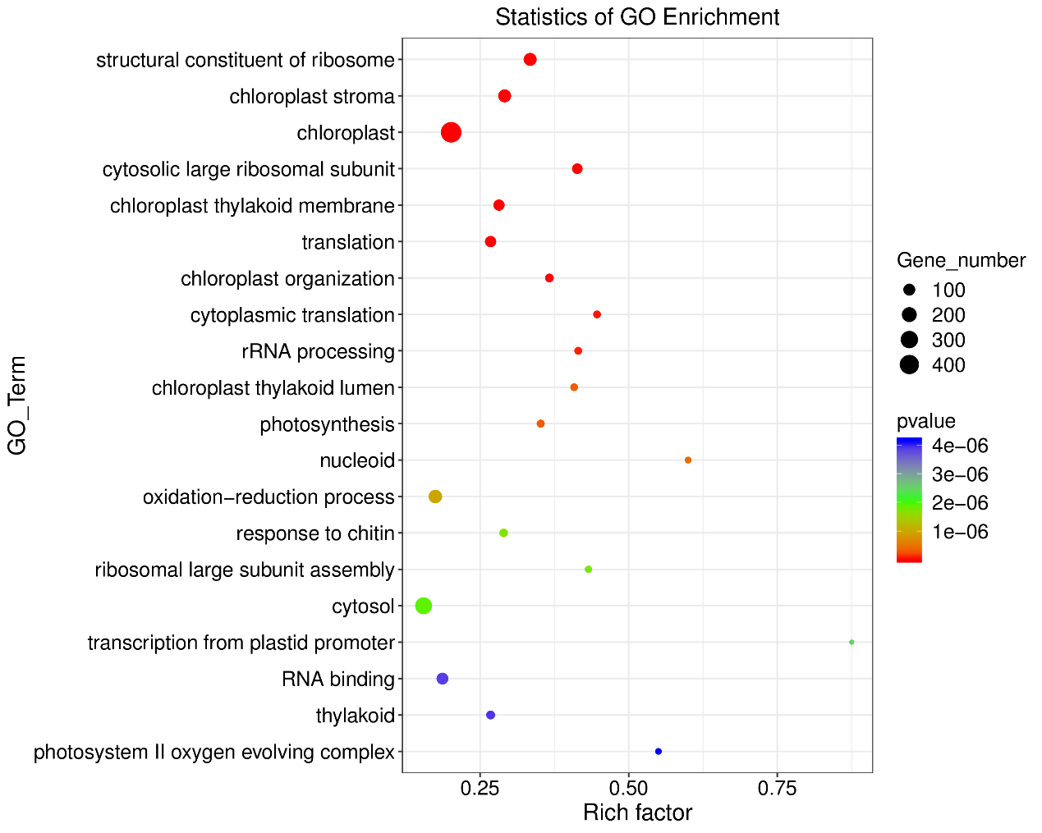

B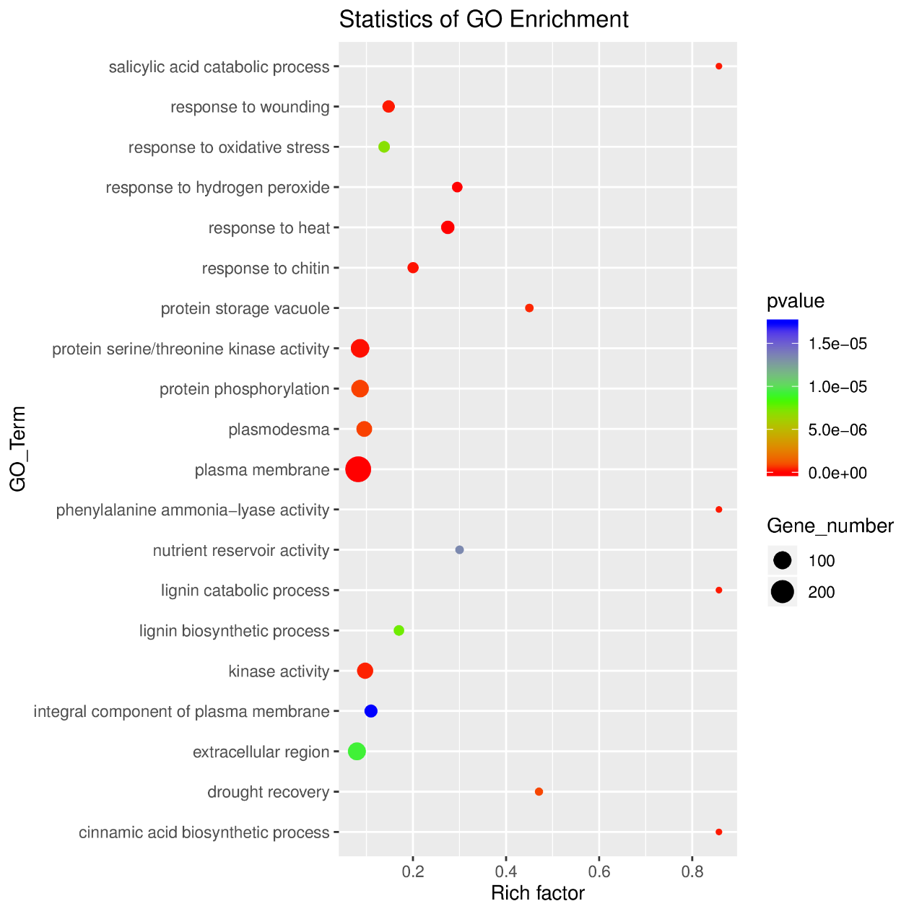

C
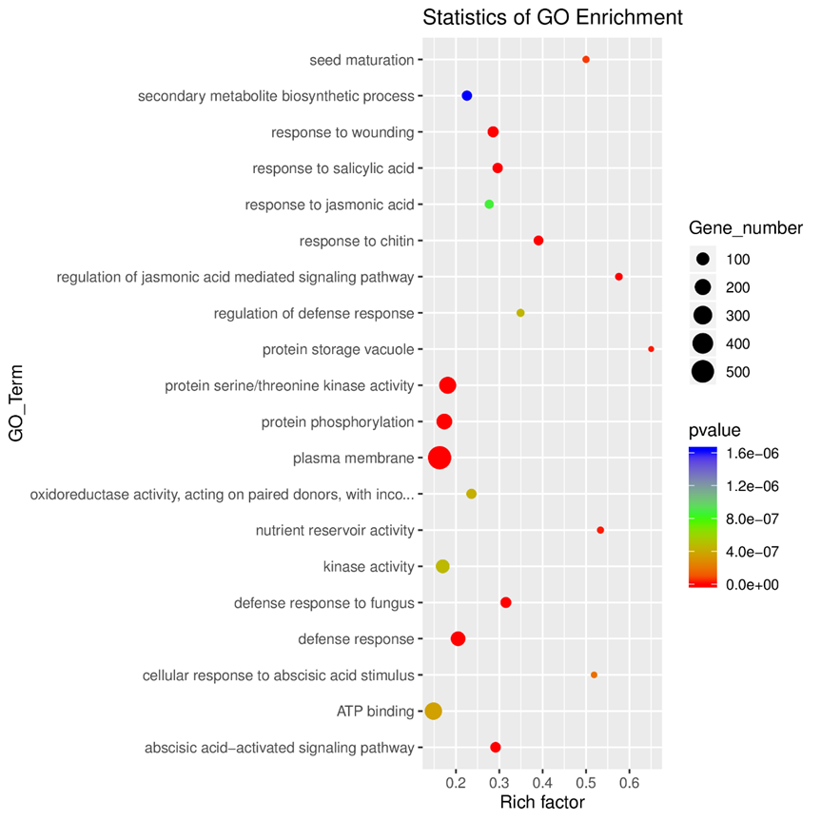

D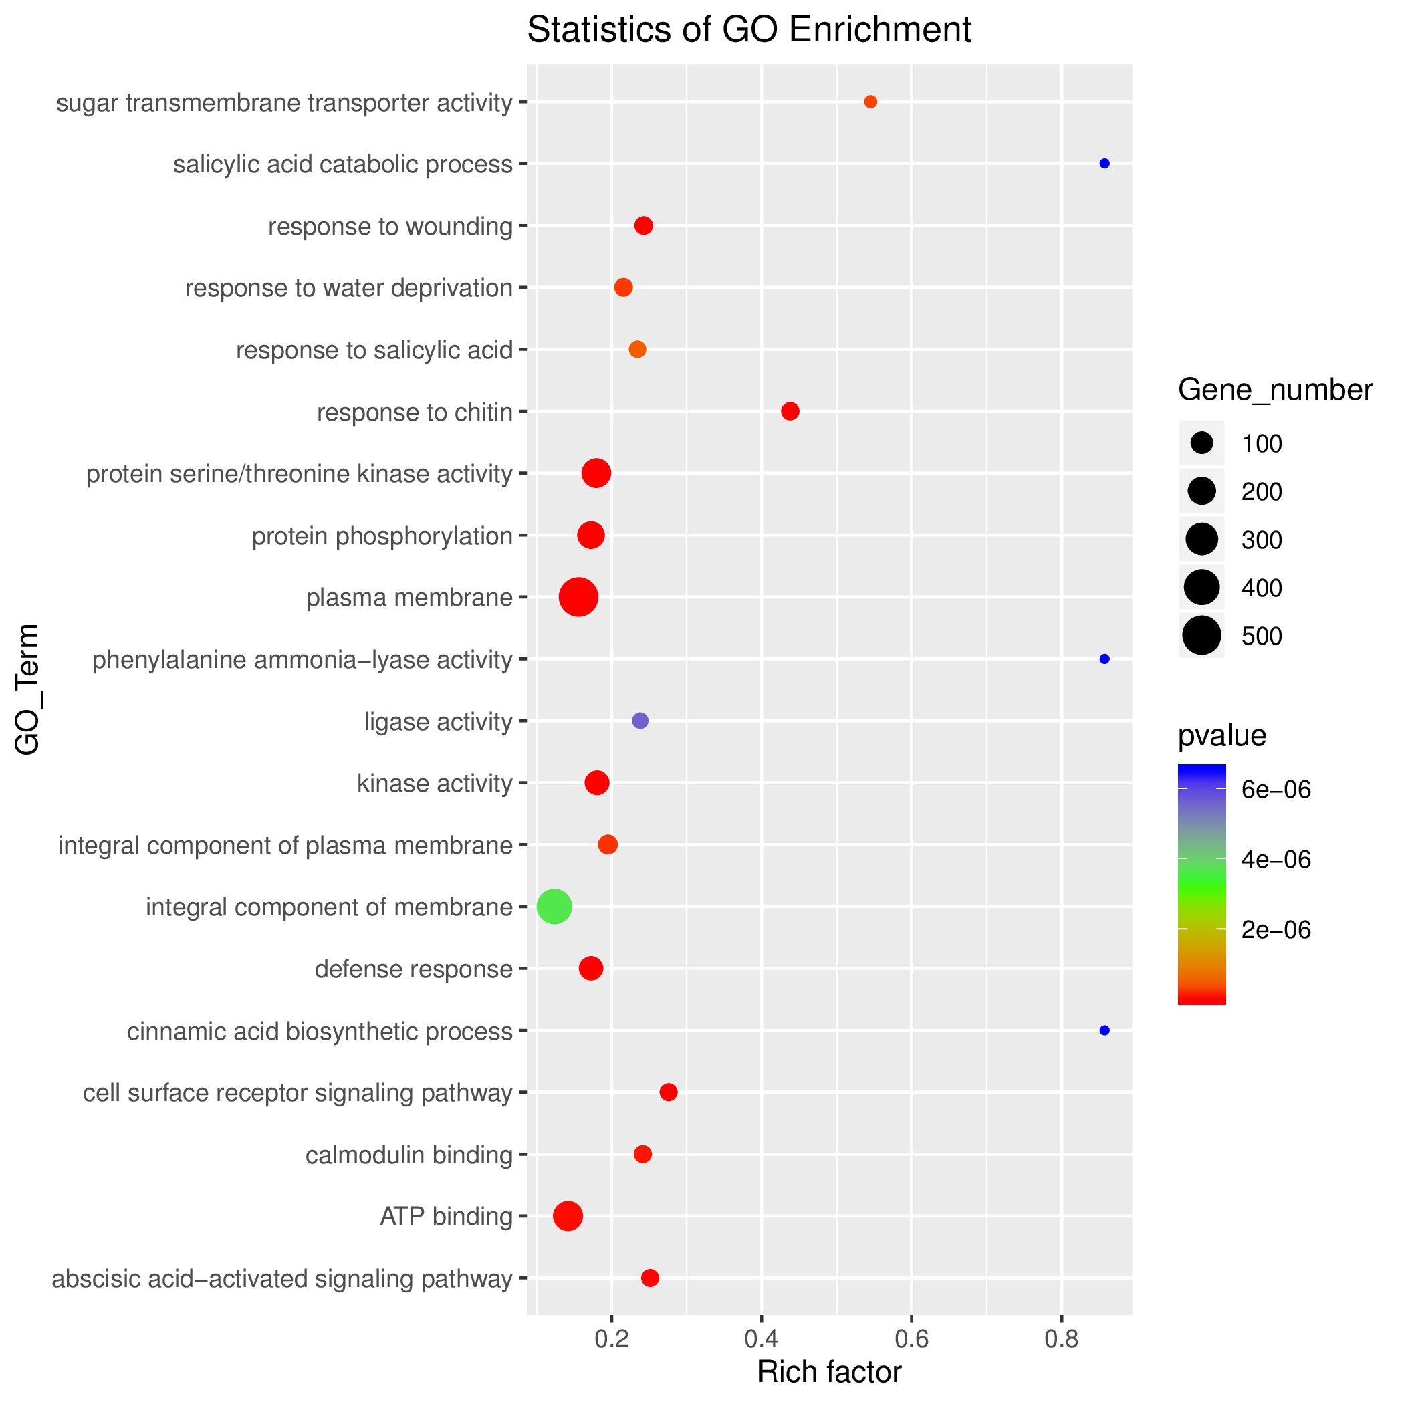

Supplementary Fig. S3 KEGG analysis of DEGs between WFYT025 in the environment of early rice. That showed the top 20 most represented categories and the number of transcripts predicted to belong to each category.
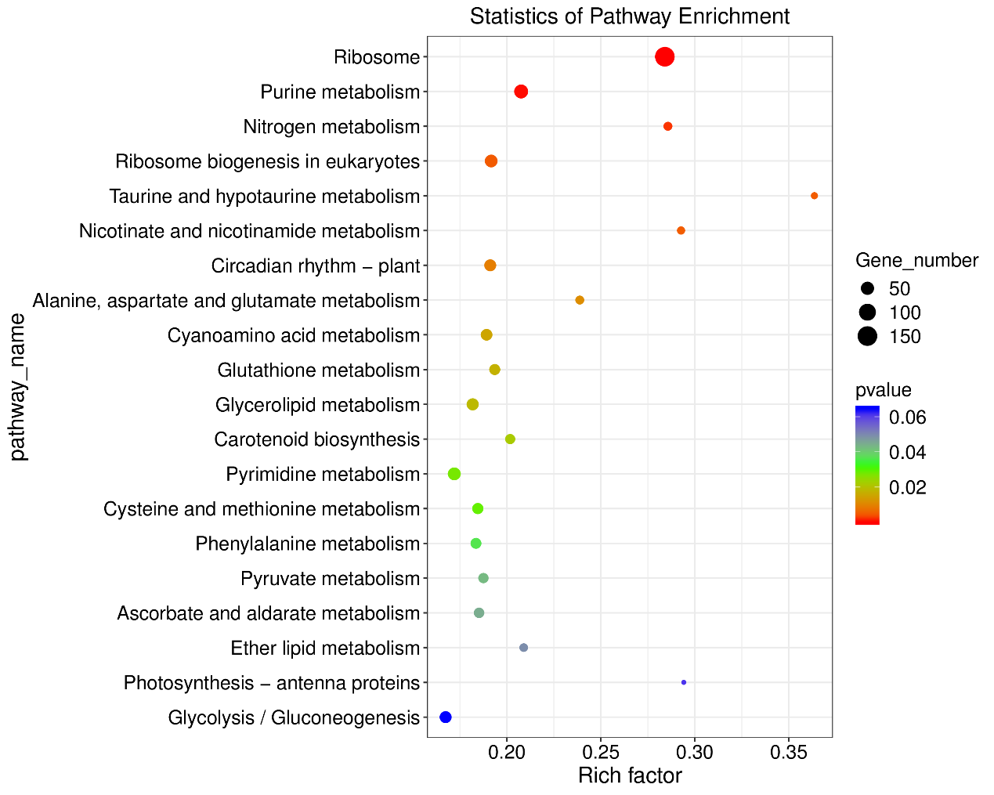

Supplementary Fig. S4 Correlation between gene expression profile of co-expression module and three phenotypic data (Thousand grain weight; Length; Width)

Supplementary Fig. S5 Is the overall gene expression profile of the co-expression module MidnightBlue, which has the highest correlation with TKW.

