Support Information
Adsorption of Cu²⁺ on different samples
0.1g of BSP, CNF aerogel, CNF/PVA aerogel and CNF/PVA/PEI nanoparticles were adsorbed in Cu²⁺ solution with concentration of 20mg/L, pH of 6 and temperature of 25°C in a constant temperature water bath generator for 2h to compare their removal rates in Cu²⁺ solution. As shown in the Fig.S1, the removal rate of cellulose is only about 16%, and when cellulose is converted into nanocellulose, the removal rate is doubled. The removal rate of CNF/PVA aerogel has reached 80%, which may be improved due to the increase of specific surface area. Compared with the first three samples, the removal rate of CNF/PVA/PEI nanoparticles was the highest.

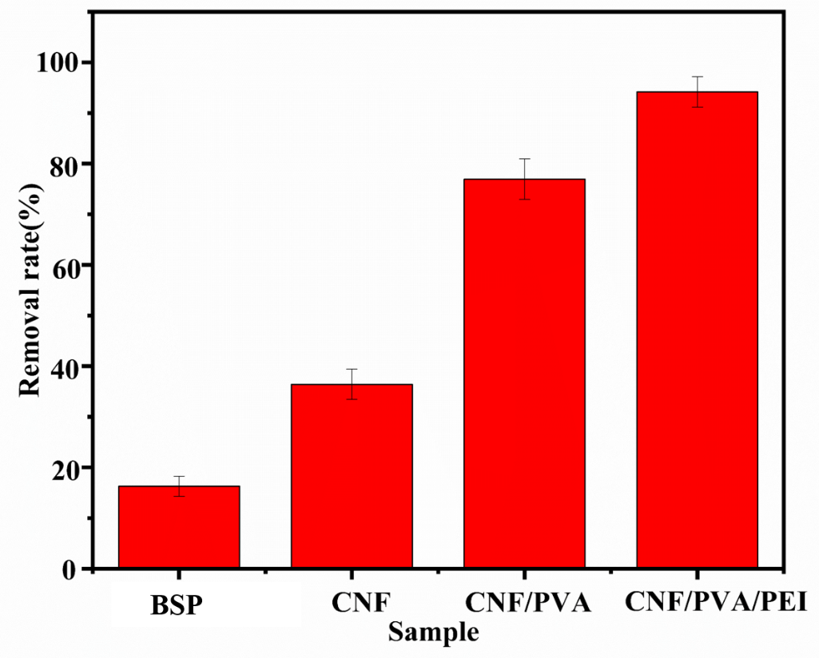
Figure.S1 Cu²⁺ removal rate (%) by BSP, CNF aerogel, CNF/PVA/PEI aerogel, CNF/PVA/PEI nanoparticles from deionized water contaminated with 20mg/L of Cu²⁺

