Supplementary Table 1: Composition of VL-70 + Cactus Extract Agar (VLCEA) medium
Ingredients | Quantity/ L distilled water
3-(N-morpholino) propanesulfonic acid | 2.09 g
MgSO₄ / MgSO₄ . 7H₂O | 24.09 mg / 49.3 mg
CaCl₂ / CaCl₂ . 2H₂O | 66.61 g / 88.2 g
K₂HPO₄ | 27.02 mg
Growth substrate (Starch) | 0.5g
Selenite tungstate solutionª | 1mL
Trace element solution SL-10^{b} | 1mL
Agar | 18 g
Cactus root/shoot extract (Filter sterilized and added after autoclaving) | 10 mL
pH | 7.2 ± 0.2

ªSelenite tungstate solution (Per litre stock solution)
NaOH | 0.5 g
Na2SeO3·5H2O | 3 mg
Na2WO4·2H2O | 4 mg
Distillated water | 1 L
Stored at 4°C
^{b}Trace element solution SL-10 (Per litre stock solution)
HCL (25%, 7.7 M) | 10 mL
FeCl₂·4H₂O / FeCl₃·6H₂O | 1.5 g / 2.04 g
ZnCl₂ | 70 mg
MnCl₂·4H₂O | 100 mg
H₃BO₃ | 6 mg
CoCl₂·6H₂O | 190 mg
CuCl₂·2H₂O | 2 mg
NiCl₂·6H₂O(or NiCl₂ 13mg) | 24 mg
Na₂MoO₄·2H₂O | 36 mg
Distilled water | 990 mL
Stored at 4°C

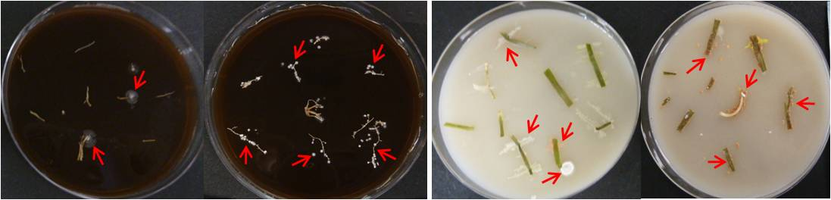
- (b)

Supplementary Figure 1: Representative pictures showing the emergence of colonies of endophytic actinobacteria on the isolation media plates [HVA medium (a) and MSA medium (b)] from the surface sterilized root bits of cactus.

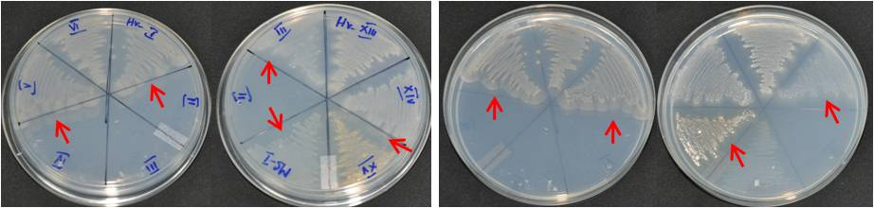
Back side view Front side view

Supplementary Figure 2: Representative picture showing growth of endophytic actinobacteria on the N-free Jensen medium.

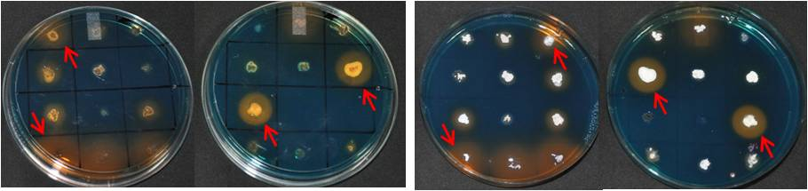
Back side view Front side view

Supplementary Figure 3: Representative picture showing orange-yellow halo zone representing the siderophore production trait of the endophytic actinobacteria on the modified CAS medium.

Supplementary Figure 4: Figure showing no detectable nitrogenase activity among the selected root-endophytic actinobacterial isolates, except positive control [A. chroococcum isolate (Ac-EPS-1)] in the acetylene reduction assays performed using GC-FID.

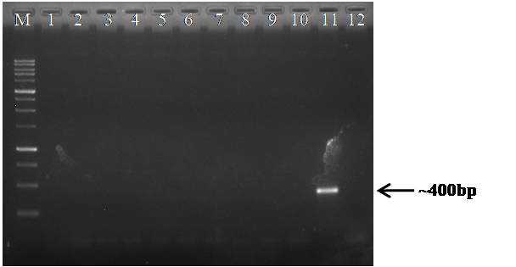

Supplementary Figure 5: Agarose gel picture showing no amplification of nifH gene from endophytic actinobacterial isolates, which showed growth on the N-free Jensen medium (nifH primers used: IGK3/ DVV [34, 35]; Lane Lane M- 1 kbp ladder; Lane 1-10 selected endophytic actinobacterial isolates; Lane 11- Bradyrhizobium diazoefficiens USDA 110, used as a positive control for carrier of nifH gene; Lane 12- Negative control).

