Supplementary Information for

RBM10 interacts with CTBNNBIP1 and represses lung adenocarcinoma progression through the Wnt/β- catenin pathway

Correspondence: Yan Yu, Email: yuyan@hrbmu.edu.cn;
Bo Pan, Email: panbo1291@126.com

This file includes:

Supplementary Tables
Additional file 1: table S1 to Additional file 2: table S2

Supplementary Figures
Additional file 1 to Additional file 5

Additional file 1: Table S1 Primers sequences
GENE | Forward (5’to 3’) | Reverse (5’to 3’)
RBM10 | GCACGACTATAGGCATGACAT | AGTCAAACTTGTCTGCTCCA
E-cadherin | GCTGGACCGAGAGAGTTTCC | CAAAATCCAAGCCCGTGGTG
Vimentin | CGGGAGAAATTGCAGGAGGA | AAGGTCAAGACGTGCCAGAG
Slug | TCCTGGTCAAGAAGCATTTCAA | TTGTGGTATGACAGGCATGGA
Twist | GCCAGGTACATCGACTTCCTCT | TCCATCCTCCAGACCGAGAAGG
c-MYC | AGCGACTCTGAGGAGGAAC | TGTGAGGAGGTTTGCTGTG
cyclinD1 | GATCAAGTGTGACCCGGACT | CTTGGGGTCCATGTTCTGCT
β-catenin | AAAGCGGCTGTTAGTCACTGG | CGAGTCATTGCATACTGTCCAT
TCF3 | CTCGAGAAGAACAGGCCAAG | GGGGCAGGTACTGAACACAT
TCF4 | GATGCTCTGGGGAAAGCACT | GTGCCTGCTGAGAGAGATGG
LEF1 | AGAACACCCGGATGACGGA | GGCATCATTATGTACCCGGAAT
MMP7 | AAATGCCAACAGTTTAGAAGCC | ATTATTTCTATGACGCGGGAGT
MMP3 | GGTGTGGAGTTCCTGATGTTGGTC | AGCCTGGAGAATGTGAGTGGAGTC
MMP10 | CAGCGGACAAATACTGGAGAT | CTTAGGCTCAACTCCTGGAAAG
CTNNBIP1 | GGAAGAGTCCGGAGGAGATG | CTCTGCACCCTGGTCGAT
GAPDH | GACTCATGACCACAGTCCATGC | AGAGGCAGGGATGATGTTCTG

Additional file 2: Table S2 Primers antibody
Antibody | Manufacturer | Diluted
RBM10 | Abcam, Ab72423 | 1:1000
E-cadherin | Proteintech, 20874-1-AP | 1:1000
Vimentin | Proteintech, 10366-1-AP | 1:1000
Slug | Cell signaling technology, #9585 | 1:1000
Twist | Cell signaling technology, #69366 | 1:1000
N-cadherin | Cell signaling technology, #13116 | 1:1000
EPCAM | ABclonal, A1177 | 1:500
β-catenin | Abcam, Ab32572 | 1:5000
c-MYC | Abways, CY5150 | 1:5000
cyclinD1 | Abways, CY5404 | 1:1000
MMP7 | Abways, CY1224 | 1:500
TCF3 | Cell signaling technology, #2883 | 1:1000
TCF4 | Cell signaling technology, #2569 | 1:1000
LEF1 | Cell signaling technology, #2203 | 1:1000
CTNNBIP1 | Abcam, Ab129011 | 1:1000
β-actin | Proteintech, 66009-1-Ig | 1:10000

Additional file 1: Figure S1 Verification of transfection efficiency qRT-PCR and Western blot analysis of RBM10 mRNA and protein expression in A549 or H1299 cell lines transfected with RBM10 si-RNA-1/-3 and si-NC, and the same cell lines infected with RBM10 overexpression lentivirus (RBM10) and negative control (vector). GAPDH was applied as the endogenous control for qRT-PCR, and β-actin was used as a loading control for western blot assay. The results were represented as mean ± SD. *P < 0.05, **P < 0.01.
Additional file 1: Figure S2 Soft agar colony formation assays using the transfected cells. The scale bar is 100μm.
Additional file 2: Figure S1 (a) Schematic diagram of subcutaneous xenograft model in BALB/c nude mice. (b) Stable overexpression of RBM10 in A549 cells and the transfection efficiency were assessed by Western blot.
Additional file 2: Figure S2 Schematic diagram of lung metastasis model in BALB/c nude mice.
Additional file 3: Figure S1 The expression relationship between RBM10 and CDH1 (E-cadherin), Vimentin, ZEB1, ZEB2 in LUAD in published database from ChipBase (http://deepbase.sysu.edu.cn/chipbase/).
Additional file 3: Figure S2 IHC staining of EMT markers (E-cadherin, Vimentin) in xenograft tumors.
Additional file 3: Figure S3 qRT-PCR results of the EMT markers (E-cadherin, Vimentin, slug, twist) in A549 or H1299 cells with knockdown or overexpressing RBM10. The results were represented as mean ± SD. *P<0.05
Additional file 3: Figure S4 The mRNA levels of ZEB1, ZEB2, MMP3, MMP7 and MMP10 in LUAD cells by qRT-PCR. The results were represented as mean ± SD. *P<0.05
Additional file 4: Figure S1 Gene ontology (GO) analysis and KEGG analysis of RBM10-dependent genes. (a) Gene ontology (GO) analysis involved biological processes (left) such as biological adhesion, cell proliferation and growth, and cellular component (right), including cell junction. (b) KEGG analysis was significantly associated with cancer-related functions, including cellular motility, growth and death and etc.
Additional file 4: Figure S2 Pathway analysis of genes that were significantly and differentially expressed in H1299-si-RBM10 cells and control cells using KEGG database.
Additional file 4: Figure S3 Negative correlation between RBM10 and the four common of the Wnt/β-catenin pathway target genes (CTNNB1 (also called β-catenin), Wnt5a, c-MYC, and CD44) in LUAD, analyzed at the ChipBase and StarBase.
Additional file 4: Figure S4 The effect of RBM10 knockdown (a, b) or overexpression (c, d) on the mRNA levels of β-catenin, cyclin-D1, c-MYC and MMP7 in LUAD cells assayed by qRT-PCR.
Additional file 4: Figure S5 IF assay results of β-catenin in RBM10-overexpressing A549 cells.
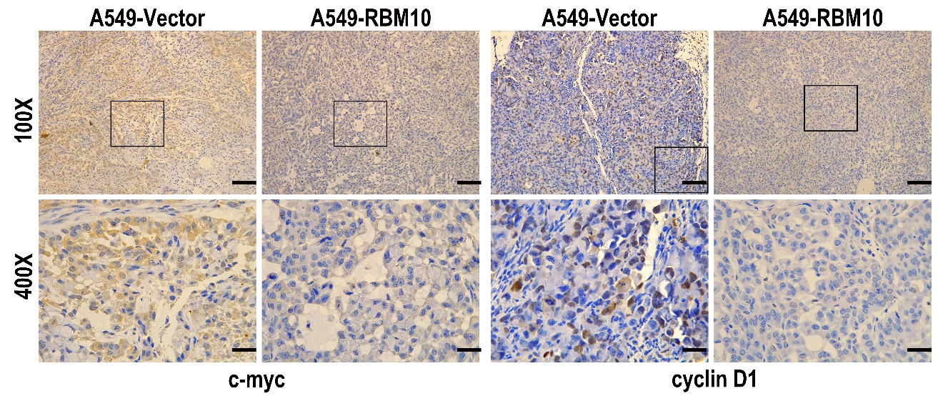
Additional file 4: Figure S6 The expression of c-MYC and cyclinD1 were examined by IHC staining in the xenograft tumor tissues.
Additional file 5: Figure S1 CTNNBIP1 is the low expression in LUAD (a) The expression of CTNNBIP1 in various tumors was observed from TCGA databases. (b, c) the expression of CTNNBIP1 in LUAD was reported from UALCAN and StarBase website. (d) The CTNNBIP1 mRNA levels in LUAD were obtained from GEPIA. (e) Box plots showed that expression levels of CTNNBIP1 were gradually reduced with clinical stage progression. (f) qRT-PCR analysis of CTNNBIP1 mRNA levels in a series of LUAD cell lines and the control cell lines HBE. (g) The OS analysis of 504 LUAD patients in KM Plotter database. The results were represented as mean ± SD. *P < 0.05, all experiments were repeated three times.
Additional file 5: Figure S2 After transfection with CTNNBIP1 siRNA1 in stable RBM10 for 48 h, the cell migration, and invasion ability were estimated by Transwell assays. The results were represented as mean ± SD. *P < 0.05, **p<0.01, all experiments were repeated three times.

