Supplementary Information for
Biophysical Considerations in the Rational Design and Cellular Targeting of Flexible Polymeric Nanoparticles

Samaneh Farokhirad^{1,2},∗ Sreeja Kutti Kandy²,† Andrew Tsourkas³,‡ Portonovo
S. Ayyaswamy^{4,6},§ David M. Eckmann⁵,¶ and Ravi Radhakrishnan^{2,3∗∗}
¹ Department of Mechanical Engineering, New Jersey Institute of Technology, Newark, NJ, USA
² Department of Chemical and Biomolecular Engineering, University of Pennsylvania, Philadelphia, PA, USA
³ Department of Bioengineering, University of Pennsylvania, Philadelphia, PA, USA
⁴ Department of Mechanical Engineering and Applied Mechanics, University of Pennsylvania, Philadelphia, PA, USA
⁵ Department of Anesthesiology, The Ohio State University, Columbus, OH, USA

⁶ Department of Mechanical and Aerospace Engineering, University of California, Los Angeles, CA, USA

Supplementary Methods

- Mesoscale model for multivalent binding of star polymer NPs to the cell membrane
The computational platform is based on equilibrium statistical mechanics, which couples continuum field models for cell membranes with coarse-grained molecular-scale models for the NP, antibodies, and target receptors. We adopt the coarse-grained approach developed in earlier works ¹⁻⁵ and further extend it to model binding of ligand-coated deformable NPs to a membrane functionalized with the target receptors. Each receptor and ligand molecule is taken as flexible rods of lengths and, respectively. The target membrane is taken as a square patch of dimension and chosen as a set of nodes connected by bonds to form a triangulated surface. Membrane elasticity is studied using the Helfrich effective Hamiltonian, which describes the bending energy of the membrane surface and involves the effective bending rigidity $κ$, given by:
$$H_{m}=\sum_{i=1}^{N_{v}}{\frac{k}{2}{\left(c_{1,i}+c_{2,i}\right)}^{2}A_{i}}$$ | S1
Here $A_{i}$ is the curvilinear area of the membrane-associated with node $i$, and $c_{1,i}$ and $c_{2i}$ are the maximum and minimum principal curvatures at each node, respectively. Since membrane conformation has a fixed projected area, i.e., $A_{p}=L^{2}$, any nonzero value of the membrane excess area $A_{ex}$ accommodates the additional area through undulations and is given by$A_{ex}=(A-A_{p})/A×100$, where, $A=\sum_{i=1}^{N_{v}}{A_{i}}$ is the total curvilinear area of the membrane. The connectivity of the membrane is not fixed, which allows nodes to change neighbors and move throughout the membrane ⁶. in order to maintain membrane fluidity. Two different $A_{ex}$ are explored in our studies; these reflect two different membrane tension values: namely high $A_{ex}$ reflective of low tension and vice versa. A mapping of $A_{ex}$ to tension is available from previously published studies ⁷⁻⁹.

Models for three types of NPs. We model three types of NPs; flexible, rigid-tethered, and rigid.
Flexible NP. The microstructure of lysozyme-core/dextran-shell cross-linked polymer NPs was recently modeled as a star polymer with 25 arms attached to the core ⁵, which was verified experimentally. In order to model the conformational dynamics of the star polymer, we consider a topology where each bead is connected to other beads through bonds and cross-links modeled via pair potentials ⁵. The stiffness of the links between beads is derived from the freely jointed chains model (FJC), i.e., $k_{s}=\frac{3k_{B}T}{N_{k}b_{k}^{2}}$ with $N_{k}$ and $b_{k}$ being the number of Kuhn's segments per bead and the size of each Kuhn's segment respectively. The NP stiffness in the model is then varied by introducing additional harmonic interactions between the beads (cross-links) to create NP models with five different stiffness changing from 0.43 kPa (Model 1) to 15.02 kPa (Model 5). All beads of a flexible NP interact by their adjacent connected beads through a harmonic potential, and the excluded volume interactions between beads are derived from Weeks-Chandler-Anderson (WCA) potential. The total interaction energy of the flexible NP is then given by:
$$H_{NP}=\sum_{i}{\sum_{j}{\frac{1}{2}k_{s}{\left(r_{ij}-r_{0}\right)}^{2}}}+\sum_{i}{\sum_{j}{4ϵ\left[{\left(\frac{σ}{r_{ij}}\right)}^{12}-{\left(\frac{σ}{r_{ij}}\right)}^{6}+\frac{1}{4}\right]}}$$ | S2
Here, $r_{ij}=\left|r_{i}-r_{j}\right|$ is the distance between two connecting beads $i$, and $j$ and $r_{0}$ is the equilibrium bond distance which is set to twice the bead radius. The second term is a summation overall $i,j$ pairs and enforces excluded volume, where $ϵ=0.7k_{B}T$ is the interaction strength and $σ$ is the excluded volume radius.
Rigid NP. The model presented for rigid NP was taken from ³. The rigid NP is a sphere with targeting ligands loaded directly on its surface at a density of $N_{l}=162/NP.$
Rigid-tethered NP. The model for the rigid-tethered NP is the same as that of the rigid NP, except the targeting ligands are attached to the NP surface via polymeric tethers. We model the tethers using FJC model by assuming a tether elasticity. The parameters of the rigid-tethered model are available in ¹.

Model for receptors expressed on membrane surface. Following ¹⁰, we consider the receptor molecules diffusing on the membrane surface. They are represented as cylindrical beams of total length $L_{r}$ with flexural angles $θ$ and $ϕ$, measured with respect to the membrane normal. When unbound, the receptors are perpendicular to the membrane surface in their vicinity with $θ=ϕ=0$. Flexural angles of a receptor $i$ are defined with respect to its equilibrium upright position on the membrane surface which leads to an orientational dependence of the bond energy:
$$H_{f}=\sum_{i=1}^{m}{\frac{k_{f}}{2}{\left(L_{r}sinθ_{i}\right)}^{2}}$$ | S3
Equation S3 is activated only when a receptor is bonded to a ligand; therefore, the summation extends from 1 to $m$, where $m$ is the multivalency. Here, $k_{f}$ is the flexural stiffness of the receptors and $θ_{i}$ is the flexure angle for the $i$th receptor participating in the multivalent interaction.
Receptor-ligand bonds. The NP is functionalized using ligand molecules specific to target receptors on the membrane surface. Specifically, we consider an engineered antibody specific for ICAM-1 receptors. The ligand molecules in our model are distributed on the beads of the flexible NP and modeled as detachable springs that are connected to the ICAM-1 receptors. The receptor-ligand bond energy depends on the bond length and we employ the Bell potential for the binding interaction between a ligand $i$ and a receptor $j$, which is a quadratic function of the bond length:
$$H_{b}=\sum_{i=1}^{m}{\left[∆G_{0}+\frac{1}{2}k_{b}^{eff}{\left(d_{i}-d^{eq}\right)}^{2}\right]}$$ | S4
for $d_{i}≤d^{*}$ and 0 for $d_{i}≥d^{*}$. Here, $d_{i}$ is the distance between the tip of the $i$th receptor participating in the multivalent interaction and the ligand it is bound to, and $d^{eq}$ is the cutoff distance for the binding interaction, i.e., $d^{eq}=σ/2+L_{l}$. $∆G_{0}$ denotes the free energy of binding of a single receptor with its ligand. $d^{*}$ specifies the range of distance where binding can occur and is given by $d^{*}={\left(-\frac{2∆G_{0}}{k_{b}^{eff}}\right)}^{1/2}+d^{eq}$. In the description above, the effective stiffness of the receptor-ligand bond (i.e., $k_{b}^{eff}$) is given by a combination of the molecular stiffness surrounding the receptor-ligand bond ¹⁰ and that of the polymer segment represented by a bead, i.e., $k_{b}^{eff}=\frac{k^{s}×k^{ICAM-anti ICAM}}{k^{s}+k^{ICAM-anti ICAM}}$ with $k^{ICAM-antiICAM}≅1 N/m$ being the spring constant of a receptor-ligand bond.
The total energy of a deformable NP bound to a deformable membrane with $m$ multivalent bonds come from the four contributions: the membrane energy ($H_{m}$), the NP energy ($H_{NP}$ ), the receptor energy ($H_{f}$ ), and the binding/unbinding energy ($H_{b}$).
$$H=H_{m}+H_{f}+H_{NP}+H_{b}$$ | S5
We use Metropolis Monte Carlo (MC) method to sample configurations of the functionalized NP-membrane system at thermal equilibrium. The set of MC moves of the system in its configurational space consists of six independent trial moves: the first is the standard MC move for the membrane, where a randomly selected node on the triangulated surface is moved to a new position to simulate thermal fluctuations in the membrane ^{11,12}. The second type of trial move is the standard MC move to translate the NP to a new position through the use of equations of motion with Brownian dynamics of beads of NP. To update the bead position, we include Brownian ($F_{i}^{Br}$) force and non-Brownian forces such as forces due to the intermolecular interactions from all other beads ($F_{i}^{NP})$, including bead-bead interaction and bead-bead repulsion, and force due to binding interaction between receptor-ligand pairs ($F_{i}^{b}$) and solve:
$$\frac{∆r_{i}}{∆t}=\frac{F_{i}^{Br}+F_{i}^{NP}+F_{i}^{b}}{ξ_{i} }$$ | S6
where $ξ_{i}=6πμa$ is the friction factor. The Brownian forces are considered as white noise which yields the following expression:
$$〈F_{i}^{Br}(t)〉=0$$  $$〈F_{i}^{Br}(t)F_{j}^{Br}(t')〉=6k_{B}Tξ_{i} δ_{ij}δ\left(t-t^{'}\right)I$$ | S7
With $I$ being the second-order identity tensor and $δ\left(t-t^{'}\right)$ is the Dirac delta function. The spring restoring force and the force due to excluded volume effect are derived from the interaction energy defined in Equation S2. The binding interaction force for a receptor-ligand pair is derived from the Bell potential defined in Equation S4.
We use the forward explicit Euler time integration method to discretize Equation S7 and solve for updating the positions of the beads within a time step, which is chosen and also modified during runtime such that nearly 50% of the attempted moves are accepted. The third trial move is to simulate membrane fluidity by the membrane bond-flip move, in which a randomly chosen link is cut and replaced by a new link ⁶. The new link connects two initially unconnected nodes associated with the triangles sharing the cut link. The fourth and fifth types of trial moves are random diffusion and flexure of receptors, respectively. Binding/unbinding interaction of receptor-ligand pairs is the sixth type of trial move where a bond is formed between a randomly selected receptor-ligand pair if they are previously unbound, and the bond is broken/retained (with equal probability) if the selected pair is already in the bound state. Trial moves (1)-(5) are accepted or rejected according to the standard Metropolis criterion ¹³ in the canonical ensemble, whereas the trial move for the formation and breakage of receptor-ligand bonds is performed and accepted by a configurational bias Monte Carlo move using the Rosenbluth sampling technique ¹³.

- Free energy analysis
We have recently proposed novel methods to quantify the equilibrium bound state of a ligand coated NP (rigid or flexible) bound to a substrate (rigid or flexible) in terms of the losses in the configurational entropies and the gain in binding enthalpy to assess the binding avidity of a given system ¹. Upon multivalent binding of NP to the cell surface, the competition between the losses in the configurational entropies and the gain in binding enthalpy depends on the stiffness of the NP and the membrane, the receptor expression level, and the ligand density. The enthalpy of binding is computed as $〈H〉$, with the ensemble averages of $H$ in Equation S5 computed during the MC simulation run. The entropic terms arose from fluctuations in the positions of the center of mass of the beads of the NP, the motion of membrane vertices, and the spatial fluctuations of all receptors are calculated as follows;
Entropy of flexible NP. The fluctuation in the motion of the system can be approximated, using quasi-harmonic analysis, as those arising from a superposition of independent harmonic oscillators. The configurational entropy of the flexible NP is computed from the principal component analysis (PCA) of positional fluctuations recorded in the MC trajectories:
$$S_{qh}=k_{B}\sum_{i}{\left[\frac{ℏω_{i}/k_{B}T}{exp\left(ℏω_{i}/k_{B}T\right)-1}-ln\left[1-exp\left(-ℏω_{i}/k_{B}T\right)\right]\right]}$$ | S8
Here $ℏ$ is the Plank's constant divided by $2π$ and $ω_{i}$ is the set of angular frequencies which is connected to the eigenvalues through the equipartition theorem. In the calculation of quasi-harmonic entropy, three eigenvalues ($≈0$) correspond to translation about the center of mass, three eigenvalues correspond ($≈0$) to rotation about the center of mass, and the remaining $3N-6$ eigenvalues correspond to vibrational motions.

Entropy of deformable membrane. We have proposed two different methods to compute the configurational entropy of the membrane in more general and non-trivial configurations, such as when bound to a rigid, rigid-tethered, or flexible NP through multivalent receptor-ligand bonds. In the first method, similar to NP, we have used the trajectories of positional fluctuation of the vertices of the membrane and compute the entropy through the harmonic oscillator model. We call this procedure the PCA method or the real space method, which has been utilized in this study to estimate the membrane entropy. In the second method, we have performed a Fourier analysis of membrane height undulations according to its physical properties-namely, the bending rigidity ($κ$) and surface tension ($γ$) and described the membrane shape in the Monge gauge by its height. The details of the PCA and Fourier methods are provided in ¹. We also have demonstrated that both methods give the same estimate for the entropy of the membrane.

Entropy of diffusing receptors: The translational entropy of $N_{r}$ receptors is computed using the Sackur-Tetrode equation. In the dilute limit, when the surface coverage is low, the receptors can move freely about on the surface without interacting with each other and therefore act as a two-dimensional ideal gas. The Sackur-Tetrode equation for an ideal gas of indistinguishable molecules with mass of m is given by $S_{receptors}=k_{B}\left[\sum_{i=1}^{N_{r}}{ln\left(\frac{2πmk_{B}T}{N_{r}h^{2}}σ_{xi}σ_{yi}\right)+2}\right]$. Here $σ_{xi}$ and $σ_{yi}$ are the principal root-mean-square fluctuations for the center of mass of receptor $i$.

- Predicting and controlling NPs accessibility in cell surface
It is important to highlight that whereas here we mainly discuss the role of NP mechanical properties on the binding avidity and accessibility of NPs, there is another crucial aspect that controls the NP accessibility to the nanostructured environment, and that is the presence of the cytoskeleton in the cell periphery which maintains the overall shape of the cell. We have adopted the model for the membrane patch with the presence of cytoskeletal pinning that can diffuse on the membrane surface from a recent proposed work ⁸ and characterized the adhesion induced NP/membrane conformations as a function of membrane excess area and the pinning density. While the cytoskeletal elements are not explicitly present in our coarse-grained model, we consider their effects in our model for NP adhesion to the cell surface by introducing the pining sites on the membrane to bind the membrane to the cytoskeletal proteins via specific linker proteins. The binding interaction between membrane vertices and cytoskeletal proteins is modeled using the Bell potential:
$$H_{cyto}=∆G_{0}+\frac{1}{2}k_{cyto}d^{2},$$ | S9
Here $d$ is the distance between the reaction sites of the interacting membrane vertices and cytoskeletal element, $k_{cyto}$ is the interaction spring constant and $∆G_{0}$ is the free energy change at equilibrium state (i.e., $d=0$).

To model a membrane patch that assembles curvature inducting proteins in response to the binding interactions, we use the discretized version of Helfrich Hamiltonian:
$$H_{m}=\sum_{i=1}^{N_{v}}{\frac{k}{2}{\left(c_{1,i}+c_{2,i}-c_{0,i}\right)}^{2}A_{i}}$$ | S10
Here $c_{0,i}$ is the induced curvature that represents the presence of protein at the surface. In our model, a binding interaction between an NP-antibody and a surface receptor induces a protein coat assembly, and hence for every vertex associated with bound receptors, we assign $c_{0,i}=0.06/nm$ based on earlier work ¹⁴.

Supplementary Figures and Tables

Supplementary Figure 1
(a)$A_{ex}\sim 6\%$ (b)$A_{ex}\sim 20\%$
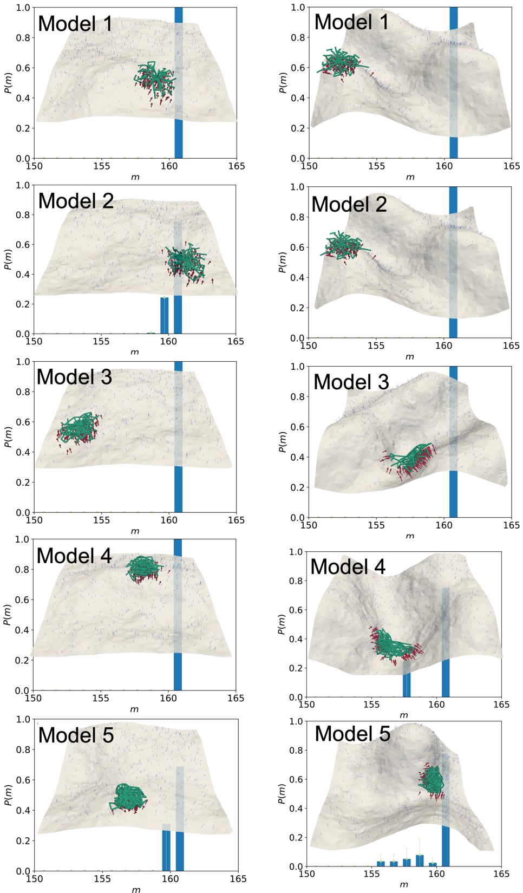
Supplementary Figure 1: (a)-(f) The equilibrium distribution of the number of simultaneous receptor-ligand bonds for a star polymeric NP with $N_{ab}=162/NP$ as functions of NP stiffness and membrane excess area ($A_{ex}$).

Supplementary Table 1
$$A_{ex}=6\%$$ | Model 1 | Model 2 | Model 3 | Model 4 | Model 5
Enthalpy ($ΔH/k_{B}T$)  Receptor-Ligand  Bead-Bead | -2969.3 (11.8)  -3.4 (23.7) | -2955.5 (13.4)  -261.5 (14.12) | -2958.3 (8)  -246.1 (41.9) | -2951.8 (4.9)  380.0 (124.8) | -2927.6 (12.5)  -193.3 (189.0)
Entropy ($-TΔS/k_{B}T$)  NP  Receptor  Membrane | 191.6 (13.5)  1220.2 (5.4)  44.2 (0.7) | 177.0 (26.6)  1219.4 (22.7)  336.0 (3.3) | 58.2 (130.0)  1252.9 (27.2)  332.4 (5.2) | 136.4 (21.2)  1226.2 (5.8)  251.4 (0.6) | 105.0 (16.6)  1224.0 (7.5)  244.2 (2.2)
$$A_{ex}=20\%$$ | Model 1 | Model 2 | Model 3 | Model 4 | Model 5
Enthalpy ($ΔH/k_{B}T$)  Receptor-Ligand  Bead-Bead | -2971.0 (6.8)  19.8 (78.9) | -2958.3 (8.7)  271.5 (7.0) | -2964.9 (12.6)  337.9 (22.6) | -2930.9 (27.6)  559.6 (307.2) | -2930.1 (37.5)  79.3 (31.2)
Entropy ($-TΔS/k_{B}T$)  NP  Receptor  Membrane | 175.6 (5.3)  1194.9 (14.1)  35.5 (3.5) | 165.1 (20.0)  1204 (17.4)  325.4 (3.2) | 167.3 (13.1)  1235.8 (6.4)  325.4 (4.0) | 116.0 (18.9)  1207.1 (15.7)  246.2 (2.7) | 105.3 (12.2)  1217.3 (51.9)  241.5 (1.7)
Supplementary Table 1: Report of the mean (with standard deviation) of individual energy components between different stiffness of flexible NPs in Fig. 2 as a function of membrane excess areas.

Supplementary Figure 2
(a) Flexible NP, $A_{ex}\sim 6\%$
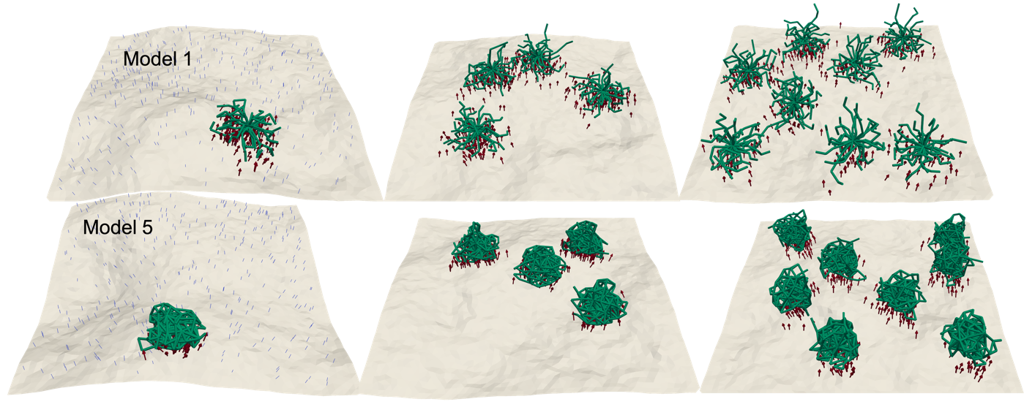
(b) Flexible NP, $A_{ex}\sim 20\%$
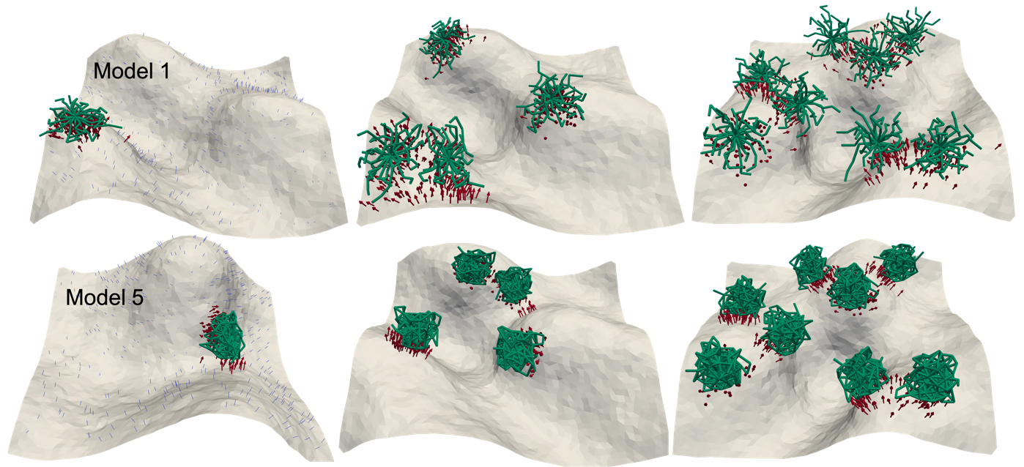
(c) Rigid NP, $A_{ex}\sim 6\%$
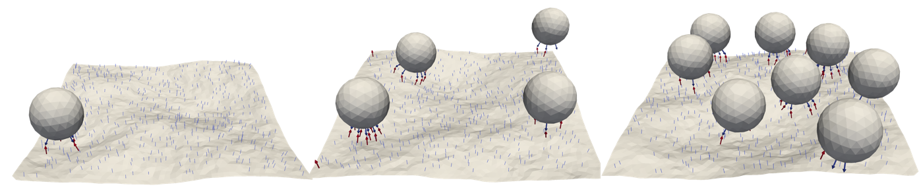
(d) Rigid NP, $A_{ex}\sim 20\%$
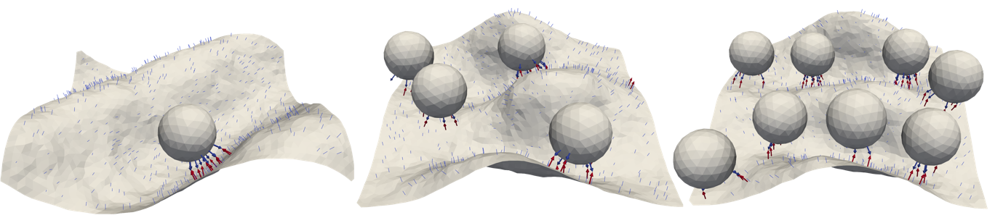
(e) Rigid-Tethered NP, $A_{ex}\sim 6\%$
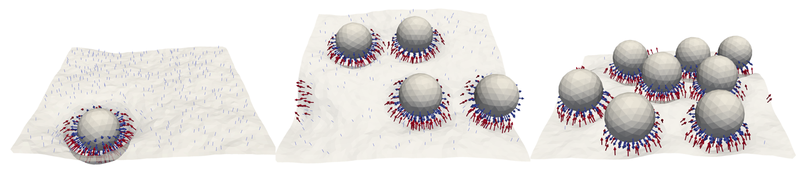
(f) Rigid-Tethered NP, $A_{ex}\sim 20\%$
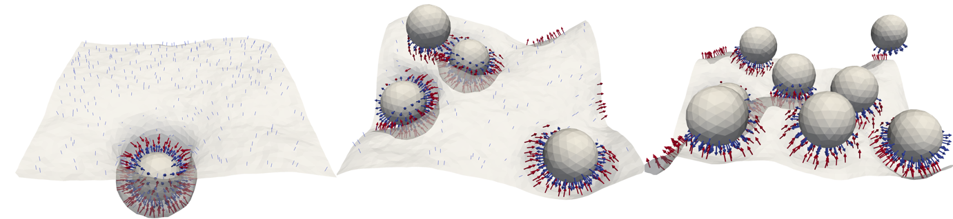
Supplementary Figure 2: a-f Effect of crowding on the binding of NPs as a function of NP type and membrane excess area $A_{ex}$. a,b, Representative equilibrium conformation of binding of one, four, and eight flexible NPs for Model 1 and Model 5 with membrane excess areas of $A_{ex}=6\%, 20\%$. c,d, Representative equilibrium conformation of binding of one, four, and eight rigid NPs (Model 6) with membrane excess areas of $A_{ex}=6\%, 20\%$. e,f, Representative equilibrium conformation of binding of one, four, and eight rigid-tethered NPs (Model 7) with membrane excess areas of $A_{ex}=6\%, 20\%$.

Supplementary Figure 3
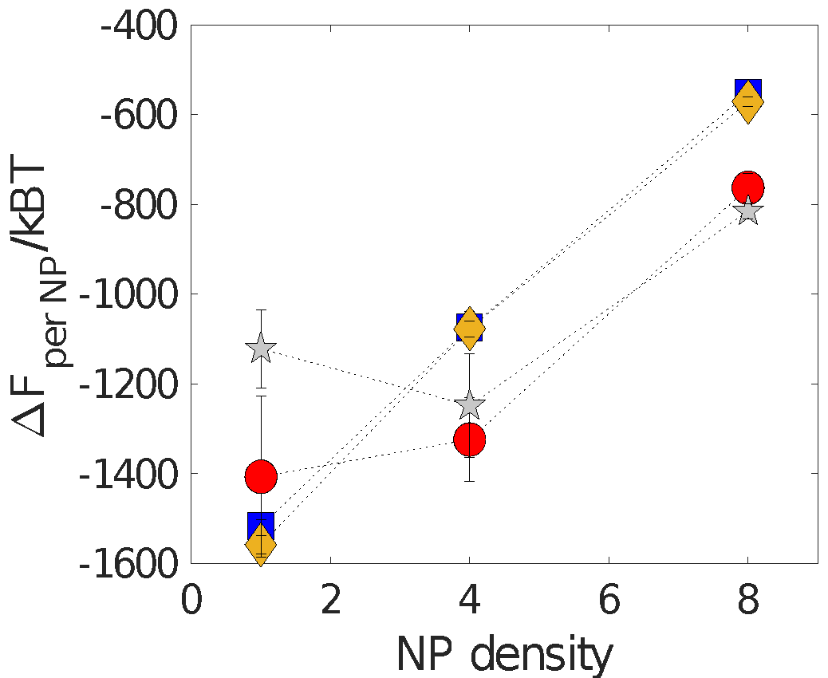 | 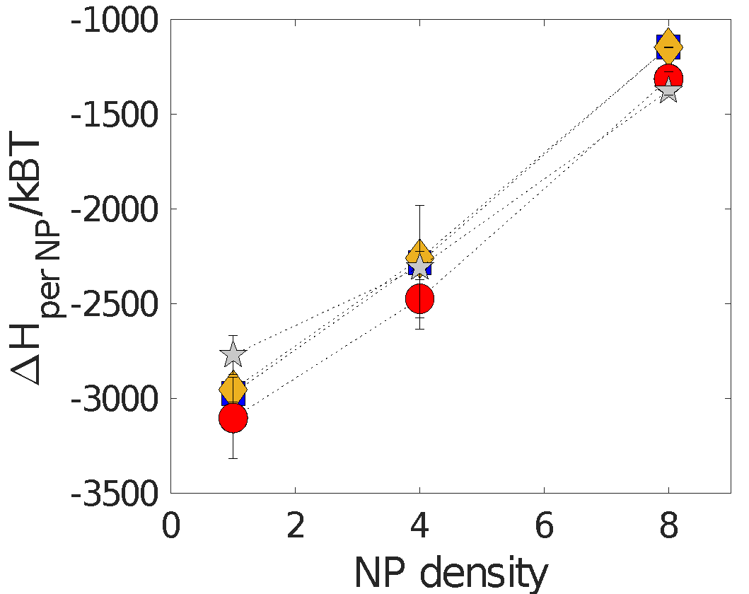 | 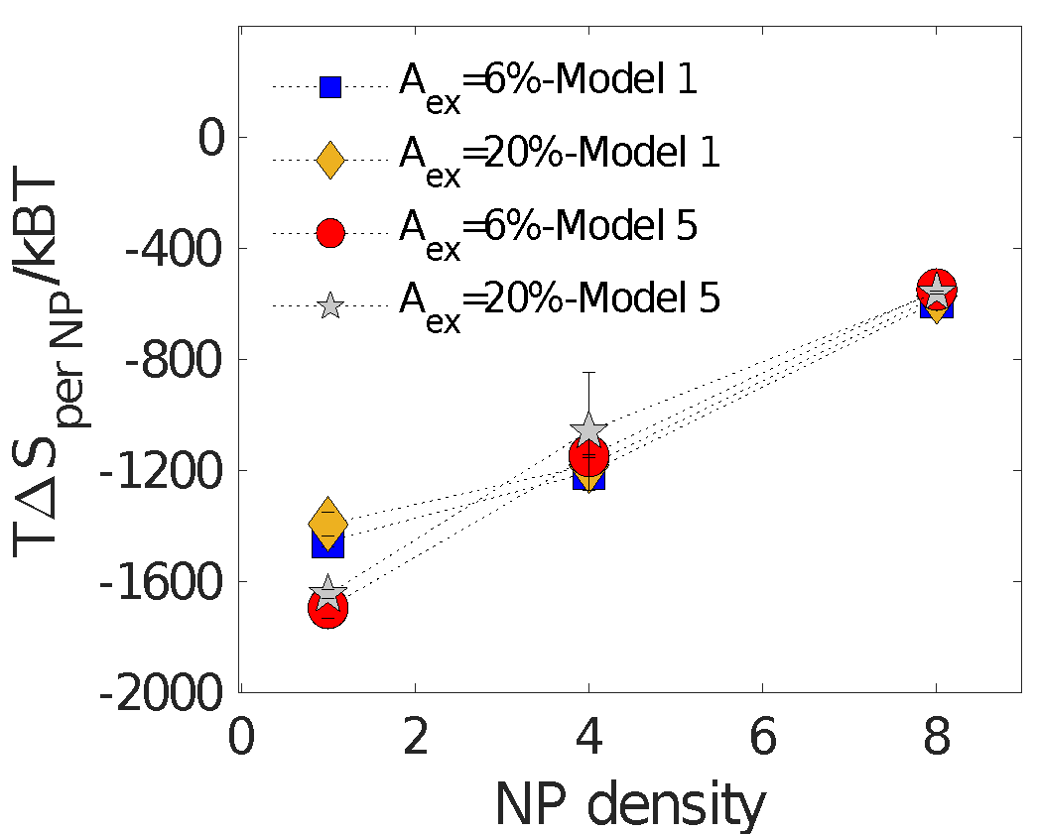
Supplementary Figure 3: Comparison of relative free energies $∆F/NP$ and other internal energies ($∆H/NP, T∆S/NP$) of the system as a function of density and stiffness of flexible NP.

Supplementary Figure 4
$N_{pin}=0.05$ $N_{pin}=0.1$
(a) $A_{ex}\sim 6\%$
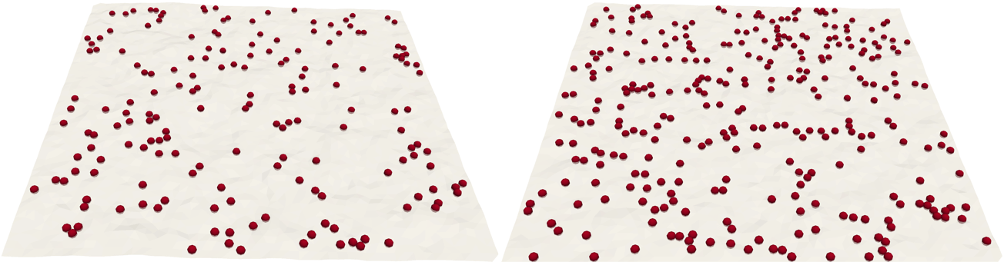
(b) $A_{ex}\sim 20\%$
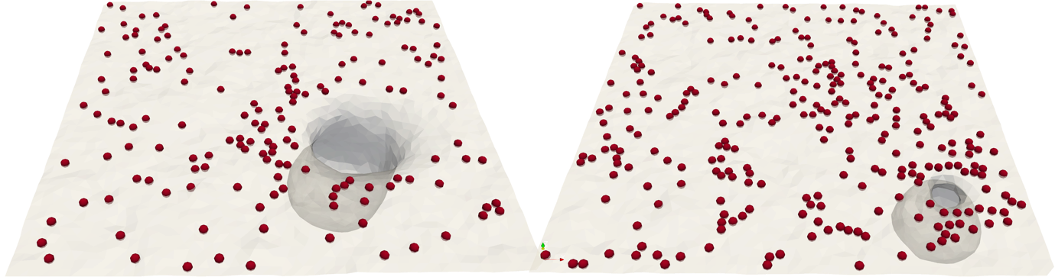
(c) $A_{ex}\sim 34\%$
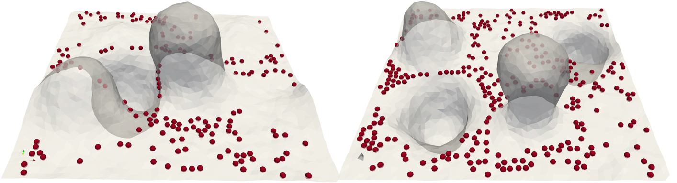
Supplementary Figure 4: a-c Representative equilibrium conformation of the membrane patch as a function of diffusive pins ($N_{p}$) and membrane excess area ($A_{ex}$). The red spheres on the membrane shows the locations of the pinning sites. a, At low excess area $A_{ex}=6\%$, the membrane for both pinning densities shows a flat morphology. b, $A_{ex}=20\%$ leads to more natural fluctuations, which can be much easily channelized into the protrusions or vesicular membrane buds. c, The effect of pinning is more prominent upon an increase in the number of pins for $A_{ex}=34$, where the high bending energy associated with the vesicular region is balanced by the local pinning energy.

Supplementary Figure 5
(a) $A_{ex}\sim 6\%$
Flexible NP – Model 1 Flexible NP – Model 5 Rigid NP Rigid-Tethered NP
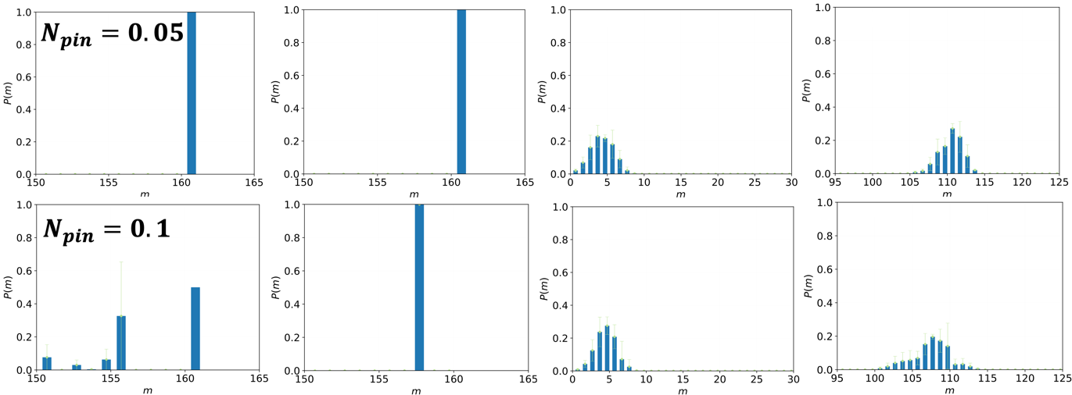
(b) $A_{ex}\sim 20\%$
Flexible NP – Model 1 Flexible NP – Model 5 Rigid NP Rigid-Tethered NP
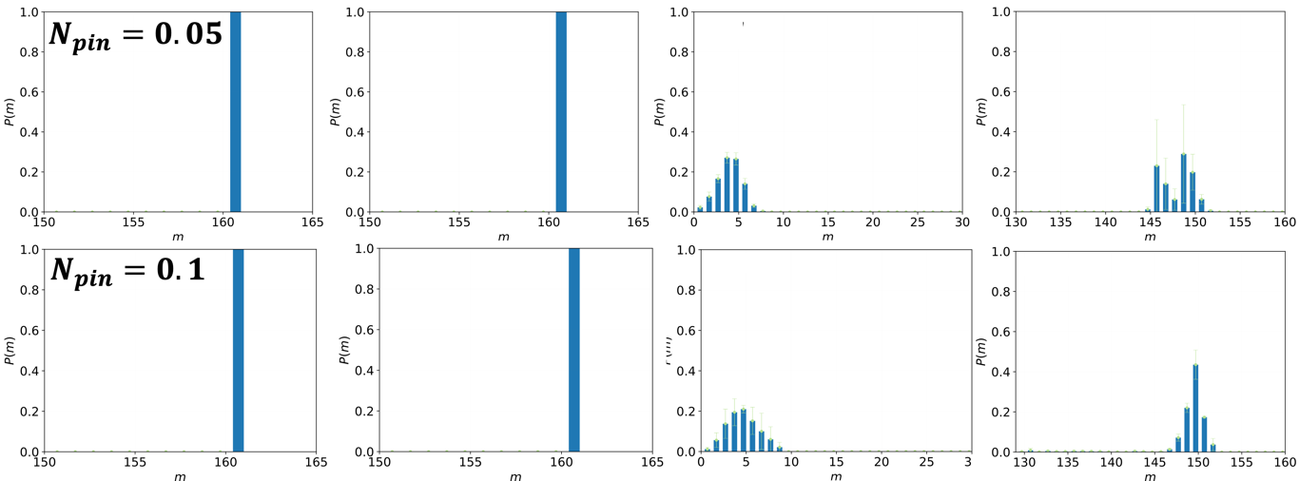
(c) $A_{ex}\sim 34\%$
Flexible NP – Model 1 Flexible NP – Model 5 Rigid NP Rigid-Tethered NP
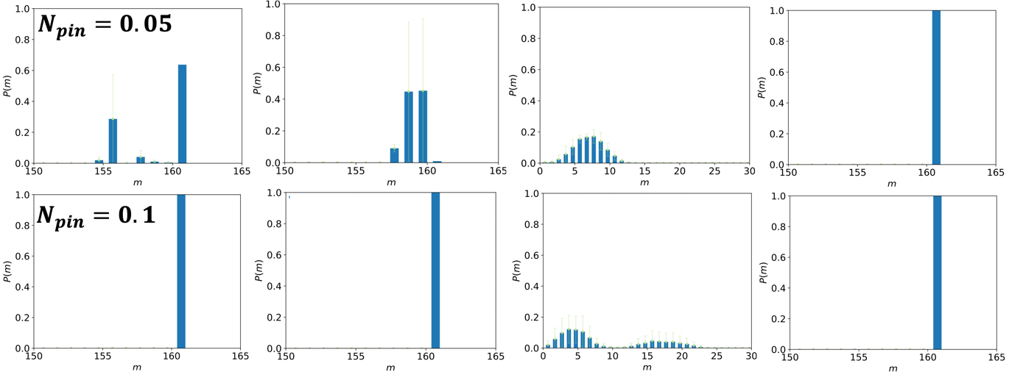
Supplementary Figure 5: a-c, Histogram representation of multivalency of membrane-NP system in presence of flexible, rigid and rigid-tethered NPs, showing the effect pining interactions at different $A_{ex}$ and $N_{pin}$.

Supplementary Figure 6
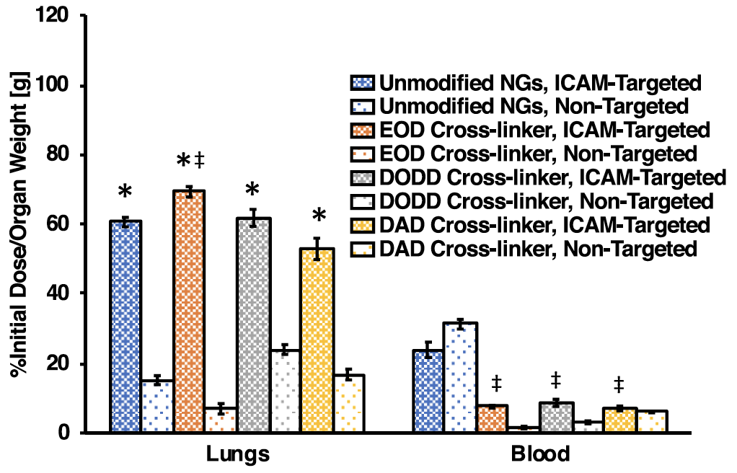
Supplementary Figure 6: Figure 4D of [20]. Targeting of cross-linked NGs to ICAM. In vivo retention of ICAM-targeted (dark bars) or IgG-functionalized NGs (light bars) in mouse blood and lungs at 30 min after intravenous bolus injection (blue bars: unmodified NGs, n = 4 ICAM-targeted, n = 4 nontargeted; orange bars: EOD-cross-linked NGs, n = 4 ICAM-targeted, n = 4 nontargeted; gray bars: DODD-cross-linked NGs, n = 4 ICAM-targeted, n = 4 nontargeted; and yellow bars: DAD cross-linked NGs, n = 4 ICAM-targeted, n = 4 nontargeted.

Supplementary Table 2
NP/cell surface type | Methods | Findings and citation
Rigid/Rigid | MC/in vivo, in vitro, AFM | Enhanced binding at large ligand surface coverage ¹⁰
Rigid/Rigid | MC/in vivo | Increased selectivity using controlled reduction of receptor surface density ¹⁵.
Rigid/Flexible | MC/in vivo | Binding kinetics are influenced by mechanotype & phenotype of target cells ³
Flexible/- | CGMD/in vitro | 1. Computed stiffness of the NP falls in the range of moderately soft materials.  2. Model 5 in the computation best represents the properties of the polymeric NP utilized  in the experiments ⁵
Flexible/Rigid | CGMD & MC/in vivo, in vitro | Shear-enhanced binding, effects of RBC volume fraction and NP stiffness ^{2,16}
Flexible/Flexible | CGMD & MC | NP flexibility and membrane undulations dictate the receptor-ligand translational entropy making the entropy compensation context-specific ¹
Supplementary Table 2: Summary of model validation by comparison to experiments for binding of functionalized NPs to diffusing ICAM-1 receptors on the cell surface

Supplementary Table 3
Property | Symbol | Value
Membrane surface area | $$L^{2}$$ | $$0.25 μm^{2}$$
Mass of each membrane vertex | $$m_{v}$$ | $$5.5×{10}^{-19}g$$
Number of links | $$N_{links}$$ | $$7699$$
Number of membrane vertices | $$N_{v}$$ | $$2702$$
Receptor length | $$L_{ant}$$ | $$19 nm$$
Number of receptors | $$N_{r}$$ | $$2000$$
Receptor flexural rigidity | $$k_{f}$$ | $$7000 pN.nm^{2}$$
Number of ligands per NP | $$N_{l}$$ | $$162$$
Ligand length | $$L_{l}$$ | $$15 nm$$
Bending rigidity | $$κ$$ | $$20k_{B}T$$
Free energy of binding per receptor-ligand bond | $$∆G_{0}$$ | $$-7.98×{10}^{-20}J$$
Flexible NP | Symbol | Value
Bead radius | $$R_{flexible}$$ | $$6.8 nm$$
Bead mass | $$m_{b}$$ | $$1.44×{10}^{-19}g$$
Number of beads in an arm | $$N_{b}$$ | $$4$$
Number of arms attached to a core | $$f$$ | $$25$$
Molecular weight of Dextran monomer | $$M_{monomer}$$ | $$160 Da$$
Molecular weight of Dextran polymer | $$M_{polymer}$$ | $$71 kDa$$
Size of each Kuhn segment | $$b_{k}$$ | $$0.44 nm$$
Size of monomer | $$b$$ | $$1.5 nm$$
Number of monomers per bead | $$N$$ | $$108$$
Number of Kuhn segments per bead | $$N_{k}$$ | $$246$$
Stiffness of spring between beads | $$k_{s}$$ | $$1.74×{10}^{-4} J/m^{2}$$
Rigid-tethered NP | Symbol | Value
Radius | $$R_{rigid-tethered}$$ | $$50 nm$$
Stiffness | $$k_{rigid-tethered}$$ | $$3.3×{10}^{-4} J/m^{2}$$
Rigid NP | Symbol | Value
Radius | $$R_{rigid}$$ | $$50 nm$$
Stiffness | $$k_{rigid}$$ | $$1 J/m^{2}$$
Supplementary Table 3: Details of the system parameters for binding of functionalized NPs to diffusing ICAM-1 receptors on the cell surface.

Supplementary Figure 7
(a)  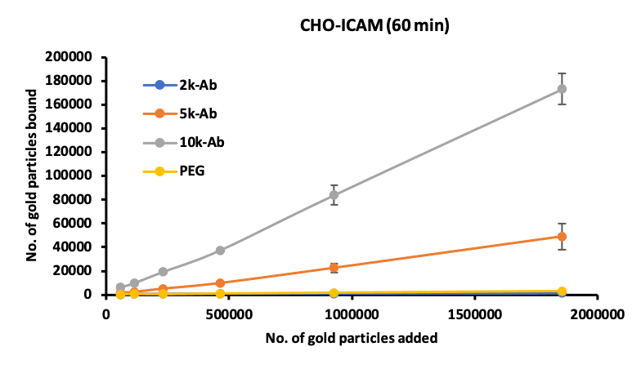 | (b)  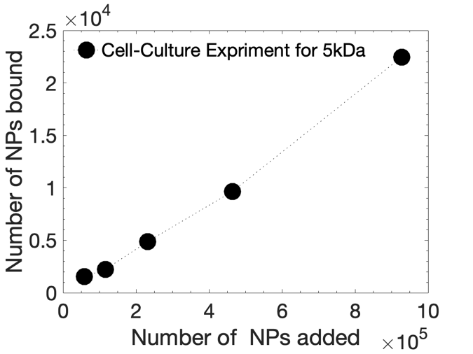
(c)  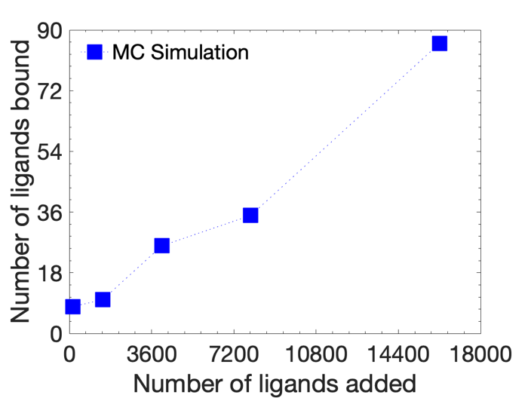 | (d)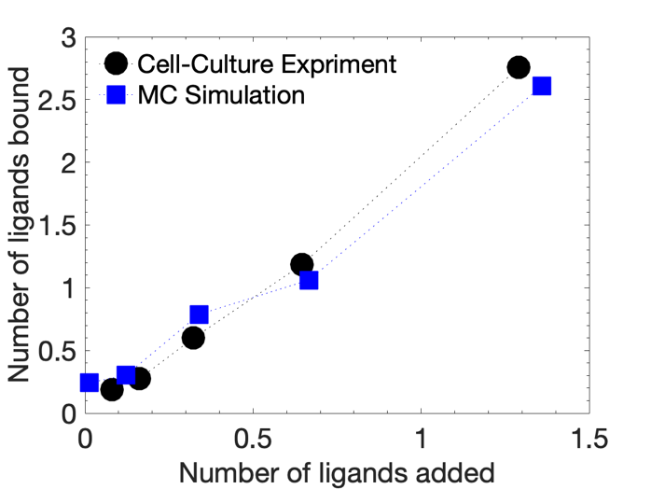
Supplementary Figure 7: a-d, Binding of antibody-PEGylated gold nanoparticles to the ICAM cell. a, Cell culture experiment to quantify number of bound NPs under different number of added gold NPs with various molecular weight (and size) for polyethylene glycol tethers. b, Cell culture experiment for coated gold-tethered NPs with a molecular weight of $5 kDa$. c, Monte Carlo simulation for the number of bound ligands against the total number of added ligands per NP. d. Comparison of the number of bound NPs in the experiment with the number of bound ligands per NP in the simulation. The x-axis is normalized by taking the average number of added ligands for five represented symbols (and added NPs in the experiment), whereas the y-axis is normalized by the average number of bound ligands (and bound NPs in the experiment).

Description of Supplementary Movies (movies uploaded separately)

Supplementary Movie 1: This movie shows the binding dynamics of Model 1 of a flexible nanoparticle to a flexible membrane with excess area $A_{ex}=20\%$ (see Fig.2 of the main text). The blue cylinders on the membrane show freely diffusing receptors. The red arrows on the membrane show bound receptors.

Supplementary Movie 2: This movie shows the binding dynamics of Model 2 of a flexible nanoparticle to a flexible membrane with excess area $A_{ex}=20\%$ (see Fig.2 of the main text).

Supplementary Movie 3: This movie shows the binding dynamics of Model 3 of a flexible nanoparticle to a flexible membrane with excess area $A_{ex}=20\%$ (see Fig.2 of the main text).

Supplementary Movie 4: This movie shows the binding dynamics of Model 4 of a flexible nanoparticle to a flexible membrane with excess area $A_{ex}=20\%$ (see Fig.2 of the main text).

Supplementary Movie 5: This movie shows the binding dynamics of Model 5 of a flexible nanoparticle to a flexible membrane with excess area $A_{ex}=20\%$ (see Fig.2 of the main text).

Supplementary Movie 6: This movie shows the binding dynamics of Model 1 of four flexible nanoparticles to a flexible membrane with excess area $A_{ex}=20\%$ (see Fig.3 of the main text).

Supplementary Movie 7: This movie shows the binding dynamics of Model 1 of eight flexible nanoparticles to a flexible membrane with excess area $A_{ex}=20\%$ (see Fig.3 of the main text).

Supplementary Movie 8: This movie shows the binding dynamics of four rigid nanoparticles to a flexible membrane with excess area $A_{ex}=20\%$ (see Fig.3 of the main text). The blue cylinders on the membrane show freely diffusing receptors. The red arrows on the membrane show bound receptors. The blue arrows on the nanoparticle show bound ligands.

Supplementary Movie 9: This movie shows the binding dynamics of eight rigid nanoparticles to a flexible membrane with excess area $A_{ex}=20\%$ (see Fig.3 of the main text).

Supplementary Movie 10: This movie shows the binding dynamics of four rigid-tethered nanoparticles to a flexible membrane with excess area $A_{ex}=20\%$ (see Fig.3 of the main text).

Supplementary Movie 11: This movie shows the binding dynamics of eight rigid-tethered nanoparticles to a flexible membrane with excess area $A_{ex}=20\%$ (see Fig.3 of the main text).

Supplementary Movie 12: This movie shows the binding dynamics of Model 1 of a flexible nanoparticle to a flexible membrane with excess area $A_{ex}=34\%$ and pinning density $N_{pin}=0.1$ (see Fig.4 of the main text).

Supplementary Movie 13: This movie shows the binding dynamics of a rigid nanoparticle to a flexible membrane with excess area $A_{ex}=34\%$ and pinning density $N_{pin}=0.1$ (see Fig.4 of the main text).

Supplementary Movie 14: This movie shows the binding dynamics of a rigid-tethered nanoparticle to a flexible membrane with excess area $A_{ex}=34\%$ and pinning density $N_{pin}=0.1$ (see Fig.4 of the main text).

Supplementary References

1 Farokhirad, S., Bradley, R. P. & Radhakrishnan, R. Thermodynamic analysis of multivalent binding of functionalized nanoparticles to membrane surface reveals the importance of membrane entropy and nanoparticle entropy in adhesion of flexible nanoparticles. Soft Matter 15, 9271-9286, doi:10.1039/C9SM01653H (2019).
2 Farokhirad, S. et al. Stiffness can mediate balance between hydrodynamic forces and avidity to impact the targeting of flexible polymeric nanoparticles in flow. Nanoscale 11, 6916-6928, doi:10.1039/C8NR09594A (2019).
3 Ramakrishnan, N. et al. Biophysically inspired model for functionalized nanocarrier adhesion to cell surface: roles of protein expression and mechanical factors. R Soc Open Sci 3, 160260, doi:10.1098/rsos.160260 (2016).
4 McKenzie, M., Ha, S. M., Rammohan, A., Radhakrishnan, R. & Ramakrishnan, N. Multivalent Binding of a Ligand-Coated Particle: Role of Shape, Size, and Ligand Heterogeneity. Biophysical Journal 114, 1830-1846, doi:10.1016/j.bpj.2018.03.007 (2018).
5 Sarkar, A., Eckmann, D. M., Ayyaswamy, P. S. & Radhakrishnan, R. Hydrodynamic interactions of deformable polymeric nanocarriers and the effect of crosslinking. Soft Matter 11, 5955-5969, doi:10.1039/c5sm00669d (2015).
6 Ramakrishnan, N., Sunil Kumar, P. B. & Radhakrishnan, R. Mesoscale computational studies of membrane bilayer remodeling by curvature-inducing proteins. Physics Reports 543, 1-60, doi:http://dx.doi.org/10.1016/j.physrep.2014.05.001 (2014).
7 Ramakrishnan, N. et al. Excess area dependent scaling behavior of nano-sized membrane tethers. Phys Biol 15, 026002, doi:10.1088/1478-3975/aa9905 (2018).
8 Kandy, S. K. & Radhakrishnan, R. Emergent membrane morphologies in relaxed and tense membranes in presence of reversible adhesive pinning interactions. Physical Biology 16, 066011, doi:10.1088/1478-3975/ab48d5 (2019).
9 Tourdot, R. W., Ramakrishnan, N., Baumgart, T. & Radhakrishnan, R. Application of a free-energy-landscape approach to study tension-dependent bilayer tubulation mediated by curvature-inducing proteins. Phys Rev E Stat Nonlin Soft Matter Phys 92, 042715, doi:10.1103/PhysRevE.92.042715 (2015).
10 Liu, J. et al. Computational model for nanocarrier binding to endothelium validated using in vivo, in vitro, and atomic force microscopy experiments. Proc Nat Acad Sci 107, 16530-16535 (2010).
11 Ramakrishnan, N., Sunil Kumar, P. B. & Ipsen, J. H. Monte Carlo simulations of fluid vesicles with in-plane orientational ordering. Phys Rev E Stat Nonlin Soft Matter Phys 81, 041922 (2010).
12 Kroll, D. M. & Gompper, G. Scaling behavior of randomly triangulated self-avoiding surfaces. Phys. Rev. A 46, 3119 (1992).
13 Frenkel, D. & Smit, B. Understanding Molecular Simulations. From Algorithms to Applications. (Academic Press, 1996).
14 Tourdot, R. W., Bradley, R. P., Ramakrishnan, N. & Radhakrishnan, R. Multiscale computational models in physical systems biology of intracellular trafficking. IET Syst Biol 8, 198-213, doi:10.1049/iet-syb.2013.0057 (2014).
15 Zern, B. J. et al. Reduction of nanoparticle avidity enhances the selectivity of vascular targeting and PET detection of pulmonary inflammation. ACS Nano 7, 2461-2469, doi:10.1021/nn305773f (2013).
16 Farokhirad, S., Ramakrishnan, N., Eckmann, D. M., Ayyaswamy, P. S. & Radhakrishnan, R. Nanofluid Dynamics of Flexible Polymeric Nanoparticles Under Wall Confinement. Journal of heat transfer 141, 052401-052401-052406, doi:10.1115/1.4043014 (2019).

