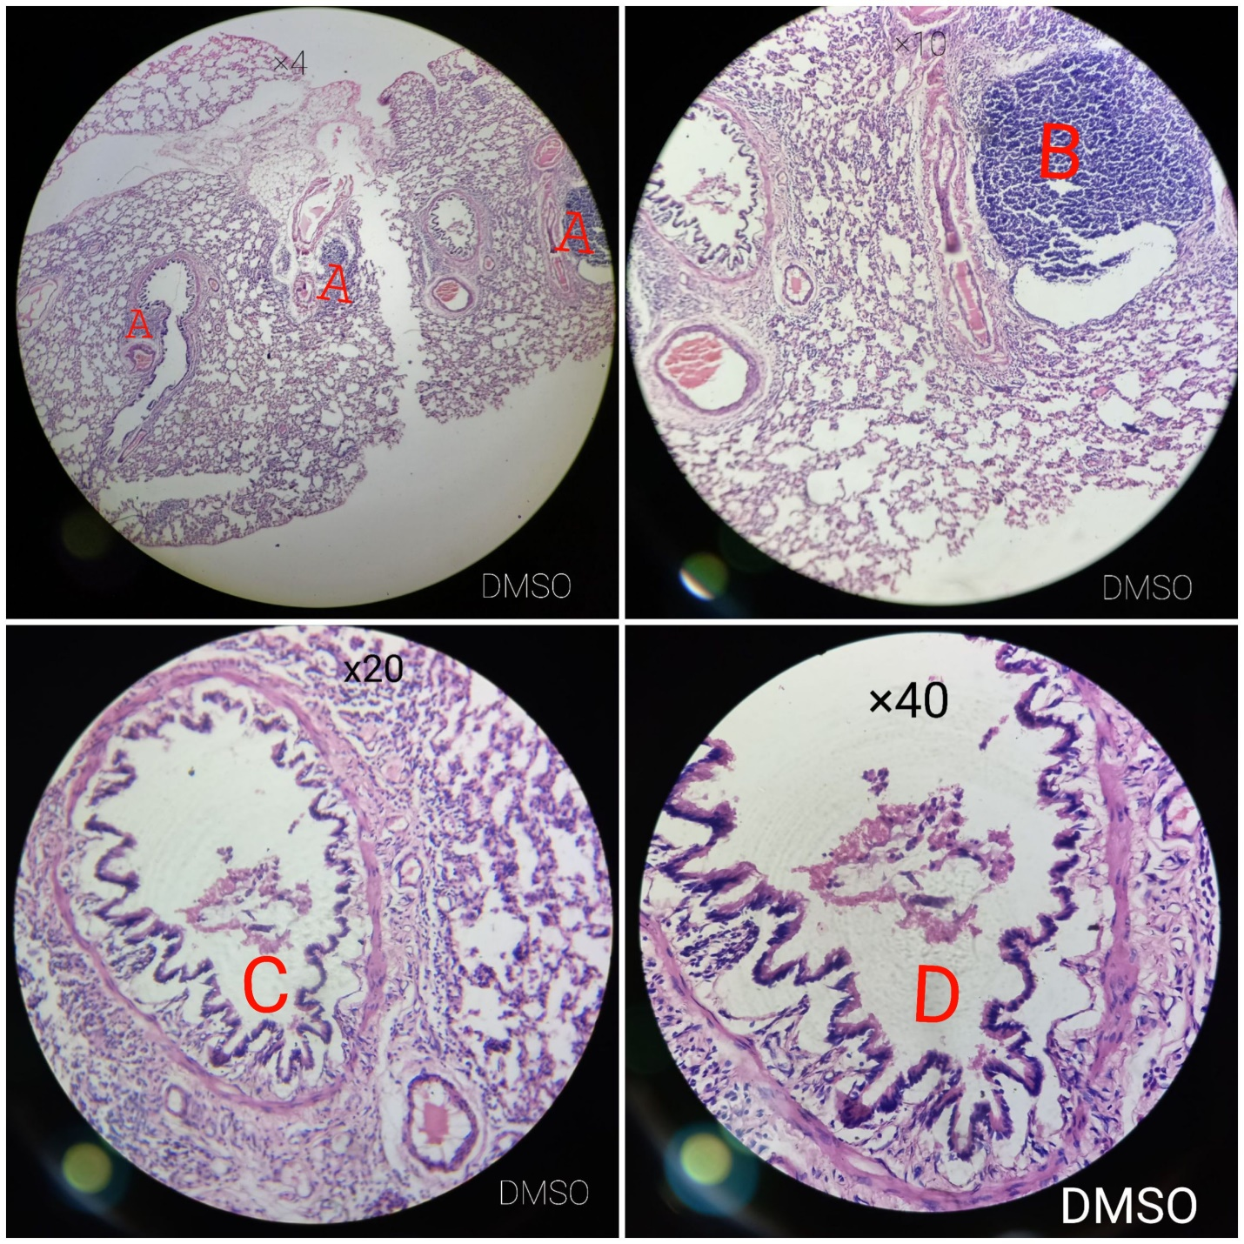
Plate 1: Adenocarcinoma with reduced alveolar space (A and B), bloody bronchioles with mononuclear cells infiltration (C and D) in a rat administered 30 mg/kg body weight of dimethyl sulfoxide (DMSO).
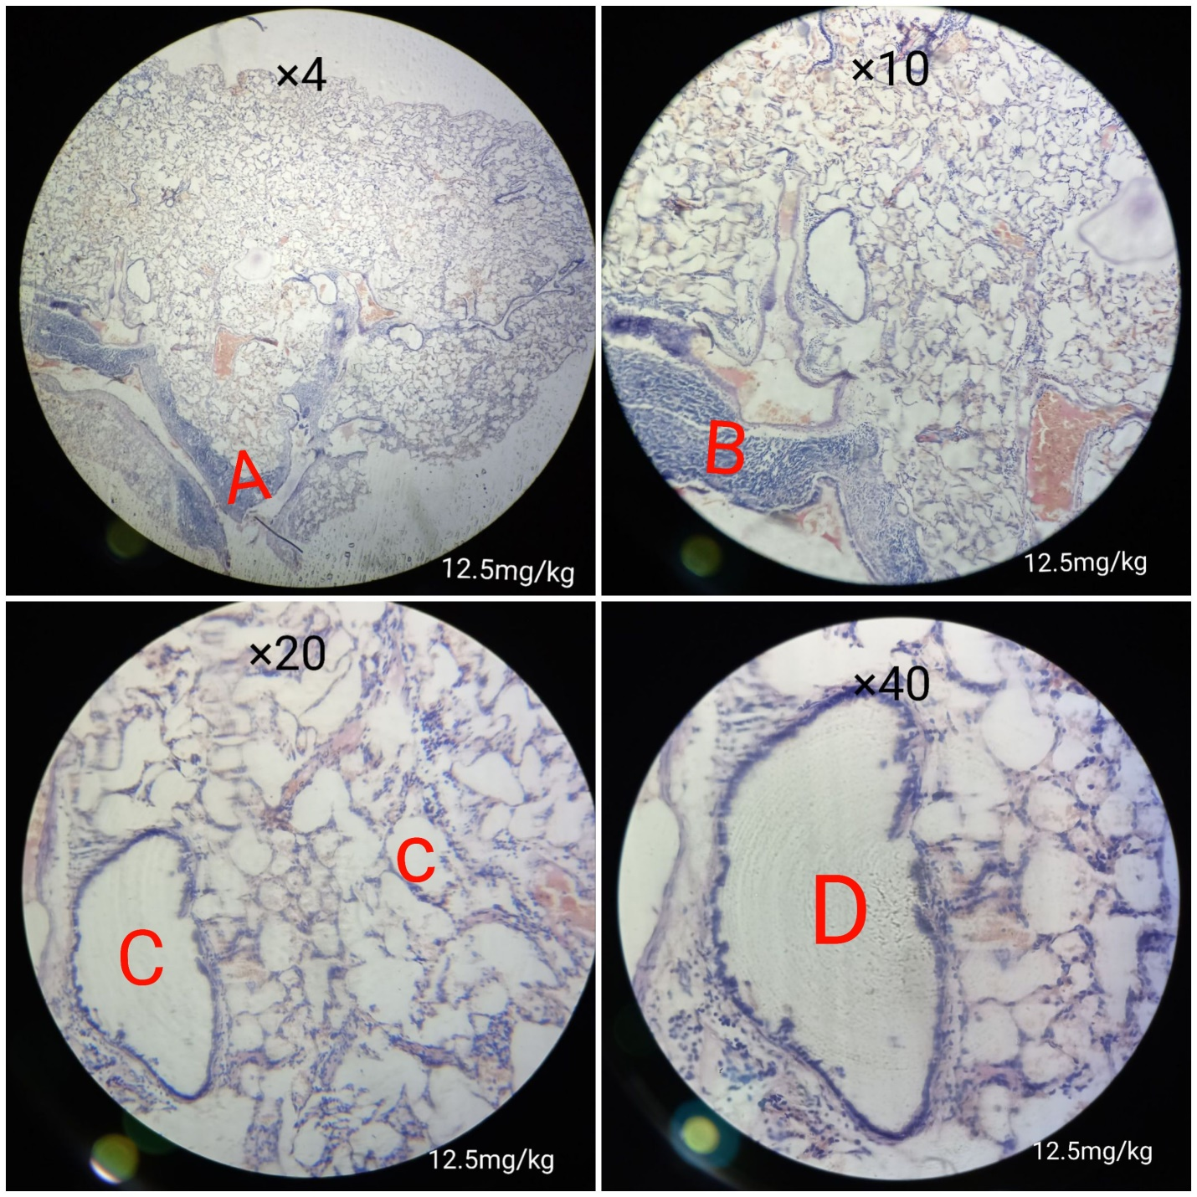
Plate 2: Shows adenocarcinoma (A and B), damaged alveolar sacs with infiltrated interseptal spaces (C and D) in a rat administered 12.5 mg/kg body weight of anthracene in DMSO.
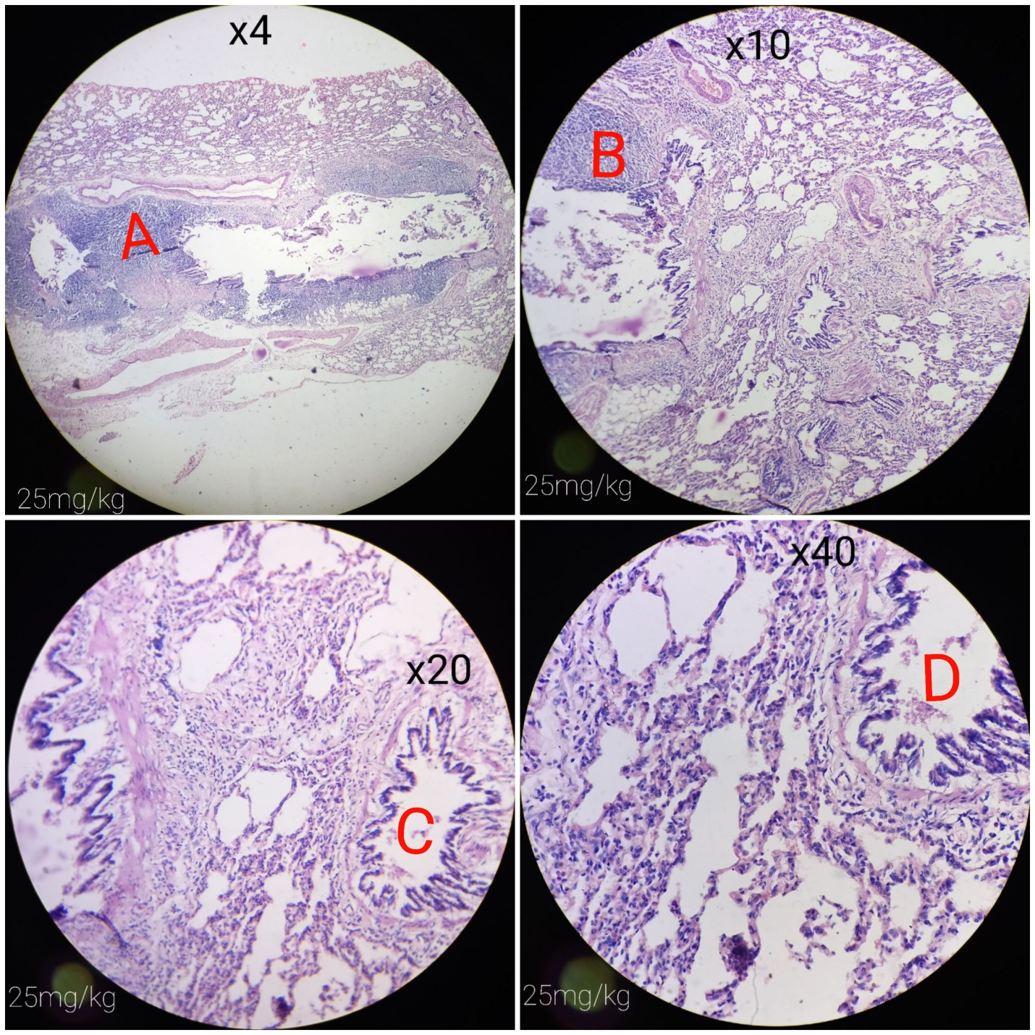
Plate 3: Shows adenocarcinoma (A and B) and bronchiole infiltrated by mononuclear cells (C and D) in rat administered 25 mg/kg body weight of anthracene in DMSO.
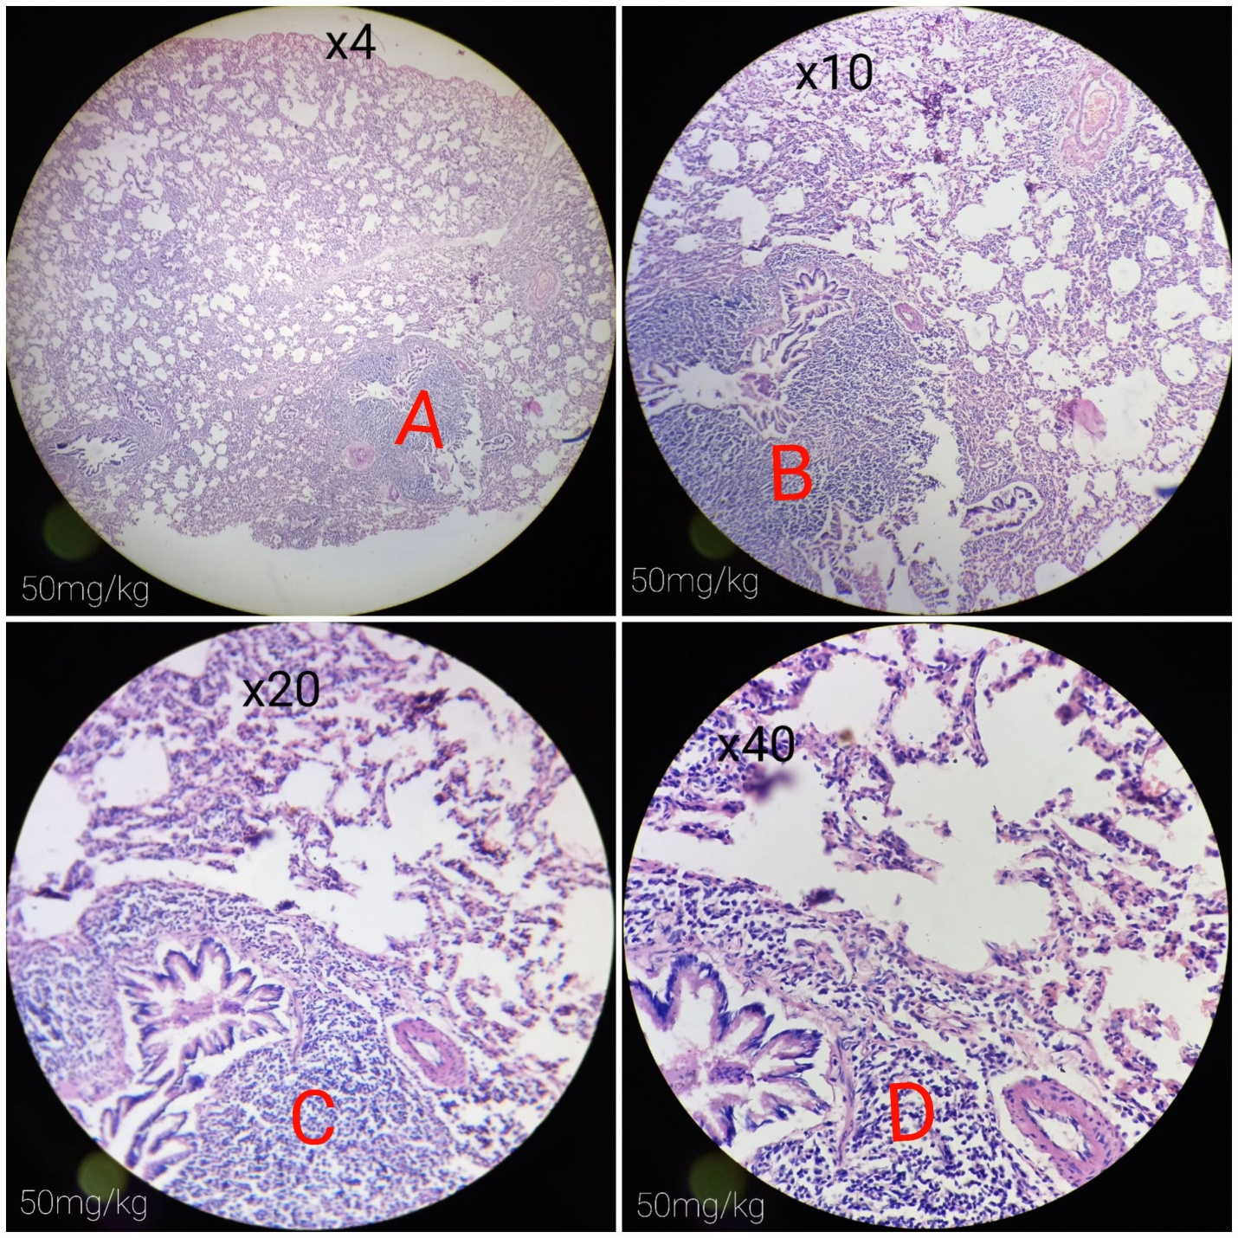
Plate 4: Shows adenocarcinoma (A and B) and sennis mononuclear cells infiltration (C and B) in rat administered 50 mg/kg body weight of anthracene in DMSO.
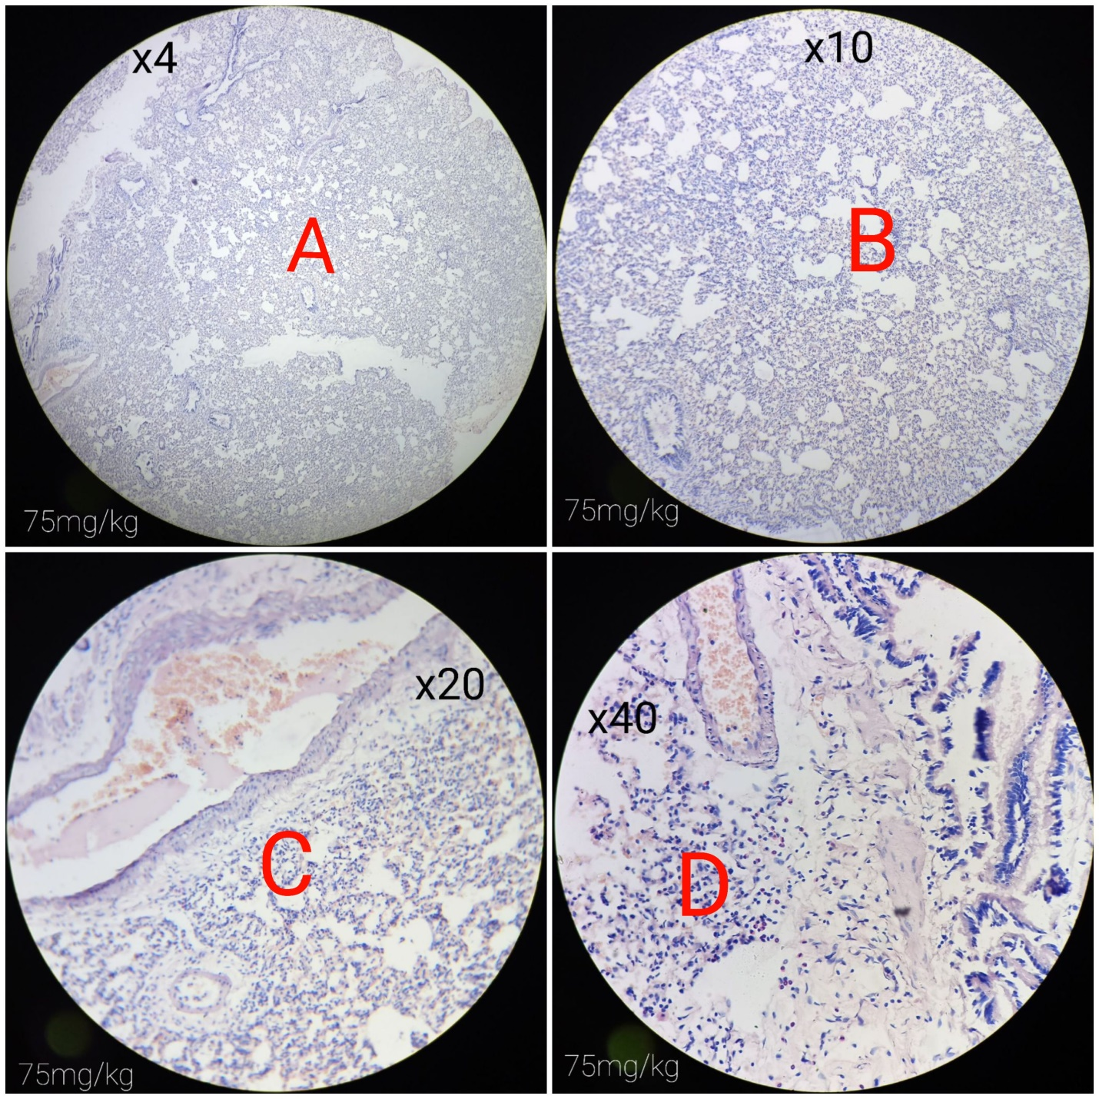
Plate 5: Shows alveolar spaces (A and B) and mononuclear cells infiltration (C and D) in rat administered 75 mg/kg body weight of anthracene in DMSO.

