SPPLEMENTAL MATERIAL
Definition 1
Figure S1 Results of quality assessment using the Cochrane Collaboration’s risk of bias tool (Randomized Controlled Trial) 2
Figure S2 Forest plot for the association between blood transfusion strategies with in-hospital and follow-up mortality 3
Figure S3 Funnel plot analysis of potential publication bias 4
Figure S4 A leave-one-out sensitivity analysis of this meta-analysis 5

Definition
  - All-cause mortality: All of the deaths that occur in the included population, regardless of the cause.
  - Overall mortality: It includes in-hospital all-cause mortality and follow-up all-cause mortality.
  - In-hospital mortality: All-cause mortality during hospitalization.
  - Follow-up mortality: All-cause mortality during the follow-up period.
  - Major adverse cardiovascular events (MACEs): MACEs is defined as a composite of reinfarction, stroke, heart failure, and emergency repeated percutaneous coronary intervention.
  - In-hospital MACEs: MACEs during hospitalization.
  - Follow-up MACEs: MACEs during the follow-up period.

Figure S1 Results of quality assessment using the Cochrane Collaboration’s risk of bias tool (Randomized Controlled Trial)
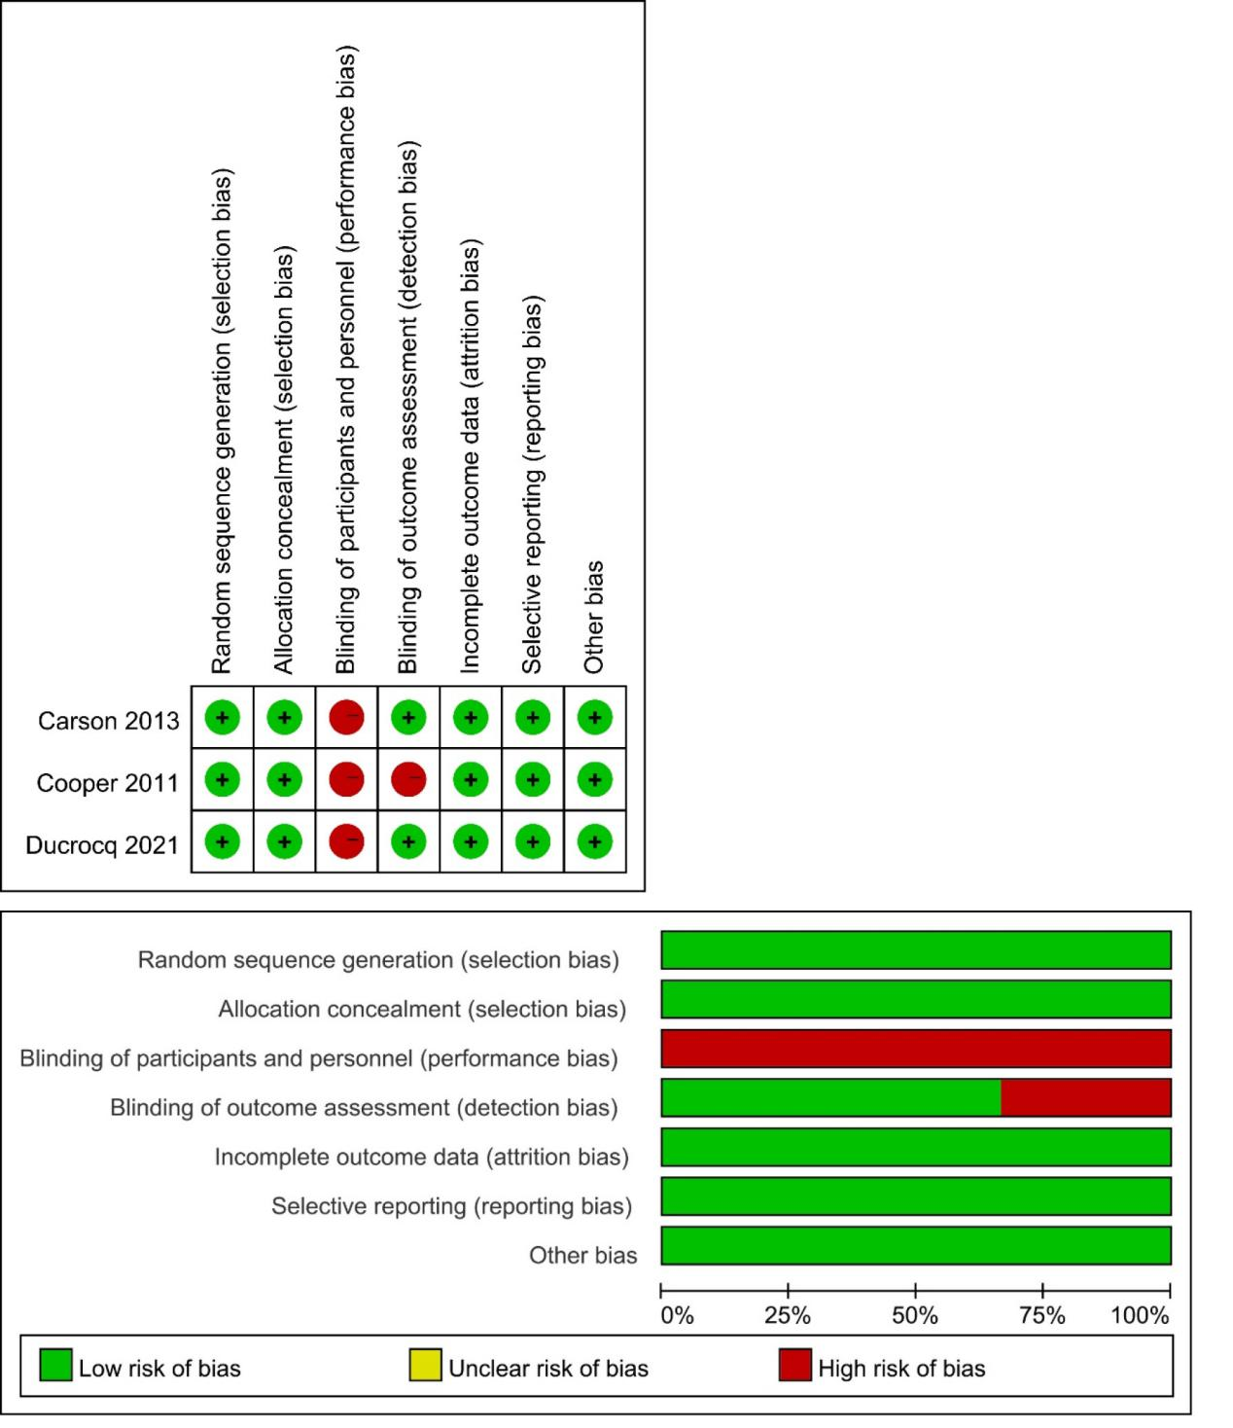

Figure S2 Forest plot for the association between blood transfusion strategies with in-hospital and follow-up mortality
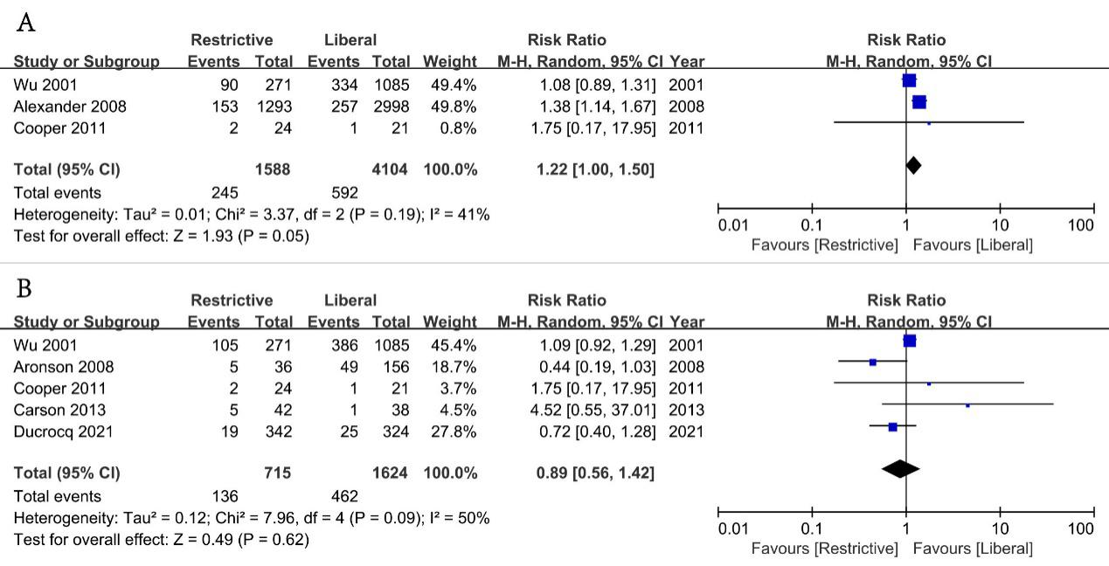
A: In- hospital mortality; B: Follow-up mortality

Figure S3 Funnel plot analysis of potential publication bias
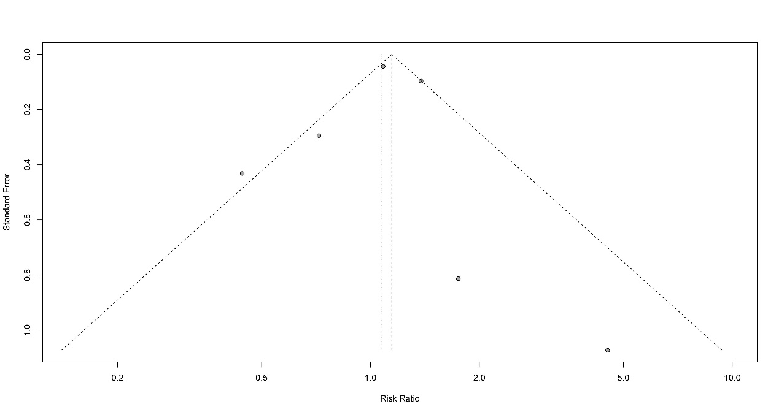

Figure S4 A leave-one-out sensitivity analysis of this meta-analysis
