Supplementary Materials for “Genome-wide mutation landscape of SARS-CoV-2”

Supplementary Figure Legenes
Supplementary Fig. S1. The distribution of SNP frequency.
Supplementary Fig. S2. The distribution of different SNP types.
Supplementary Fig. S3. The distribution of different SNP annotation types.
Supplementary Fig. S4. The fold change (FC) of each continent on each SNP hotspot.
Supplementary Fig. S5. The continent distribution of 3,159 genome sequence.
Supplementary Tables.
Supplementary Table S1. The frequency of each SNV
Supplementary Table S2. The genomic bin enrichment of 244 high frequent SNVs
Supplementary Table S3. The 22 SNP hotspots with its annotation type
Supplementary Table S4. The enrichment analysis of each continent on each SNP hotspot.
Supplementary Table S5. The information of 1,656 genome sequences that containing SNP at locus 23,403.
Supplementary Table S6. Mutation sensitivity score of each amino acid in spike glycoprotein
Supplementary Table S7. The 3,160 genome sequences information
Supplementary Figures
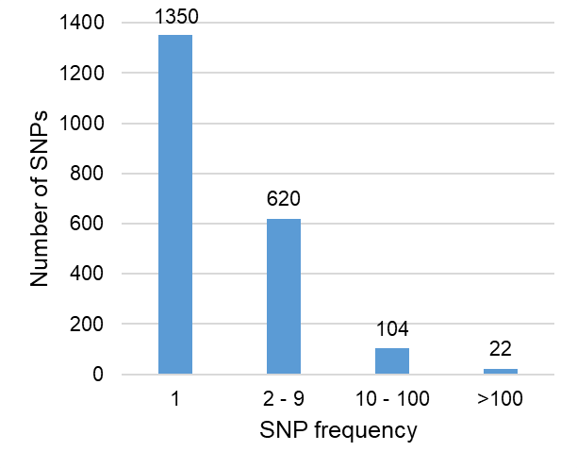
Supplementary Fig. S1. The distribution of SNP frequency.
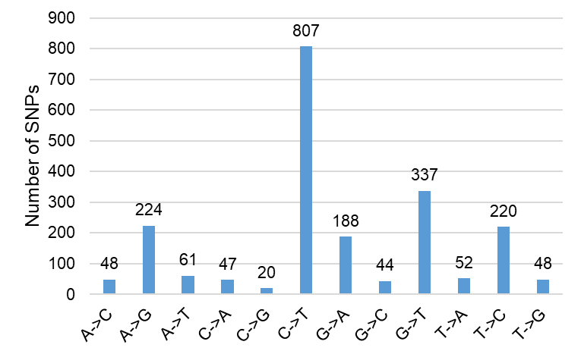
Supplementary Fig. S2. The distribution of different SNP types.
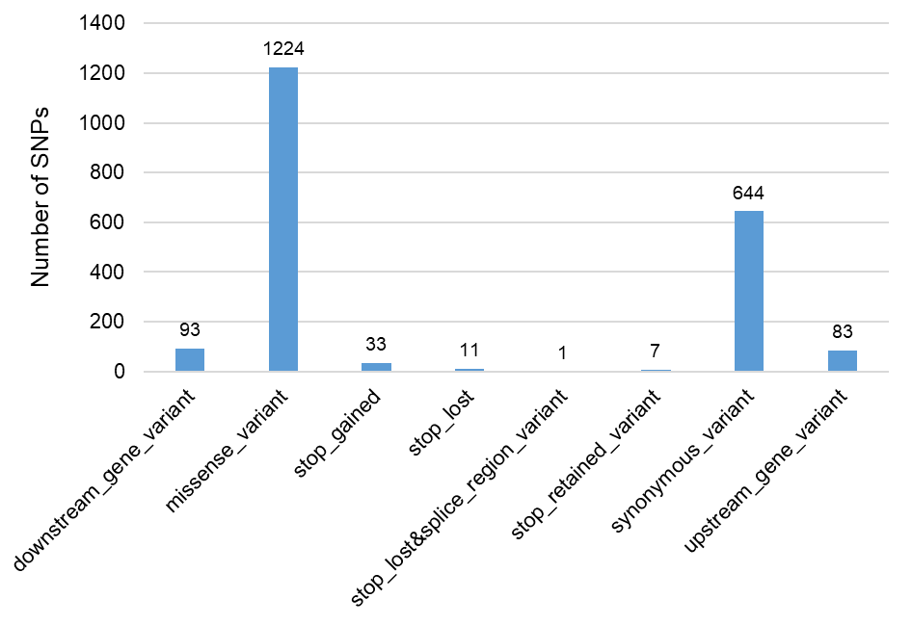
Supplementary Fig. S3. The distribution of different SNP annotation types.
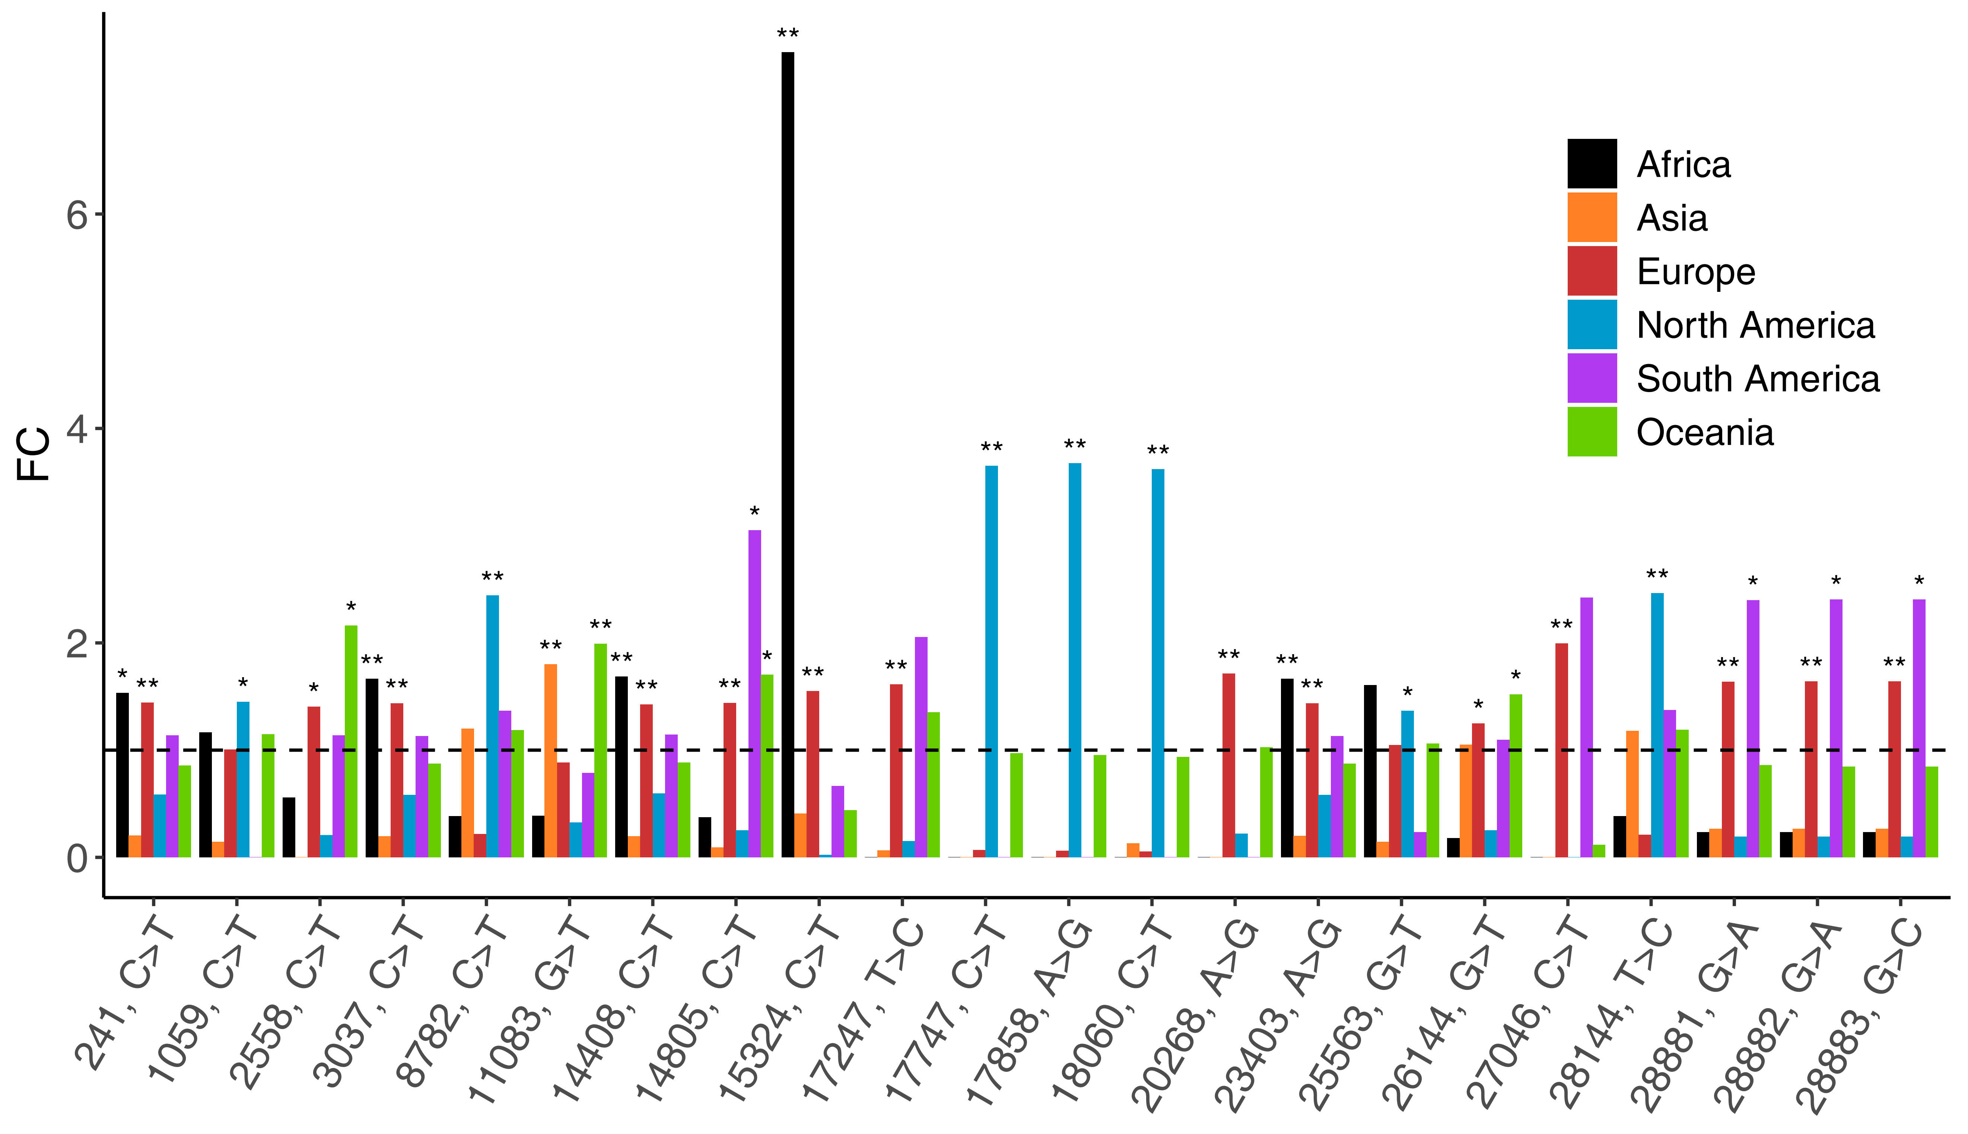
Supplementary Fig. S4. The fold change (FC) of each continent on each SNP hotspot. The black dash line indicates FC = 1, * means 1e-6 < p < 0.01, .** means p < 1e-6.
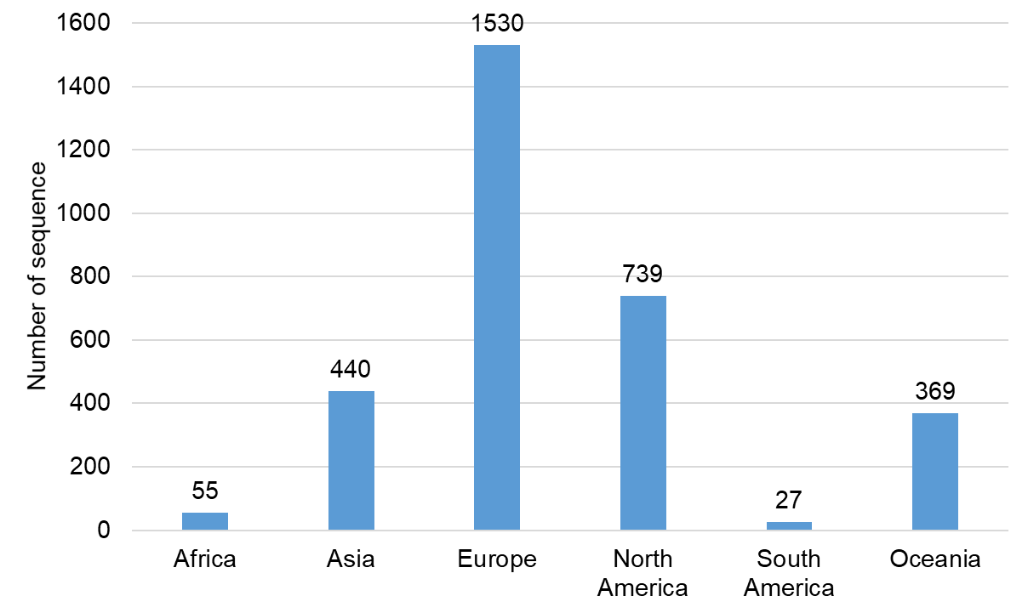
Supplementary Fig. S5. The continent distribution of 3,159 genome sequence.

