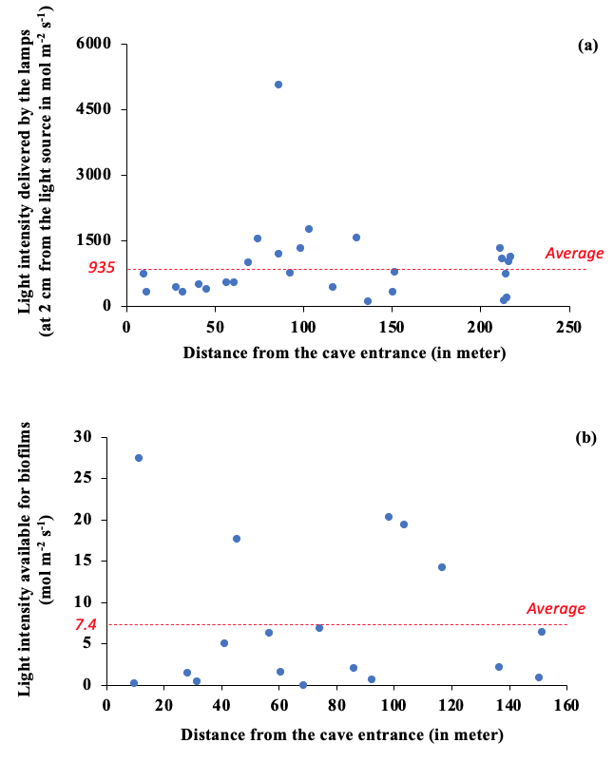
Sup. 1 Evolution of the light intensity delivered by the artificial light inside the cave and the light available for the biofilms.

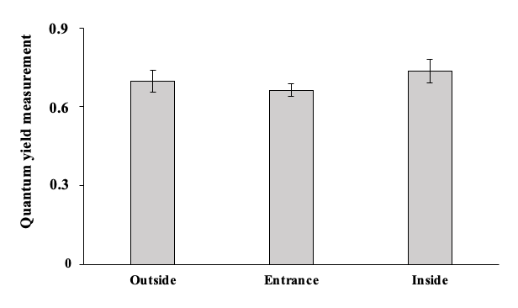

Sup. 2 Quantum yield measurements of the sampled biofilms outside, at the entrance and inside the Azé cave. The average values of the three area were not statistically significant.
Sup. 3 The biofilm colorimetric parameters were measured with a spectrophotometer. Color measurements were analyzed according to the CIELAB color system. The a* scale is associated with changes in redness-greenness (positive a* is red and negative a* is green).

