Response to editor
Thanks for your letter.
Thanks for your critical examination. Your comments are very helpful for the revision of this manuscript. We are sending the revised manuscript according to the comments. The revised parts are in red and the reply to each point is listed below:

After a careful editing examination of your paper, I am sorry to inform you that your manuscript is not acceptable for publication by ESPR in the present format however I encourage you to resubmit as a new manuscript after the appropriate changes. For information, self-plagiarism isn’t allowed, just as plagiarism.
Indeed, we have identified that several parts of the manuscript are copied/pasted from previous published publications. Your manuscript exhibits a similarity percentage higher than 30% with already published papers.
The manuscript contains a number of phrases taken from other published papers, most notably in the abstract (line no. 3-10), introduction section (1st paragraph) but also in subsection 3.1 (1st paragraph).
Due to the copyright rules, we are not allowed to accept your paper in its current form. I suggest you to modify several sentences and to resubmit the paper to the journal ESPR. Please use a software for detecting potential plagiarism with already published works such as Turnitin. (http://www.turnitinuk.com/)

Response: We referred to the writing style of some published papers, which leaded to high similarity between manuscript and published papers. We guarantee the authenticity of the data.
We used Turnitin to detect potential problems with manuscripts. The similarity with published papers was less than 10%.
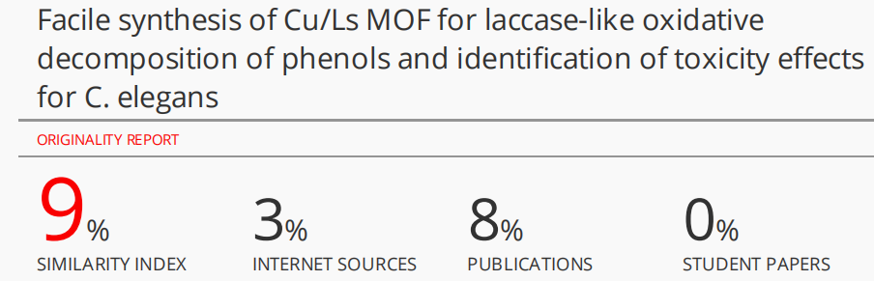
We hope the revised manuscript will meet with approval.

