Supplementary Data 1. Cathodolumiescence (CL) images of zircons

Circles are labelled according LA-ICP-MS spot (Supplementary Data 2). Zircon selected for ID-TIMS dating are denoted by ‘zX’ (Supplementary Data 2). LA spots that either burned through the crystal and into the epoxy during analysis or had a raw data spectrum that indicated inclusions were also analyzed are denoted by ‘(x)’. Data for those points are not included Supplementary Data 2.

A. Escarpment Ignimbrite (YIU99026)
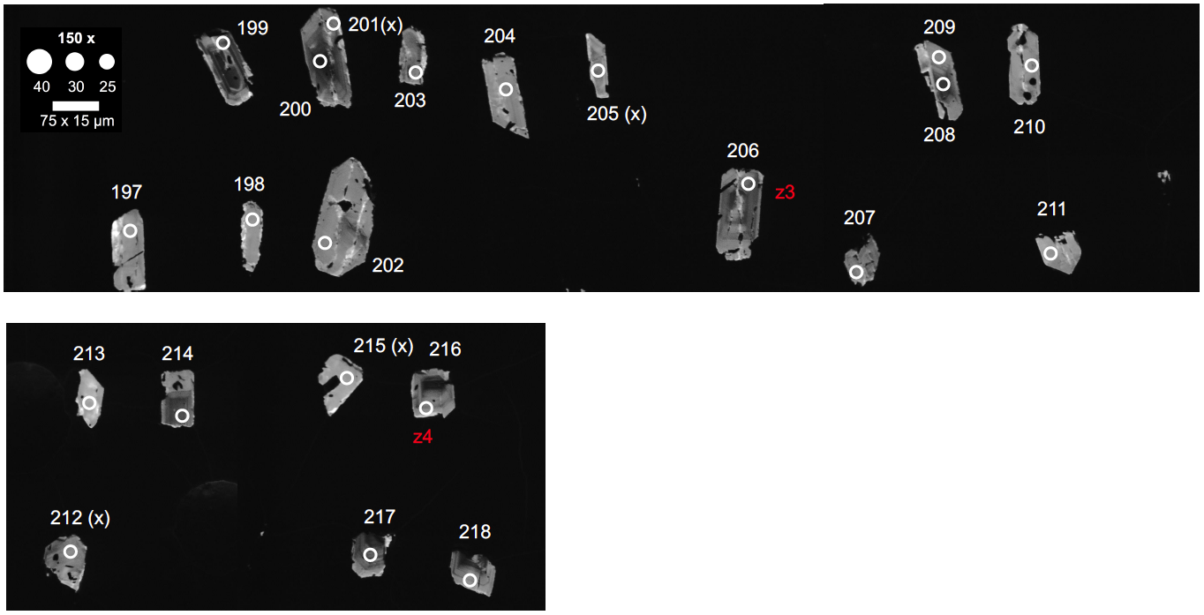

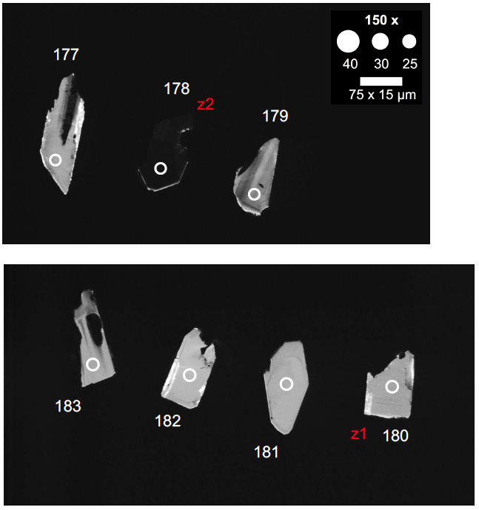

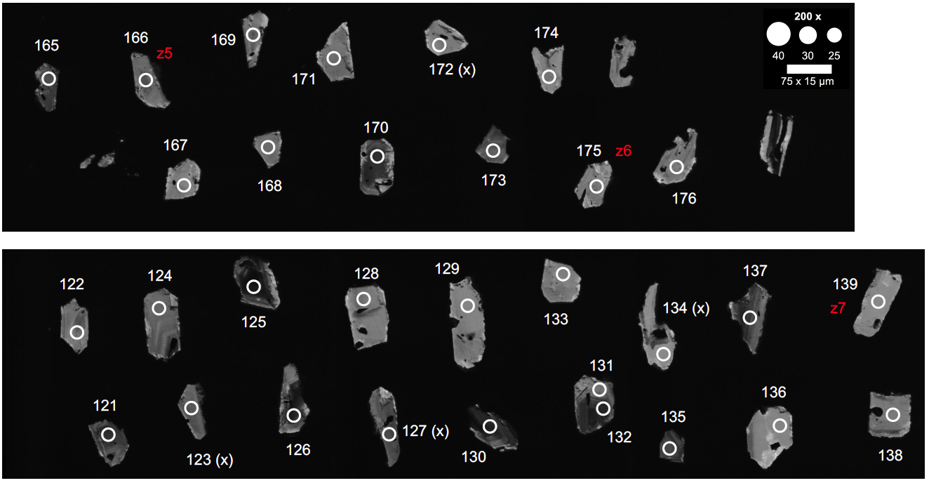

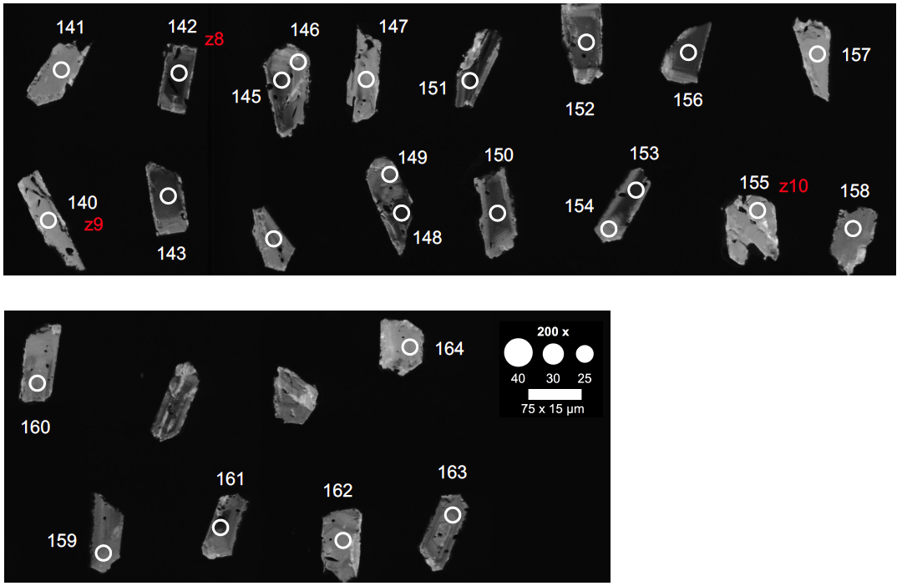

B. Upper SAM Ignimbrite (YIU99210)
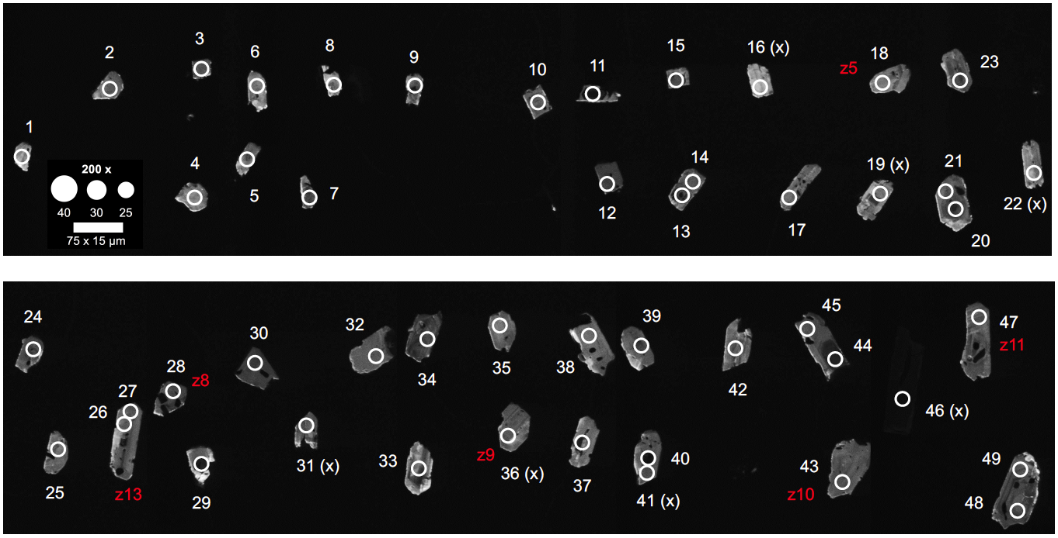

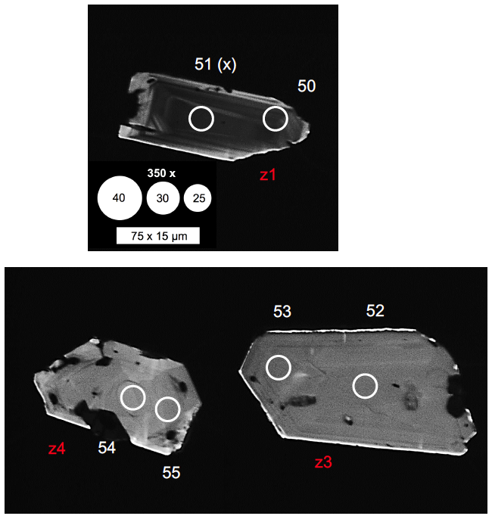

C. Sana’a Ignimbrite (YIU99206)
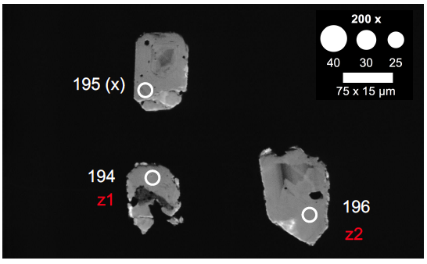

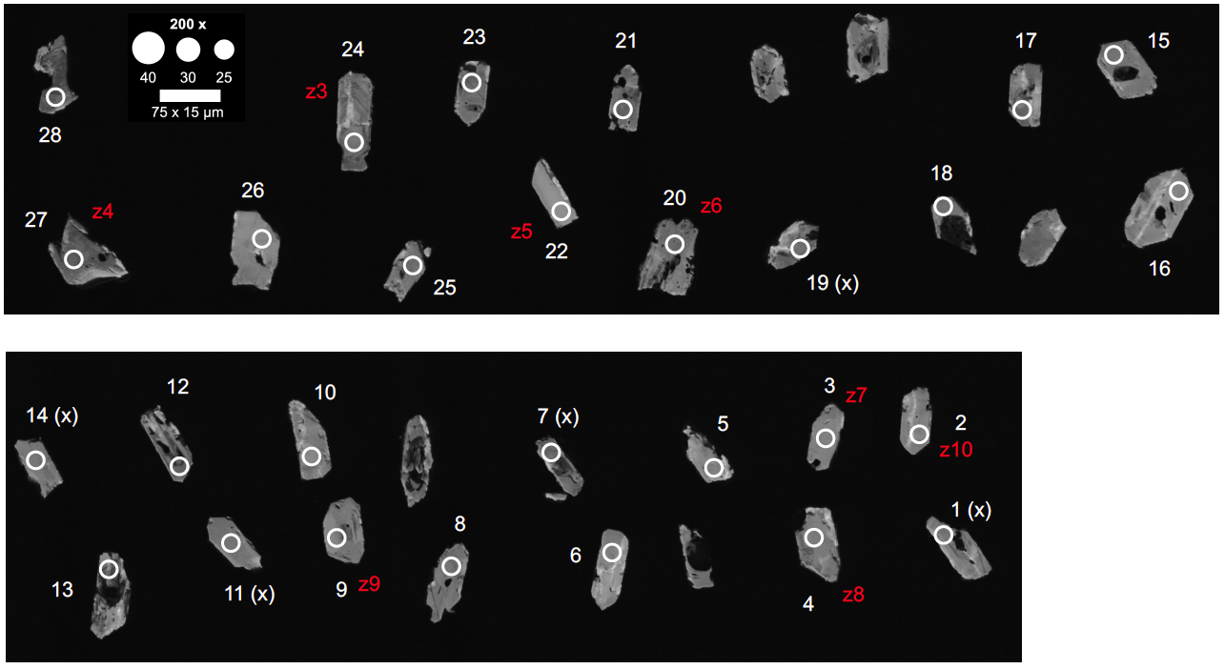

D. Iftar Alkalb (YIU99172)
