Cellulosic fiber: mechanical fibrillation-morphology-rheology relationships
Tianzhong Yuan^{a,b}, Jinsong Zeng^{a,b,}*, Bin Wang^{a,b,}*, Zheng Cheng^{a,b}, and Kefu Chen^{a,b}
ª State Key Laboratory of Pulp and Paper Engineering, Plant fiber research center, School of Light Industry and Engineering, South China University of Technology, Guangzhou 510640, China;
^{b} Guangdong Plant Fiber High-Valued Cleaning Utilization Engineering Technology Research Center, South China University of Technology, Guangzhou 510640, China.
*Corresponding author
*Jinsong Zeng. E-mail: fezengjs@scut.edu.cn Tel: +86-15820223660
*Bin Wang. E-mail: febwang@scut.edu.cn Tel: +86-13560481802;

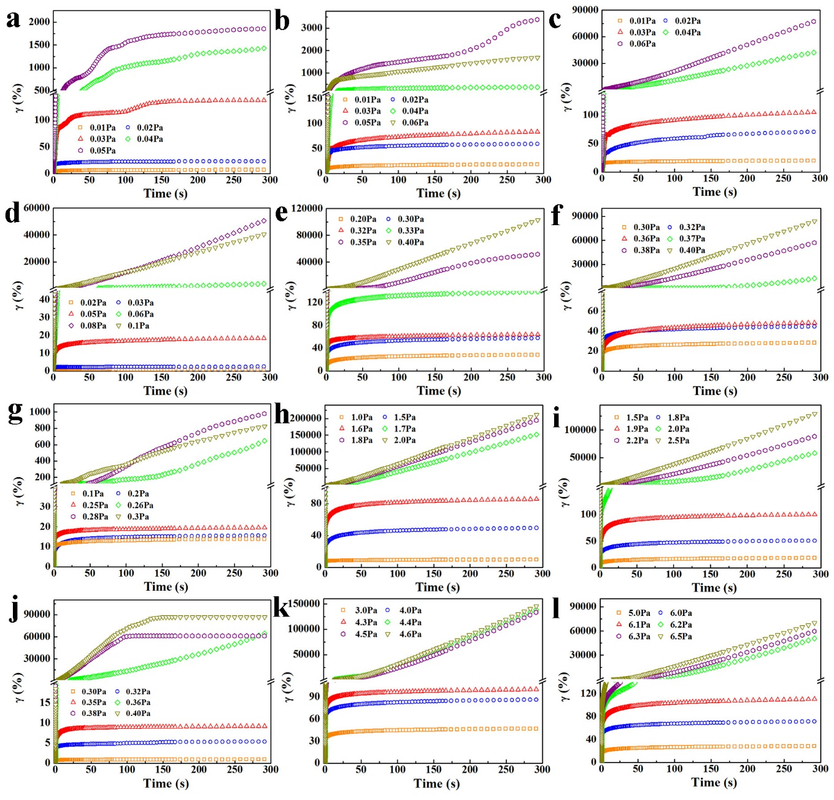
Fig. S1 Viscoelastic response of NFC suspensions with different concentrations for shear stress values lower and higher than the yield stress, A10-0.25 (a), A10-0.50 (d), A10-0.75 (g), A10-1.0 (j), A20-0.25 (b), A20-0.50 (e), A20-0.75 (h), A20-1.0 (k), A40-0.25 (c), A40-0.50 (f), A40-0.75 (i), A40-1.0 (l),.

