Supplementary Materials for

Glutathionylation of fibronectin records mechanical history, priming an integrin switch and myofibroblast polarization

Wei Li^{1,2}, Leandro Moretti², Chiuan-Ren Yeh², Matthew P. Torres¹, Thomas H. Barker²*
Correspondence to: thomas.barker@virginia.edu

This PDF file includes:

Supplementary Figures 1 to 8
Captions for Table S1, S2

Other Supplementary Materials for this manuscript include the following:

Table S1
Table S2

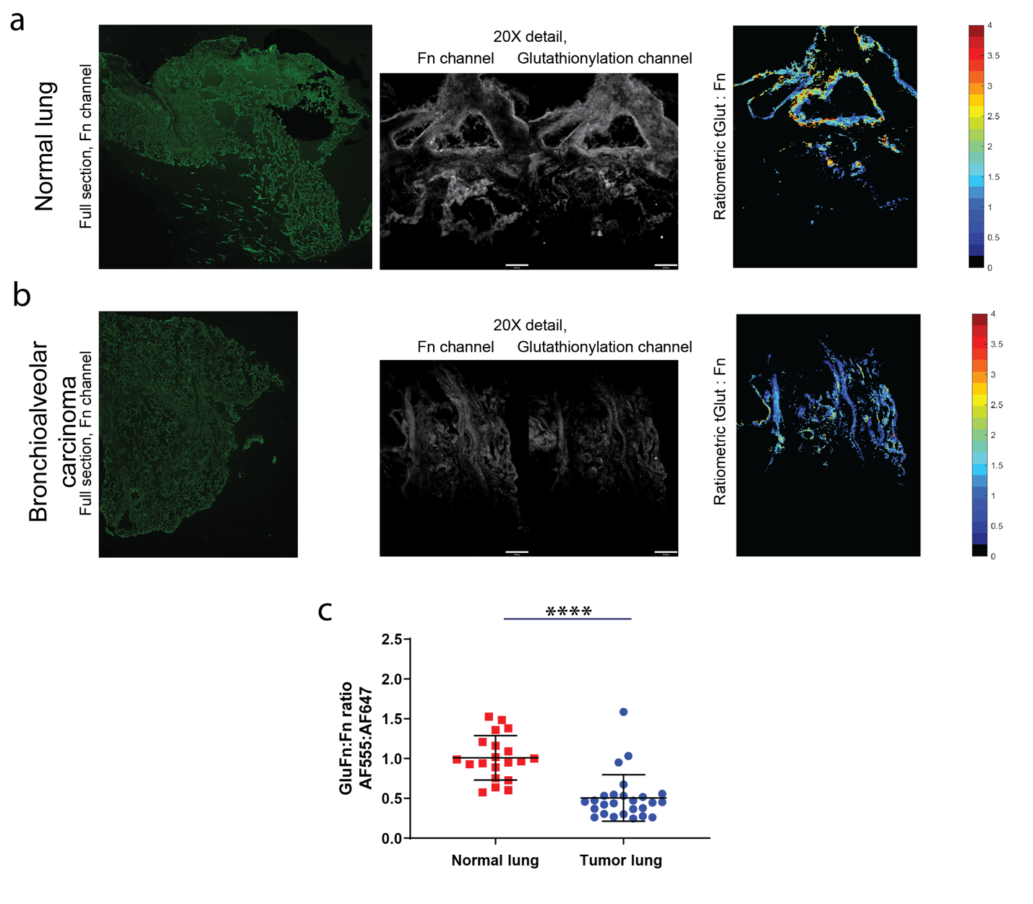

Supplementary Figure 1. (A) Left, full section of normal lung tissue (Fn, AF647). Middle panels, 20X detail of the Fn (AF647) and glutathionylation channels (AF555), scale bar 54 μm. Right panel, resulting ratiometric image. (B) Left, full section of lung bronchioalveolar carcinoma tissue (Fn, AF488). Middle panels, 20X detail of the Fn (AF647) and glutathionylation channels (AF555), scale bar 54 μm. Right panel, resulting ratiometric image. (C) Plots of median pixel-by-pixel GluFn:Fn ratios from at least 20 random fields per condition, lung bronchioalveolar carcinoma or patient matched normal lung. Glutathionylation of Fn is highly significantly increased (p<0.0001). Mann-Whitney two-tailed statistical tests was employed.

Supplementary Figure 2. Analysis of unmodified dECM by mass spectrometry. Total and ECM-specific proteins identified in unmodified dECM. Percentages represent the number of proteins identified within each category relative to the total number of proteins identified. A minimum of 2 unique peptides was used as a filter for positive identification.

Supplementary Figure 3. Validation of de-glutathionylation by DTT treatment of single fibronectin fibers and decellularized matrix (dECM). Manually deposited fibronectin fibers (A) and dECM (B) were created on PDMS substrates mounted on the strain devices. Both manually deposited fibers and dECM was strained to λ=2.0, treated with FITC labeled GSSG. The glutathionylated single fibers and dECM were then treated with either DTT or a buffer control. Ratiometric images (FITC-SSG:AF555-Fn) of single fibers (A) and dECM (B) were quantified, dot plots demonstrate that glutathionylation can be reversed by DTT. Mann-Whitney two-tailed statistical tests was employed.

Supplementary Figure 4. Cryptic cysteines in the 7th and 15th type III repeats are essential for glutathionylation impacts on fiber modulus. (A) Schematic setup and bright field image of Atomic Force Microscopy (AFM) tip pulling on single mutant fibronectin fiber. (B) Plasmids containing fibronectin cDNA with site-specific mutagenesis of the cryptic cysteines in the 7th and 15th type III repeats (Fn^{C1232A} and Fn^{C2136V}, respectively, gift from Chris Lemmon) were used to produce purified mutant fibronectin. Mutant fibronectin was used to manually deposit fiber, which were then stretched with the underlying PDMS substrate, incubated with GSSG, then relaxed to their original length followed by AFM measurement. (B) Stress-strain plot of unmodified mutant fibronectin fiber (Red) and GSSG-treated mutant fibronectin fiber (Blue). There is no significant difference in modulus between them. The shaded areas are the standard deviation of the datasets.

Supplementary Figure 5. Cryptic cysteines in the 7th and 15th type III repeats are essential for glutathionylation impacts on fiber elasticity. Mutant fibronectin (Fn^{C1232A} and Fn^{C2136V}) fibers were manually deposited on micropatterned PDMS. (A) For elasticity testing, manually deposited fibronectin fibers were only stretched by the AFM tip. An initial stress-strain profile was established for the unmodified fiber through a series of step-wise defined strain amounts with concurrent force measurement. Following the complete series, the fiber was allowed to fully recover to its original state, followed extension to λ=2.0 with the AFM tip to allow GSSG (10mM, 30 min) incubation followed by relaxation and subsequent elasticity measurement as before. Similarly, the fiber was subsequently treated with DTT (1mM, 40 min) followed by elasticity measurement. (B) Representative plot of a full sequence on a single mutant fiber in stress-strain plot. Cysteine-modified fibronectin fibers show no response to GSSG treatment of subsequent DTT treatment. (C) The elasticity plots observed are not a function of multiple interrogations of a single mutant fiber nor DTT treatment (D).

Supplementary Figure 6. Fibronectin (Fn) is a target of glutathionylation. Western blot (A) and dot blot (B) showed fibronectin glutathionylation with anti-fibronectin antibody and anti-glutathione (GSH) antibody. Soluble fibronectin was first incubated at different temperature: 37°C, 55°C, 75°C and 95°C in the presence of oxidized glutathione (GSSG) to demonstrate the requirement of protein unfolding to expose the cryptic cysteines enabling modification. Glutathionylation is observed in fibronectin solutions at 75°C and 95°C but not 37°C or 55°C. The glutathionylation modification was reducible with dithiothreitol (DTT). For western blot, soluble fibronectin was heat-denatured at 95°C for 20 minutes with GSSG.

Supplementary Figure 7. Glutathionylation does not influence the bulk modulus of dECM. dECMs were formed on flexible PDMS substrates and mounted on strain device as previously described. Fibronectin-rich dECM was strained (λ=2.0), incubated with oxidized glutathione (GSSG), then relaxed to original length followed by AFM measurement of bulk modulus using a beaded tip (25µm polystyrene bead). Force indentation curves was analyzed using a Hertz model. (A) Image of decellularized matrix with AFM cantilever on top, red triangular area is AFM cantilever with a 25µm polystyrene bead. (B) Modulus data on unmodified dECM (red) and glutathionylated dECM (blue) displaying no significant difference between the two measured moduli. Scale bar is 50μm.

Supplementary Figure 8. Glutathionylated dECM encourages greater cell spreading. (A) Naïve Human Foreskin Fibroblast were seeded on unstrained (λ=1.0) or strained (λ=2.0) unmodified or glutathionylated dECMs. Fibronectin was labeled with AF555 (red). The cell cytoskeletal protein actin was labeled with AF488-phalloidin (green) and nucleus was labeled with Hoechst (blue). (B) Quantitative analysis of cell area on dECMs demonstrates that cells on strained dECM spread more than on unstrained dECM. Glutathionylation of dECM leads to greater cell spreading on either condition, compared to their unmodified dECM controls. Scale bar is 12μm. Kruskal-Wallis test statistical tests was employed.

Table S1. (separate file)
Glutathionylated proteins in decellularized matrix sample.

Table S2. (separate file)
Statistic Source Data

