Thyroid-related hormone levels versus the severity of hearing loss
We performed a linear correlation analysis and drew the scatterplots of thyroid-related hormone levels versus severity of hearing loss (Fig 3), and found no association between moderately severe-to-profound SSNHL and TSH when hearing loss was treated as a continuous variable.

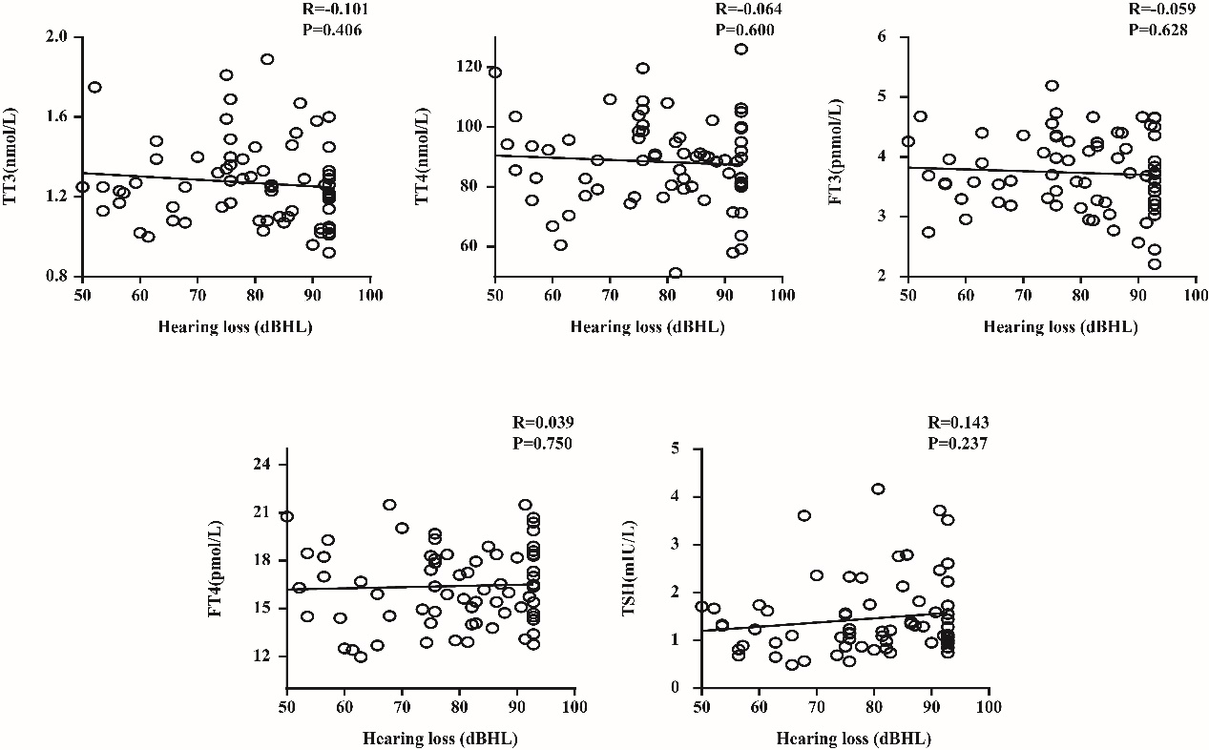Fig 3. Plots of thyroid-related hormone levels versus the severity of hearing loss
TT3, total triiodothyronine; TT4, total thyroxine; FT3, free triiodothyronine; FT4, free thyroxine; TSH, thyroid stimulating hormone; R, correlation coefficient
Data are presented as correlation coefficients and P values.

