Combined liquid and mass conditions
Mass spectrometry scanning parameters:
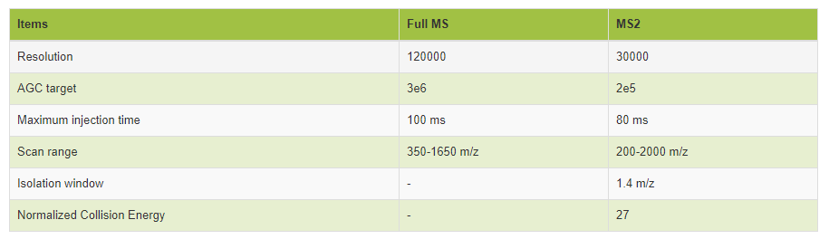

Liquid elution gradient:
The flow rate was 300nL/min. Buffer A was 0.1%FA aqueous solution and buffer B was 0.1%FA /80% ACN/20% water.
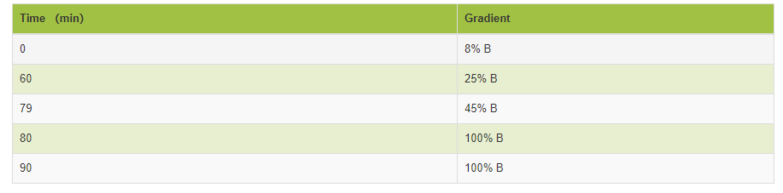

The peptide segment after enzymatic hydrolysis of each sample was separately collected on the machine. The scanning range was set to 350-1250 m/z, and the isolation window was 26 m/z.
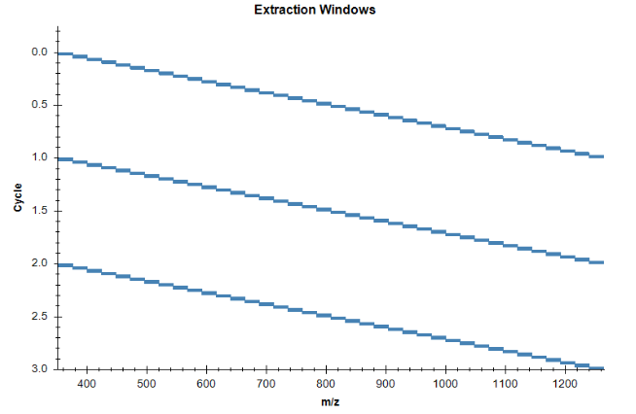

DIA mass spectrometry scanning parameters:
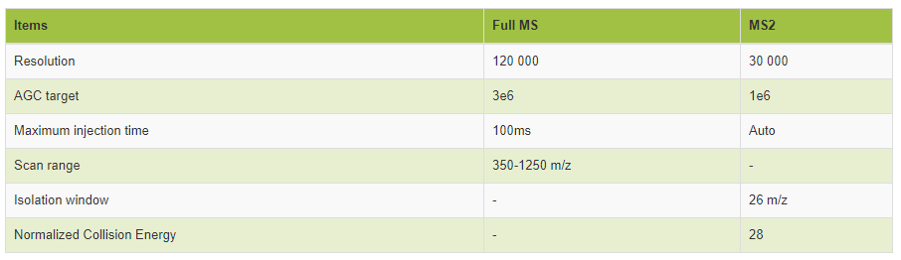

The elution gradient of DIA liquid phase:
The flow rate was 300nL/min. Buffer A was 0.1%FA aqueous solution and buffer B was 0.1%FA /80% ACN/20% water.

ectronaut Pulsar software to search and build the library. The main parameters are:
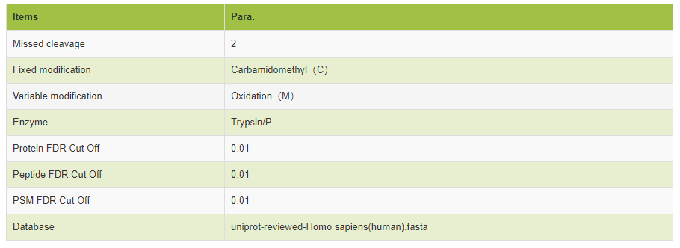
The DIA raw data is processed using the Spectronaut Pulsar software. The key steps are as follows.
1) Open the Analysis module of the Spectronaut Pulsar software and select "+" to create new Analysis;
2) Complete parameter setting step by step and start analysis according to software prompts;
3) After completion of analysis, enter the "Report" module to export quantitative data.
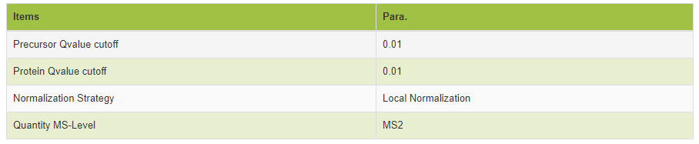

PRM method export
- Import the pre-scanned RAW data into SpectrDive and correct the retention time according to the iRT standard peptide sections. The correction curve is as follows (IRT pre-sweep correction curve):
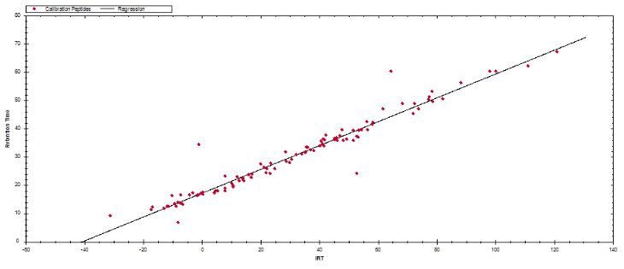
(2) Set the scheduled method and export:
Scan time window setting:
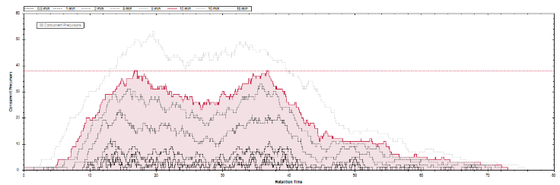

Table.1 Reagents and Instruments
Reagent | Manufacturer | Model
TMT10 labeling kit | ThermoScientific | 90111LCS
TMT6 labeling kit | ThermoScientific | 90066B
iTRAQ Labeling Kit | ABSCIEX | 4381663
Plasma de-abundance protein kit (small column) | ThermoFisher | 85165
Plasma de-abundance protein kit (large column) | Millipore | 122642
SDS lysate | Sangon Biotech | P0013G
BCA kit | ThermoScientific | 23227
Mass spectrometry water | ThermoScientific | W6-4
Mass spectrometric grade acetonitrile | ThermoScientific | A955-4
PMSF | Amresco | PB0425-5G
Disodium hydrogen phosphate dodecahydrate | Sangon Biotech | ST1725-500G
Sodium dihydrogen phosphate monohydrate | Sangon Biotech | S0823-100G
NaCl | Sangon Biotech | ST1218-1000G
40%Acr-Bis | Sangon Biotech | B546014-0500
Tris-HCl（pH6.8 pH8.8） | Sangon Biotech | B546020-0250 B546019-0250
APS | Sangon Biotech | AB0072-25G
TEMED | Sangon Biotech | A100761-0025
Tris | Sangon Biotech | A600194-0500
Glycerin | Sangon Biotech | G0854-500ML
BPB | Sangon Biotech | B0449-5G
TFA | Sangon Biotech | TS4295-013
IAA | Sangon Biotech | A600539-0005
Urea | Sangon Biotech | UB0148-2000G
TEAB | Sangon Biotech | A510932-0500
DTT | Sangon Biotech | A620058-0005
Glycine | Sangon Biotech | 17-1323-01
SDS | Sangon Biotech | 17-1313-01
Phosphoric acid | Sangon Biotech | 10015418
Pancreatin | Sangon Biotech | HLS TRY001C
G-250 | Sigma | 27815-25G-F
Absolute ethanol | GENERAL-REAGENT | G73537B
Isopropanol | GENERAL-REAGENT | G75885B
Tris saturated phenol | Solarbio life sciences | T0250
Formic acid | CNW | CAS:64-18-6
Phosphatase inhibitor | Roch | 4906837001
TiO2 | Sangon Biotech | 5020-75000
Sucrose | Sangon Biotech | A100335-0250
EDTA-2Na | Sangon Biotech | A500838-0500
acetone | Sangon Biotech | 40064485
NaCl | Sangon Biotech | A501218-0001
Ammonium acetate | Sangon Biotech | CAS 631-61-8
Instrument | Manufacturer | Model
Q ExactiveMC-ICP-MS | ThermoFisher
Q Exactive PlusMC-ICP-MS | ThermoFisher
Easy-nLC 1200FPLC | ThermoFisher
Orbitrap FusionMC-ICP-MS | ThermoFisher
Q Exactive HFMC-ICP-MS | ThermoFisher
High speed refrigerated centrifuge | Shanghai Lu Xiangyi Centrifuge Instrument Co., Ltd | TGL-16A
SDS-PAGEgel electrophoresis | Beijing Liuyi Instrument Factory | DYY-6C
Microplate System | Shanghai Kehua Experimental System Co., Ltd. | ST-360
ImageScanner | EPSON | ES-1000G
Precision electronic balance | Shanghai Yueping Scientific Instrument Co., Ltd. | FA2004B
freeze dryer | SCIENTZ | SCIENTZ-10N
High pH separation liquid chromatograph | Agilent | Agilent 1100 series
PolySULPHOETHYL A (5 μm, 200 Å) column (200 × 9.4 mm) | PolyLC Inc. | 209SE0502
96 well SPE desalting column | ThermoFisher | 60309-001
Ultrasonic Cell Disruptor | SCIENTZ | SCIENTZ-IID
3KDultrafiltration tube | Miilipore | UFL900396

