Supporting information

PCDD/F removal at low temperatures over Vanadium-based catalyst: insight into the superiority of mechanochemical method
Minghui Tang¹, Qiulin Ye¹, Cuicui Du¹, Yaqi Peng*¹, Chengetai Portia Makwarimba¹, Yao He², Shengyong Lu*¹
¹ State Key Laboratory for Clean Energy Utilization, Institute for Thermal Power Engineering, Zhejiang University, Hangzhou 310027, China
² POWERCHINA Central China Electric Power Engineering Co., Ltd., Zhengzhou 450007, China
* Corresponding author: Yaqi Peng (pengyaqi@zju.edu.cn), Shengyong Lu (lushy@zju.edu.cn)

Contents

Table S1-S2

Figure S1-S8

Table S1 Dioxin inlet concentration
I-TEF | Congener | Test of PCDD/F inlet concentration（pg I-TEQ/m³） |  |  |  | Average inlet concentration | RSD  （%）
 |  | 1# | 2# | 3# | 4#
1 | 2378-TCDD | 89.9 | 121.6 | 144.0 | 112.0 | 116.9 | 24.1
0.5 | 12378-PeCDD | 231.2 | 261.2 | 245.2 | 247.2 | 246.2 | 8.6
0.1 | 123478-HxCDD | 42.3 | 45.6 | 33.8 | 38.7 | 40.1 | 15.6
0.1 | 123678-HxCDD | 76.8 | 74.2 | 60.8 | 67.0 | 69.7 | 13.2
0.1 | 123789-HxCDD | 54.4 | 54.6 | 44.3 | 39.7 | 48.3 | 31.0
0.01 | 1234678-HpCDD | 38.6 | 35.4 | 28.5 | 31.7 | 33.6 | 17.7
0.001 | 12346789-OCDD | 5.5 | 4.6 | 2.8 | 4.8 | 4.4 | 27.9
0.1 | 2378-TCDF | 46.8 | 66.1 | 76.9 | 66.2 | 64.0 | 27.5
0.05 | 12378- PeCDF | 60.7 | 69.3 | 73.3 | 67.0 | 67.6 | 10.6
0.5 | 23478 PeCDF | 1113.7 | 1270.4 | 1281.0 | 1199.8 | 1216.2 | 9.7
0.1 | 123478-HxCDF | 380.4 | 377.2 | 314.6 | 332.8 | 351.2 | 13.4
0.1 | 123678-HxCDF | 376.7 | 378.8 | 309.0 | 353.7 | 354.5 | 9.3
0.1 | 234678-HxCDF | 72.9 | 70.9 | 63.7 | 66.9 | 68.6 | 8.0
0.1 | 123789-HxCDF | 416.2 | 411.4 | 343.5 | 395.2 | 391.6 | 8.2
0.01 | 1234678-HpCDF | 116.1 | 116.6 | 88.6 | 84.6 | 101.5 | 31.4
0.01 | 1234789-HpCDF | 19.1 | 16.7 | 14.5 | 12.8 | 15.8 | 34.3
0.001 | 12346789-OCDF | 7.6 | 6.4 | 3.0 | 3.2 | 5.1 | 75.0
 | PCDDs | 538.8 | 597.2 | 559.3 | 541.2 | 559.1 | 9.0
 | PCDFs | 2610.1 | 2783.7 | 2568.1 | 2582.4 | 2636.1 | 6.4
 | SUM | 3148.9 | 3381.0 | 3127.4 | 3123.6 | 3195.2 | 6.8

Table S2 Binding energies (eV) and curve fitting results of V 2p 3/2 and O1s XPS spectra.

Catalyst | V 2p 3/2(eV) |  |  |  |  | O 1s (eV) |  |  |  | Relative percentage (%)
 | V⁵⁺ |  | V⁴⁺ |  |  | O_{α} |  | O_{β} | V⁵⁺/ (V⁴⁺+ V⁵⁺) | O_{α}/  (O_{α}+O_{β})
VTi-WI | 517.4 |  | 516.3 |  |  | 531.6 |  | 530.0 | 77% | 9%
VTi-SG | 517.4 |  |  | 516.3 |  | 531.6 |  | 530.0 | 72% | 13%
VTi-MC2 | 517.4 | 516.3 |  |  |  |  | 531.4 | 529.8 | 80% | 18%

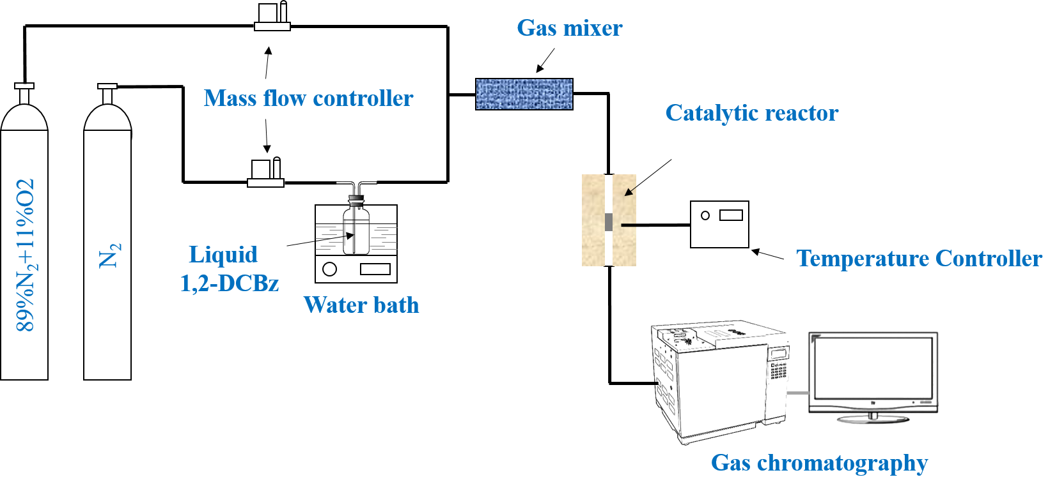

Figure S1. Diagrammatic illustration of 1,2-DCBz catalytic degradation device

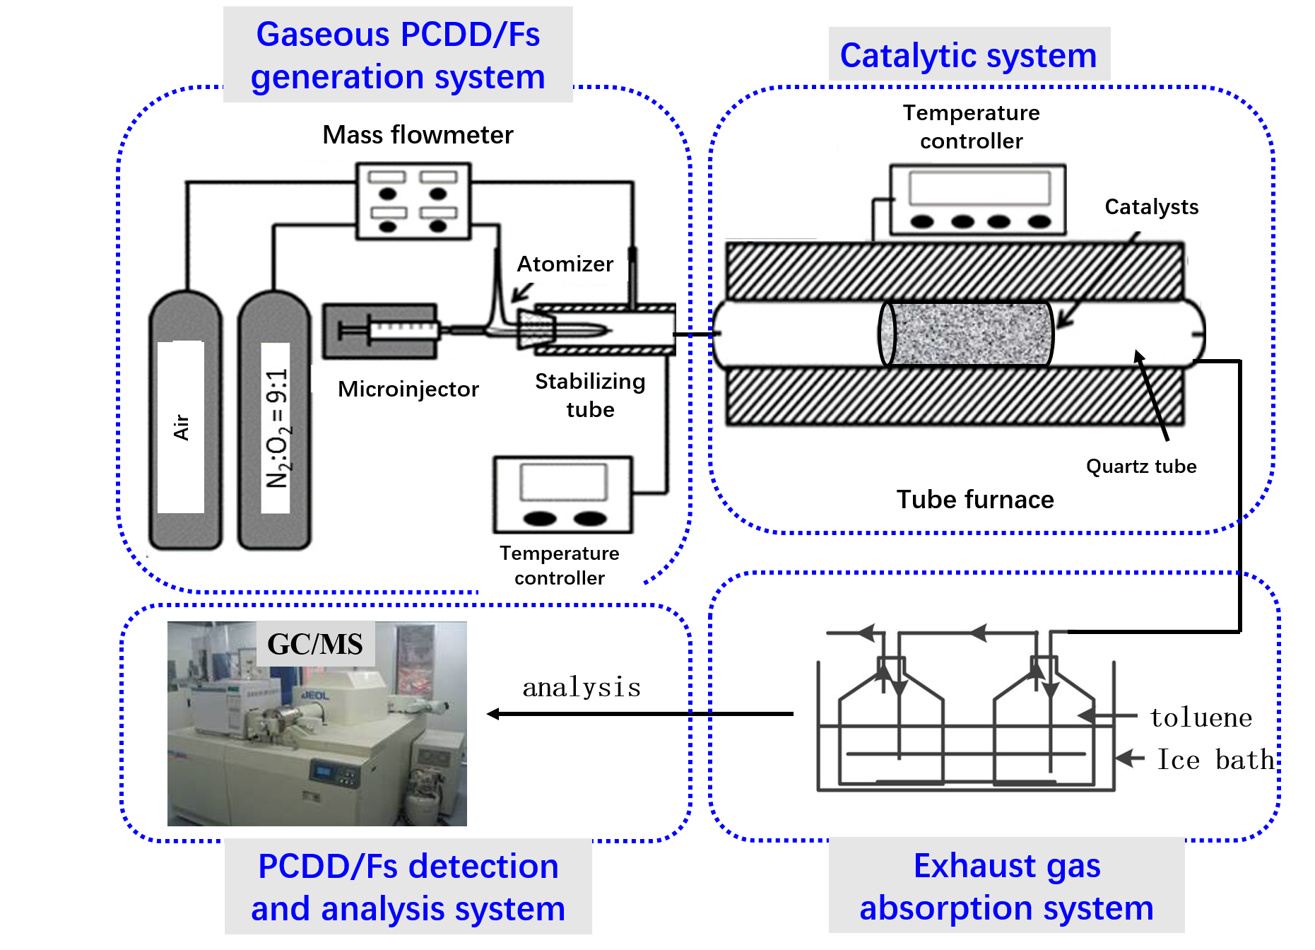

Figure S2. Diagrammatic illustration of gaseous PCDD/Fs
catalytic degradation apparatus

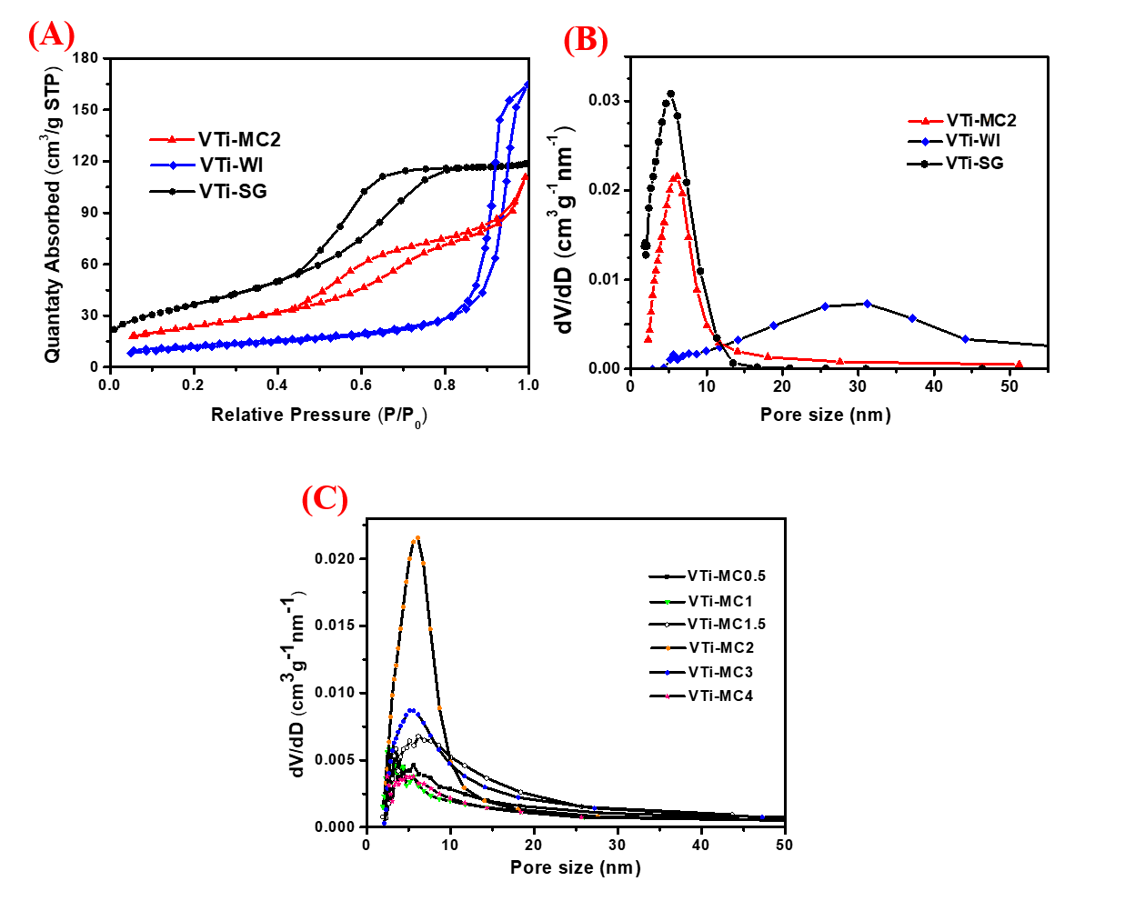

Figure S3. (A) N₂ adsorption/desorption isotherms, (B) pore size distributions
for various V₂O₅/TiO₂ and (C) pore size distributions for various VTi-MCt

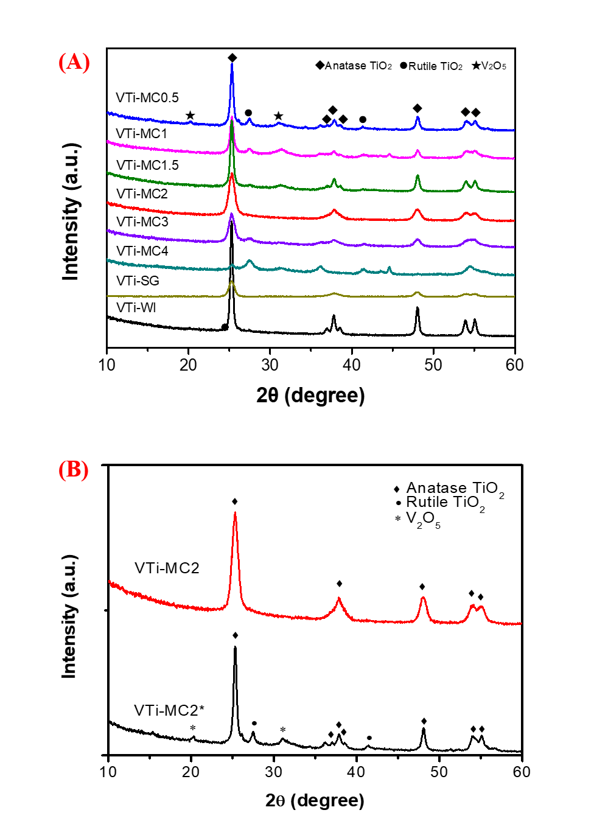
Figure S4. The wide-angle XRD diffraction patterns of various V₂O₅/TiO₂ samples.

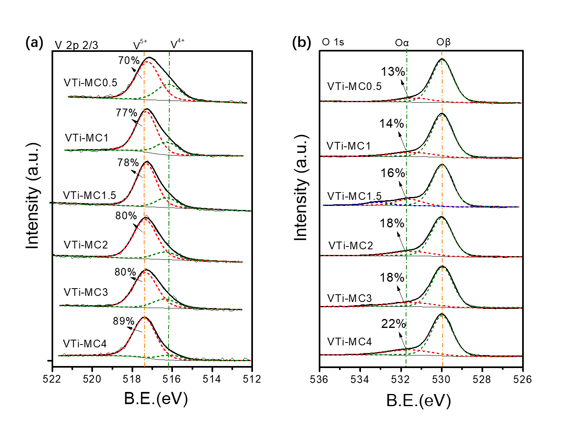
Figure S5. XPS patterns of various VTi-MC catalysts prepared with
different ball-milling time (a)V 2p 3/2, (b) O1s.

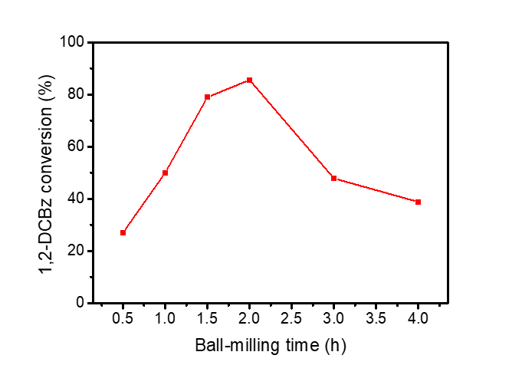
Figure S6. The 1,2-DCBz removal efficiency of various V₂O₅/TiO₂ samples with different Ball milling time at 150 ºC. (7000 h⁻¹, 117 ppm)

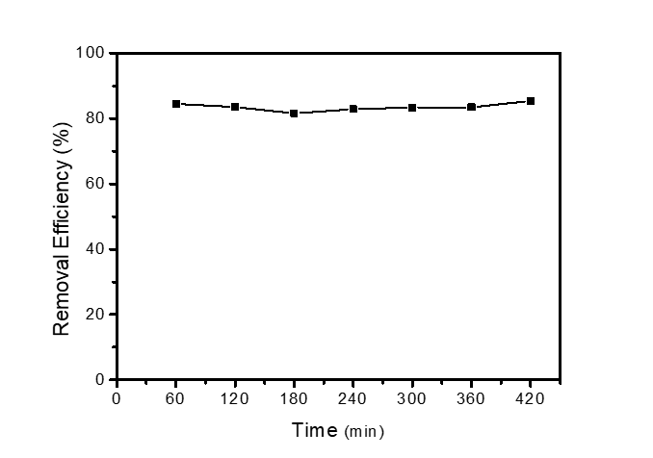
Figure S7. Stability test of VTi-MC2 for 1,2-DCBz removal (7000 h⁻¹, 117 ppm, 150 ºC)

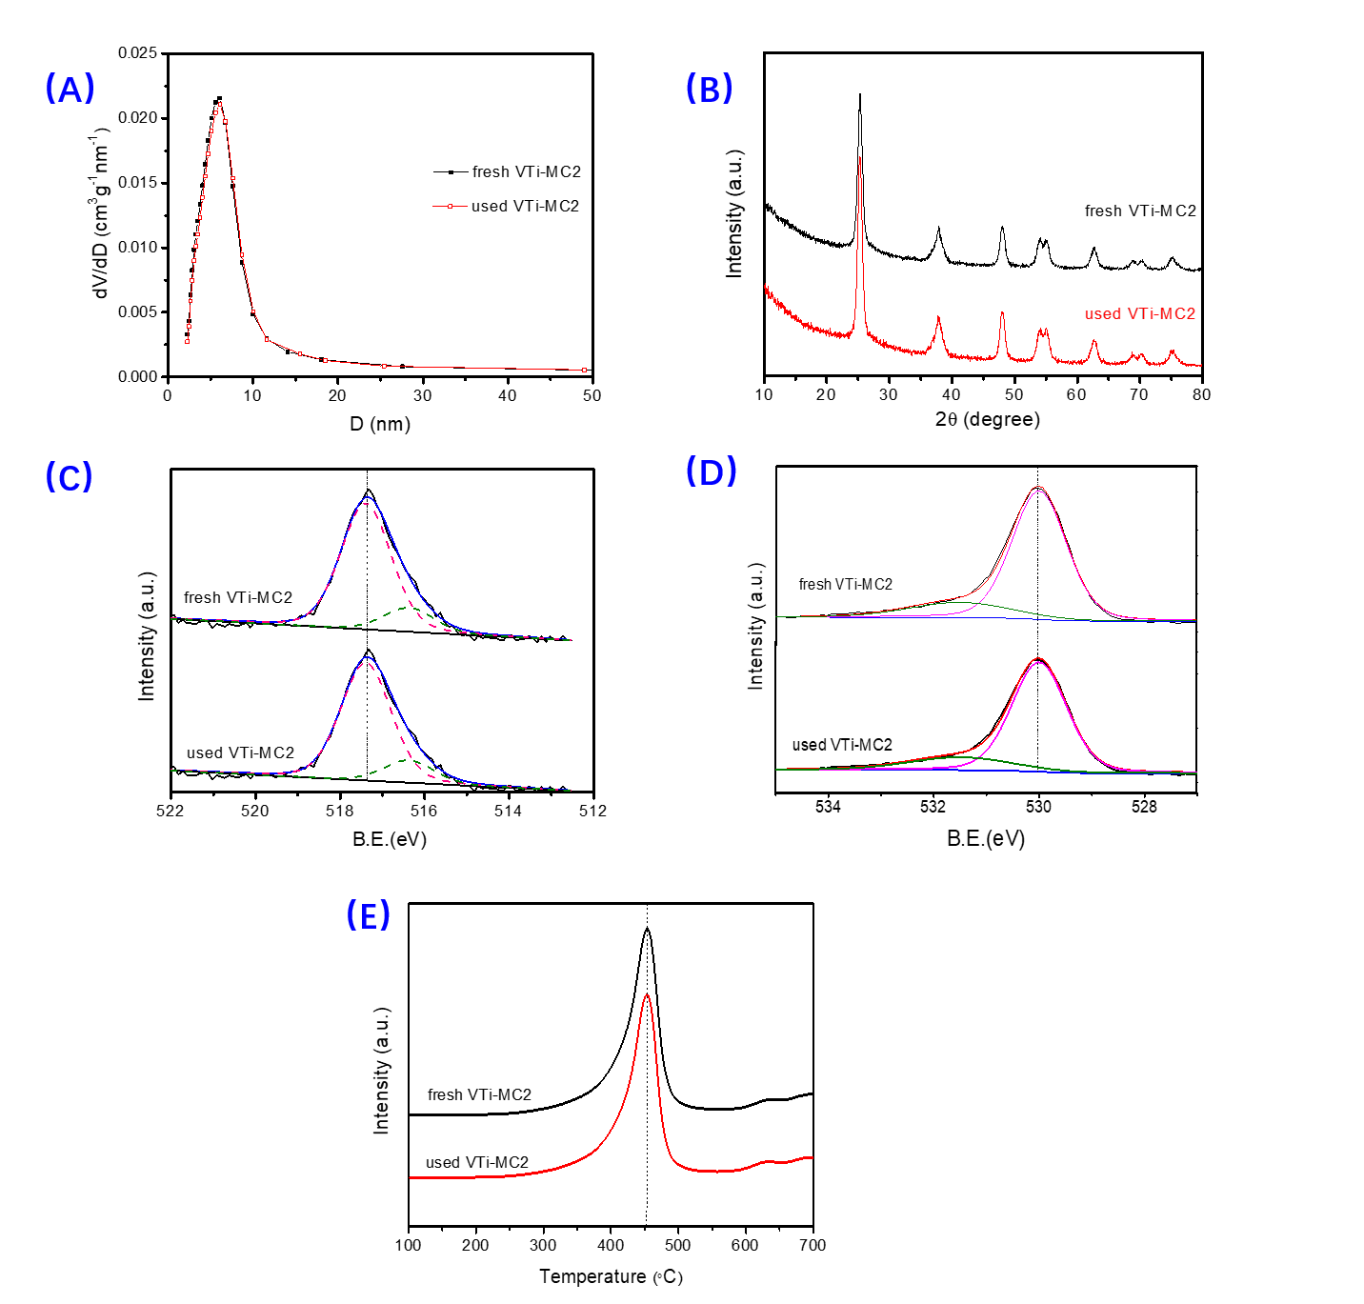
Figure S8. The characterization results of (A) N₂ adsorption and desorption, (B) XRD, (C)XPS of V 2p 2/3, (D) XPS of O 1s and (E) H2-TPR with fresh and used VTi-MC2

