Supplement 2

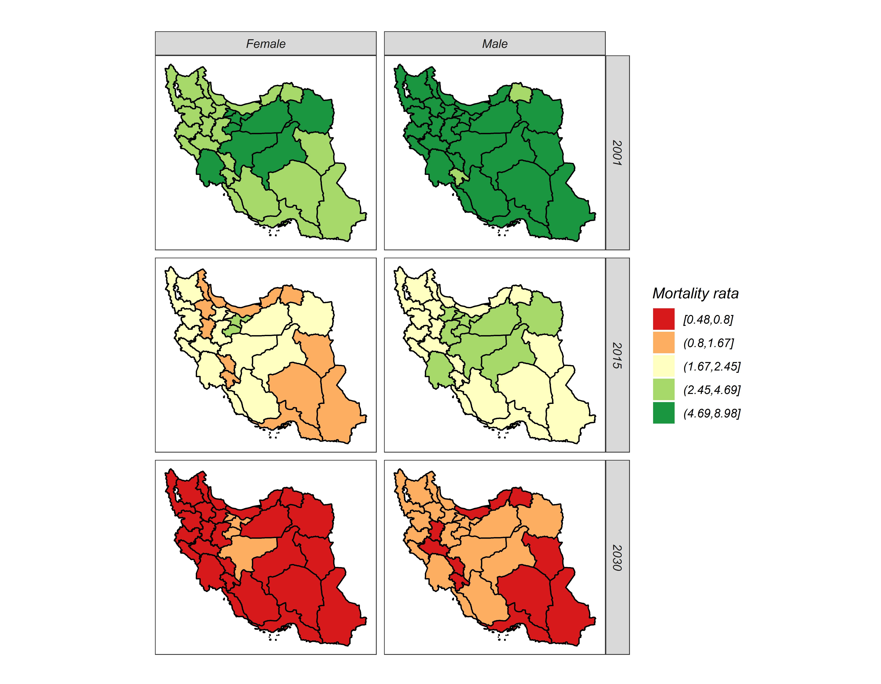

Fig1. Provincial disparity of Esophageal cancer in Iran in 2001, 2015 and 2030, by sex

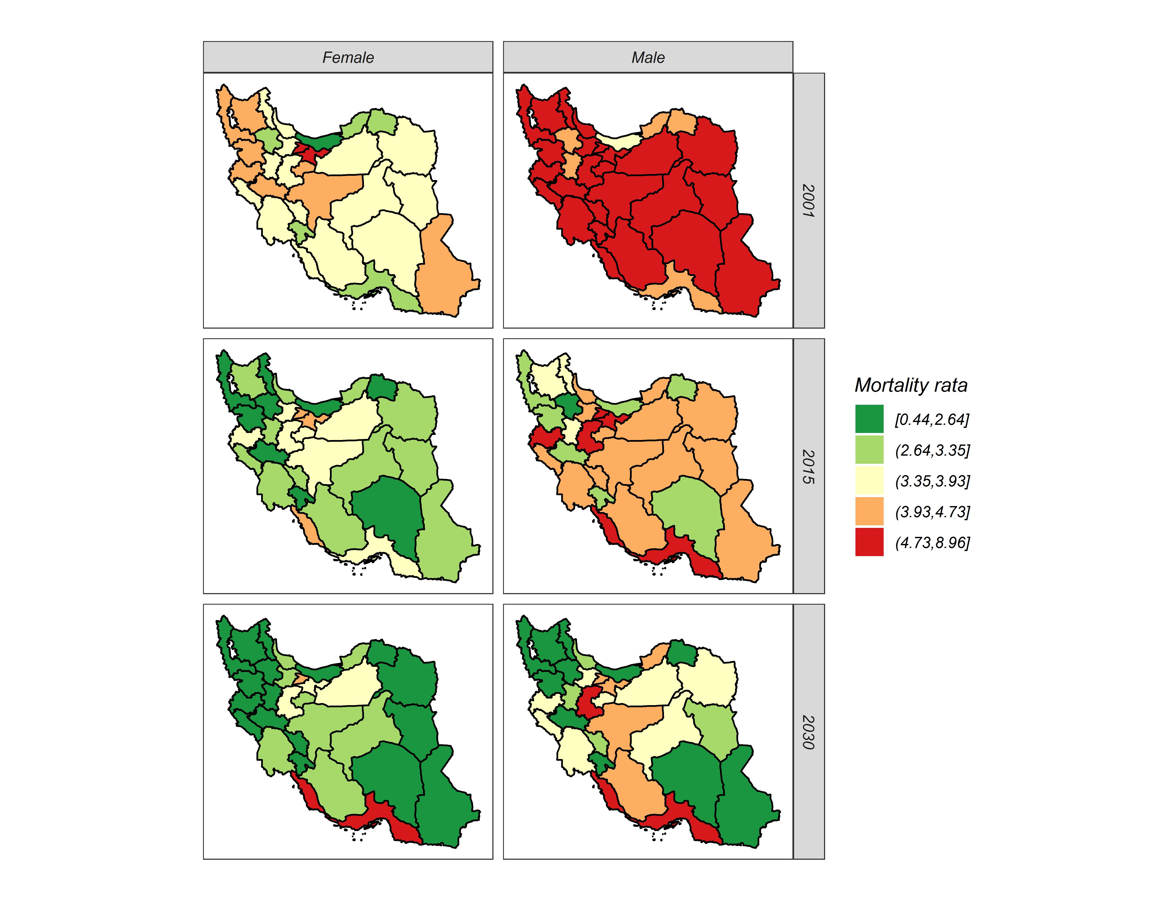

Fig2. Provincial disparity of Colon and rectum cancer in Iran in 2001, 2015 and 2030, by sex

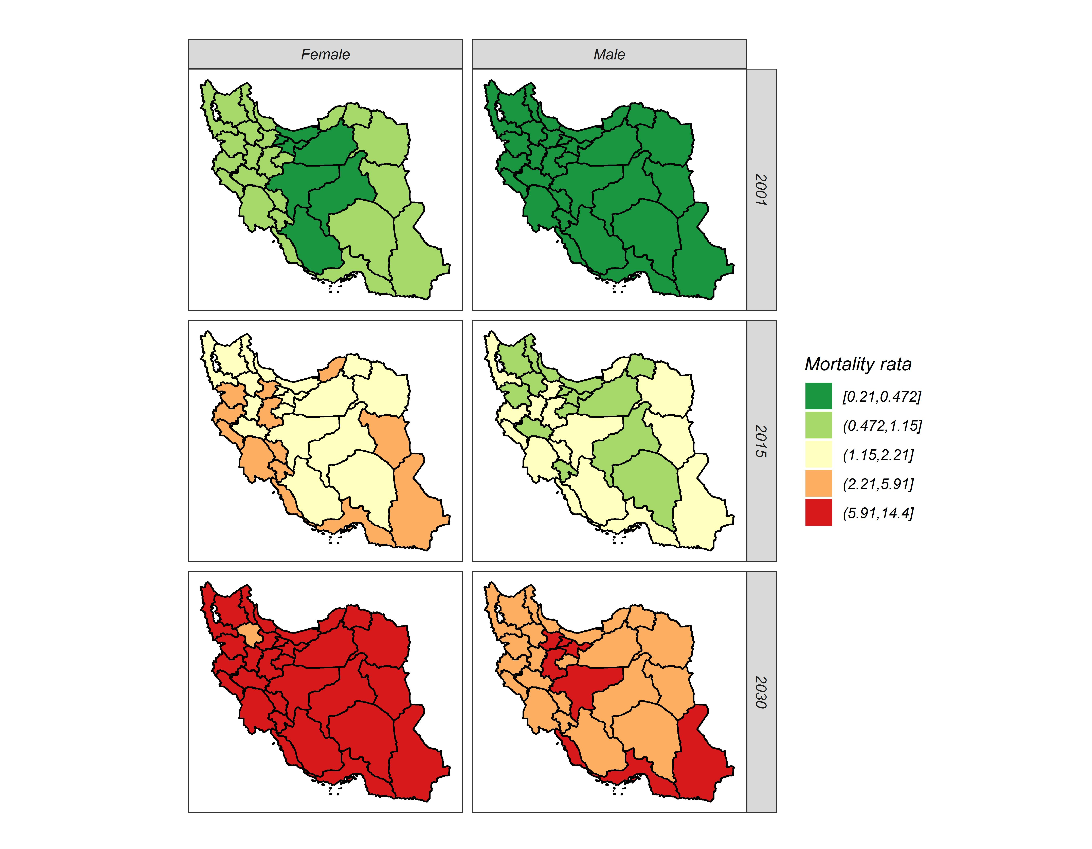
Fig3. Provincial disparity of Gallbladder Cancer in Iran in 2001, 2015 and 2030, by sex

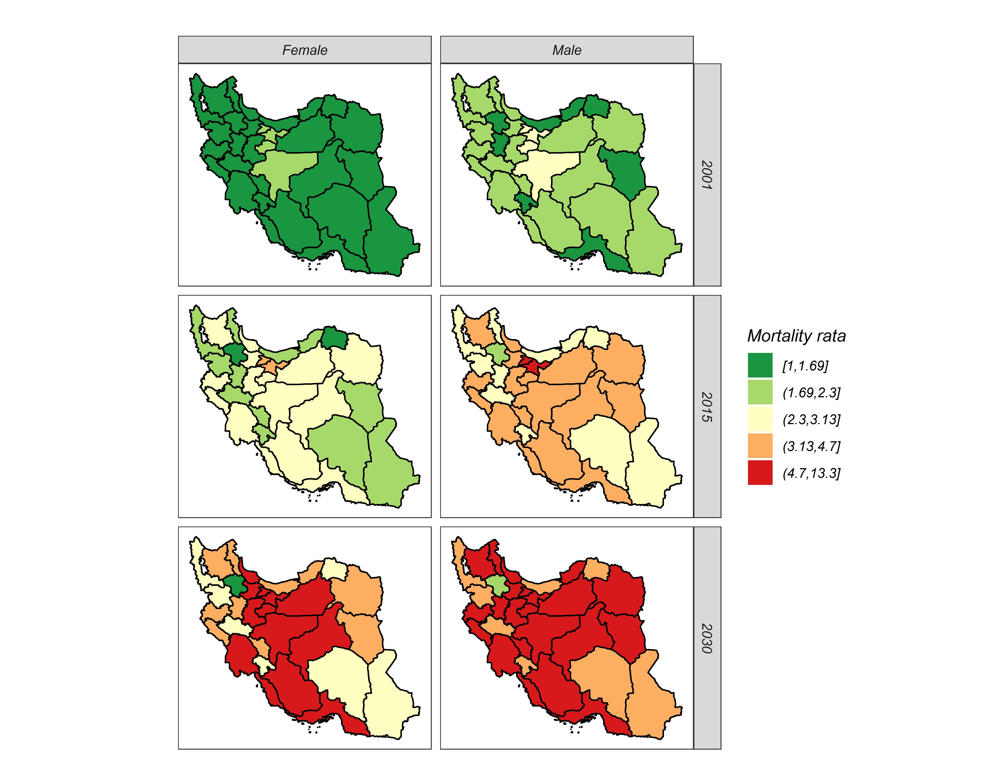

Fig4. Provincial disparity of Pancreases cancer in Iran in 2001, 2015 and 2030, by sex

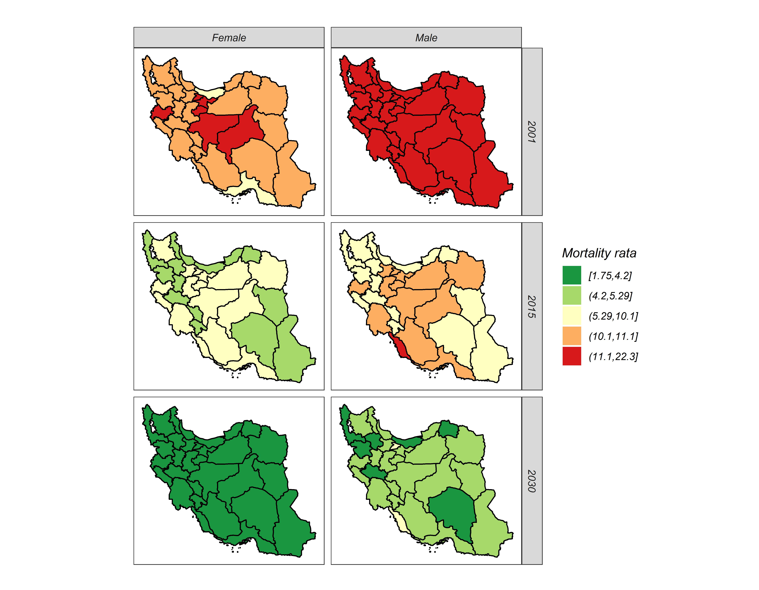
Fig5. Provincial disparity of Stomach cancer in Iran in 2001, 2015 and 2030, by sex

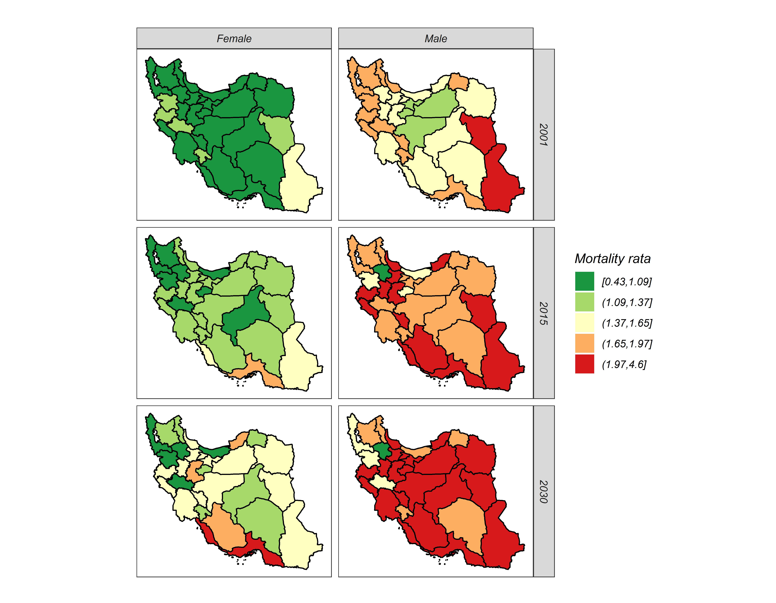
Fig6. Provincial disparity of Liver cancer in Iran in 2001, 2015 and 2030, by sex

