Transcriptomic analysis combined with IPMS revealed tissue-dependent miR156/SPL13 regulatory mechanism in alfalfa drought tolerance

Table S7. Shell scripts of Linux and R-software scripts used to analyze and visualize data
Raw reads before trimming with sickle
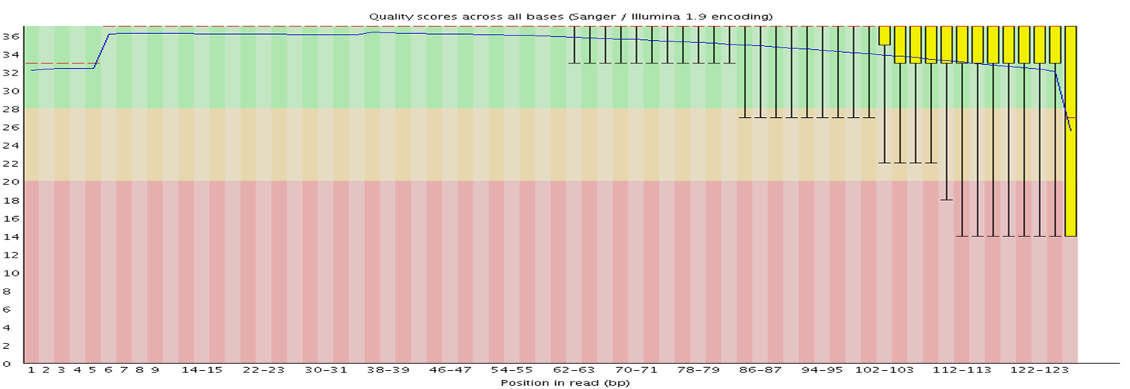
After trimming with sickle
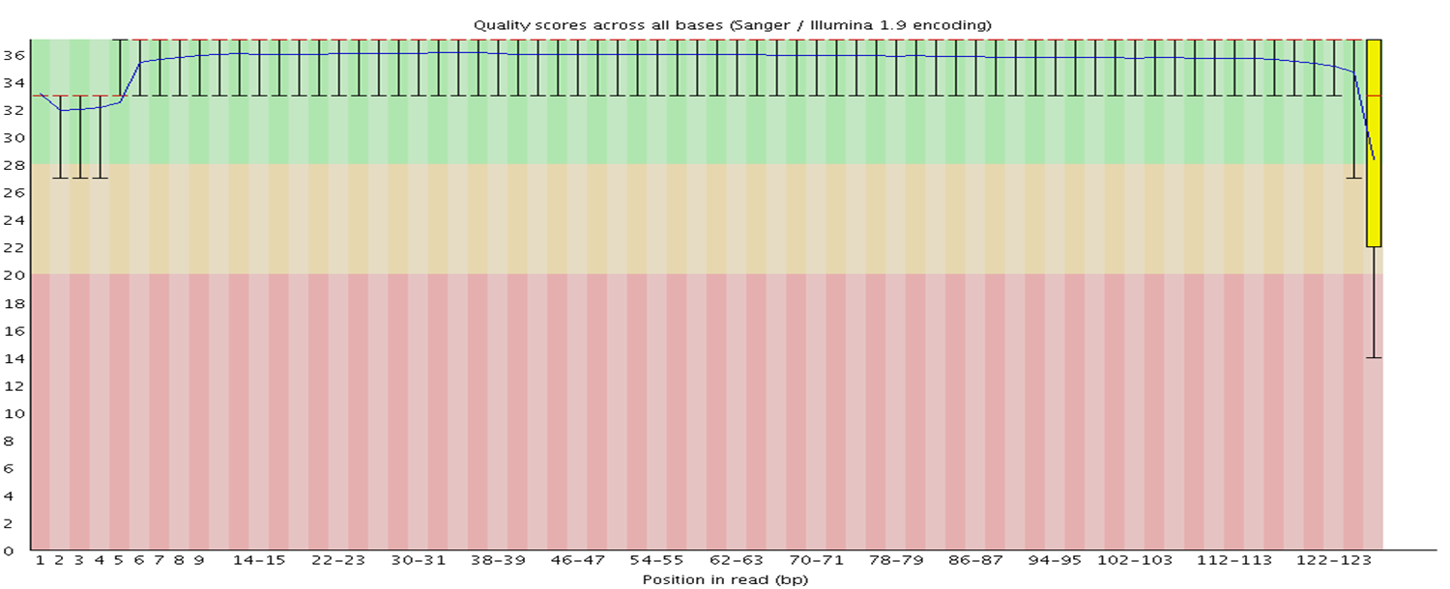
1 Trimming sequence end reads with default parameters before mapping
sickle pe -f EV-stem-trt1_R1_001.fastq -r EV-stem-trt1_R2_001.fastq -t sanger -o trimmedEV-stem-trt1_R1_001.fastq -p trimmedEV-stem-trt1_R2_001.fastq -s trimmedEV-stem-trt1.fastq
2 Map the reads for each sample to the reference genome
Tophat2 -p 8 -G JCVI.Medtr.v4.20130313.gtf -o EV-leaf-untrt1_thout JCVI.Medtr.v4.20130313 trimmedEV-leaf-untrt1_R1_001.fastq trimmedEV-leaf-untrt1_R2_001.fastq
3 Assemble transcripts for each sample with reference gene structure
cufflinks -p 8 -o ./EV-stem-trt1_clout ./EV-stem-trt1_thout/accepted_hits.bam
4 Run Cuffmerge on all assemblies to create a single merged transcriptome annotation
cuffmerge -g JCVI.Medtr.v4.20130313.gtf -s JCVI.Medtr.v4.20130313.fa -p 8 assemblies.txt
# assemblies.txt contains file directory paths of cufflinks generated ‘transcript.gtf’ files of all samples treated with both control and drought conditions.
5 Run Cuffdiff by using the merged transcriptome assembly along with the BAM from Tophat for each replicate
cuffdiff -o diff_out -b JCVI.Medtr.v4.20130313.fa -p 8 -L S13-leaf-trt,EV-leaf-trt -u merged_asm/merged.gtf S13-leaf-trt/S13-leaf-trt1_thout/accepted_hits.bam,S13-leaf-trt/S13-leaf-trt2_thout/accepted_hits.bam,S13-leaf-trt/S13-leaf-trt3_thout/accepted_hits.bam EV-leaf-trt1/EV-leaf-trt1_thout/accepted_hits.bam,EV-leaf-trt1/EV-leaf-trt2_thout/accepted_hits.bam,EV-leaf-trt1/EV-leaf-trt3_thout/accepted_hits.bam
6 Run featureCounts to get exon read count from ‘.bam’ files generated with tophat2
featureCounts v1.6.3; Command:featureCounts -T 8 -t exon -a Mt4.0v2_genes.gtf -o read_countnew.txt ./leaf/EV-leaf-trt1.bam ./leaf/EV-leaf-trt2.bam ./leaf/EV-leaf-trt3.bam ./leaf/EV-leaf-untrt1.bam ./leaf/EV-leaf-untrt2.bam ./leaf/EV-leaf-untrt3.bam ./leaf/S13-leaf-trt1.bam ./leaf/S13-leaf-trt2.bam ./leaf/S13-leaf-trt3.bam ./leaf/S13-leaf-untrt1.bam ./leaf/S13-leaf-untrt2.bam ./leaf/S13-leaf-untrt3.bam ./stem/EV-stem-trt1.bam ./stem/EV-stem-trt2.bam ./stem/EV-stem-trt3.bam ./stem/EV-stem-untrt1.bam ./stem/EV-stem-untrt2.bam ./stem/EV-stem-untrt3.bam ./stem/S13-stem-trt1.bam ./stem/S13-stem-trt2.bam ./stem/S13-stem-trt3.bam ./stem/S13-stem-untrt1.bam ./stem/S13-stem-untrt2.bam ./stem/S13-stem-untrt3.bam ./root/EV-root-trt1.bam ./root/EV-root-trt2.bam ./root/EV-root-trt3.bam ./root/EV-root-untrt1.bam ./root/EV-root-untrt2.bam ./root/EV-root-untrt3.bam ./root/S13-root-trt1.bam ./root/S13-root-trt2.bam ./root/S13-root-trt3.bam ./root/S13-root-untrt1.bam ./root/S13-root-untrt2.bam ./root/S13-root-untrt3.bam
7 Differential analysis results with CummeRbund with R-software
library(cummeRbund)
cuff_data<-readCufflinks('diff_out') #Create a CummeRbund database from the Cuffdiff output
csDensity(genes(cuff_data)) #Plot the distribution of expression levels for each sample
csScatter(genes(cuff_data), 'BvDD', 'DD') #Compare the expression of each gene in two conditions with a scatter plot
csVolcano(genes(cuff_data), 'BvDD', 'DD') #Create a volcano plot to inspect differentially expressed genes
#Exporting figures from R in Linux
png("csVolcanoBvDC_DC.png", width=1024, height=800, res=150)
csVolcano(genes(cuff_data), 'BvDC', 'DC',alpha=0.05, showSignificant=T)
graphics.off()
8 Preparing the exon read counts for Plotting PCA with R-software
sampleinfo <- read.delim("SampleInfo.txt", stringsAsFactors=F)
seqdata <- read.delim("read_count.txt", comment = "#", stringsAsFactors=F)
library(dplyr)
library(tibble)
newTable <- sampleinfo
basal <- which(newTable$trt=="basal")
newTable <- newTable[basal, ]
newTable <- newTable[basal, c("trt", "Sample", "tissue", "Group")]
colnames(newTable)[1] <- "trt"
countdata <- seqdata %>%
column_to_rownames("Geneid") %>% # turn the geneid column into rownames
select(sampleinfo$Sample) %>% # keep sample columns using sampleinfo$Sample
as.matrix()
keep <- rowSums(countdata) > 5
countdata <- countdata[keep,]
librarySizes <- colSums(countdata)
barplot(librarySizes,
names=names(librarySizes),
las=2,
main="Exon read count library sizes")
abline(h=7e6, lty=4)
# Get log2 counts per million
logcounts <- log2(countdata + 1)
# make a colour vector
statusCol <- as.numeric(factor(sampleinfo$Status)) + 1
# Check distributions of samples using boxplots
boxplot(logcounts,
xlab="",
ylab="Log2(exon read counts)",
las=2,
col=statusCol,
res=600)
# to alleviate the problem of rlog installation
library(ggfortify)
library(DESeq2)
rlogcounts <- rlog(countdata)
# Plotting PCA with R-software
pcDat <- prcomp(t(rlogcounts))
autoplot(pcDat)
jpeg('rplot.jpg');
p<-autoplot(pcDat,
data = sampleinfo,
fill="Group",
addEllipses = TRUE, ellipse.type = "confidence",
shape="Genotype", subtitle = 'PC1 versus PC2', vlineType = c('dotdash', 'solid', 'dashed'), hline = 0, size=5, label.size=6, width=4, height=4, units = 'in', res=480) +
scale_shape_manual(values=c(21, 24)) +
guides(fill = guide_legend(override.aes=list(shape=22)))
p + theme(panel.background = element_rect(fill = "white",
colour = "black",
size = 1, linetype = "solid"));
dev.off()

9 Visualization of Gene Ontology-term analysis corresponding Molecular function, Biological process, and cellular components using R-software. The script for assignment of a particular function is obtained from Revigo (http://revigo.irb.hr/) as ‘revigo.names’ followed by R-based visualization.
library(treemap)
# Run the data ‘revigo.names’ obtained from the Revigo (http://revigo.irb.hr/) website
stuff <- data.frame(revigo.data);
names(stuff) <- revigo.names;
stuff$abslog10pvalue <- as.numeric( as.character(stuff$abslog10pvalue) );
stuff$freqInDbPercent <- as.numeric( as.character(stuff$freqInDbPercent) );
stuff$uniqueness <- as.numeric( as.character(stuff$uniqueness) );
stuff$dispensability <- as.numeric( as.character(stuff$dispensability) );
png( file="revigo_treemap.png", width=1024, height=800, res= 150)
treemap(
stuff,
index = c("representative","description"),
vSize = "abslog10pvalue",
fontface.labels=c(2,3),
type = "categorical",
vColor = "representative",
title = "Cellular Component Gene Ontology treemap",
align.labels=list(
c("center", "center"),
c("center", "bottom")
),
inflate.labels = FALSE,
lowerbound.cex.labels = 0,
bg.labels = "#CCCCCCAA",
border.col=c("white","white"),
position.legend = "none")
dev.off()

10. circlize, an R-software package circular data visualization
library(circlize);
exp = read.table("leaf.txt", sep = "\t", header = T, stringsAsFactors = F);
exp_p = read.table("leaf_p.txt", sep = "\t", header = T, stringsAsFactors = F);
ss = read.table("stem.txt", sep = "\t", header = T, stringsAsFactors = F);
ss_p = read.table("stem_p.txt", sep = "\t", header = T, stringsAsFactors = F);
rr = read.table("root.txt", sep = "\t", header = T, stringsAsFactors = F);
rr_p = read.table("root_p.txt", sep = "\t", header = T, stringsAsFactors = F);

df=data.frame(exp);
dfp=data.frame(exp_p);
dfs=data.frame(ss);
dfsp=data.frame(ss_p);
dfr=data.frame(rr);
dfrp=data.frame(rr_p);

Mdtr = data.frame(
name = c("Chr1", "Chr2", "Chr3", "Chr4", "Chr5", "Chr6", "Chr7", "Chr8"),
start = c(0, 0, 0, 0, 0, 0, 0, 0),
end = c(52981375, 45728990, 55497394, 56578691, 43625231, 35241025, 49172401, 45563928))
circos.par("start.degree" = 90);
circos.genomicInitialize(Mdtr);
f=colorRamp2(breaks=c(-3, 0, 3), colors=c("blue", "white", "red"));
circos.genomicTrackPlotRegion(df, stack = TRUE,panel.fun =function(region, value, ...) {circos.genomicRect(region, value, col =f(value[[1]]),border =f(value[[1]]), ...)}, bg.border = NA, track.height = 0.075);
circos.genomicTrackPlotRegion(dfp, panel.fun =function(region, value, ...) {circos.genomicPoints(region, value, pch = 16, cex = 0.02, col="green", ...)}, track.height = 0.1);
circos.genomicTrackPlotRegion(dfs, stack = TRUE,panel.fun =function(region, value, ...) {circos.genomicRect(region, value, col =f(value[[1]]),border =f(value[[1]]), ...)}, bg.border = NA, track.height = 0.075);
circos.genomicTrackPlotRegion(dfsp, panel.fun =function(region, value, ...) {circos.genomicPoints(region, value, pch = 16, cex = 0.02, col="green", ...)}, track.height = 0.1);
circos.genomicTrackPlotRegion(dfr, stack = TRUE,panel.fun =function(region, value, ...) {circos.genomicRect(region, value, col =f(value[[1]]),border =f(value[[1]]), ...)}, bg.border = NA, track.height = 0.075);
circos.genomicTrackPlotRegion(dfrp, panel.fun =function(region, value, ...) {circos.genomicPoints(region, value, pch = 16, cex = 0.02, col="green", ...)}, track.height = 0.1);
lgd = Legend(at = c(-3, -2, 0, 2, 3), col_fun = f, title_position = "topleft", title = "Log2 FC");
draw(lgd, x = unit(3, "mm"), y = unit(3, "mm"), just = c("left", "bottom"));
circos.clear()

