Additional file 2: Protein classifications according to biological processes (file 1), cellular compartment (fig 2), molecular function (fig 3), protein class (fig 4) and pathway analysis (fig 5).

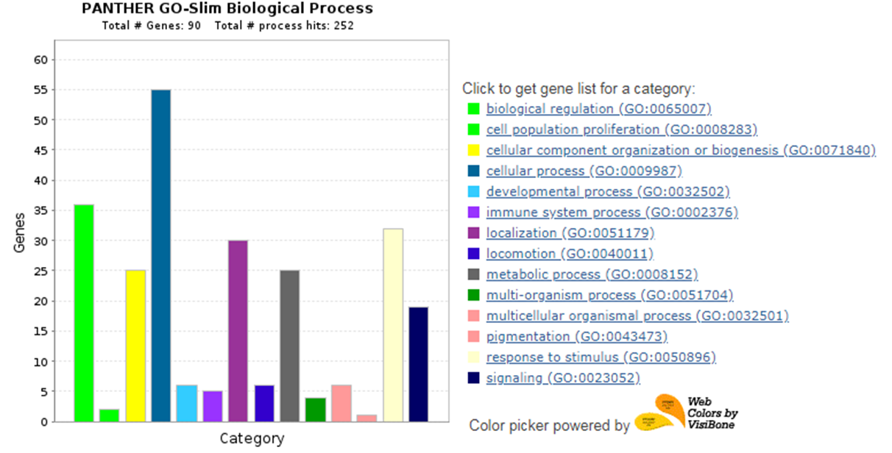
Supplementary Fig 1: Protein classification based on biological processess. Based on the literature the identified 104 proteins could have a role in more than one biological process. Some of the proteins’s biological processess are not known yet.

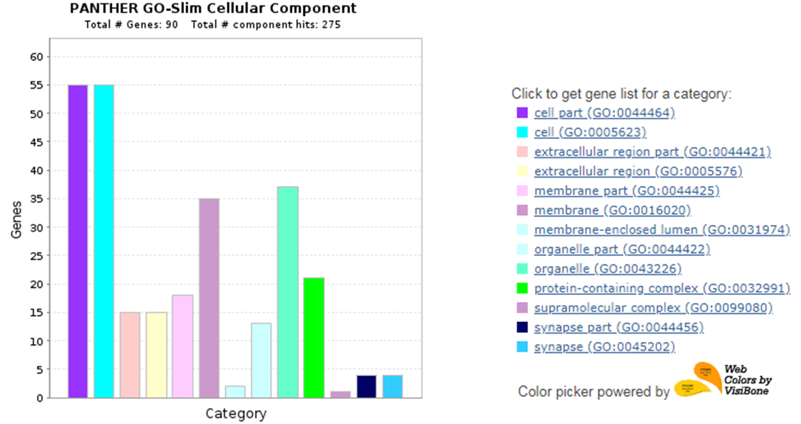
Supplementary Fig 2: The cellular compartment information for the identified proteins.

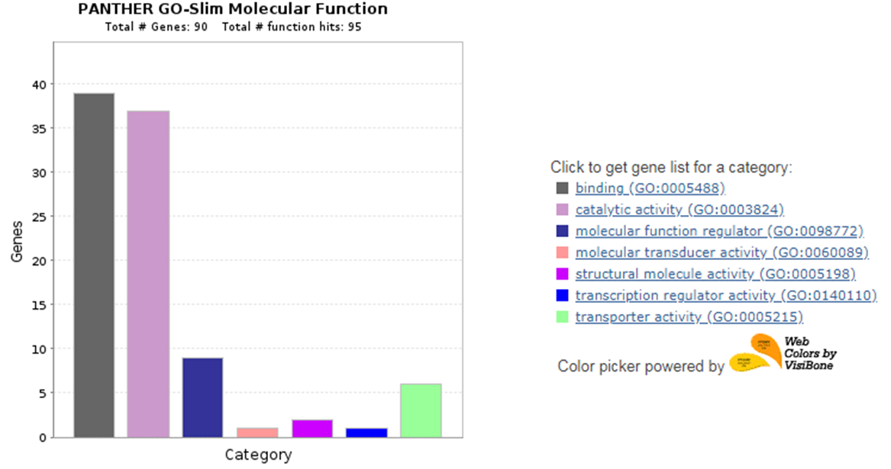
Supplementary Fig 3: Molecular functions carried out by the identified proteins. Only 90 of the 104 identified proteins have known molecular functions.

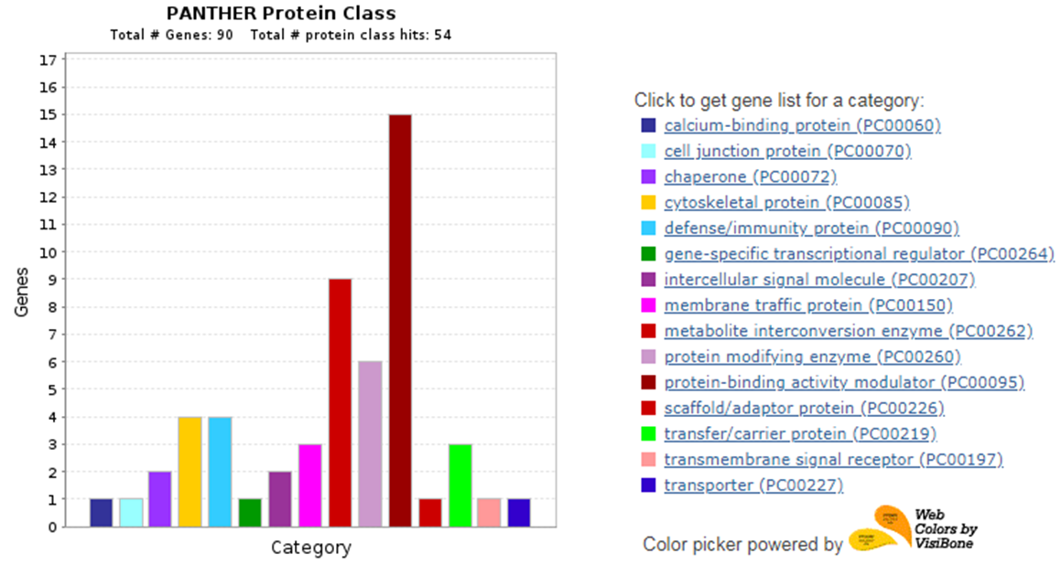

Supplementary Fig 4: Protein class classifications of the identified proteins.
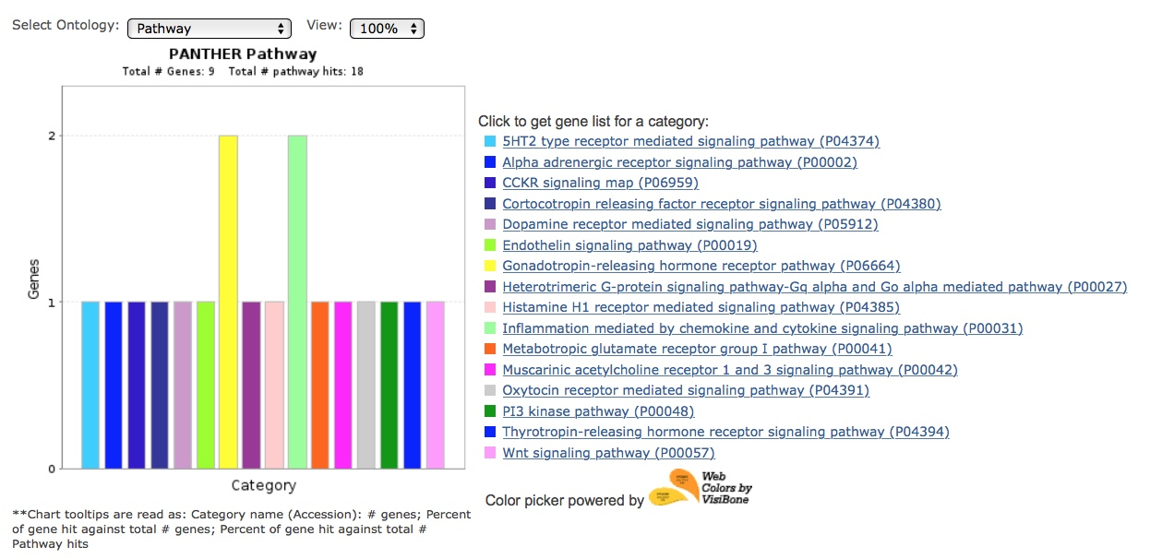
Supplementary Fig 5: Pathway analysis of the identified proteins that were significantly changed.

