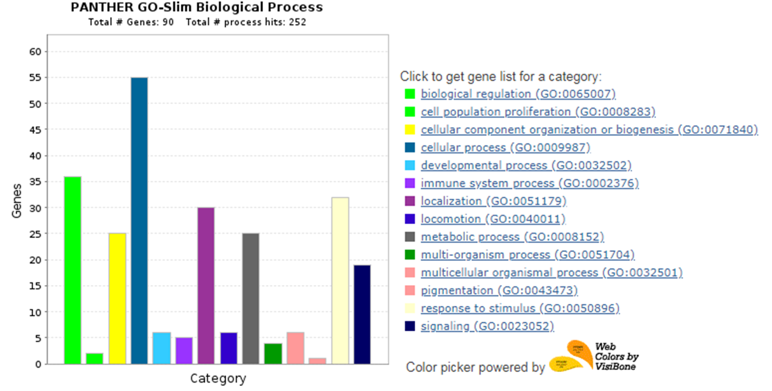
Supplementary Fig 1: Protein classification based on biological processess. Based on the literature the identified 107 proteins could have a role in more than one biological process. Some of the proteins’s biological processess are not known yet.

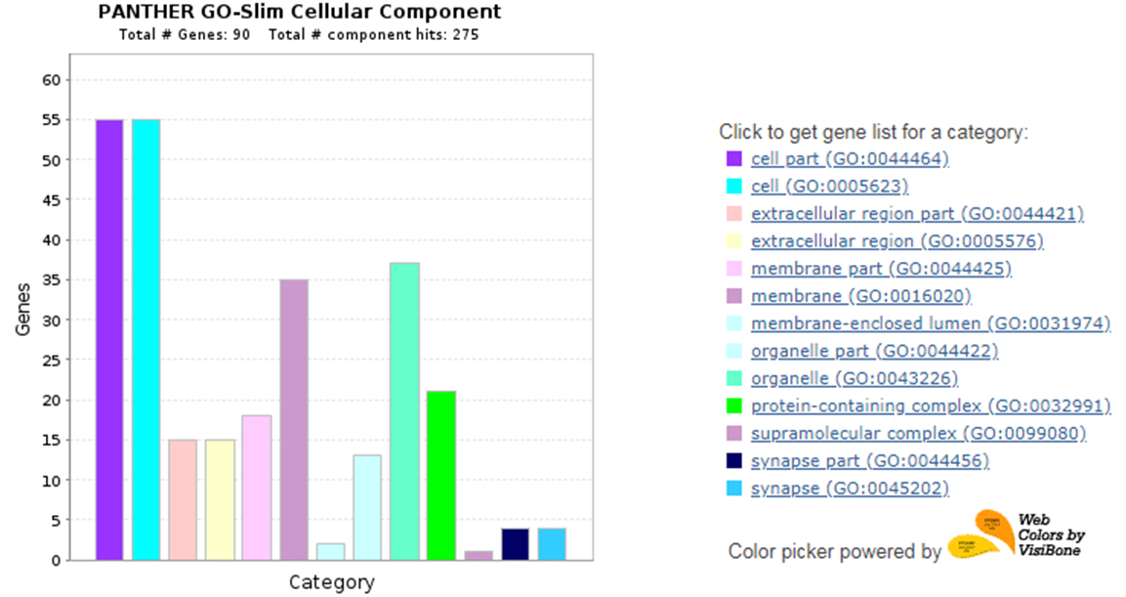

Supplementary Fig 2: The cellular compartment information for the identified proteins.

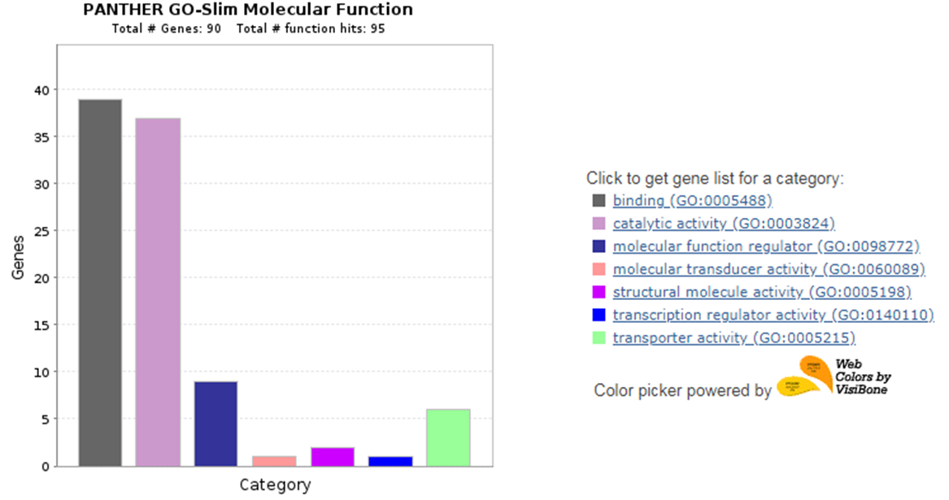
Supplementary Fig 3: Molecular functions carried out by the identified proteins. Only 90 of the 107 identified proteins have known molecular functions.

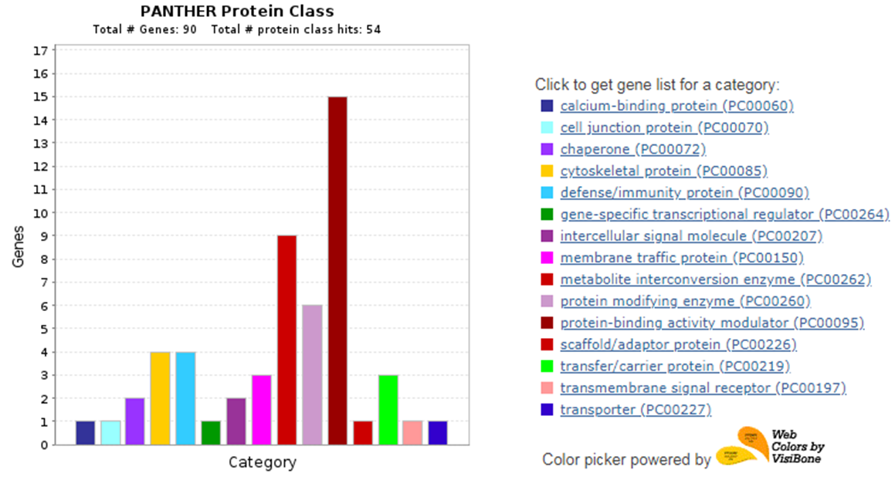

Supplementary Fig 4: Protein class classifications of the identified proteins.
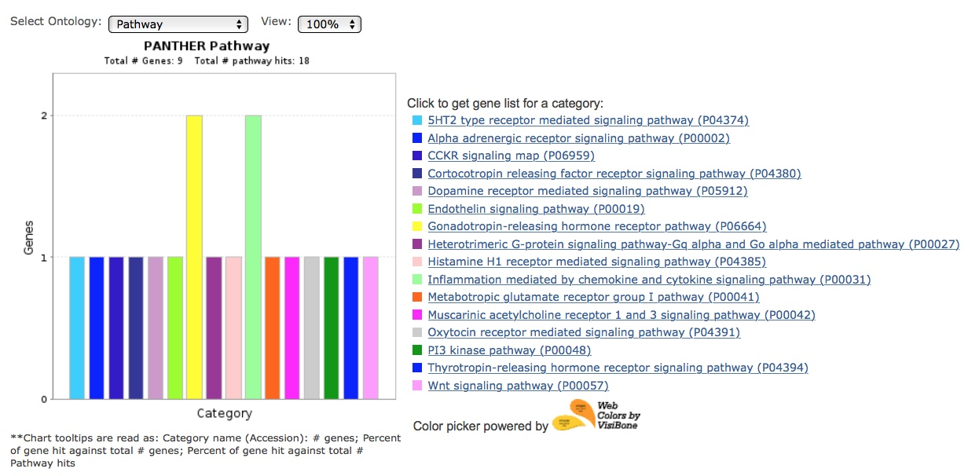
Supplementary Fig 5: Pathway analysis of the identified proteins that were significantly changed.

