Dear Editors-in-Chief
Cancer Nanotechnology

We are pleased to submit our manuscript entitled “Radiolabeling and PET-MRI microdosing of the experimental cancer therapeutic, MN-anti-miR10b, demonstrates delivery to metastatic lesions in a murine model of metastatic breast cancer” by Mariane Le Fur et al. for publication in Cancer Nanotechnology.

In our earlier work, we identified microRNA-10b (miR10b) as a master regulator of the viability of metastatic tumor cells. This knowledge allowed us to design a miR10b-targeted therapeutic consisting of anti-miR10b and magnetic nanoparticles (MN), termed MN-anti-miR10b. In preclinical studies, we demonstrated that MN-anti-miR10b caused durable regressions of established metastases. As a first step towards translating MN-anti-miR10b for clinical applications, we needed to develop a radiolabeled version of MN-anti-miR10b for the extended studies in human metastases. In this manuscript, we devised a method to efficiently radiolabel MN-anti-miR10b with Cu-64 (⁶⁴Cu) and evaluated the pharmacokinetics and biodistribution of the radiolabeled product at two different doses in murine models. In addition, we evaluated the uptake of ⁶⁴Cu-MN-anti-miR10b by metastatic lesions using both in vivo and ex vivo positron emission tomography-magnetic resonance imaging (PET-MRI). As a result, we observed a comparable distribution of the therapeutic after administration of a microdose or macrodose. Our results demonstrate that PET-MRI following a microdose injection of the agent will accurately reflect the innate biodistribution of the therapeutic. The tools developed in the present study lay the groundwork for the clinical testing of MN-anti-miR10b and other similar therapeutics in patients with cancer and we are keen to share the results with the broader research community through potential publication in Cancer Nanotechnology.

Thank you for the exciting opportunity to publish in your journal.

Sincerely,

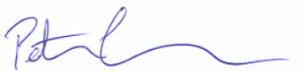
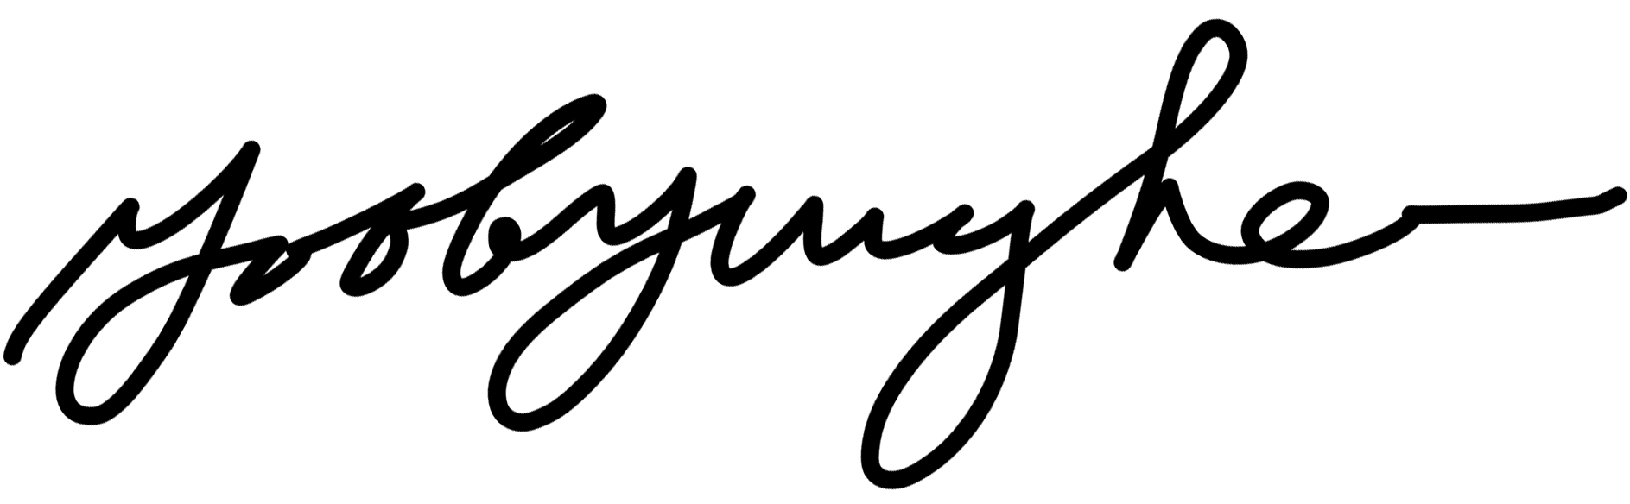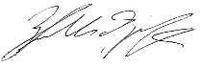
Byunghee Yoo Ph.D. Zdravka Medarova Ph.D. Peter Caravan Ph.D.
Instructor Associate Professor Professor

