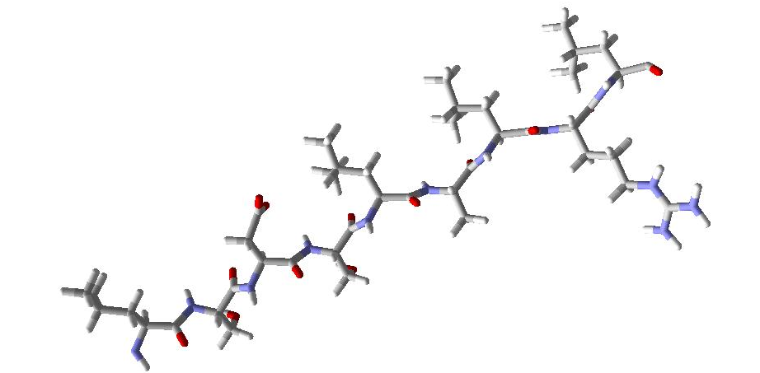

A.The structure of predicted epitope" LSDSLALRL" was painted by PyMol software.

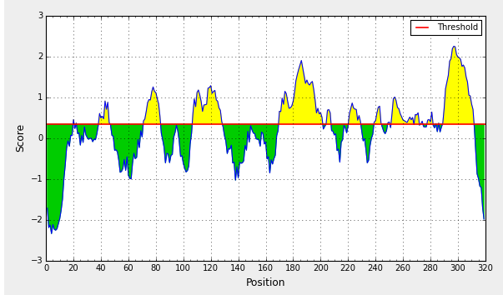
B. Prediction B cell epitopes from Length proteins by IEDB. The amino acids may be able to epitopes were shown in yellow regions above the threshold line .there are a range of epitopes at the 160 -200 and 250 to 315 range approximately.

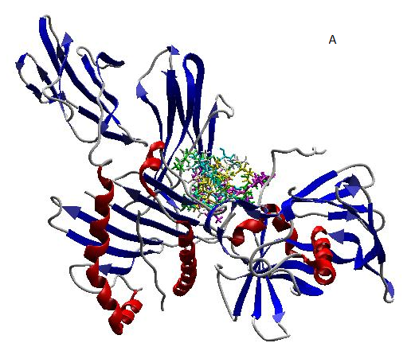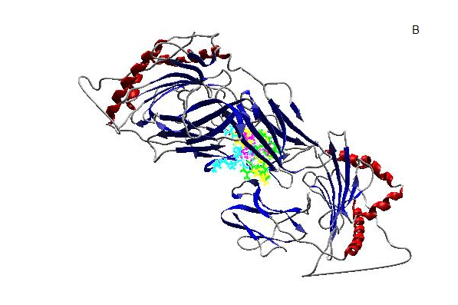
C. Molecular docking analysis was done between (A) HLA-A 0101, (B) HLA-DRB1 0101, and LSDSLALRL peptide. The alleles are showed as secondary structure and the epitope was displayed as colorful sticks.

