Gemini surfactant assisted synthesis of mesoporous Mn/Mg bimetal doped TiO₂ nanomaterial: Characterization and photocatalytic activity studies under visible light irradiation
Sankara Rao Miditana, Siva Rao Tirukkovalluri*, Imandi Manga Raju, Shaik Abdul Alim, Genji Jaishree, M.L.V. Prasanna Chippada
Department of Inorganic & Analytical Chemistry, A.U. College of Science & Technology, Andhra University, Visakhapatnam, Andhra Pradesh, India-530003.
* Correspondence: +91 7702110459, sivaraoau@gmail.com

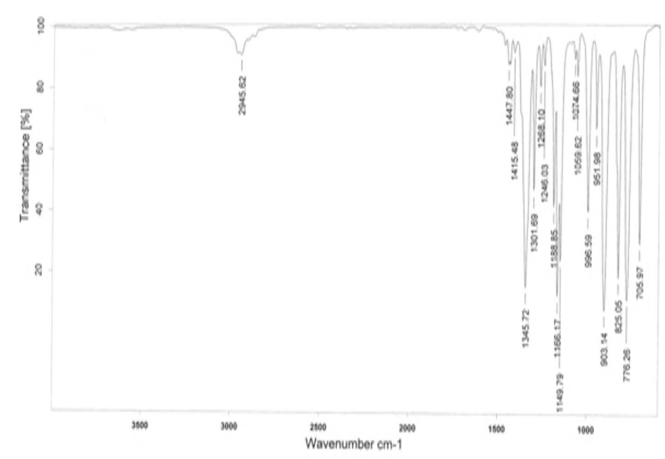
Fig. S1 FT-IR spectra of Gemini Surfactant.

