Supplementary Information

Quantitative fit-testing of a locally produced, reusable, valved half-face respirator during the COVID-19 pandemic

Arnaud Romeo Mbadjeu Hondjeu, William C. K. Ng, Vahid Anwari, Maggie Z.X. Xiao, Dmitry Rozenberg, Kate Kazlovich, Edem Afenu, Joshua Hiansen, Azad Mashari

The reusable, silicone, valved respirator combined with pleated-membrane filters (Duo) originated from a previous Simple Silicone Mask Figure S1.
The next section will provide instruction for 3D Print Settings and Silicone casting process of Duo.
3D Print Settings and Silicone casting process

Preliminary to mold 3D printing, the STL (Standard Triangle Language) files were processed to g.code files using Prusa Slicer (v.2.2.0). Default print settings for PET-G (glycol-modified polythylene terephthalate) filament were used; applying a system preset layer thickness of 0.15 mm for the ports and the molds, with a 20% infill.
The harness was 3 D printed at 40% infill, using a layer thickness of 0.30 mm. The design is under a CERN Open Hardware License Version 2-Strongly Reciprocal license.

To manufacture the silicone respiratory body, 3 molds are required and need to be 3D printed first.
Link for stl files (normal size and small size) are in the GitHub page of tgh-apil/Reusable-N95-Respirator/source files/siliconebodymask/normalsize/stl/

Normal size

Mold part 1: 3mm thick mask - interface mod - Mould part 1.stl

Mold part 2: 3mm thick mask - interface mod - Mould part 2 - reinforced axis.stl
Mold part 3: print both sides

Left side: 3mm thick mask - interface mod - Mould part 3 - L v1.stl
Right side: 3mm thick mask - interface mod - Mould part 3 - R v1.stl

Small size
Mold part 1: 3mm thick mask - nose - Mould part 1.stl

Mold part 2: 3mm thick mask - nose - Mould part 2 reinforced axis.stl
Mold part 3: print both sides

Left side: 3mm thick mask - nose - Mould part 3 - L v1.stl

Right side: 3mm thick mask - nose - Mould part 3 - R v1.stl

After the 3-part molds are 3 D printed, the surfaces of the molds need to be sprayed with a thin coat of Ease Release ® 200 (Mann Release Technologies Inc, Macungie, PA) and set aside to dry for approximately 5 minutes. The purpose of Ease Release ® is to make it easier to remove the silicone cast once it is finished curing. This process is like spraying a thin coat of oil on a bed pan surface prior to baking a cake or bread.
Next, assemble the 3-part molds together as shown in Figure S2, using screws (6 mm) to tighten the two wings of Part 2 into the base (Part 1). If clamps are available, use these to hold part 2 (left and right) pieces together with part 1 (the base). For seal gaps between the Part 2 left and right wings, liquid plastic glue can be used for sealing.
- Pour 75 mL of Dragon Skin 20 Part A and 75 mL of Dragon Skin 20 Part B into two separate buckets. (Note: a single bucket can be used by first pouring equal amount of Part A and then B together, the bucket must be able to hold at least 500 mL volume).
- Next, mix the equal amounts of Part A and B together, using a mixing stick. Thorough mix to ensure the components are completely mixed. After 5 mins of mixing, five drops of food coloring can be added to obtain different colors of silicone respirators (optional).
- Next, degas the mixture in a vacuum chamber (up to 30 inches of mercury pressure). Degas until the mixture expands and collapses on itself. Then remove the bucket containing the silicone mixture from the degassing chamber. (Note: it is recommended but not necessary to degas in a vacuum chamber, however tiny microbubbles will be present in the final silicone body, the microbubbles do not negatively affect the performance of the respirator).
- Once the silicone mixture appears clear without any visible bubbles pour the mixture into the mold from the top. Continue pouring the silicone mixture until there is a small amount of silicone overflowing from the top of the mold. Observe the silicone settling into the mold, tiny microbubbles will start appearing and disappearing from the mold. If required, pour more silicone to ensure the mold is full and overflowing a little bit.
- Set the mold aside to cure for at least 4 hours.
- After 4 hours, remove the silicone respirator body from the mold by carefully separating the 3-component mold. Figure S3. represents the Duo respirator silicone body.
- Clean the respirator body in a bleach solution, then rinse with water. Clean the 3-part mold components and get ready for the next mold.
- With the silicone respirator body ready, gather other components for the respirator, as shown on Table 1.
Duo components

Duo Components | Description/Material | Figures, References
Respirator body | Bio-safe, elastic, and durable silicone rubber (Dragon Skin 20™, Smooth-On Inc., Macungie, PA). Created using a mold making technique requiring a 3-component, 3D printed mold. | Figure S2. represents the 3D printed mold  Figure S3. represents the Duo respirator silicone body.
Pleated cartridge filter (x2) | Medical grade pleated respiratory filter (Hydro-Guard™ Mini breathing filter, tested and passed NIOSH 99.7-99.9% Particulate Filtration  Efficiency, Intersurgical®, Burlington, CA). Connector outer diameter 22.6 mm fits universal adapter. | Figure S4. The pleated membrane filters are shown
Inhalation filter holder (x2) | 3D printed, houses the inspiratory valve seat, attachment point for inspiratory pleated filters and the silicone respirator body | Figure S5. Depicts inspiratory valves  GitHub link: Inspiration Valve Adapter T3 - INSP v2.stl
Exhalation valve seat and cap (x1) | 3D printed, houses the expiratory valve seat, and the non-pleated single layer expiratory filter paper. Attaches to silicone respirator body. | Figure S6.  GitHub link: Expiration Valve Adapter C26.5 v3 rectangle tabs.stl  GitHub link: Expiration valve adapter cap.stl
Exhalation filter paper | Single layer of Halyard 100 (5cm x 5cm) surgical sterilization wrap. | See Figure S6.
Inhalation valve leaflet (x2)  Exhalation valve leaflet (x1) | Same thin, mushroom shaped, medical grade silicone leaflet inserted on the inspiratory and expiratory valve. | Figure S7. The silicone mushroom shaped valve leaflets used in the expiratory and inspiratory valve seats.
Harness (x1) | 3D printed PET-G plastic; 4-pronged harness secures respirator body to user’s face using two elastic straps | Figure S8.  GitHub link: Mask-Harness-Duo-(M)-v8.stl
Elastic straps (x2) | Dimensions: length 60 cm, width 1 cm, thickness 1.4 mm. | Figure S8.
Table S1: The components required to produce Duo half-face respirator.

See Figure S9 for a complete picture of the separate components for the Duo half-face respirator.
See Figure S10 for an image of a fully assembled Duo half-face respirator.

Resources
1.Respirator body Silicone Rubber: Dragon Skin™ 20 curing liquid silicone from SMOOTH-ON (https://www.smooth-on.com/products/dragon-skin-20/)
Product can be purchased (in Canada) from: https://www.sculpturesupply.com/detail.php?id=799651&sf=category&vl=Rubber+Silicones

2. Inspiratory Pleated Filter: Hydro-Guard ™ Mini: Intersurgical Ltd: https://ca.intersurgical.com/

3. Expiratory filter: Halyard sterilization wrap: H100, or other (H200, H300):https://products.halyardhealth.com/surgical-solutions/sterilization-solutions/sterilization-wraps/halyard-kimguard-one-step-sterilization-wrap.html

4.One-way silicone leaflet for valves: https://www.alibaba.com/product-detail/Custom-Medical-Grade-Clear-One-Way_62448938592.html?spm=a2700.details.deiletai6.1.5a1140cebbx52W

5.Elastic Strap: any elastic strap can be used (width 1 cm)

6. Harness and molds: 3D printing filament: PET-G, can be purchased from any local 3D printing supply store.

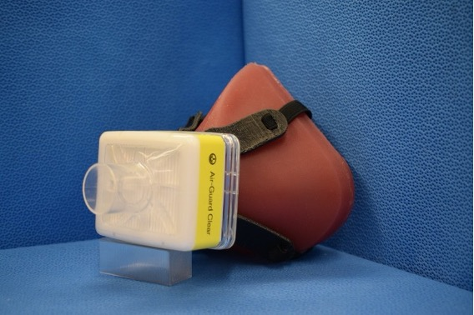

Figure S1. The simple silicone respirator is shown, the predecessor of Duo.

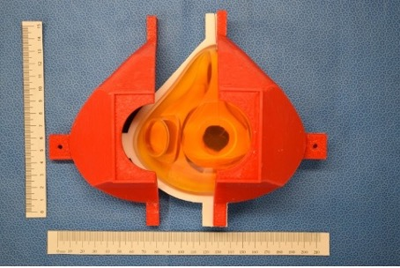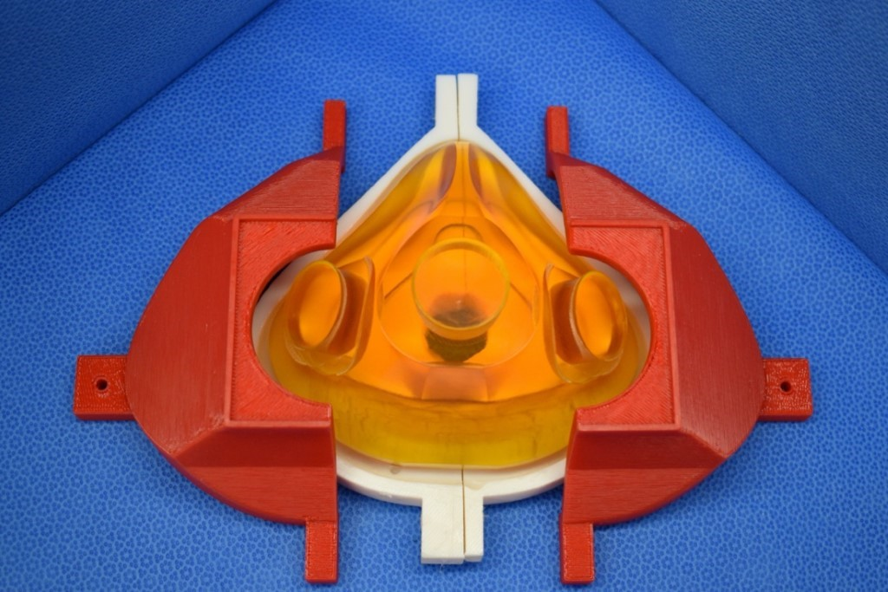

Figure S2. 3D printed 3-part mold component to manufacture the silicone respirator body

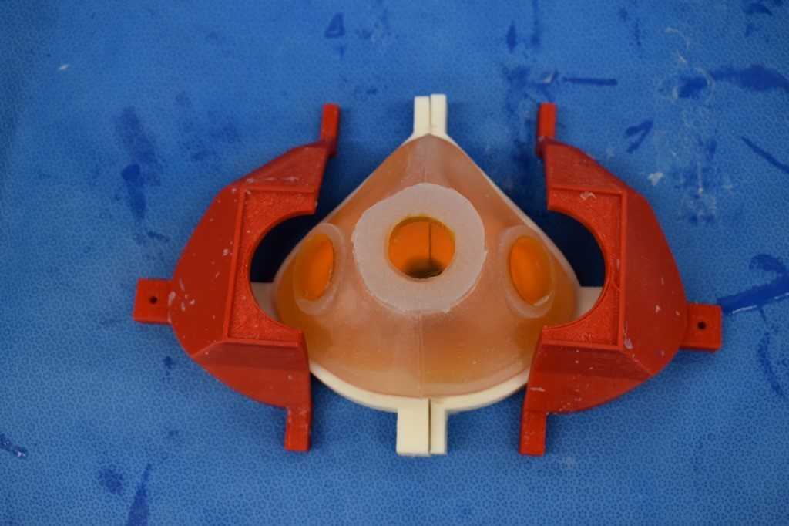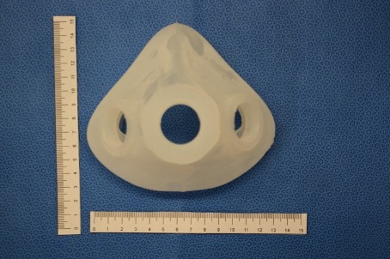

Figure S3. The Duo respirator body made molded from a 2-part skin safe silicone.
- The 3-part mold disassembled and the silicone respirator body is retrieved.
- The final silicone respirator body is shown after removal from the 3-part mold.

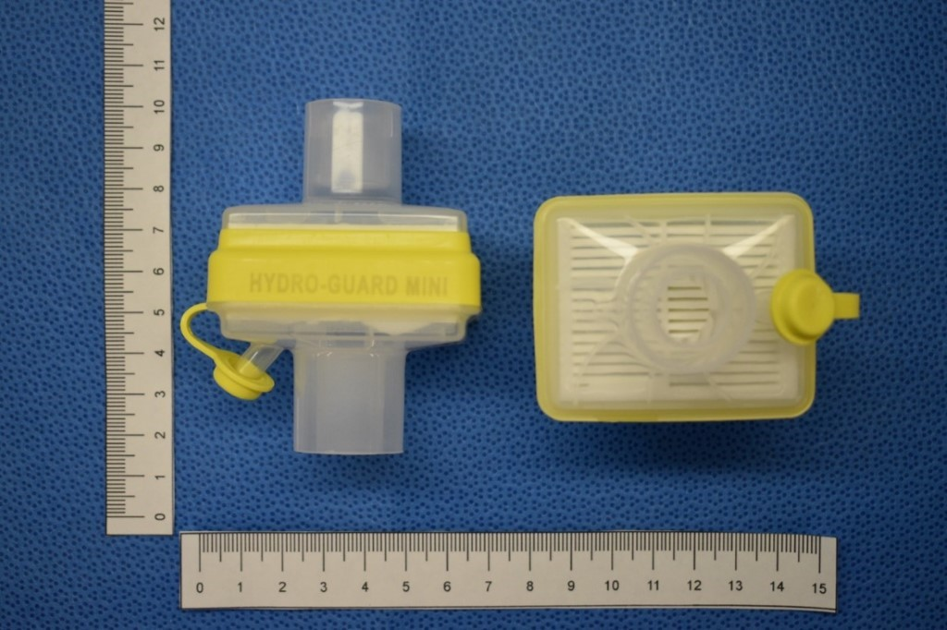

Figure S4. The pleated membrane filters are shown.

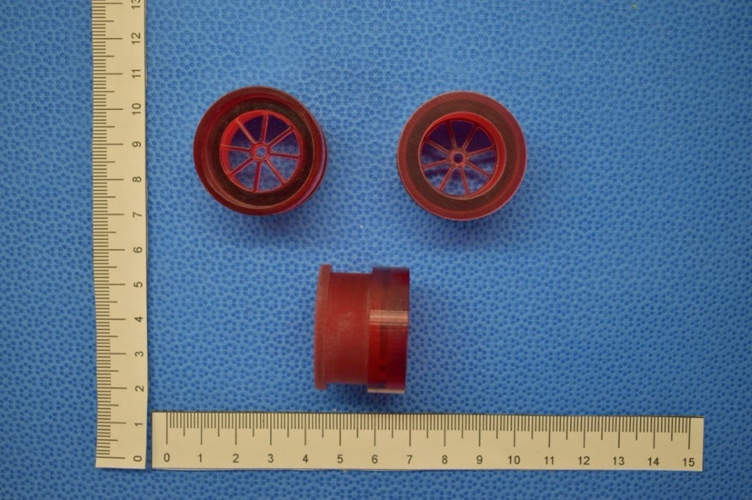
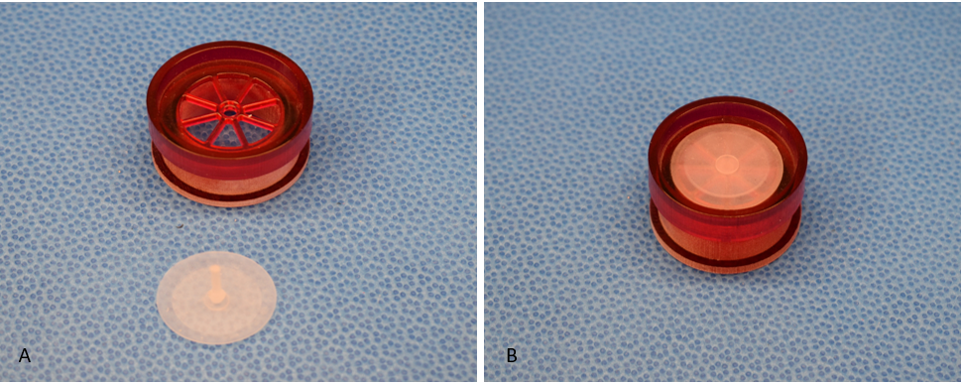
Figure S5. The inspiratory valves component are shown.

a) Different prospective of the inspiratory valve
b) Inspiratory valve components unassembled
c) The assembled exhalation port

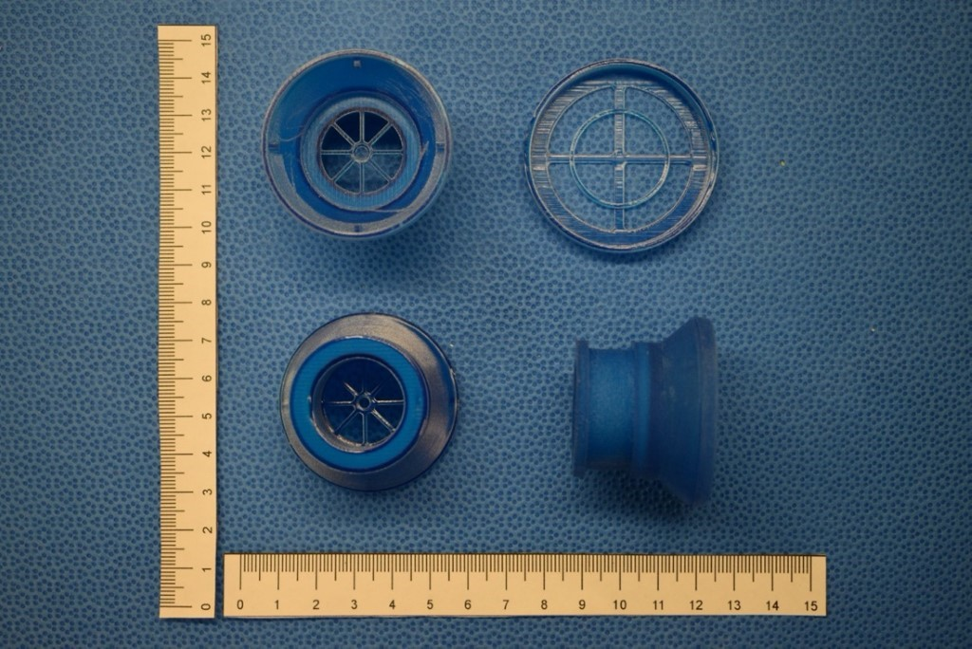
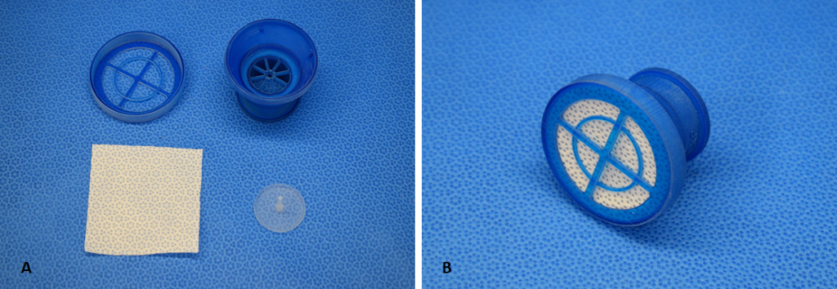

Figure S6. The exhalation valve is representing
a) Different prospective of the expiratory valve
b) depicts the expiratory port components unassembled with the single layer of Halyard 100.
c) shows the assembled exhalation port

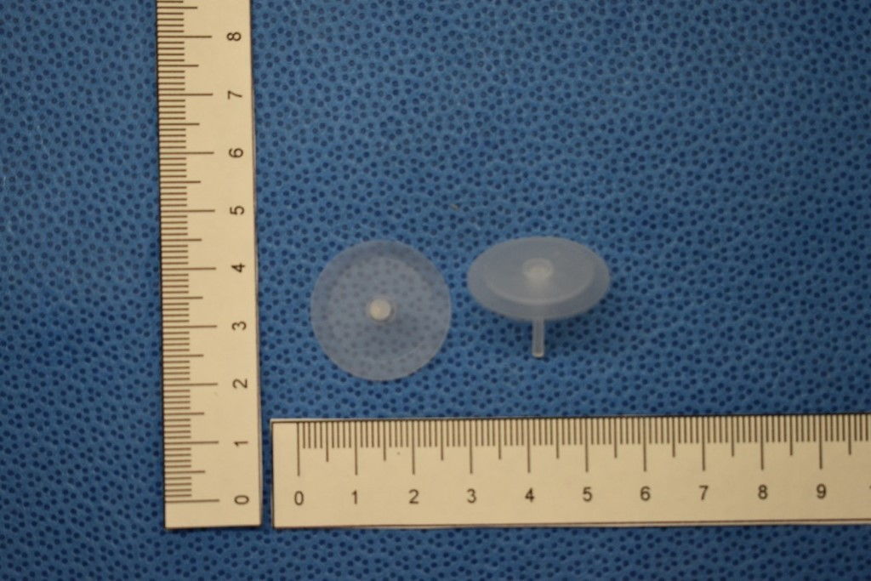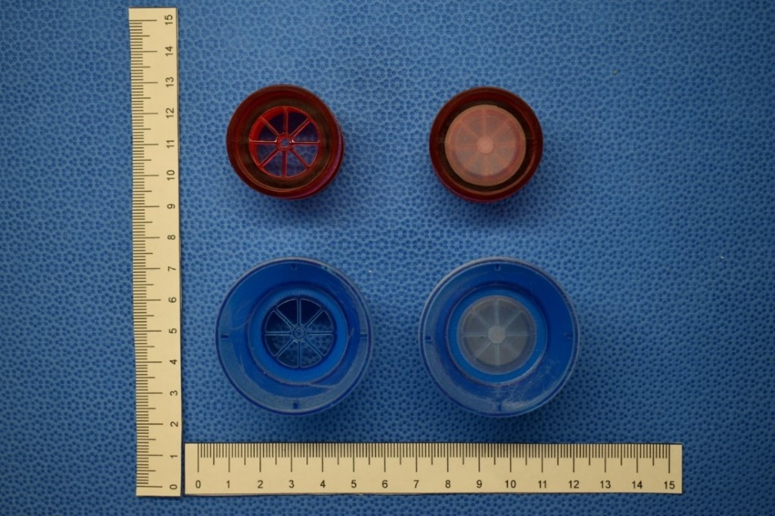

Figure S7. The silicone mushroom shaped valve leaflets used in the expiratory and inspiratory valve seats.

- Mushroom shaped, medical grade silicone leaflet.
- Medical grade silicone leaflet on the expiratory and inspiration port
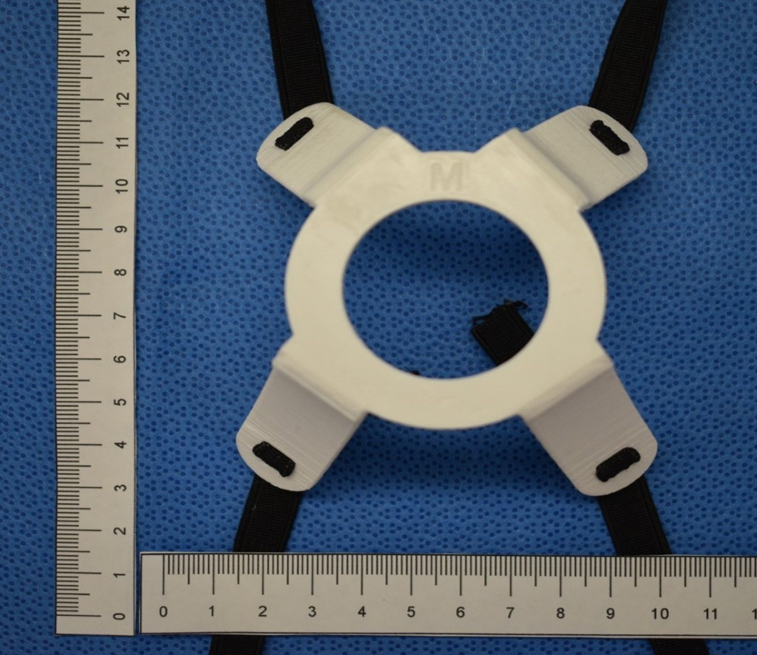

Figure S8. 3D printed 4-pronged harness is shown with two elastic straps.

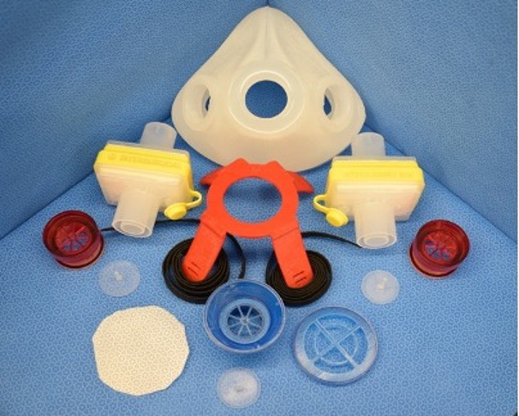

Figure S9. Duo Half face respiratory all components shown unassembled.

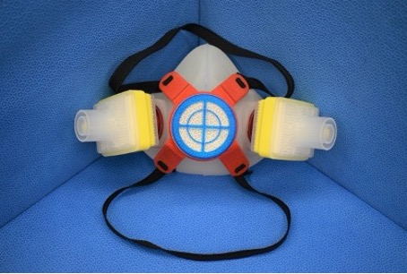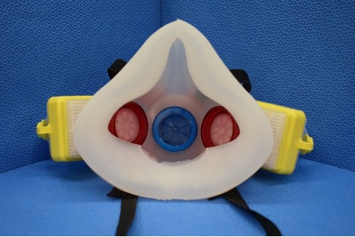

Figure S10. A fully assembled reusable, silicone, valved respirator (Duo).

a) depicts the anterior view of the Duo demonstrating two pleated cartridge filter
b) depicts the internal view of the Duo demonstrating two inspiratory ports (red) and expiratory port (blue).

Disclaimer: Advanced Perioperative Imaging Lab (APIL) and/or any of its affiliates do not make any endorsements for the use of products described above. The Duo respirator has not gone through regulatory approval from any applicable agencies. Users of the Duo are advised to carefully test and seek regulatory approval for the device prior to use. If the Duo is made in house for use in healthcare settings, users must be fit tested to ensure the respirator meets regulatory standards (CSA Z94.4 or similar). It is advised that users be quantitatively fit tested using an Accufit or Portacount respirator fit tester.

