Mechanistic insight into DsyB/DSYB, key enzymes in marine dimethylsulfoniopropionate synthesis
Supplementary materials:

Fig. S1. DsyB activation by Labrenzia aggregata dsyB⁻ extracts. L. aggregata dsyB⁻ strain J571 cell lysates were heat-killed and separated from protein on a PD10 column. 50μL of 10 x 1 ml fractions from the PD10 column were added to 5mM of pure R. denitrificans DsyB protein and assayed for MTHB S-methyltransferase activity detected as DMSHB by GC. No DMSHB was detected in the absence of DsyB protein with any fraction.

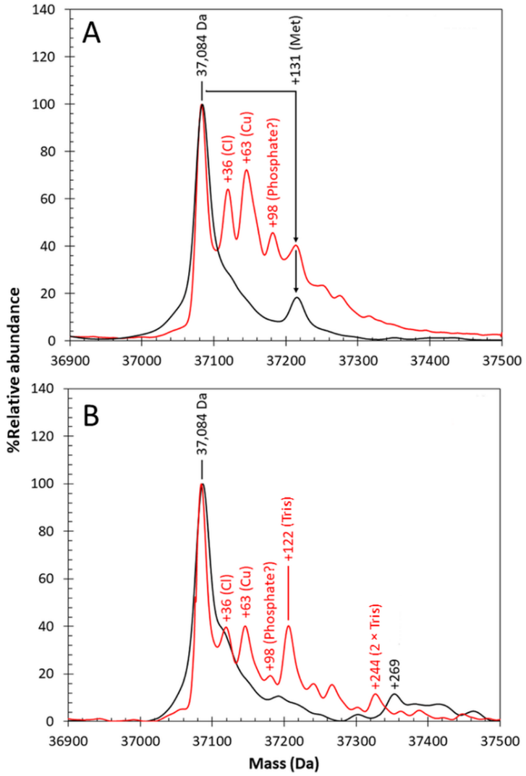
Fig. S2. Mass spectrometric analyses of DsyB. (A) Deconvoluted LC-MS spectrum of as-isolated DsyB (~10 μM) in 25 mM Tris, 100 mM NaCl pH 8 (black line), and deconvoluted non-denaturing spectrum of as-isolated DsyB (~20 μM) in 250 mM ammonium acetate pH8.0 buffer (red line). The partial cleavage of the N-terminal Met residue is indicated by the observation of two protein peaks separated by the mass of a single Met residue (131 Da). (B) As in (A) but DsyB was pre-activated by addition of lysate from L. aggregata dsyB deletion strain. The mass of the main protein peak is indicated and adduct species are labelled with the additional mass and origin (if known). The DsyB sample used for experiments reported in (B) was different to that of (A), with a more extensive degree of N-terminal Met cleavage; hence, the +131 Da peak is less well resolved.
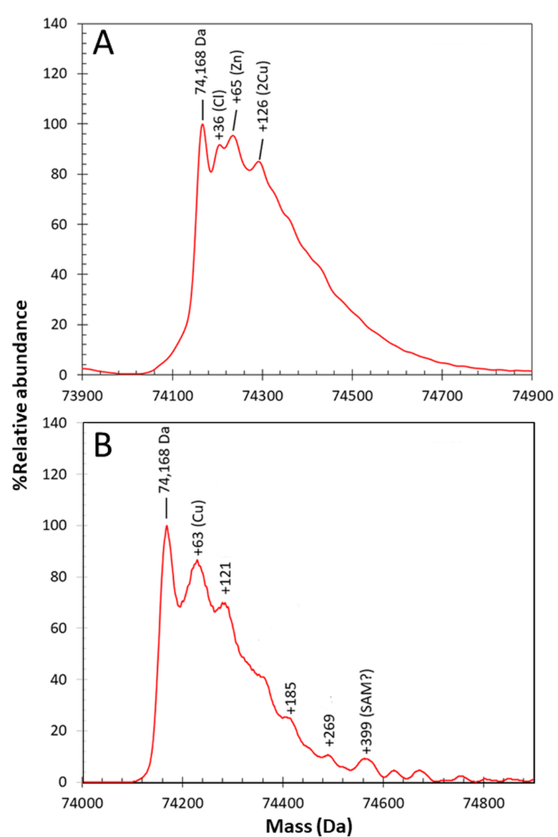
Fig. S3. Mass spectrometric analyses of dimeric DsyB under non-denaturing conditions. (A) Deconvoluted non-denaturing mass spectrum of as-isolated DsyB (~20 μM) in 250 mM ammonium acetate pH 8.0 buffer. (B) As in (A) but DsyB was pre-activated by addition of lysate from L. aggregata dsyB deletion strain. The mass of the main DsyB dimer peak is indicated and adduct species are labelled with the additional mass and origin (if known).

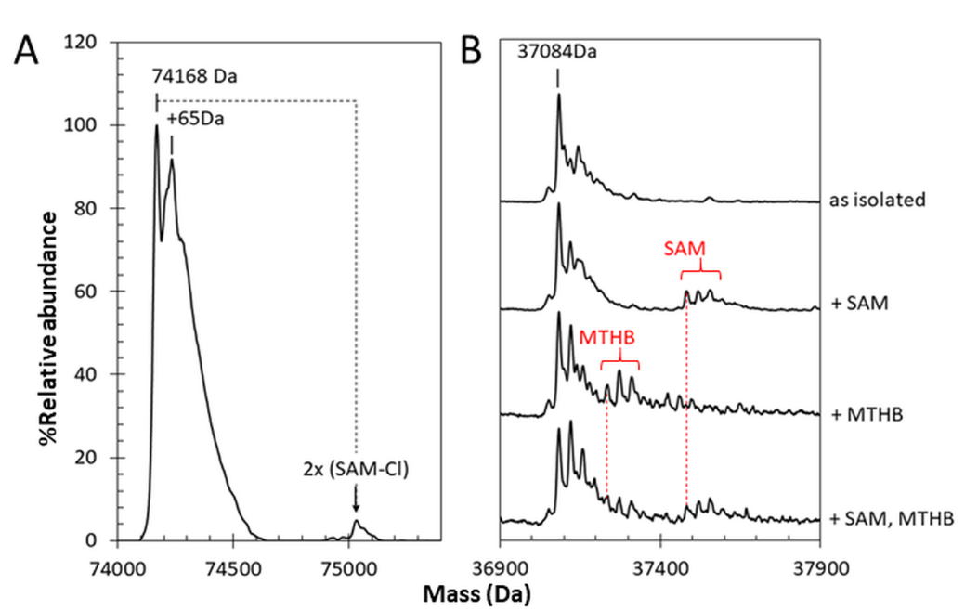
Fig. S4. Substrate binding to DsyB probed by mass spectrometry. Deconvoluted mass spectra of DsyB under non-denaturing conditions in the presence of SAM and MTHB. (A) Peaks due to a DsyB dimer, metal (+65 Da) and (SAM-Cl)₂ adducts are indicated. (B) The DsyB monomer and adducts due to SAM and MTHB are as indicated. Presence of both SAM and MTHB leads to reduction in substrate adduct peaks.

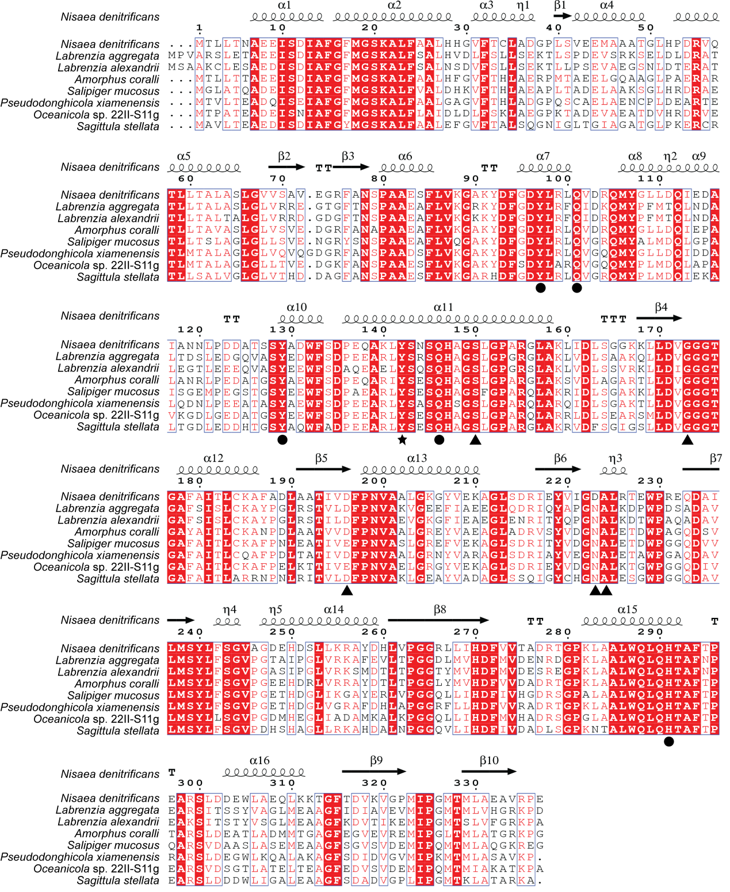
Fig. S5. Sequence alignment of bacterial DsyB proteins. Nisaea denitrificans belongs to the order Rhodospirillales, Amorphus coralli belongs to Rhizobiales, and the other strains are Rhodobacterales. Black dots indicate residues involved in MTHB binding, black triangles indicate residues involved in SAM binding, and residue Tyr142 is marked by a black star.

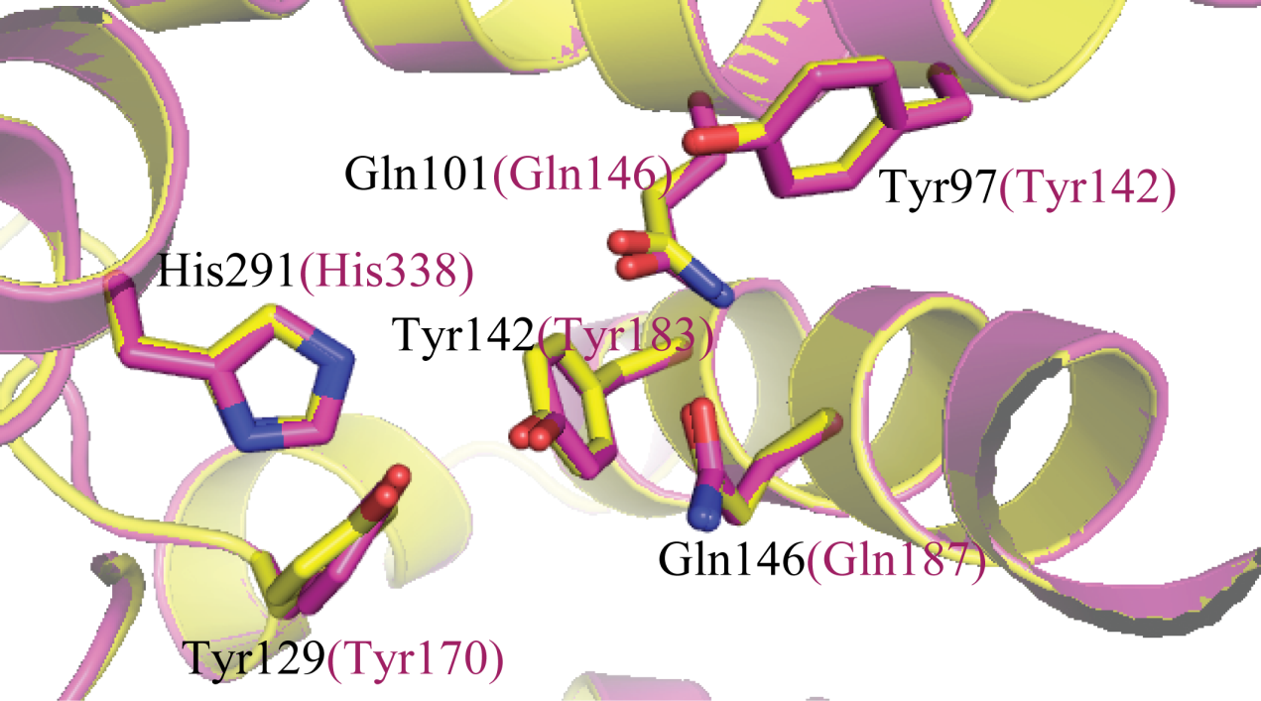
Fig. S6. Structural alignment of DsyB from N. denitrificans (yellow) and DSYB from Chrysochromulina tobin CCMP291 (purple). The structure of DSYB was modelled using SWISS-MODEL (https://swissmodel.expasy.org/). Residues involved in binding MTHB and catalysis from DsyB and from DSYB are labelled in black and purple, respectively.

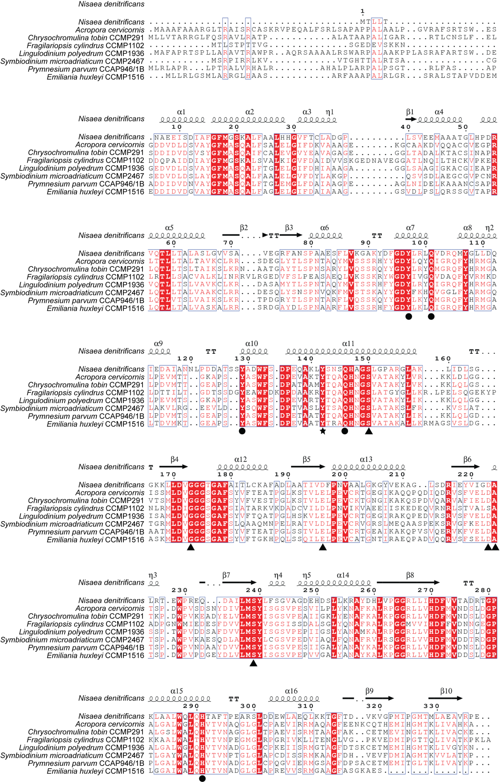
Fig. S7. Sequence alignment of DsyB and eukaryotic DSYB proteins. Black dots indicate residues involved in MTHB binding, black triangles indicate residues involved in SAM binding, and residue Tyr142 is marked by a black star.

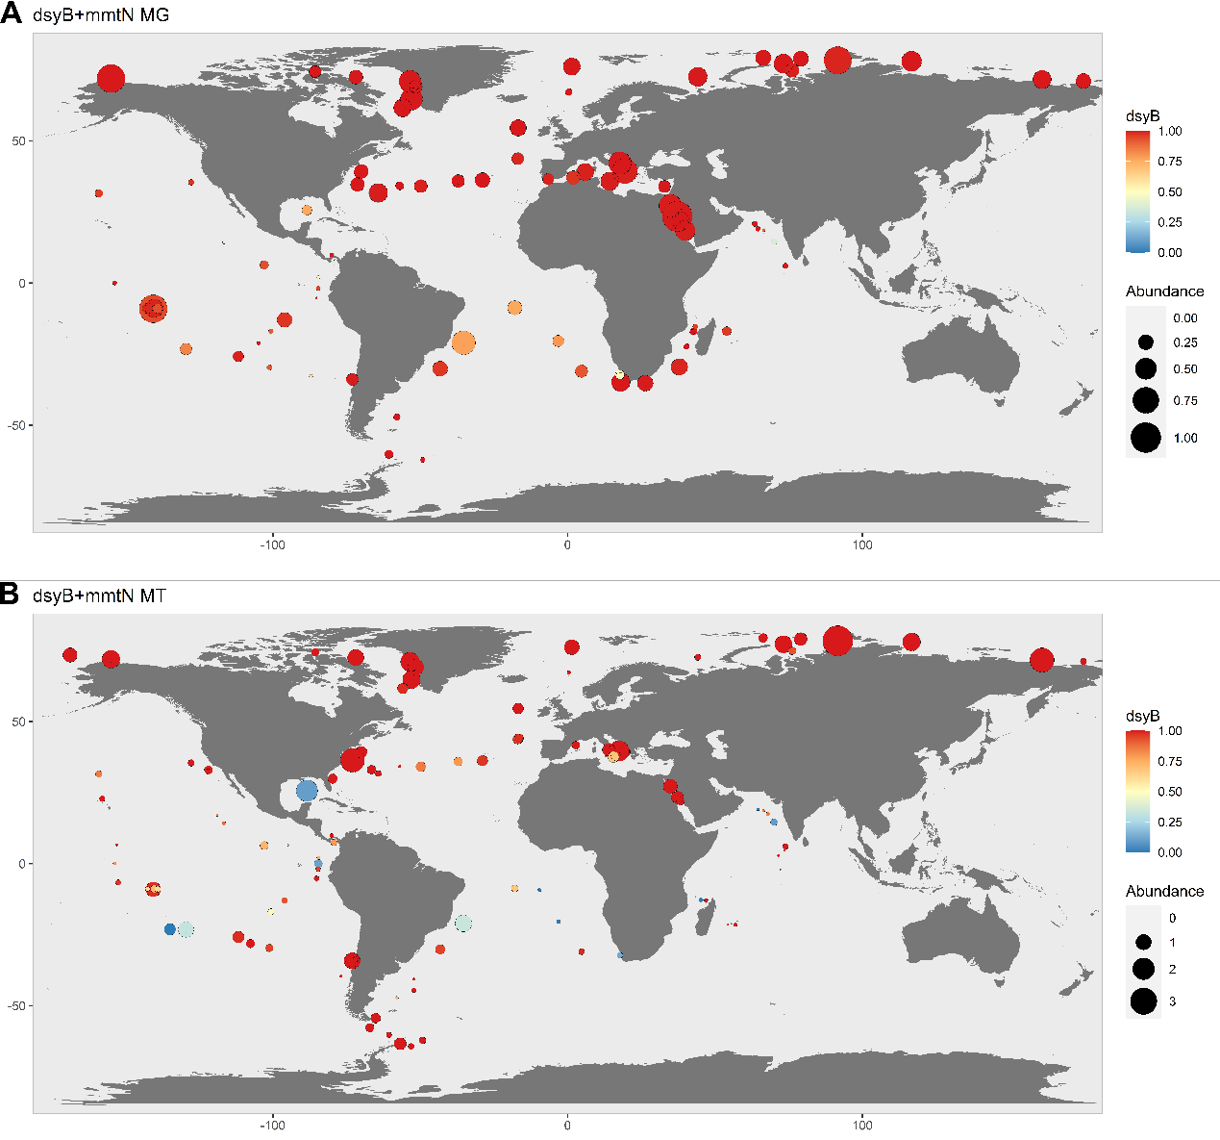

Fig. S8 Bubble plot of global distribution of dsyB/mmtN in ocean metagenomes (A) and metatranscriptomes (B). The sum of the average abundances of dsyB and mmtN across all depths as a percentage of the median of 10 single copy marker genes are shown by the bubbles. The colour bar indicates the relative abundance of dsyB:mmtN with red indicating 100% dsyB and blue indicating 100% mmtN.

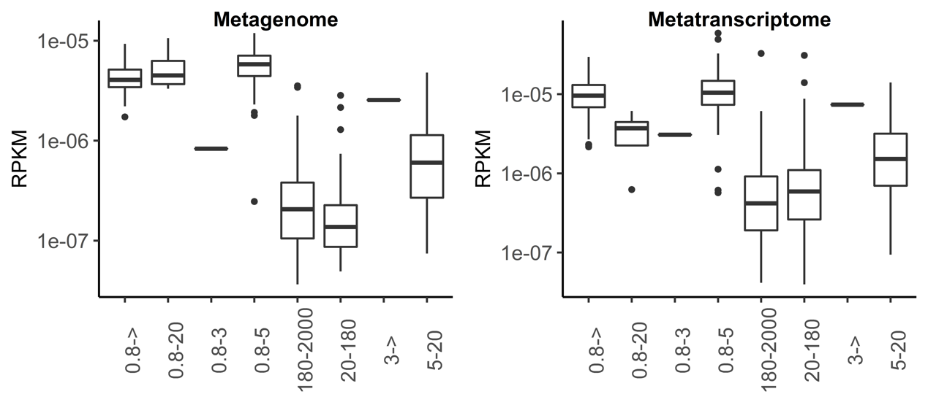
Fig. S9. DSYB abundance (reads per kilobase per million mapped reads) by filter fraction size in the metagenome and metatranscriptome databases.

Table S1. Crystallographic data collection and refinement
Parameters | DsyB-SAM complex  Se derivative | DsyB-SAM complex | DsyB-SAH-MTHB  complex
Diffraction data
Space group | P2₁2₁2₁ | P2₁2₁2₁ | P2₁
Unit cell
a, b, c (Å) | 75.6, 114.9, 152.6 | 76.5, 115.9, 153.1 | 88.1, 69.3, 104.3
α, β, γ (°) | 90.0, 90.0, 90.0 | 90.0, 90.0, 90. 0 | 90.0, 92.2, 90.0
Resolution range (Å) | 50.0-2.7 (2.8-2.7) * | 50.0-2.4 (2.49-2.40) | 50.0-2.4 (2.49-2.40)
Redundancy | 26.2 (25.3) | 6.8 (7.0) | 3.7 (3.7)
Completeness (%) | 100.0 (100.0) | 99.9 (100.0) | 99.7 (99.7)
R_{merge}** | 0.2 (0.4) | 0.1 (0.5) | 0.1 (0.5)
I/σI | 37.8 (9.9) | 42.5 (6.9) | 24.0 (4.1)
Refinement statistics
R-factor |  | 0.19 | 0.19
Free R-factor |  | 0.25 | 0.27
RMSD from ideal geometry
Bond lengths (Å) |  | 0.008 | 0.008
Bond angles (°) |  | 1.16 | 1.13
Ramachandran plot (%)
Favoured |  | 93.7 | 95.9
Allowed |  | 6.2 | 4.1
Outliers |  | 0.1 | 0
Overall B-factors (Å²) |  | 46.9 | 43.0
*Numbers in parentheses refer to data in the highest resolution shell.
** R_{merge}=∑_{hkl}∑_{i}|I(hkl)_{i} -<I(hkl)>|/∑_{hkl}∑_{i}I(hkl)_{i}, where I is the observed intensity, <I(hkl)> represents the average intensity, and I(hkl)_{i} represents the observed intensity of each unique reflection.

Table S5. Strains and Plasmids used in this study.

Strain/Plasmid | Description | Reference
Escherichia coli BL21 (DE3) | Strain used for DsyB expression for protein purification | New England BioLabs.
Rhizobium leguminosarium J391 | Streptomycin resistant derivative of wild type strain 3841 used for the expression of genes cloned in plasmid pLMB509 | Young et al. (2006)
Labrenzia aggregata J571 | Labrenzia aggregata LZB033 with mutation in dsyB gene. | Curson et al. (2017)
Nisea denitrificans DR41_21 | Wild type strain DSM 18348 | DSMZ, Leibniz Institute, Germany.
pLMB509 | Plasmid vector for taurine inducible expression of cloned genes in J391 and J571. | Tett et al. (2012)
pRK2013 | helper plasmid used in triparental mating | Figuski and Helinski. (1979)
SNP-1304 | Nisaea denitrificans DR41_21 dsyB gene coned into pLMB509 | this study
SNP-1305 | derivative of SNP-1304 with Y97A mutation | this study
SNP-1306 | derivative of SNP-1304 with Q101A mutation | this study
SNP-1307 | derivative of SNP-1304 with Y129A mutation | this study
SNP-1308 | derivative of SNP-1304 with Y142A mutation | this study
SNP-1309 | derivative of SNP-1304 with Q146A mutation | this study
SNP-1310 | derivative of SNP-1304 with H291A mutation | this study

Table S6. Primers used in this study.

Primers | Sequence (5’-3’) | Purpose
DsyB-F | GGAATTCCATATGACGTTGCTGACAAACGCC | Amplification of the genomic dsyB gene
DsyB-R | CCGCTCGAGCTCCGGCCGCACGGCCTCG
Y97A-F | AATACGATTTCGGCGACGCTCTGCGTCTGCAGGTGG | Construction of the mutant Tyr97Ala
Y97A-R | CCACCTGCAGACGCAGAGCGTCGCCGAAATCGTATT
Q101A-F | GACTATCTGCGTCTGGCGGTGGACCGGCAGAT | Construction of the mutant Gln101Ala
Q101A-R | ATCTGCCGGTCCACCGCCAGACGCAGATAGTC
Y129A-F | GATGCCACCAGCTCCGCCGCCGACTGGTTCTC | Construction of the mutant Tyr129Ala
Y129A-R | GAGAACCAGTCGGCGGCGGAGCTGGTGGCATC
Y142A-F | CGGAACAGGCAAAGCTCGCTTCCAACAGCCAGCATG | Construction of the mutant Tyr142Ala
Y142A-R | CATGCTGGCTGTTGGAAGCGAGCTTTGCCTGTTCCG
Q146A-F | CTCTATTCCAACAGCGCGCATGCCGGCTCCCT | Construction of the mutant Gln146Ala
Q146A-R | AGGGAGCCGGCATGCGCGCTGTTGGAATAGAG
H291A-F | CTGGCAGCTCCAGGCCACCGCCTTCACG | Construction of the mutant His291Ala
H291A-R | CGTGAAGGCGGTGGCCTGGAGCTGCCAG
N.d dsyBF  N.d dsyBR  N.d gyrBF  N.d gyrBF  N.d recAF  N.d recAF | GGGTCTAAGGCGTTATTTG  CAGTCGGCGTAGGAGC  CTATCACGAAAACACGCTC  GCTTCATACGCCTTGGA  AGAATGGCGGCACTTG  CTAGGCAGCGAGACTTTG | For RT-qPCR

