Supplementary Materials & Methods, Tables and Figures

Cancer testis antigen expression in hepatocellular carcinoma and paired tumor-free liver tissue

Lisanne Noordam¹, Zhouhong Ge¹, Hadiye Özturk¹, Michail Doukas², Shanta Mancham¹, Patrick P.C. Boor¹, Lucia Campos Carrascosa¹, Guoying Zhou¹, Thierry P.P. van den Bosch², Qiuwei Pan¹, Jan N.M. IJzermans³, Marco J. Bruno¹, Dave Sprengers¹, Jaap Kwekkeboom¹
¹Department of Gastroenterology and Hepatology, Erasmus MC-University Medical Center, Rotterdam, the Netherlands. ²Department of Pathology, Erasmus MC-University Medical Center, Rotterdam, the Netherlands. ³Department of Surgery, Erasmus MC-University Medical Center

Materials & Methods
Liver and healthy tissue samples
Cirrhotic and healthy (liver) tissues
Freshly frozen healthy liver tissues (n=21) were obtained during liver transplantation from donor liver grafts at the end of cold ischemic storage. Archived freshly frozen tissue samples of non-cancerous cirrhotic livers (n=35) were retrieved from the tissue bank of the Department of Pathology, Erasmus Medical Center Rotterdam. The non-cancerous cirrhotic liver tissues had been retrieved from patients who underwent liver transplantation for liver cirrhosis in our center between May 2007 and June 2017. The etiology of the cirrhosis was determined by information from medical records, laboratory tests and pathological examination of the explanted livers. Cirrhotic livers with malignancies, diagnosed by pathological examination, were excluded.
RNA isolated from fresh frozen healthy adrenal gland (R1234004-50), artery (HR-810), brain (R1234035-50), colon (R1234090-50), heart (R1234122-50), lung (R1234152-50), muscle (R1234171-50), ovary (HR-406), pancreas (R1234188-50), skin (R1234218-50), small intestine (R1234226-50), stomach (HR-302), testis (R1234260-50), throat (R1234263-10), thymus (HR-702), thyroid (R1234265-50), trachea (R1234160-50), urinary bladder (R1234010-50) and uterus (R1234274-50) tissues were purchased from AMS Biotechnology Ltd, Abingdon, UK. Bone marrow derived from a healthy donor (Department of Hematology, Erasmus MC), healthy kidney tissue obtained from a donor kidney (Department of Internal Medicine, Erasmus MC) and RNA of healthy testis tissues (Department of Pathology, Erasmus MC) were kindly provided. Lymph node and spleen tissues were collected from samples retrieved during liver transplantation in our center in September 2019.
Quantitative real-time PCR
RNA was isolated using the NucleoSpin® RNA isolation kit of Macherey-Nagel (Dueren, Germany) according to manufacturer’s instructions. RNA (4 ug) was reverse-transcribed into cDNA using PrimeScript™ RT master Mix (Perfect Real Time, Takara, cat# RR036A), according to the manufacturer’s instructions. RT-qPCR was performed using SYBR™ Green PCR Master Mix (ThermoFisher) in a StepOnePlus™ Real-Time PCR System (Applied Biosystems), using 12.5 ng cDNA per reaction, with the following conditions: 50°C for 2 minutes, 95°C for 2 minutes, then 38 cycles of 95°C for 15 seconds, 58-62°C for 15 seconds (according to the Tm of the primers), 72°C for 1 minute, and then finally for the Melt Curve stage 95°C for 15 seconds, 60°C for 1 minute and a 0.7°C step-wise increase until 95°C was reached. All Ct-values over 35 were considered negative. The level of target gene expression relative to the geometric mean of three control genes (HPRT1, GUSB, PMM1)² was calculated by 2^{-ΔΔT} method, after which a cut-off of 0.001 was used to define expression. All amplifications were performed in at least two technical repeats. Means of technical replicates were used for analysis. Primers were designed with Primer Blast (NCBI), efficiency was determined by dilution of cDNA and product length was determined by gel electrophoresis.
Immunohistochemistry
The FFPE blocks of the HCC and TFL tissues were examined by a pathologist (MD) to mark tumor and tumor-free liver tissues. A TMA Grand Master (2.5; 3D Histech) was used to create tissue microarrays (TMA). Three tissue cores of 1 mm were taken of each tissue and placed in a recipient formalin block. Immunohistochemistry (IHC) was performed using an automated, validated and accredited staining system (Ventana Benchmark ULTRA, Ventana Medical Systems, Tucsen, AZ, USA) using the optiview universal DAB detection Kit (cat.760-700, Ventana Medical Systems). In brief, following deparaffinization and heat-induced antigen retrieval tissue sections were incubated with each of the primary antibodies according to their optimized incubation time and concentration (Supplementary Table S2). The antibodies were titrated using testis as a positive control tissue and placenta and spleen as negative control tissues. Incubation was followed by hematoxylin II counter stain for 12 minutes and then a blue colouring reagent for 8 minutes according to the manufacturer’s instructions (Ventana Medical Systems, Tucsen, AZ, USA). The stained TMAs were then scanned using a Nanozoomer (Hamamatsu), and analyzed using NDP.view2 software (Hamamatsu).

Search query:
(("cancer testis antigen"[All Fields] OR ((("cancer"[All Fields] OR "neoplas*"[All Fields]) AND ("testis"[All Fields] OR "testes"[All Fields]) AND ("Antigens, Neoplasm"[Majr] OR "antigen*"[All Fields] OR "Ags"[All Fields] OR "ag"[All Fields] OR "gene"[All Fields] OR "genes"[All Fields] OR "antigen*"[All Fields])))) AND (("Carcinoma, Hepatocellular"[Majr]) OR "Fibrolamellar hepatocellular carcinoma" [Supplementary Concept] OR "liver cell carcinoma"[All Fields] OR "liver cancer"[All Fields] OR "hepatocellular carcinoma cell line"[All Fields] OR (("liver"[All Fields] OR "hepat*"[All Fields]) AND ("carcinoma*"[All Fields] OR "ca"[All Fields] OR "cas"[All Fields] OR "cancer*"[All Fields])) OR "hepatocarcinom*"[All Fields])) AND "Humans"[Mesh]

Pubmed search 04-10-2018

Supplementary Table S1. Primer sequences and annealing temperatures (Tm) used for RT-qPCR.
Primer | Tm | Forward Primer | Reverse Primer | Product Length
CAGE1 | 60 | TCATCCGAAGTCCATGACCA | GACTCTTCCTGGAGTGGTTG | 118
CBLL2 | 62 | TTCCACCAGAACAGCACACC | AACGGTTTCCCACTGGATGG | 146
CCDC83 | 60 | AGGAGGGCAGGCCTTTTTAATC | TCCATTGTGCTGGTTAGCTATGA | 148
CPXCR1 | 60 | CAGCCAGTCATACTATCCTC | CTACAGTCATTAGGAGGCTC | 118
CSAG2/3 | 58 | GGAGTGGGCCAACACTATCC | GGCTGTCCGAAGAGAGACTG | 123
CT45 | 62 | ATGCACATCACTCCCAGGTG | TTGTTTCCTTGCTGGAGGAGA | 147
CT47A1 | 60 | ACCTAGACGCAGCAGAGGT | AACTTGAACACTGTCACATACATCC | 141
CTAG1A/B | 60 | GGCTTCAGGGCTGAATGGA | TGTTGCCGGACACAGTGAAC | 191
Cxorf48 | 60 | CTGGCAACGTGCCTCTAAAAG | AAGATGGCGAGGCACAACAT | 110
DDX53 | 60 | GTTGGTGTGGTCATTGGTTAC | CGCTTTGGCCTTTGCTTTCAT | 144
DPPA2 | 62 | CAATCTCCTTCCATCCCAGGGT | ACCAGTGTCAAAATCACACTTTCC | 118
DUSP21 | 62 | TTGTCAATGCCTCGGTGGAA | CGAGTCACGAGCATCGGTAA | 86
FAM46D | 60 | AGCCTTAACGGATGAAGGAAAA | AAACTCCAGCTAGTGAAACTCC | 92
FATE1 | 62 | ATGGAGCTTGGATCTCGGTC | CTCAGCATTCTGGGCTTTGG | 155
FBXO39 | 60 | TGATAGATCTCCTGCCCACCT | CTCGTCGAGTGACTCATGGTT | 83
FMR1NB | 60 | TCCTGCTGTTCGTGTGCTAC | TCAGCAAAGCTTCCAATGCG | 147
FTHL17 | 60 | ATCAACAGCCACATCACGCT | CATTTTGTCGTCCGACAGGC | 132
GAGE1 | 60 | ACCTGAGTCATCTTAAAACATGTGA | AGTAAACATGAAGCAGAGTGCC | 80
GPC3 | 60 | AACCATGTCTATGCCCAAAGGT | CCAGAGCCTCCAATGCACTC | 108
GUSB | 58 | CAGGTGATGGAAGAAGTGG | GTTGCTCACAAGGTCACAG | 171
HORMAD1 | 60 | CAACGAATCTAGCATGTTGTC | CACAATCACCATCCTTAAAACC | 188
HPRT1 | 58 | GCTATAAATTCTTTGCTGACCTGCTG | AATTACTTTTATGTCCCCTGTTGACTGG | 140
LUZP4 | 60 | CTTCGTTTCGGAAGCTAACGC | CTCCGATGGCGATGTCTATGA | 217
MAGEA1 | 60 | AGAAGCGAGGTTTCCATTCTGA | GGAATCCTGTCCTCTGGGTTG | 116
MAGEA2 | 62 | CTCCAGCTTCTCGACTACCATC | GACTCCAGGTCGGGAAACATTC | 148
MAGEA3 | 62 | ATCTTCAGCAAAGCTTCCAGT | GGTGGCAAAGATGTACAAGTGG | 93
MAGEA4 | 58 | GAGCTTCTGCGTCTGACTCG | TGTCTGCTCAGAACCTTGTCTC | 85
MAGEA8 | 60 | GGTCGGCTTGAGATCGGCT | CCTCAGCTTGACTGCTACTACTG | 150
MAGEA9B | 60 | GCTTGATACCGGTGGAGGAG | GGTTAGCCTGTCCCGAGAAC | 124
MAGEA10 | 62 | GAGATCGGCTGAAGAGAGCG | ACTCTTGTCAGATCCTGCGAC | 140
MAGEB1 | 60 | TGAAGTAGTGAGCAGCCAAGA | GCTGGCAGCACCAATAAATGT | 172
MAGEB2 | 58 | TCCTGACTTCCGCTTTGGAGGC | GCACGGAGCTTACTCTTCTGACC | 135
MAGEB3 | 60 | CTACCCAAACCTCTTCTCAGCC | AGACCCTGGATCCTCCCTCTA | 144
MAGEB6 | 62 | ACCCTTGTCAGCAAGCTAGG | GATCACAACCAGGAGCGACA | 99
MAGEC1 | 62 | GGCCATCTTGGGAGTCTGAA | TGGAGCACCTTGAAGACTGG | 106
MAGEC2 | 62 | GGAGTCAAGGCCTGTTGGAT | GGGAGGCATGACGACTTCTT | 84
PAGE1 | 62 | GGCTGAAGTTGTGAAATATGGGT | CTGCAGATGCTCCCTCATCC | 177
PAGE5 | 62 | TGATGTCAGGGAGGGGACTC | TGGTTTCAGTCTTCATTTGTCTTGG | 105
PASD1 | 62 | TGCAGAGGTTGAGCAGTATGG | GGATTCACCTCAGGCTCACC | 153
PLAC1 | 60 | ACACAGCAAGTTCCTTCTTCC | GAGGATTTCTTCTTCTGGCAGC | 118
PMM1 | 58 | CGAGTTCTCCGAACTGGAC | CTGTTTTCAGGGCTTCCAC | 86
RNF17 | 60 | GGACAATGCAGTGGTCCAAAG | AGGAGCACCAAGAGAATCGAA | 137
SAGE1 | 58 | CCTTAGCTGACTCTGGTGCTC | GACTCGTTTGAAGTGGAGAAGC | 150
SLCO6A1 | 62 | TGGCCTTGGGTGTAAGCTATG | ATCCAACAACGTCCTGTGTG | 136
SPANXA | 62 | ATGATGCCGGAGACCCCAAC | GTGGTCATTCAGCAGTTCCTCT | 144
SPANXC | 60 | CGCTACAGGAGGAACGTGAA | ATTCCTCCTCCTCCATTTGG | 100
SPANXN3 | 62 | ACCAGAATCATGGAACAGCCAA | TGTTTGGTACCTCTTGCATCTC | 106
SYCP1 | 62 | CTATCTGTGGACATCTGCCAA | TTGGTTTTGTTGGTGTCTTCAC | 80
TEKT5 | 62 | GGTCCATGACAACGTGGAGA | TGCTGAGCATCCCGGTTATC | 126
TFDP3 | 60 | TTGGAGGTGTGTTCACGACG | CTGAGATCCACCGGAGCTTG | 113
TPPP2 | 60 | GCAAAGTCAAGGCCAAGAACG | CTGGACTCTTCCCTTTGAAGC | 99
TSPY | 62 | ACAAGATTGCTGAGTCCCCTG | TCAACAACTGGGAGTCCCCT | 149
ZCCHC13 | 62 | TGCTACAACTGTGGGAGAAGC | TGACGATCACAGTCACGAGC | 122

Supplementary Table S2. Antibodies used for immunohistochemistry.
Antibody | Host Species | Dilution | Company | Clone | Lot number | Procedure | Ab incu-bation at 37˚C
PAGE1 | Rabbit | 1:1000 | Sigma-Aldrich | Polyclonal | R04065 | Optiview CC1 32' | 32 minutes
TSPY | Rabbit | 1:200 | Sigma-Aldrich | Polyclonal | R59337 | Optiview CC1 32' | 32 minutes
MAGEA9 | Mouse | 1:50 | Prof. Y. Fradet, Québec, Canada³ | 14A11 | N/A | Optiview CC1 32' | 32 minutes
MAGEC2 | Rabbit | 1:500 | Sigma-Aldrich | Polyclonal | A115364 | Optiview CC1 32' | 32 minutes
CT47A1 | Rabbit | 1:8000 | Sigma-Aldrich | Polyclonal | R39285 | Optiview CC1 32' | 32 minutes
MAGEA1 | Mouse | 1:50 | Santa Cruz | MA454 | B0507 | Optiview CC1 32' | 32 minutes
MAGEB2 | Rabbit | 1:500 | Sigma-Aldrich | Polyclonal | R109336 | Optiview CC1 32' | 32 minutes
SLCO6A1 | Rabbit | 1:200 | Sigma-Aldrich | Polyclonal | R72094 | Optiview CC1 32' | 32 minutes
MAGEC1 | Mouse | 1:3200 | Santa Cruz | CT7-33 | A1807 | Optiview CC1 32' | 32 minutes

Supplementary Table S3. Results of the literature search and overview of included articles.
Study | Gene(s) | Population | Detection method | Outcome
Wei Y, et al. Int J Oncol. 2018⁴ | MAGEA9 | HCC patients (n=90; China) | IHC | IHC: 40/90 (44%) MAGEA9+
Jiao Y, et al. PLoS One. 2017⁵ | TFDP3 | HCC cell line (HepG2) and normal human hepatocyte cell line (L-02) and HCC patients (China) | RT-qPCR and IHC | mRNA and IHC: HepG2 and L02 are both TFDP3+, expression is higher in HepG2. Also protein expression in HCC patients.
Liu, et al. Cancer Lett. 2017⁶ | CTCFL | HCC cell lines (HepG2, SMMC-7721, Huh7, HCCLM3, PLC/PRF/5), normal human hepatocyte cell lines (L-02 and WRL68) and HCC patients (n=25; China) | RT-qPCR and IHC | RT-qPCR: all cell lines positive, expression higher in HCC cell lines than normal human hepatocyte cell lines  IHC: 18/25 (72%) CTFCL^{high} and 7/25 (28%) CTCFL^{low}
Xie, et al. Drug target. 2017⁷ | TTK | Review | n.a. | Liu, Oncotarget 2015: 118/152 (77.63%) of HCC patients mRNA TTK+ – China
Charoentong, et al. Cell Rep. 2017¹ | BRDT, CAGE1, CCDC83, CPXCR1, CSAG2, CT45A1, DDX53, DPPA2, FMR1NB, FTHL17, GAGE1, LUZP4, MAGEA1, MAGEA2, MAGEA3, MAGEA4, MAGEA5, MAGEA9, FAM46D, MAGEB1, MAGEB2, MAGEB3, MAGEC1, PAGE1, PASD1, POTEA, POTEB, POTED, SLCO6A1, SPANXC, SPANXN3, SSX3, SSX5, SSX7, TSPY2, TSPY3, TSSK6, XAGE2, ZNF645, | The Cancer Genome Atlas (TCGA); including 363 HCC patients | RNA sequencing | Aforementioned genes are all correlated with CD4 and/or CD8 T cells in HCC
Kido, et al. J Genet Genomics. 2016⁸ | TSPY | TCGA and refers to Kido, et al. 2014 IHC: male HCC patients (n=287; TMA purchased from US Biomax) and RT-qPCR: male HCC patients (n=32; China) | TCGA: RNA seq  Kido, et al. 2014: RT-qPCR and IHC | This paper researches the TSPY co-expression network (TCN), which is activated in 30% of HCCs (TCGA).  Kido, et al. 2014: RT-qPCR: 15/32 (46.9%) TSPY+  IHC: 55/287 (19.2%) TSPY+
Fu, et al. Int J Clin Exp Pathol. 2015⁹ | ACRBP | HCC cell lines (Bel-7404¹, HepG2², QGY-7703³, QGY-7701⁴, BEL-7402⁵, SMMC-7721⁶) | RT-PCR¹⁻⁶, IHC^{1,2} and WB^{1,2} | RT-PCR: 6/6 cell lines  IHC: 2/2 cell lines  WB: 2/2 cell lines
Wang, et al. Int J Clin Exp Pathol. 2015¹⁰ | MAGEA3, MAGEA4, MAGEC2, NY-ESO-1 | HCC cell lines (LO2, HepG2, Hep3B, Huh7, SMMC-7721) and HCC patients (China; n=142) | RT-PCR and IHC | Cell lines: 4/5 cell lines for 4 TAAs.  HCC patients: 112/142 (78.9%) MA3+, 48/142 (33.8%) MA4+, 106/142 (74.6%) MC2+, 20/142 (14.1%) NY-ESO-1+. No expression in TFL.  IHC: 108/142 (76.1%) MA3+, 44/142 (31.0%) MA4+, 99/142 (69.7%) MC2+, 19/142 (13.4%) NY-ESO-1+
Sideras, et al. Br J Cancer. 2015¹¹ | MAGEA1, MAGEA3/4,  MAGEA10, MAGEC1, MAGEC2, NY-ESO-1, SSX2, SP17 | HCC patients (Netherlands; n=133) | IHC | 9.8% MAGEA1+, 3.0% MAGEA3/4+, 7.5% MAGEA10+, 17.3% MAGEC1+, 19.5% MAGEC2+, 3.8% NY-ESO-1+, 0% SSX2+, 87% SP17+. No expression in TFL, except SP17 (88.0%)
Melis, et al. J Transl Med. 2014¹² | NUF2, TTK, MAGEA3, CEP55 | HBV+ HCC patients (n=10; Italy) | RT-PCR | Expression of al 4 TAAs in 10 patients, both in HCC and TFL, but higher in HCC.
Li, et al. J Transl Med. 2014¹³ | TSPY | HCC cell lines (HepG2, SMMC7721, Huh7, MHCC97L, MHCC97H, HCCLM3) and HCC patients (n= 52;China) | RT-PCR | 6/6 cell lines and expression of TSPY in male HCC tissues, but not female HCC tissues
Deng, et al. Hepatology. 2014¹⁴ | DUSP21, CT45, ZCCHC13, MAGEA9, MAGEB6, PIHD3, PNMA5, MPC1L, IL13RA1 | HCC patients (n=24; China?) | RT-PCR | 8/24 (33.3%) DUSP21+, 7/24 (29.2%) CT45+, 4/24 (16.7%) ZCCHC13+, 3/24 (12.5%) MAGEA9+, 3/24 (12.5%) MAGEB6+, 4/24 (16.7%) PIHD3+, 6/24 (25%) PNMA5+, 6/24 (25%) MPC1L+, 1/24 (4.2%) IL13RA1+
Xia, et al. Int J Clin Exp Pathol. 2013¹⁵ | SP17, MAGEC1, NY-ESO-1 | HCC patients (n=45; China) | IHC | 16/45 (35.6%) MAGEC1+, 7/45 (15.6%) NY-ESO-1+, 36/45 (80%) SP17+
Zhou, et al. Oncol Rep. 2013¹⁶ | FAM9C | HCC cell lines (SSMC-7721, QGY-7703, BEL-7404, BEL-7405, YY-8103, Huh7) and HCC patients (n=46; China) | RT-qPCR and IHC | RT-qPCR: 25/46 HCC patients have upregulation of FAM9C in T compared to TFL  Cell lines: 2/6 FAM9C+  IHC showed nuclear staining (T>TFL)
Chen, et al. Genet Test Mol Biomarkers. 2013¹⁷ | CTCFL | HCC cel lines (SMMC-7721, BEL-7402, Huh7, HepG2) and HCC patients (n=105; China) | RT-PCR, IHC and WB | Cell lines: 3/4 CTCFL+ (RT-PCR and WB)  HCC patients: 58/105 (55.2%) CTCFL+ (IHC)
Song, et al. Oncol Rep. 2012¹⁸ | AKAP3, CTp11 | HCC cell lines (SNU-354, SNU-398, SNU-423, SNU-449, HepG2) and HCC patients (n= 10; Korea) | RT-PCR | 5/10 (50%) AKAP3+, 1/9 (11.1%) CTp11+
Li, et al. Bull Cancer. 2012¹⁹ – no full text | CABYR-c | HCC patients (n=20; China) | RT-PCR and WB | Both mRNA and protein expression are significantly higher in HCC compared to TFL
Yoon, et al. Tohoku J Exp Med. 2011²⁰ | RNF17 | HCC patients (n=28; Korea), CCA patients (n=5) and combined HCC-CCA (n=8) – Korea | RT-qPCR | 4/28 (14.3%) HCC RNF17+, 1/5 (20%) CCA RNF17+, 2/8 (25%) combined HCC/CCA RNF17+. No expression in TFL.
Tseng, et al. Oncol Rep. 2011²¹ | CABYR-a/b, CABYR-c/d, CABYR-e | HCC cell lines (HepG2, Huh7) and HCC patients (n=16; Taiwan) | RT-PCR and WB | Cell lines: 2/2 expressed CABYR-a/b and CABYR-c/d  HCC patients: 7/16 (43.8%) CABYR-a/b+, 14/16 (87.5%) CABYR-c/d+, 0/16 (0%) CABYR-e+
Wang, et al. Oncol Rep. 2009²¹ | NY-ESO-1, CTAG2, SSX1 | HCC patients (n=64; China) | RT-PCR | 19/64 (29.7%) NY-ESO-1+, 29/64 (45.3%) CTAG2+, 24/64 (37.5%) SSX1+
Riener, et al. Int J Cancer. 2009²² | MAGEA4, MAGEC1, MAGEC2, GAGE, NY-ESO-1 | HCC patients (n=146; Switzerland), CCA (n=50), GBC (n=32) | IHC | HCC: 0/146 (0%) MAGEA4+, 17/146 (12%) MAGEC1+, 50/146 (34%) MAGEC2+, 16/146 (11%) GAGE+, 3/146 (2%) NY-ESO-1+.  No expression in CCA.  GBC: 4/32 (13%) MAGEC2+, 1/32 (3%) GAGE+, 1 (3%) NY-ESO-1+, 0/32 MAGEC1/MAGEA4+
Lu, et al. Chin Med J. 2007²³ | NY-ESO-1, SSX1 | HCC patients (n=36; China) | RT-PCR | 4/36 (11.1%) NY-ESO-1+, 22/36 (61.1%) SSX1+
Wu, et al. Life Sci. 2006²⁴ | SSX2, SSX5 | HCC patients (n=36; China) | RT-PCR | 13/36 (36.1%) SSX2, 17/36 (47.2%) SSX5
Watanabe, et al. Cancer Sci. 2005²⁵ | IGSF11 | HCC cell line (Alexander, Huh7, HepG2, SNU475) | RT-PCR | HCC cell lines: 3/4 IGSF11+
Yin, et al. Br J Cancer. 2005²⁶ | TSPY | HCC cell lines (hep-hcc-1, hep-hcc-2, hep-hcc-HLE, Hep3B, COS7) and HCC patients (n= 57;China) | RT-PCR | 20/57 (35%) TSPY+
Shi, et al. Br J Cancer. 2005²⁷ | DDX53 | HCC patients (n=33; China) | RT-PCR | 13/33 (39.4%) DDX53+
Peng, et al. Cancer Lett. 2005²⁸ | MAGEA1, MAGEA3, MAGEA4, MAGEA10, SSX1, SSX2, SSX4, SSX5, NY-ESO-1, MAGEB1, MAGEB2, MAGEC1, MAGEC2, SYCP1 | HCC patients (n=73; China) | RT-PCR | 51/73 (69.9%) MAGEA1+, 35/73 (47.9%) MAGEA3+, 6/30 (20%) MAGEA4+, 11/30 (36.7%) MAGEA10+, 29/43 (67.4%) SSX1+, 26/73 (35.6%) SSX2+, 21/43 (48.8%) SSX4+, 13/43 (30.2%) SSX5+, 31/73 (42.5%) NY-ESO-1+, 13/25 (52%) MAGEB1+, 15/25 (60%) MAGEB2+, 12/25 (48%) MAGEC1+, 17/25 (68%) MAGEC2+, 10/30 (33.3%) SYCP1+
Sato, et al. Int J Oncol. 2005²⁹ – no full text | NY-ESO-1, CTAG2 | HCC patients – Japan | RT-PCR and IHC | IHC: 3/10 (30%) NY-ESO-1+ - all 10 samples expressed NY-ESO-1 mRNA  1/6 (16.7%) CTAG2+ - all 6 samples expressed CTAG2 mRNA
Yang, et al. Lab Invest. 2005³⁰ | FATE | HCC patients (n=35; China) | RT-PCR and IHC | RT-PCR: 10/15 (66%) FATE+  IHC: 7/35 (20%) FATE+
Dong, et al. Biochem Cell Biol. 2004³¹ – no full text | FATE | HCC patients (China) | RT-PCR | 25% of HCC samples FATE+
Dong, et al. Br J Cancer. 2004³² | ZNF165 | HCC patients (n=42; China) | RT-PCR | 22/42 (52%) ZNF165+
Zhao, et al. World J Gastroenterol. 2004³³ | MAGEA1, MAGEC2, SSX1, SPANXC | HCC patients (n=105; China) | RT-PCR | 79/105 (75.2%) MAGEA1+, 59/105 (56.2%) MAGEC2+, 76/105 (72.4%) SSX1+, 66/105 (62.9%) SPANXC+
Li, et al. Lab Invest. 2003³⁴ – no full text | MAGEC2 | HCC patients (n=70; China) | IHC | 26/70 (37.1%) MAGEC2+
Dong, et al. Br J Cancer. 2003³⁵ | FATE, TPTE | HCC patients (n=62; China) | RT-PCR | 41/62 (66%) FATE1+, 24/62 (39%) TPTE+
Luo, et al. Cancer Immun. 2002³⁶ | MAGEA1, MAGEA3, MAGEA4, GAGE, NY-ESO-1, SSX1, SSX2, SSX4, SYCP1, LUZP4 | HCC patients (n=21; China) | RT-PCR | 4/21 (19%) MAGEA1+, 5/21 (24%) MAGEA3+, 1/21 (4.8%) MAGEA4+, 8/21 (38%) GAGE+, 0/21 (0%) NY-ESO-1+, 8/21 (38%) SSX1+, 2/21 (9.5%) SSX2+, 2/21 (9.5%) SSX4+, 6/21 (29%) SYCP1+, 4/21 (19%) LUZP4+
Wang, et al. J Immunol. 2002³⁷ | MAGEC2, TFDP3 | HCC patients (n=20; China) | RT-PCR | 14/20 (70%) MAGEC2+, 5/17 (29.4%) TFDP3+
de Wit, et al. Int J Cancer. 2002³⁸ | DSCR8 | HCC cell lines (Hep3B, HepG2, PLC/RPF/5, Huh7) | RT-PCR | 1/4 cell lines DSCR8+
Ono, et al. Proc Natl Acad Sci U S A. 2001³⁹ | ACRBP | HCC patients (n=5; Japan) | RT-PCR | 2/5 (40%) ACRBP+
Chen, et al. Cancer Lett. 2001⁴⁰ | SSX1, SSX2, SSX4, SSX5, SYCP1, NY-ESO-1 | HCC patients (n=30; Taiwan) | RT-PCR | 24/30 (80%) SSX1+, 14/30 (46.7%) SSX2+, 22/30 (73.3%) SSX4+, 10/30 (33.3%) SSX5+, 2/30 (6.7%) SYCP1+, 11/30 (36.7%) NY-ESO-1+

Supplementary Table S4. Frequency table of healthy liver tissues (n=21) expressing mRNA of the CTAs. Colors correlate to the percentage of positive healthy liver tissues.
 | mRNA⁺ healthy liver (%) |  | mRNA⁺ healthy liver (%)
CAGE1 | 0.0 | MAGEA10 | 0.0
CBLL2 | 42.9 | MAGEB1 | 19.0
CCDC83 | 0.0 | MAGEB2 | 0.0
CPXCR1 | 0.0 | MAGEB3 | 28.6
CSAG2/3 | 85.7 | MAGEB6 | 28.6
CT45 | 14.3 | MAGEC1 | 4.8
CT47A1 | 0.0 | MAGEC2 | 0.0
Cxorf48 | 0.0 | NYESO1 | 0.0
DDX53 | 47.6 | PAGE1 | 0.0
DPPA2 | 0.0 | PAGE5 | 100.0
DUSP21 | 23.8 | PASD1 | 0.0
FAM46D | 0.0 | PLAC1 | 0.0
FATE1 | 33.3 | RNF17 | 4.8
FBXO39 | 100.0 | SAGE1 | 0.0
FMR1NB | 0.0 | SLCO6A1 | 0.0
FTHL17 | 42.9 | SPANXA | 66.7
GAGE1 | 23.8 | SPANXC | 38.1
HORMAD1 | 100.0 | SPANXN3 | 0.0
LUZP4 | 0.0 | SYCP1 | 47.6
MAGEA1 | 0.0 | TEKT5 | 100.0
MAGEA2 | 23.8 | TFDP3 | 33.3
MAGEA3 | 14.3 | TPPP2 | 100.0
MAGEA4 | 0.0 | TSPY | 0.0
MAGEA8 | 0.0 | ZCCHC13 | 38.1
MAGEA9 | 0.0

Supplementary Table S5. Expression of excluded CTAs in HCC patients and in cirrhotic liver tissues without malignancy.
 | mRNA-positive HCC (%)¹ | mean in mRNA-+ HCC  (range)² | Relative expression HCC  (compared to testis)³ | mRNA-positive TFL (%)⁴ | mean in mRNA-+ TFL (range)⁵ | Relative expression TFL  (compared to testis)⁶ | mRNA-positive cirrhotic tissue⁷
CCDC83 | 0.00 | #VALUE! |  | 0.00 | #VALUE! |  | 0
CPXCR1 | 2.02 | 0.001 (0.001-0.001) | 0.00378 | 0.00 | #VALUE! |  | 0
Cxorf48 | 8.25 | 0.157 (0.002-0.991) | 1.839 | 2.04 | 0.012 (0.001-0.023) | 0.139 | 2.9
DPPA2 | 1.03 | 0.135 (0.135-0.135) | 1.204 | 0.00 | #VALUE! |  | 0
FAM46D | 5.15 | 0.003 (0.002-0.004) | 0.058 | 0.00 | #VALUE! |  | 2.9
FMR1NB | 6.19 | 0.031 (0.002-0.124) | 0.022 | 1.02 | 0.088 (0.088-0.088) | 0.062 | 0
LUZP4 | 6.19 | 0.106 (0.001-0.49) | 0.242 | 1.02 | 0.279 (0.279-0.279) | 0.636 | 0
MAGEA4 | 6.19 | 0.803 (0.001-2.559) | 28.036 | 0.00 | #VALUE! |  | 0
MAGEA8 | 3.09 | 0.014 (0.004-0.022) | 5.115 | 0.00 | #VALUE! |  | 0
PASD1 | 2.02 | 0.017 (0.007-0.026) | 0.007 | 2.00 | 0.02 (0.019-0.021) | 0.009 | 0
PLAC1 | 4.12 | 0.014 (0.001-0.041) | 0.146 | 0.00 | #VALUE! |  | 0
RNF17 | 21.65 | 0.053 (0.001-0.507) | 0.04570 | 13.27 | 0.023 (0.002-0.134) | 0.01964 | 5.7
SAGE1 | 4.12 | 0.086 (0.008-0.15) | 0.505 | 3.06 | 0.19 (0.006-0.543) | 1.117 | 0
SPANXN3 | 1.01 | 0.004 (0.004-0.004) | 52.644 | 3.00 | 0.002 (0.001-0.003) | 27.174 | 0.0

¹Percentage of hepatocellular carcinomas (HCC) expressing mRNA of the excluded CTAs – meaning a Ct-value <35 and relative expression > 0.001 (n=100); ²Mean relative expression (relative to the geometric mean of the 3 household genes- GUSB, HPRT1, PMM1) level in HCCs expressing the CTA and range; ³Mean relative expression of the CTA in HCC expressing the CTA, relative to the relative mean expression in 3 testis tissues; ⁴Percentage of paired tumor-free liver tissues (TFL) expressing mRNA of the excluded CTAs (n=100); ⁵Mean relative expression level in TFLs expressing the CTA and range; ⁶Mean relative expression of the CTA in TFL expressing the CTA, relative to the relative mean expression in 3 testis tissues; ⁷Percentage of non-cancerous cirrhotic liver tissues expressing the CTA (n=35)

Supplementary Table S6. Patient characteristics of HCC-patients included in protein expression analysis.
Characteristic | HCC patients (n=76)
Age at surgery (years)
Mean ± SD | 60.4 ± 14.4
Median (range) | 64 (16-82)
Sex – no. (%)
Male | 47 (61.8)
Female | 29 (38.2)
Race – no. (%)
White | 64 (84.2)
African | 6 (7.9)
Asian | 5 (6.6)
Not reported | 1 (1.3)
Etiology – no. (%)
No known liver disease | 21 (27.6)
Alcohol | 17 (22.4)
Hepatitis B | 9 (11.8)
NASH | 8 (10.5)
Hepatitis C + Alcohol | 6 (7.9)
Hepatitis B + Alc/HepC/HepD/NASH | 6 (7.9)
Hepatitis C | 5 (6.6)
Fibrolamellar HCC | 3 (4.0)
Hemochromatosis + NASH | 1 (1.3)
Autoimmune hepatitis | -
Primary sclerosing cholangitis | -
Hepatitis status – no. (%)
Hepatitis B or C positive | 26 (34.2)
Chronic Hepatitis B | 15 (19.7)
Chronic Hepatitis C | 12 (15.8)
Cirrhosis – no. (%)
Yes | 23 (30.3)
No | 53 (69.7)
Tumor differentiation – no. (%)
Good | 8 (10.5)
Moderate | 41 (54.0)
Poor | 14 (18.4)
Unknown | 13 (17.1)
Vascular invasion – no. (%)
Yes | 40 (52.6)
No | 29 (38.2)
Unknown | 7 (9.2)
Number of lesions – no. (%)
1 | 40 (52.6)
>1 | 36 (47.4)
Median (range) | 1 (1-11)
Size of largest lesion (cm)
Mean ± SD | 7.4 ± 5.2
Median (range) | 6.1 (1-24)
AFP level before resection (ug/l)
Mean ± SD | 64965 ± 401956
Median (range) | 9.5 (2-3118700)

Supplementary Table S7. Cox regression analysis of HCC recurrence and HCC-specific survival based on CTA mRNA expression in HCC tumors
 | HCC recurrence |  | HCC survival
 | Univariate analysis |  | Univariate analysis
Variable | HR (95% CI) | p-value | HR (95% CI) | p-value
≥1 CTA in tumor | 1.8 (0.86-3.6) | 0.12 | 1 (0.41-2.6) | 0.94
≥2 CTAs in tumor | 1.1 (0.65-1.9) | 0.67 | 0.86 (0.39-1.9) | 0.7
≥3 CTAs in tumor | 1.1 (0.62-1.8) | 0.85 | 0.74 (0.34-1.6) | 0.47
Number of CTAs in tumor (numeric) | 1 (0.96-1.1) | 0.29 | 1 (0.87-1.1) | 1
>1 tumor | 1.2 (0.68-2) | 0.56 | 1.1 (0.49-2.4) | 0.83
>2 tumors | 2.6 (1.3-4.9) | 0.0042 | 1.8 (0.69-4.9) | 0.22
Cirrhosis | 1.6 (0.89-2.8) | 0.12 | 1.5 (0.66-3.4) | 0.33
Chronic viral hepatitis | 2.3 (1.3-4) | 0.0031 | 3.3 (1.5-7.2) | 0.0032
Vascular invasion | 1.3 (0.72-2.3) | 0.41 | 2.2 (0.96-4.9) | 0.063
Tumor > 5 cm | 1.3 (0.74-2.3) | 0.37 | 2.3 (0.9-5.7) | 0.081
AFP > 200 ug/l | 1.9 (1-3.4) | 0.034 | 2.7 (1.2-6) | 0.013
AFP > 400 ug/l | 2.4 (1.3-4.5) | 0.0051 | 3.3 (1.5-7.3) | 0.0038

Abbreviations: HR, hazard ratio; CI, confidence interval; CTA, cancer-testis antigen; AFP , alphafetoprotein

Supplementary Table S8. Cox regression analysis of HCC recurrence and HCC-specific survival based on CTA protein expression in TFL
 | Recurrence |  |  |  | HCC-specific survival
 | Univariate analysis |  | Multivariate analysis |  | Univariate analysis |  | Multivariate analysis
Variable | HR (95% CI) | p-value | HR (95% CI) | p-value | HR (95% CI) | p-value | HR (95% CI) | p-value
≥1 CTA in TFL | 1.9 (0.98-3.8) | 0.056 | 2.5 (1.2-5.0) | 0.01 | 3.5 (1.4-8.6) | 0.0071 | 5.0 (1.9-13.1) | 0.001
Number of CTAs in TFL (numeric) | 1.9 (1-3.6) | 0.035 |  |  | 3.5 (1.6-7.9) | 0.0024
>2 tumors | 3.3 (1.5-7.2) | 0.0028 | 2.5 (1.1-5.7) | 0.04 | 2.1 (0.69-6.4) | 0.19
Chronic viral hepatitis | 2.9 (1.5-5.6) | 0.0017 | 2.6 (1.3-5.4) | 0.009 | 3.4 (1.4-8.6) | 0.0081 | 4.8 (1.9-12.6) | 0.001
Vascular invasion | 1 (0.5-2.1) | 0.93 |  |  | 1.1 (0.43-2.6) | 0.89
Tumor > 5 cm | 1.1 (0.57-2.2) | 0.73 |  |  | 1.7 (0.65-4.5) | 0.28
AFP > 400 ug/l | 1.9 (0.92-4) | 0.083 |  |  | 2.4 (0.93-6.1) | 0.07

Abbreviations: HR, hazard ratio; CI, confidence interval; CTA, cancer-testis antigen; TFL, tumor-free liver; AFP , alphafetoprotein

Supplementary Figure S1. Number of CTAs co-expressed in HCC tumors and TFL, based on mRNA expression.
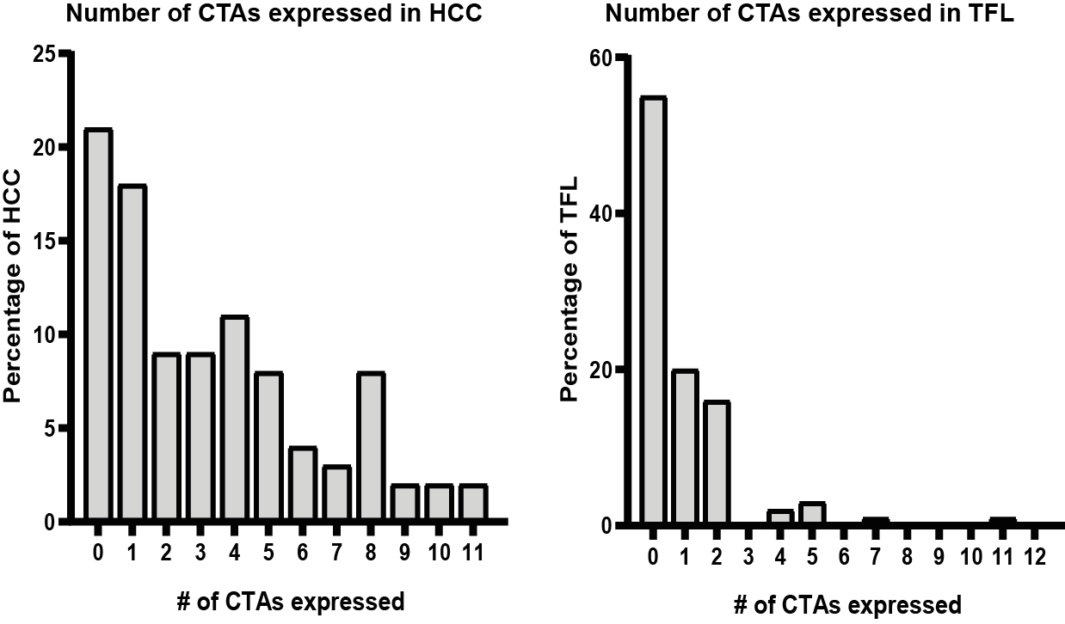

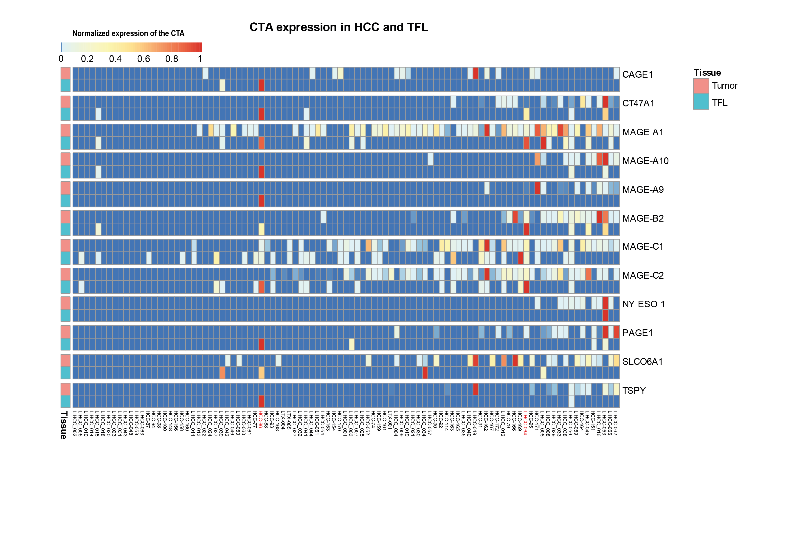Supplementary Figure S2

Supplementary Figure S2. Heatmap of CTA expression in HCC and TFL. Heatmap of mRNA expression of the 12 CTAs expressed in ≥ 10% of HCCs (rows), in HCC and TFL for every patient (columns). Patients were ordered by number of CTAs expressed in each individual tumor. The –ΔCt values were used and for normalization this data was scaled between 0 and 1 [((x-(min(x))/(max(x)-min(x)))]. Colors correspond to the value between 0 and 1 and patients LIHCC-064 and HCC-86 are highlighted in red. Heatmap was made in R, using the pheatmap package.

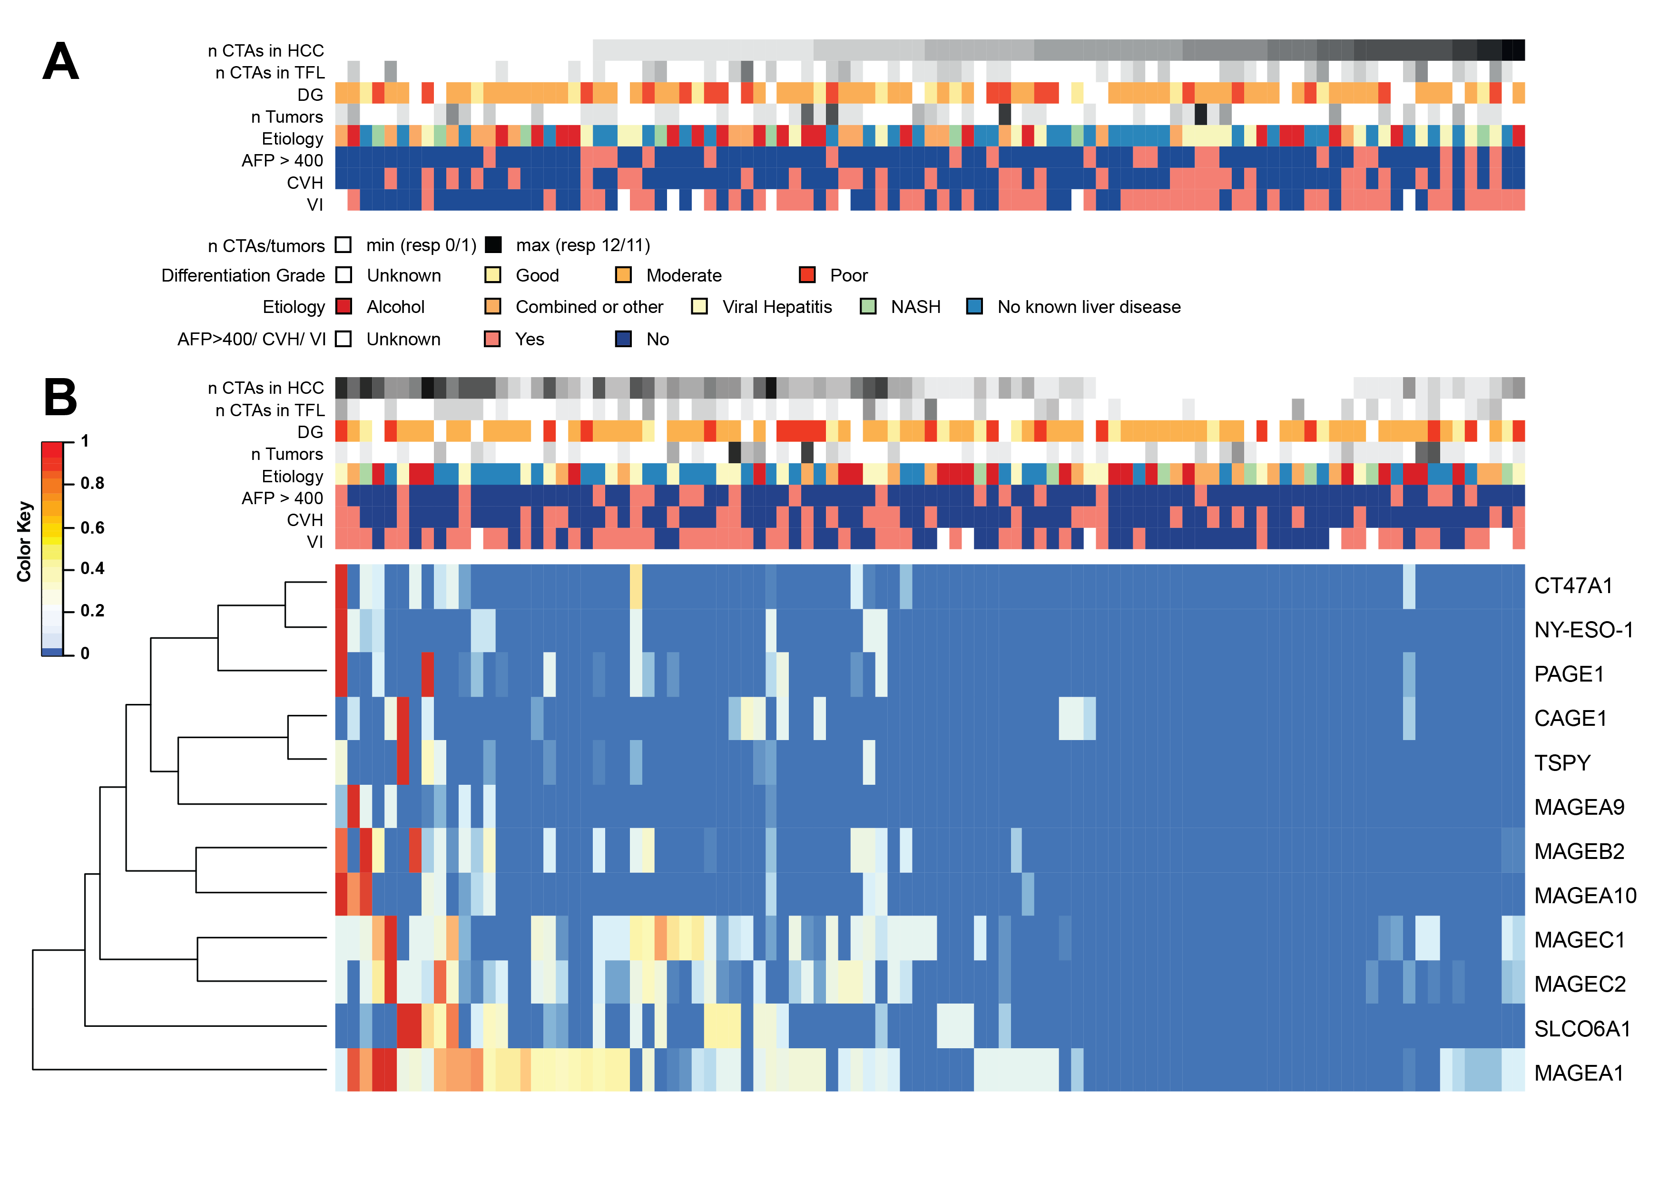
Supplementary Figure S3
Supplementary Figure S3. Hierarchical clustering of mRNA expression of the CTAs in tumors shows clustering by vascular invasion of the HCC A. Figure depicting clinical parameters in the rows and patient in the columns. Data is ordered by number of CTAs expressed in each individual tumor B. mRNA expression was normalized between 0 and 1 for every CTA and then both samples and genes were hierarchically clustered. Heatmap was made in R, using the gplots package.
Abbreviations: n CTAs in HCC , Number of CTAs expressed in HCC; n CTAs in TFL , Number of CTAs expressed in TFL; DG , Differentiation Grade; n Tumors , number of tumors; CVH , Chronic viral hepatitis; VI , Vascular Invasion.

Supplementary Figure S4
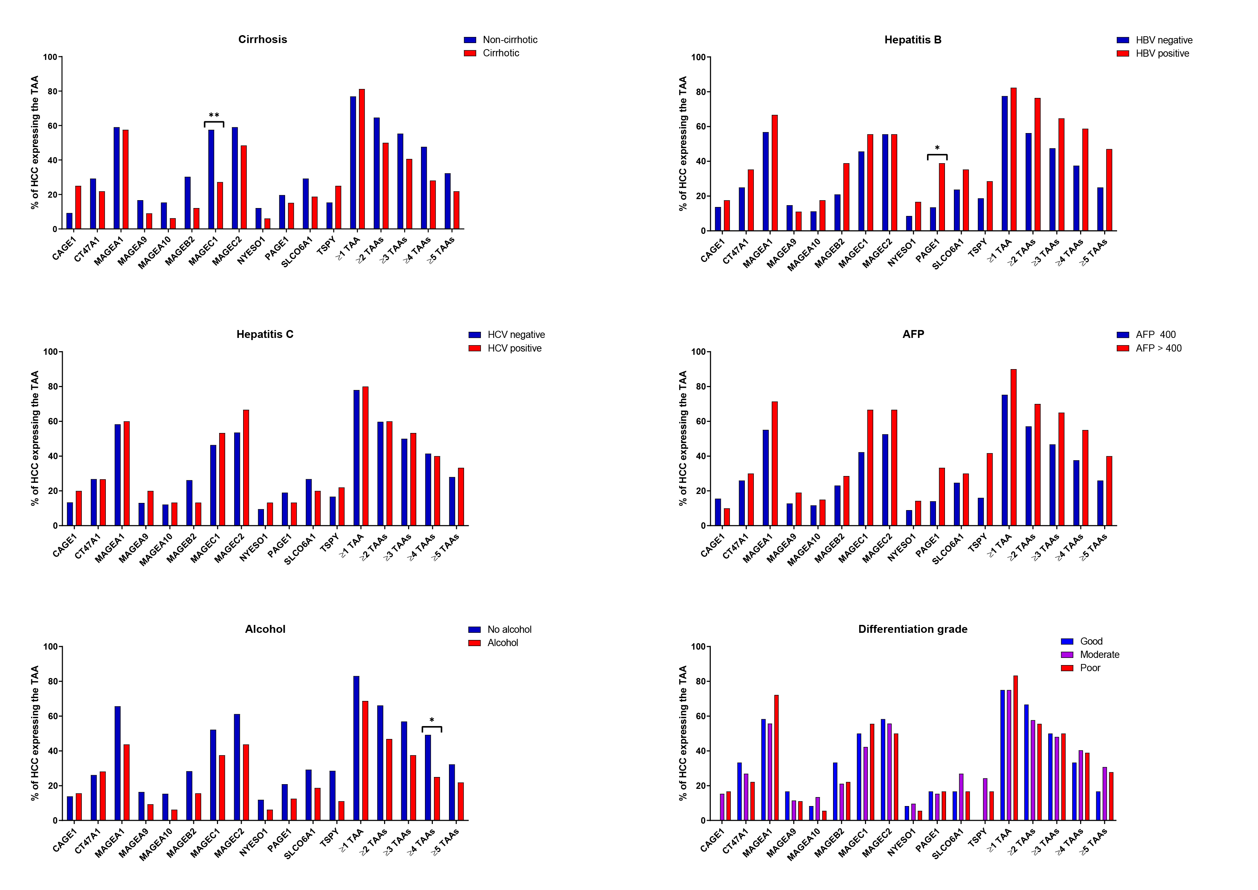Supplementary Figure S4. CTA mRNA expression in HCC tumors based on clinicopathological parameters. Chi-square test *p<0.05, **p<0.01
Abbreviations: AFP, alpha-fetoprotein
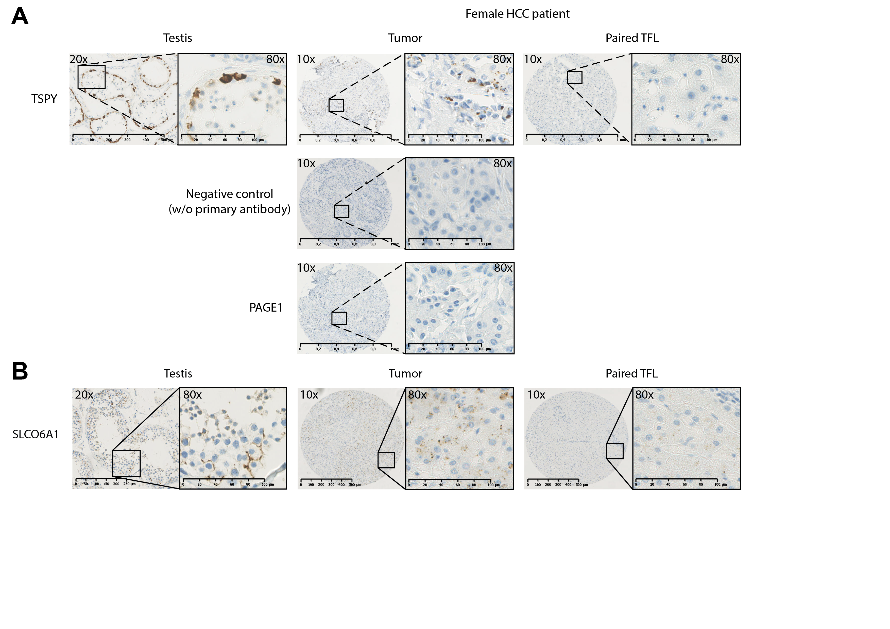Supplementary Figure S5
Supplementary Figure S5. TSPY expression in female HCC tumors and SLCO6A1 expression. A. TSPY protein expression was determined by IHC. TSPY is expressed in spermatogonia of normal testis, as expected.⁴¹ However, TSPY protein expression was also found in two female HCC patients, of which one example is shown above. The staining is absent in the negative control and in the PAGE1 stained core. TSPY is encoded by the y-chromosome, expression in women is thus biologically impossible. B. Representative example of immunohistochemical stains of SLCO6A1 in testis, a positive HCC tumor tissue and the paired TFL tissue.

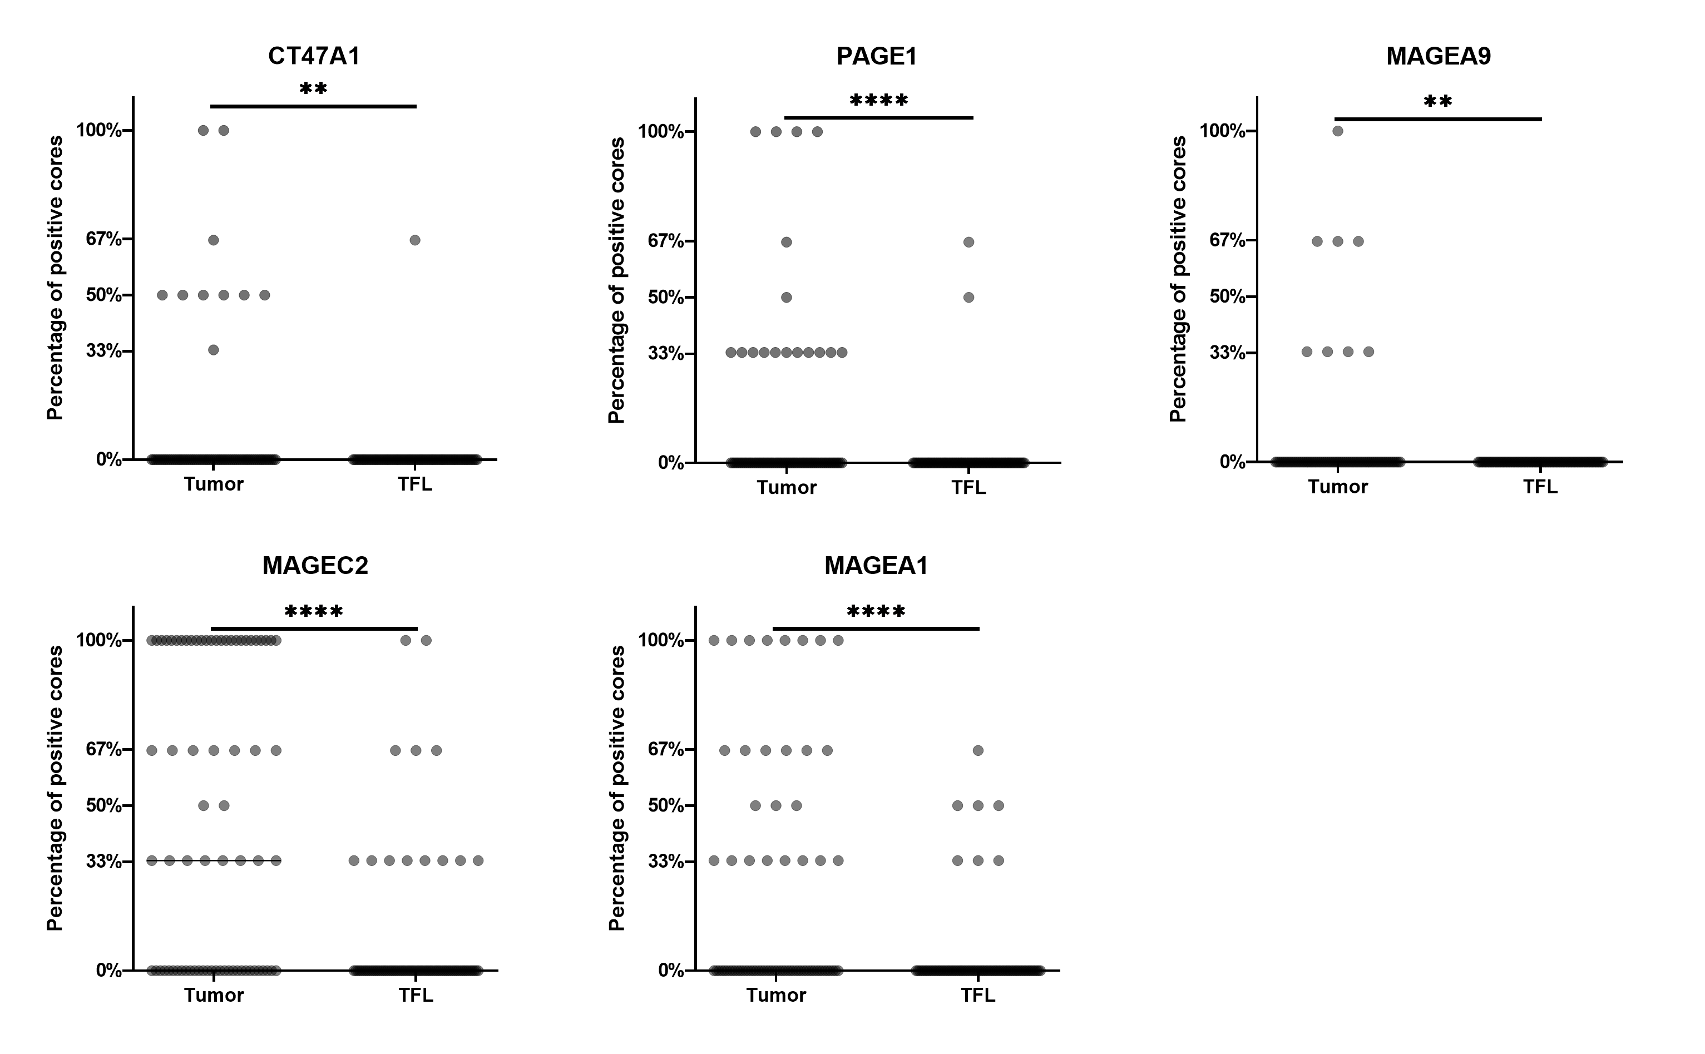Supplementary Figure S6
Supplementary Figure S6. Proteins are focally expressed in most tumors. Protein expression was determined on TMAs, which had 3 cores of each tumor and TFL. The graphs display the percentage of cores containing protein-expressing cells (a score ≥1A). Most tumors and TFL focally express the proteins, illustrated by not all cores being positive. Wilcoxon signed-rank test. ** P<0.01, **** P<0.0001

Supplementary Figure S7
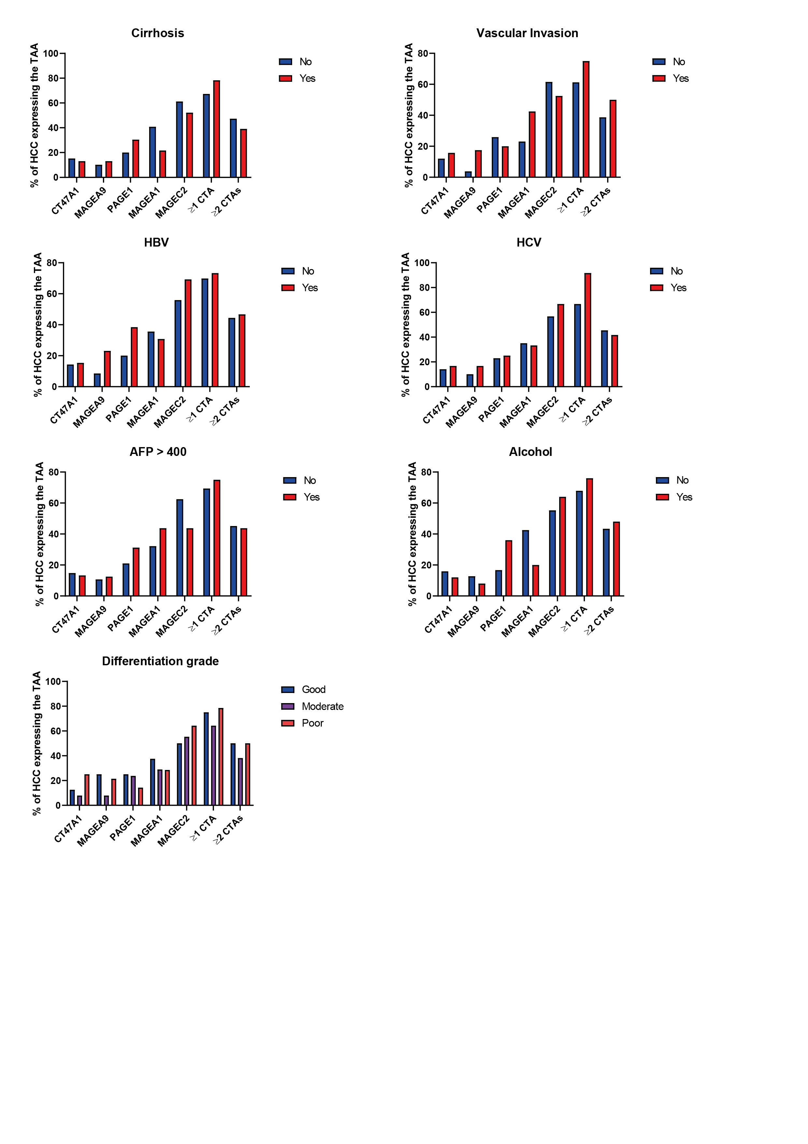
Supplementary Figure S7. CTA protein expression in HCC tumors based on clinical parameters. Protein expression in tumor tissue per clinical parameter. Chi-square test .
Abbreviations: HBV , Hepatitis B virus; HCV , Hepatitis C Virus; AFP >400 , Alphafetoprotein > 400 ug/L

Supplementary Figure S8.
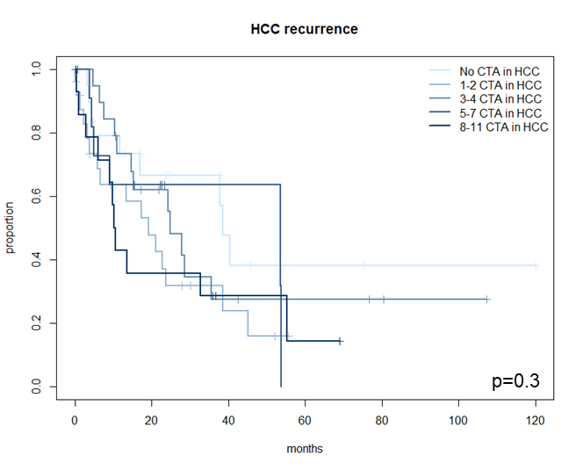
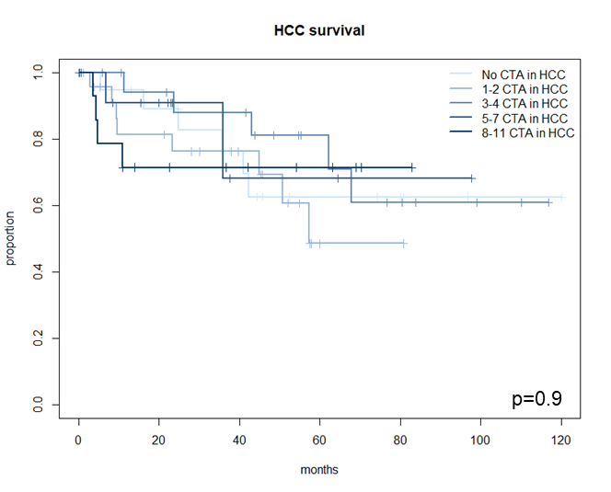

Supplementary Figure S8. HCC recurrence and HCC-specific survival by CTA mRNA-expression in tumor tissue. Log-rank test.

Supplementary Figure S9.
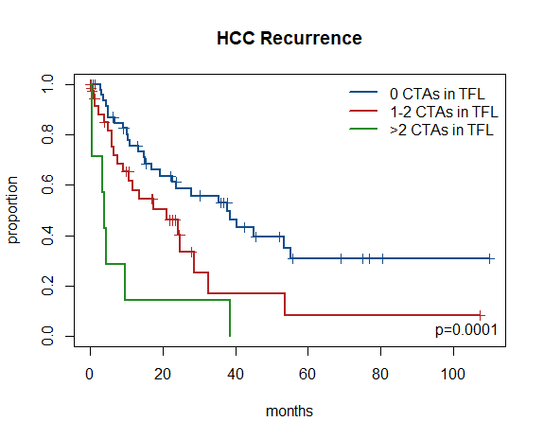
Supplementary Figure S9. HCC recurrence and HCC-specific survival by number of CTAs expressed (based on mRNA expression) in TFL. Log-rank test.

References
1. Charoentong P, Finotello F, Angelova M, et al. Pan-cancer Immunogenomic Analyses Reveal Genotype-Immunophenotype Relationships and Predictors of Response to Checkpoint Blockade. Cell Rep 2017;18:248-262.
2. Sideras K, Biermann K, Verheij J, et al. PD-L1, Galectin-9 and CD8(+) tumor-infiltrating lymphocytes are associated with survival in hepatocellular carcinoma. Oncoimmunology 2017;6:e1273309.
3. Bergeron A, Picard V, LaRue H, et al. High frequency of MAGE-A4 and MAGE-A9 expression in high-risk bladder cancer. Int J Cancer 2009;125:1365-71.
4. Wei Y, Wang Y, Gong J, et al. High expression of MAGE-A9 contributes to stemness and malignancy of human hepatocellular carcinoma. Int J Oncol 2018;52:219-230.
5. Jiao Y, Ding L, Chu M, et al. Effects of cancer-testis antigen, TFDP3, on cell cycle regulation and its mechanism in L-02 and HepG2 cell lines in vitro. PLoS One 2017;12:e0182781.
6. Liu Q, Chen K, Liu Z, et al. BORIS up-regulates OCT4 via histone methylation to promote cancer stem cell-like properties in human liver cancer cells. Cancer Lett 2017;403:165-174.
7. Xie Y, Wang A, Lin J, et al. Mps1/TTK: a novel target and biomarker for cancer. J Drug Target 2017;25:112-118.
8. Kido T, Lau YC. Identification of a TSPY co-expression network associated with DNA hypomethylation and tumor gene expression in somatic cancers. J Genet Genomics 2016;43:577-585.
9. Fu J, Luo B, Guo WW, et al. Down-regulation of cancer/testis antigen OY-TES-1 attenuates malignant behaviors of hepatocellular carcinoma cells in vitro. Int J Clin Exp Pathol 2015;8:7786-97.
10. Wang M, Li J, Wang L, et al. Combined cancer testis antigens enhanced prediction accuracy for prognosis of patients with hepatocellular carcinoma. Int J Clin Exp Pathol 2015;8:3513-28.
11. Sideras K, Bots SJ, Biermann K, et al. Tumour antigen expression in hepatocellular carcinoma in a low-endemic western area. Br J Cancer 2015;112:1911-20.
12. Melis M, Diaz G, Kleiner DE, et al. Viral expression and molecular profiling in liver tissue versus microdissected hepatocytes in hepatitis B virus-associated hepatocellular carcinoma. J Transl Med 2014;12:230.
13. Li S, Mo C, Huang S, et al. Over-expressed Testis-specific Protein Y-encoded 1 as a novel biomarker for male hepatocellular carcinoma. PLoS One 2014;9:e89219.
14. Deng Q, Li KY, Chen H, et al. RNA interference against cancer/testis genes identifies dual specificity phosphatase 21 as a potential therapeutic target in human hepatocellular carcinoma. Hepatology 2014;59:518-30.
15. Xia QY, Liu S, Li FQ, et al. Sperm protein 17, MAGE-C1 and NY-ESO-1 in hepatocellular carcinoma: expression frequency and their correlation with clinical parameters. Int J Clin Exp Pathol 2013;6:1610-6.
16. Zhou JD, Shen F, Ji JS, et al. FAM9C plays an anti-apoptotic role through activation of the PI3K/Akt pathway in human hepatocellular carcinoma. Oncol Rep 2013;30:1275-84.
17. Chen K, Huang W, Huang B, et al. BORIS, brother of the regulator of imprinted sites, is aberrantly expressed in hepatocellular carcinoma. Genet Test Mol Biomarkers 2013;17:160-5.
18. Song MH, Choi KU, Shin DH, et al. Identification of the cancer/testis antigens AKAP3 and CTp11 by SEREX in hepatocellular carcinoma. Oncol Rep 2012;28:1792-8.
19. Li H, Fang L, Xiao X, et al. The expression and effects the CABYR-c transcript of CABYR gene in hepatocellular carcinoma. Bull Cancer 2012;99:E26-33.
20. Yoon H, Lee H, Kim HJ, et al. Tudor domain-containing protein 4 as a potential cancer/testis antigen in liver cancer. Tohoku J Exp Med 2011;224:41-6.
21. Wang XY, Chen HS, Luo S, et al. Comparisons for detecting NY-ESO-1 mRNA expression levels in hepatocellular carcinoma tissues. Oncol Rep 2009;21:713-9.
22. Riener MO, Wild PJ, Soll C, et al. Frequent expression of the novel cancer testis antigen MAGE-C2/CT-10 in hepatocellular carcinoma. Int J Cancer 2009;124:352-7.
23. Lu Y, Wu LQ, Lu ZH, et al. Expression of SSX-1 and NY-ESO-1 mRNA in tumor tissues and its corresponding peripheral blood expression in patients with hepatocellular carcinoma. Chin Med J (Engl) 2007;120:1042-6.
24. Wu LQ, Lu Y, Wang XF, et al. Expression of cancer-testis antigen (CTA) in tumor tissues and peripheral blood of Chinese patients with hepatocellular carcinoma. Life Sci 2006;79:744-8.
25. Watanabe T, Suda T, Tsunoda T, et al. Identification of immunoglobulin superfamily 11 (IGSF11) as a novel target for cancer immunotherapy of gastrointestinal and hepatocellular carcinomas. Cancer Sci 2005;96:498-506.
26. Yin YH, Li YY, Qiao H, et al. TSPY is a cancer testis antigen expressed in human hepatocellular carcinoma. Br J Cancer 2005;93:458-63.
27. Shi YY, Wang HC, Yin YH, et al. Identification and analysis of tumour-associated antigens in hepatocellular carcinoma. Br J Cancer 2005;92:929-34.
28. Peng JR, Chen HS, Mou DC, et al. Expression of cancer/testis (CT) antigens in Chinese hepatocellular carcinoma and its correlation with clinical parameters. Cancer Lett 2005;219:223-32.
29. Sato S, Noguchi Y, Wada H, et al. Quantitative real-time RT-PCR analysis of NY-ESO-1 and LAGE-1a mRNA expression in normal tissues and tumors, and correlation of the protein expression with the mRNA copy number. Int J Oncol 2005;26:57-63.
30. Yang XA, Dong XY, Qiao H, et al. Immunohistochemical analysis of the expression of FATE/BJ-HCC-2 antigen in normal and malignant tissues. Lab Invest 2005;85:205-13.
31. Dong XY, Li YY, Yang XA, et al. BJ-HCC-20, a potential novel cancer-testis antigen. Biochem Cell Biol 2004;82:577-82.
32. Dong XY, Yang XA, Wang YD, et al. Zinc-finger protein ZNF165 is a novel cancer-testis antigen capable of eliciting antibody response in hepatocellular carcinoma patients. Br J Cancer 2004;91:1566-70.
33. Zhao L, Mou DC, Leng XS, et al. Expression of cancer-testis antigens in hepatocellular carcinoma. World J Gastroenterol 2004;10:2034-8.
34. Li B, Qian XP, Pang XW, et al. HCA587 antigen expression in normal tissues and cancers: correlation with tumor differentiation in hepatocellular carcinoma. Lab Invest 2003;83:1185-92.
35. Dong XY, Su YR, Qian XP, et al. Identification of two novel CT antigens and their capacity to elicit antibody response in hepatocellular carcinoma patients. Br J Cancer 2003;89:291-7.
36. Luo G, Huang S, Xie X, et al. Expression of cancer-testis genes in human hepatocellular carcinomas. Cancer Immun 2002;2:11.
37. Wang Y, Han KJ, Pang XW, et al. Large scale identification of human hepatocellular carcinoma-associated antigens by autoantibodies. J Immunol 2002;169:1102-9.
38. de Wit NJ, Weidle UH, Ruiter DJ, et al. Expression profiling of MMA-1a and splice variant MMA-1b: new cancer/testis antigens identified in human melanoma. Int J Cancer 2002;98:547-53.
39. Ono T, Kurashige T, Harada N, et al. Identification of proacrosin binding protein sp32 precursor as a human cancer/testis antigen. Proc Natl Acad Sci U S A 2001;98:3282-7.
40. Chen CH, Chen GJ, Lee HS, et al. Expressions of cancer-testis antigens in human hepatocellular carcinomas. Cancer Lett 2001;164:189-95.
41. Schnieders F, Dork T, Arnemann J, et al. Testis-specific protein, Y-encoded (TSPY) expression in testicular tissues. Hum Mol Genet 1996;5:1801-7.

