Supplementary Information for:
Site-Controlled Telecom Single-Photon Emitters in Atomically-thin MoTe₂
Huan Zhao*, Michael Thompson Pettes, Yu Zheng, and Han Htoon*
Center for Integrated Nanotechnologies, Materials Physics and Applications Division, Los Alamos National Laboratory, Los Alamos, New Mexico 87545, USA
*Corresponding authors, Email: huanzha@lanl.gov, htoon@lanl.gov
- Sample preparation
The nanopillars were fabricated using the following procedures, see Figure s1.
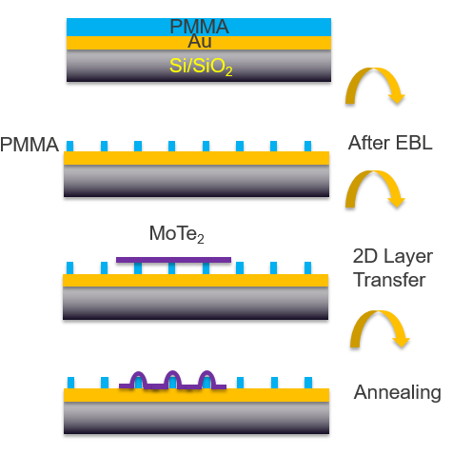
Figure s1: The fabrication process for the MoTe₂-on-PMMA nanopillar SPEs.
Each nanopillar has a diameter of ~150 nm and a height of ~100 nm. After transferring thin-layer MoTe₂ and vacuum annealing at 90°C, the strained structures were generated, see Figure s2.
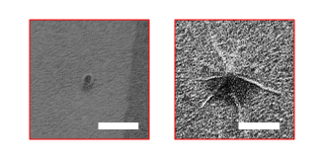
Figure s2: Left panel: SEM image of one as-fabricated PMMA nanopillar; Right panel: A nanopillar coated by a MoTe₂ monolayer. Scale bars: 500 nm.
- Spectra of 24 near-band-edge MoTe₂ localized emitters
Although strain-induced emission spans the wavelength range from 1080 nm to 1550 nm, it is more frequently observed ~20–100 meV lower than that of the MoTe₂ 2D excitons which are located at ~1050–1070 nm. In addition, the near-band-edge emission peaks typically have significantly narrower linewidths compared to those of the largely redshifted emissions. Here we plot the PL emission of 24 strained few-layer MoTe₂ localized emitters. We only display the 1080–1150 nm wavelength range to show the linewidth clearly. All the spectra were taken at a temperature of 10–13 K. Multiple sharp PL peaks are often observed at slightly different spatial locations around a single nanopillar (determined through the centroid of the PL emission). As our nanopillar could induce strain over several hundreds of nm region (See SEM image of Figure S2) capable of hosting multiple point defects, distinct localized exciton states could form in a single strain region.

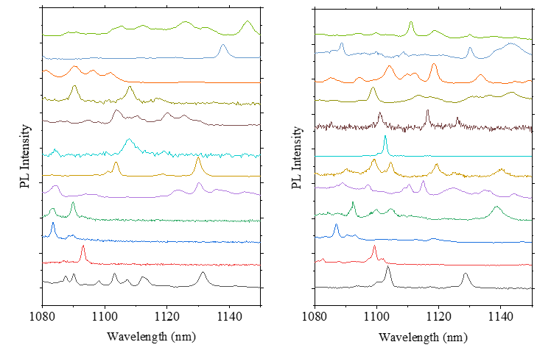
Figure s3: The spectra of 24 localized MoTe₂ emitters obtained at 10–13 K.

- Determining Single Detection Efficiency and absolution emission rate of QEs.
To measure photon collection efficiency of our system, a tunable laser output at the wavelength of the QEs (1108 nm for QE of Fig. 2 and 1540 nm for QE of Fig.3) is coupled into the microscope. The signal reflected by the gold mirror passes through the PL collection path and the power is measured before the fiber coupler of the SNSPD system and compare the laser power coupled into the objective. This measurement yield 5% and 4.4% transmission efficiency for 1108 and 1540 nm respectively. Then taking into account collection efficiency of 0.65 NA objective, coupling efficiency to SNSPD optical fiber (10% at 1108 and 30% 1540 nm) and SNSPD detector efficiencies of 25% at 1108 nm and 85% at 1540 nm, we estimate the overall collection efficiency at 1108 nm and 1540 nm to be 0.035% and 0.31% respectively. The overall collection efficiency at 1540 nm is an order of magnitude higher because the optical fiber and SNSPD detectors is optimized for 1550 nm.
Figure s4 displays the SNSPD recorded photon counts of the QE presented in main Figure 2 (1108 nm) under CW and pulse excitation as well as the pulsed-laser excited emission rate of the QE presented in main Figure 3 (1540 nm). The intensity fluctuation in all the figures are due to the drifting of the sample against the laser spot. The data yield average count rate of 1.2 kHz (pulse) and 9 kHz (CW) for QE of Figure 2 and 0.8 kHz for QE of Figure 3. Normalizing these count rates with overall collection efficiencies estimated above yield corrected absolute emission rates given in the main text.
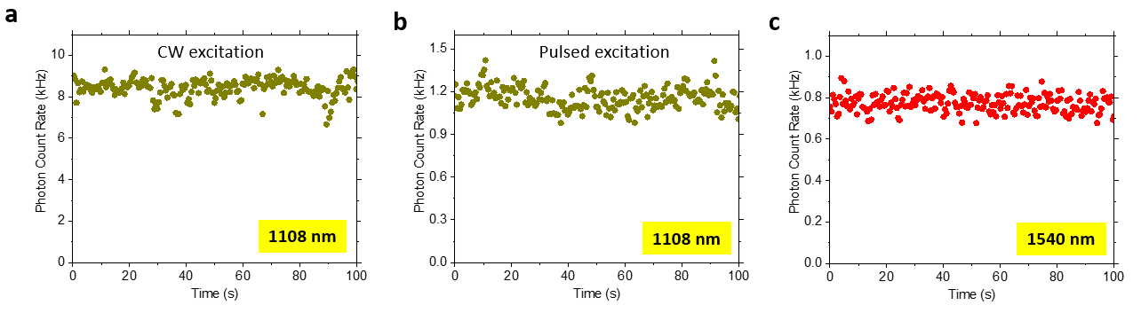
Figure s4: a,b, The measured photon emission rate of the SPE displayed in main Figure 2. a, under CW laser excitation; b, under a 48.5 MHz pulsed laser excitation; c, the measured photon emission rate of the SPE displayed in main Figure 3 under a 303 kHz pulse excitation.
- Near-band-edge emitter working at Liquid-Nitrogen temperature
Figure s5 displays a near-band-edge SPE operating at 44 K and 77 K (liquid nitrogen temperature). At elevated temperature, the PL intensity reduces and the lifetime also decreases, most likely due to non-radiative recombination facilitated by thermal energy. Photon antibunching are clearly observed in both temperatures.
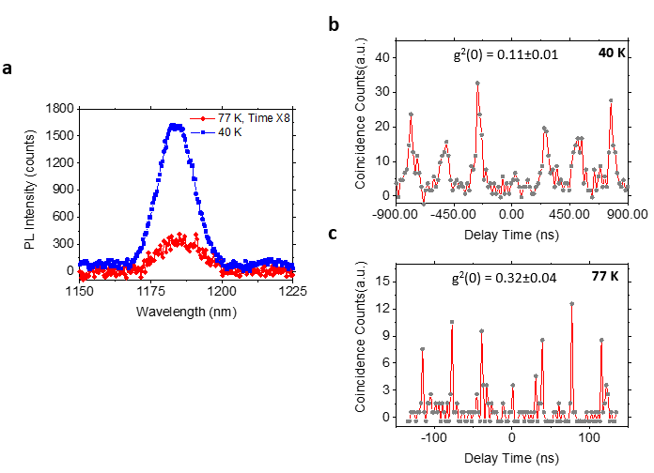
Figure s5: a, PL spectra of a near-band-edge SPE measured at 40 K and 77 K. The integration time of the 77 K measurement is 8X of that of the 40 K measurement indicating nearly 2 order of magnitude decrease in emission rate; b, c, the pulsed g²(τ) of the SPE measured at 40 K and 77 K clearly show photon antibunching.
- PL time trace of a near-band-edge emitter
Figure s6 displays a PL (Figure s6a) and PL time trace (Figure s6b) of a localized emitter. The time resolution is 1.5 s. No blinking, photon bleaching, or spectrum diffusion was observed.
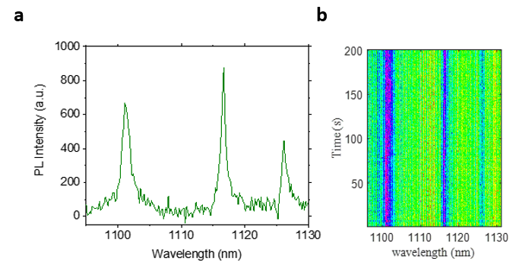
Figure s6: a, The PL spectrum of a localized emitter. b, its time dependence acquired
with (xx s integration time) .
- Highly red-shifted localized emissions
Here we plot the spectra of 24 localized emitters with emission wavelength over 1150 nm (Figure s7a, b). Most of the telecom emitters are found in multilayer MoTe₂ (layer number > 2) samples. In which cases the MoTe₂ 2D exciton peaks are usually too weak to be detected, as multilayer MoTe₂ is an indirect bandgap semiconductor. However, we have occasionally observed monolayer (featured by its 1050 nm exciton peak) and bilayer (featured by its 1060 nm exciton peak) samples with 1550 nm telecom peaks, see Figure s7c, d.
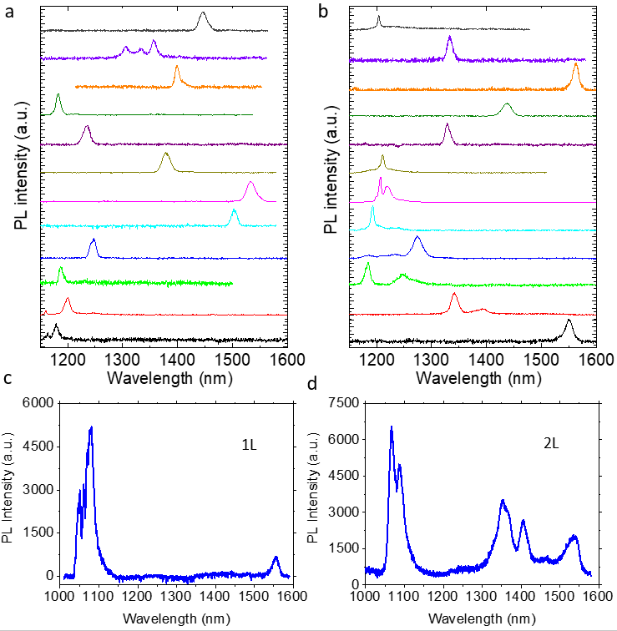
Figure s7: a and b, 24 localized emitters with emission wavelength over 1150 nm c, a monolayer MoTe₂ localized emitter with a 1550 nm PL peak; d, a bilayer MoTe₂ localized emitter with a 1540 nm PL peak.
- Nearly-unity emitter creation with high positioning accuracy
Figure s8a shows a 5-6 layer MoTe₂ flake on nanopillar array. The layer thickness is identified by AFM. Figure s8b presents the wide-field PL image of the flake with a 1300 nm long-pass filter, showing near-unity creation of localized bright emitters. Figure s8c is a PL spectrum of one of the emitters.
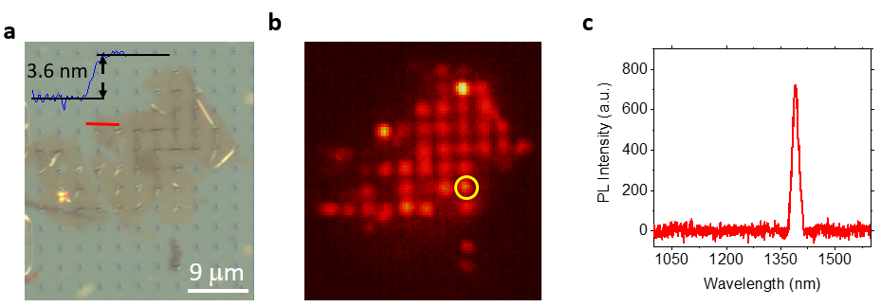
Figure s8: a, The optical image (DIC mode) of an MoTe₂ flake on nanopillar array. Inset: an AFM cross section height profile took at the red line region showing the sample is mainly a 5-6 layer flake; b, the Wide-field PL image of the 5-6 layer MoTe₂ with a 1300 nm long-pass filter; c, The PL spectrum of the dot circled in Figure s6b.
- Second-order correlation data of SPEs emitting from 1.1 to 1.6 μm.
Figure s9a shows 4 SPEs emitting from 1.1 to 1.6 mm. The second-order correlation data of each SPE are presented in s9b-s9e.
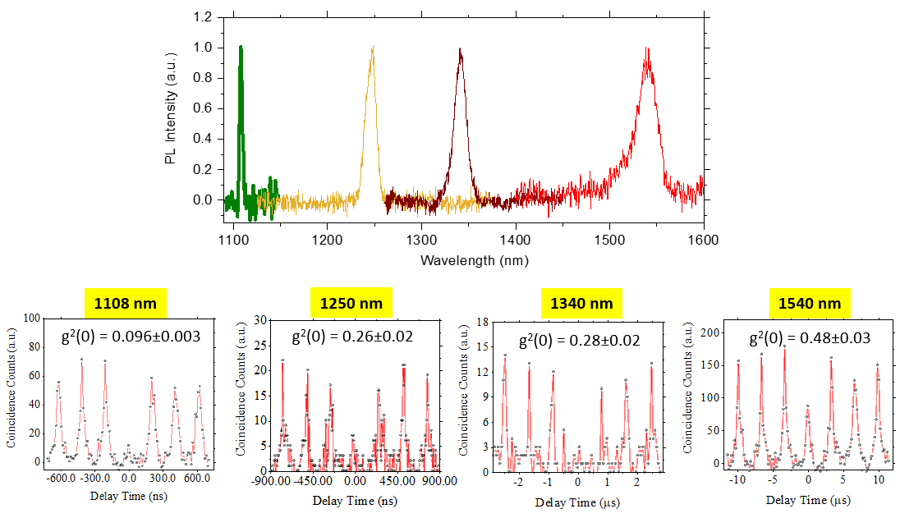
Figure s9: a, The PL spectrum of four localized emitters took at 11 – 13 K temperature, with emission wavelength centered at 1108 nm, 1250 nm, 1340 nm, and 1540 nm, respectively. b-e, the g²(τ) data of the four QEs, respectively
- Correlating the PL spectra and decay curve of the QE shown in Figure 3b and 3c
The TRPL curve presented in Figure 3c or Figure s10a is fitted by a bi-exponential decay formula, $y=Ae\text{-t/t1}+$B$e\text{-t/t2}+\text{C}$. We obtained A = 69.6, B = 82.8, τ₁ = 163 ns and τ₂ = 1.13 μs. The value Aτ₁/Bτ₂ = 1: 8 is calculated to compare the ratio of the integrated PL intensity of two PL of peaks of Figure 3b. The PL intensity ratio of the 1510 nm shoulder peak and the 1540 nm telecom peak is calculated by integrating the PL counts from each Gaussian fitted peak shown in Figure s10b. Because we applied a 1500 nm long-pass filter and a 1550±40 nm band-pass filter in the PL dynamics measurement, we only counted the “areas” with wavelength longer than 1510 nm, which is shadowed in yellow. From Figure s10b we obtained a PL intensity ratio of 1:5. By comparing the PL intensity ratio obtained from the TRPL (1:8) and that obtained from the spectrum (1:5), we attribute the longer lifetime decay component to the brighter peak. As a result, 1.13 μs decay component is assigned to the 1540 nm telecom peak.
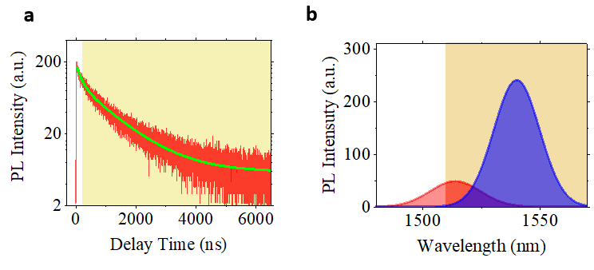
Figure s10: a, The PL decay curve presented in Figure 3c (main article). The region shadowed in yellow is the time window utilized in photon correlation measurements; b, Gaussian fit curves presented in Figure 3b (main article). The “area” of each peak is denoted by the filled color. The region shadowed in orange is the spectrally filtered region used to obtain the TRPL data.
- Photon correlation measurements and the time-gating technique
We performed both CW and pulsed laser photon correlation measurements using a two-channel SNSPD as the detector. The spectra were filtered either by a combination of long-pass and short-pass filters or a wavelength-tunable band-pass filter before entering the detector. Unfortunately, for the QE in Figure 3b-f of the main article, we do not have an appropriate optical filter to completely isolate the 1540 nm dominant peak from its shoulder peak at around 1510 nm, so the TRPL result in Figure 3c contains the unwanted contributions from the small 1510 nm shoulder peak (Figure s10b). To minimize the contribution from this short-lifetime shoulder peak in the pulsed autocorrelation measurements shown in Figure 3f, we applied a time gated 2nd order photon correlation approach²⁵ to filter the photon in temporal domain after the measurement. Using the time tagged photons collected by Hydraharp photon counting system, we post-select the photons that are detected after certain time delay following the laser excitation (gate time) and reconstruct the 2nd order photon correlation trace from the selected photons. In our case, we have a relatively faster decay component with τ₁ = 163 ns and a slower decay component with τ₂ = 1.13 μs. By selecting the gate time to be 200ns (shadowed region in Figure s10a denotes the time windows where photons are selected for the g⁽²⁾ trace), 70% of the fast-decay contribution from the higher energy could be removed along with 16% of the slow-decay, main spectral feature of interest. This choice yield g⁽²⁾(0) of 0.15 shown in Figure 3f. We note that we could increase the gate time to further reduce the contribution of the fast-decay component, but there is tradeoff as this also reduces the signal-to-noise ratio of the g⁽²⁾ trace. Here 200 ns was found to be a good time gate value to balance the time-domain filtering effect and the signal quality. Although this time-gate technique is commonly used in quantum dots, it has not been demonstrated in 2D material research yet.
- Magnetic-field dependent valley Zeeman splitting
Figure s11 plots the magnetic-field dependent valley Zeeman splitting of the localized emitter shown in Figure 4a of the main article, from which a g-factor of -3.61±0.02 is extracted.
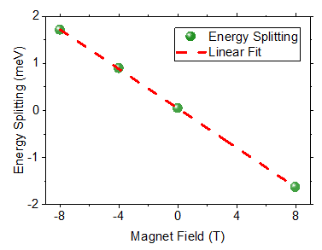
Figure s11: Field-dependent valley Zeeman splitting of the emitter shown in Figure 4a of the main article.

- A cross-linearly polarized doublet with an anomalously large zero field splitting
Although most of our cross-linearly polarized doublets show zero-field energy-splitting on the order of 1 meV, we occasionally observed anomalously large zero-field spitting for example in the SPE shown in Figure s12a. The PL intensity of the lower energy peak is plotted as a function of linear polarization detection angle, shown in Figure s12b. The data in Figure s12b was found to be proportional to sin²θ, showing the linearly polarized nature of the SPE.
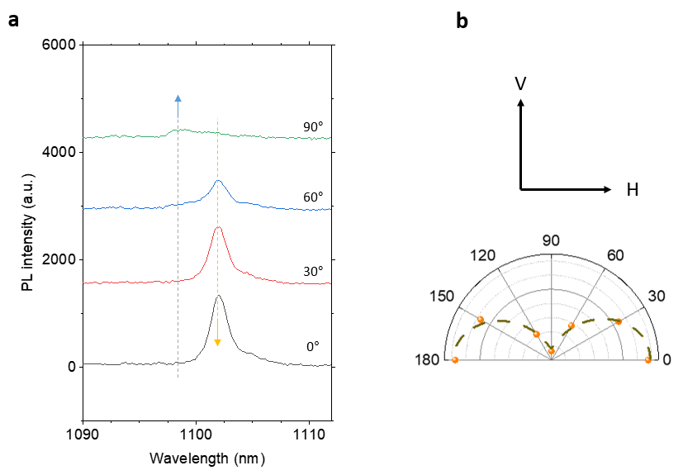
Figure s12: (a) A quantum emitter with a giant zero-field splitting of ΔE₀ = 3.7 meV; (b) The polarization-dependent emission intensity and the sinusoidal fit.

- A diagram of the optical measurement setup

Figure s13 shows a diagram of the optical path used in photon correlation and magneto-PL measurements.
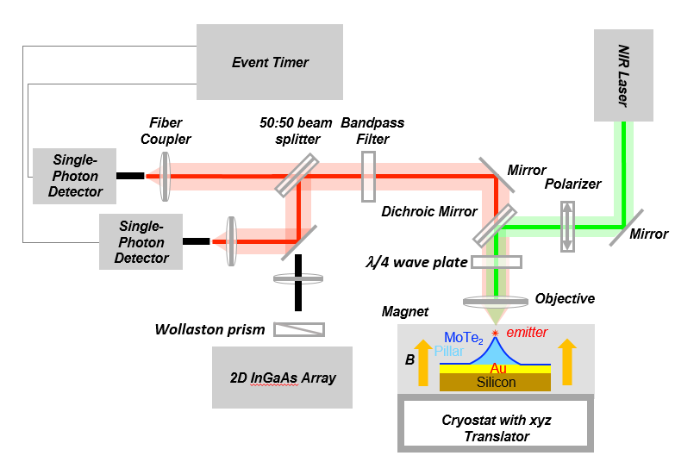
Figure s13: An illustration of the optical measurement setup.

