Reduced hepatic steatosis is associated with higher risk of hepatocellular carcinoma in chronic hepatitis B infection

Lung-Yi Mak, Rex Wan-Hin Hui, James Fung, Fen Liu, Danny Ka-Ho Wong, Ka-Shing Cheung, Man-Fung Yuen, Wai-Kay Seto

Supplementary Appendix

Supplementary table 1. Histological evaluation at the time of HCC diagnosis in 22 patients

Patient number | Time of TE before HCC diagnosis (months) | LS (kPa) | CAP (dB/m) | Type of imaging | Steatosis by imaging | Advanced fibrosis/cirrhosis by imaging | Steatosis by histology | Advanced fibrosis/ cirrhosis by histology
802 | 27.4 | 7.4 | 127 | MRI | 0 | 0 | 0 | 0
1085 | 41.3 | 8.2 | 158 | CT | 0 | 1 | 0 | 1
1147 | 12.8 | 6.6 | 161 | CT | 0 | 0 | 0 | 0
61 | 15.2 | 12.2 | 165 | CT | 0 | 0 | 0 | 1
364 | 15.0 | 6.8 | 192 | CT | 0 | 0 | 0 | 0
593 | 7.9 | 8.2 | 199 | CT | 0 | 1 | 0 | 1
388 | 37.6 | 5.3 | 200 | CT | 0 | 0 | 0 | 0
697 | 22.2 | 5.9 | 206 | CT | 0 | 1 | 0 | 1
1656 | 13.6 | 9.5 | 209 | CT | 0 | 0 | 0 | 0
318 | 23.2 | 36.3 | 212 | CT | 0 | 1 | 1 (mild) | 1
83 | 23.1 | 22.8 | 227 | CT | 0 | 1 | 0 | 1
641 | 19.9 | 10.1 | 233 | CT | 0 | 1 | 0 | 1
2286 | 17.3 | 7.7 | 238 | USG | 1 | 0 | 0 | 0
1748 | 26.4 | 6.3 | 249 | CT | 0 | 0 | 0 | 0
554 | 13.6 | 4.3 | 254 | CT | 0 | 0 | 0 | 0
786 | 41.8 | 8 | 255 | CT | 0 | 1 | 1 (mild) | 0
49 | 37.7 | 9.1 | 276 | CT | 0 | 0 | 0 | 0
1543 | 26.6 | 16.2 | 277 | CT | 0 | 1 | 1 (mild) | 1
121 | 9.4 | 14.4 | 285 | CT | 0 | 1 | 0 | 1
96 | 25.7 | 17.3 | 343 | CT | 0 | 1 | 0 | 1
991 | 16.3 | 8.8 | 359 | MRI | 0 | 0 | 1 (severe) | 0
362 | 13.3 | 8.2 | 375 | CT | 0 | 0 | 1 (moderate) | 0
1=yes, 0=no, CAP: controlled attenuation parameter, HCC: hepatocellular carcinoma, LS: liver stiffness, TE: transient elastography
Text highlighted in red denotes presence of advanced liver fibrosis/ cirrhosis on either transient elastography or histology
Text highlighted in green denotes presence of hepatic steatosis on either transient elastography or histology

Supplementary table 2. Univariate analysis of risk factors for HCC development in all patients (N=2403)

 | HCC (N=48) | No HCC (N=2355) | P value
Age | 62.9 (56.7 – 68.7) | 55.6 (46.5 – 62.8) | <0.001
Gender (male) | 36 (75%) | 1300 (55.2%) | 0.004
Body height (cm) | 163.5 (159.1 – 169) | 163.5 (157 – 169.5) | 0.775
Body weight (kg) | 64.9 (57.3 – 70.6) | 64.7 (56.2 – 73) | 0.829
Body mass index (kg/m²) | 24.0 (21.7 – 26.5) | 24.0 (21.7 – 26.9) | 0.828
Waist circumference (cm) | 88 (84 – 93) | 86 (79 – 94) | 0.147
Hip circumference (cm) | 96 (92 – 100) | 96 (92 – 101) | 0.940
Systolic blood pressure (mmHg) | 139 (120 – 156) | 133 (121 – 147) | 0.303
Diastolic blood pressure (mmHg) | 78 (72 – 88) | 79 (72 – 87) | 0.592
Diabetes mellitus (yes) | 13/ 47 (27.7%) | 642/ 2228 (28.8%) | 0.505
Glycated hemoglobin (%) | 5.7 (5.5 – 6.3) | 5.7 (5.3 – 6.4) | 0.435
Dyslipidaemia (yes) | 21/ 48 (43.8%) | 1253/ 2343 (53.5%) | 0.191
On lipid-lowering therapy (yes) | 10/48 (20.8%) | 520/2228 (23.3%) | 0.423
On anti-diabetic therapy (yes) | 12/48 (25%) | 601/2228 (26.9%) | 0.832
Platelet count (x100/L) | 127 (94 – 197) | 208 (167 – 249) | <0.001
Albumin (gram/L) | 43 (39 – 46) | 45 (43 – 47) | <0.001
Bilirubin (umol/L) | 11 (9 – 17) | 10 (7 – 13) | 0.004
Alanine aminotransferase (U/L) | 28 (22 – 39) | 26 (19 – 36) | 0.149
Aspartate aminotransferase (U/L) | 30 (24 – 40) | 26 (21 – 32) | 0.001
ALBI score | -2.97 (-3.19 to -2.58) | -3.18 (-3.34 to -3.03) | <0.001
HBV DNA (log IU/mL) | 1.3 (1.3 – 1.3) | 1.3 (1.3 – 2.7) | <0.001
HBV DNA positivity (>20 IU/mL) (Yes) | 7/48 (14.6%) | 1098/2355 (46.6%) | <0.001
HBeAg positivity (yes) | 4 (8.5%) | 226 (10.5%) | 0.444
On nucleos(t)ide analogue therapy (yes) | 44 (91.7%) | 1328 (56.4%) | <0.001
Controlled attenuation parameter (dB/m) | 216 (197 – 248) | 246 (206 – 291) | 0.001
Liver stiffness (kPa) | 9.3 (7.5 – 16.3) | 5.5 (4.4 – 7.7) | <0.001
ALBI: Albumin-Bilirubin, HBeAg: hepatitis B e antigen, HBV: hepatitis B virus

Supplementary table 3. Sensitivity analysis of multivariate regression on risk of HCC in all patients

 | Odds ratio | 95% confidence interval | P value
Mild steatosis vs. no steatosis (n=2403) | 0.433 | 0.215 – 0.87 | 0.019
Moderate steatosis vs. no or mild steatosis (n=2403) | 0.441 | 0.198 – 0.984 | 0.045
Severe steatosis vs. no or mild or moderate steatosis (n=2403) | 0.333 | 0.126 – 0.883 | 0.027
CAP when only patients with F3/F4 were included (n=371) | 0.996 | 0.987 – 1.005 | 0.339
CAP when only patients without F3/F4 were included (n=2032) | 0.991 | 0.983 – 0.999 | 0.038
CAP: controlled attenuation parameter, F3/F4: advanced fibrosis/ cirrhosis

Supplementary table 4. Univariate analysis of risk factors for HCC development in NA-treated patients (N=1349)

 | HCC (n=44) | No HCC (n=1305) | P value
Age | 62.9 | 55.9 | <0.001
Gender (male) | 33 (75%) | 837 (64.2%) | 0.153
Body height (cm) | 164 | 164 | 0.953
Body weight (kg) | 64.8 | 64.0 | 0.818
Body mass index (kg/m²) | 23.6 | 23.4 | 0.734
Waist circumference (cm) | 87 | 86 | 0.353
Hip circumference (cm) | 96 | 96 | 0.915
Systolic blood pressure (mmHg) | 140 | 134 | 0.49
Diastolic blood pressure (mmHg) | 80 | 80 | 0.672
Diabetes mellitus (yes) | 12/43 (27.9%) | 381/1223 (31.2%) | 0.739
Glycated hemoglobin (%) | 5.7 | 5.6 | 0.921
Dyslipidaemia (yes) | 20/44 (45.5%) | 706/1296 (54.5%) | 0.282
Platelet count (x100/L) | 119 | 192 | <0.001
Albumin (gram/L) | 43 | 45 | <0.001
Bilirubin (umol/L) | 12 | 10 | 0.015
Alanine aminotransferase (U/L) | 28 | 26 | 0.174
Aspartate aminotransferase (U/L) | 30 | 26 | 0.001
ALBI score | -2.93 (-3.17 to -2.55) | -3.19 (-3.34 to -3.01) | <0.001
HBV DNA (log IU/mL) | 1.3 | 1.3 | 0.41
HBV DNA positivity (>20 IU/mL) (Yes) | 3/44 (6.8%) | 191/1305 (14.6%) | 0.191
HBeAg positivity (yes) | 4 (9.3%) | 168 (13.8%) | 0.28
ETV (instead of other NA) | 81.6% | 85.9% | 0.289
NA duration before transient elastography (months) | 67.7 | 77.0 | 0.38
Controlled attenuation parameter (dB/m) | 214 | 241 | 0.002
Liver stiffness (kPa) | 9.9 | 5.9 | <0.001
ALBI: Albumin-Bilirubin, ETV: entecavir, HBeAg: hepatitis B virus, HBeAg: hepatitis e antigen, NA: nucleos(t)ide analogue

Supplementary table 5. Multivariate Cox regression analysis of risk factors for HCC development NA-treated patients

 | Hazard ratio | 95% confidence interval | P value
Age (per year) | 1.059 | 1.029 – 1.09 | <0.001
Platelet count (per 1 x 10⁹/L) | 0.997 | 0.992 – 1.003 | 0.302
Aspartate aminotransferase (per U/L) | 1.008 | 0.995 – 1.02 | 0.246
ALBI score | 2.91 | 1.425 – 5.942 | 0.003
Controlled attenuation parameter (per dB/m) | 0.993 | 0.987 – 0.999 | 0.015
Liver stiffness (per kPa) | 1.014 | 0.987 – 1.042 | 0.323

ALBI: Albumin-Bilirubin

Associated univariate analysis presented in Supplementary Table 4.
(Albumin and bilirubin were incorporated in ALBI score)

Supplementary table 6. Sensitivity analysis of multivariate regression on risk of HCC in NA-treated patients

 | Odds ratio | 95% confidence interval | P value
Mild steatosis vs. no steatosis (n=1349) | 0.463 | 0.224 – 0.956 | 0.037
Moderate steatosis vs. no or mild steatosis (n=1349) | 0.447 | 0.192 – 1.04 | 0.062
Severe steatosis vs. no or mild or moderate steatosis (n=1349) | 0.315 | 0.109 – 0.912 | 0.033
CAP when only patients with F3/F4 were included (n=275) | 0.995 | 0.987 – 1.004 | 0.312
CAP when only patients without F3/F4 were included (n=1074) | 0.987 | 0.978 – 0.996 | 0.006
CAP when only patients on ETV were included (n=1033)* | 0.993 | 0.986 – 1.001 | 0.076
CAP when only patients on TDF were included (n=171)* | 0.998 | 0.983 – 1.014 | 0.83
CAP when only patients on NA for ≥3 years were included (n=1013) | 0.992 | 0.985 – 1.000 | 0.037
CAP when only patients on NA for <3 years were included (n=336) | 0.994 | 0.983 – 1.006 | 0.359
*145 patients were on other NAs (adefovir disoproxil fumarate, lamivudine, telbivudine or combination regimens)

CAP: controlled attenuation parameter, ETV: entecavir, F3/F4: advanced fibrosis/ cirrhosis, NA: nucleos(t)ide analogue, TDF: tenofovir disoproxil fumarate

Supplementary table 7. Baseline characteristics after propensity score matching*

 | Presence of hepatic steatosis† (N=957) | Absence of hepatic steatosis† (N=957) | ASD‡
Age | 56.2 (48.5-63.2) | 55.6 (47.0-62.8) | 0.037
Gender (male) | 563 (59%) | 559 (58%) | 0.004
Liver stiffness (kPa) | 6 (4.7-8.4) | 5.3 (4.2-7.0) | 0.085
Platelet | 210 (172-248) | 208 (167-249) | 0.055
HBV DNA | 1.3 (1.3-2.7) | 1.3 (1.3-2.8) | 0.023
albumin | 45 (43-47) | 45 (43-47) | 0.017
Bilirubin | 10 (7-13) | 10 (8-13) | 0.009
AST | 26 (21-33) | 25 (22-31) | 0.027
On nucleos(t)ide analogue therapy (yes) | 544 (57%) | 537 (56%) | 0.007
* Matched by age, gender, liver stiffness, platelet, HBV DNA, albumin, bilirubin, AST and antiviral treatment.
† High CAP: CAP ≥ 248 dB/m; Low CAP: CAP <248 dB/m
‡ ASD < 0.1 denotes variables were well balanced.

Supplementary figure 1. Cumulative HCC-free survival stratified by different degrees of hepatic steatosis in all patients
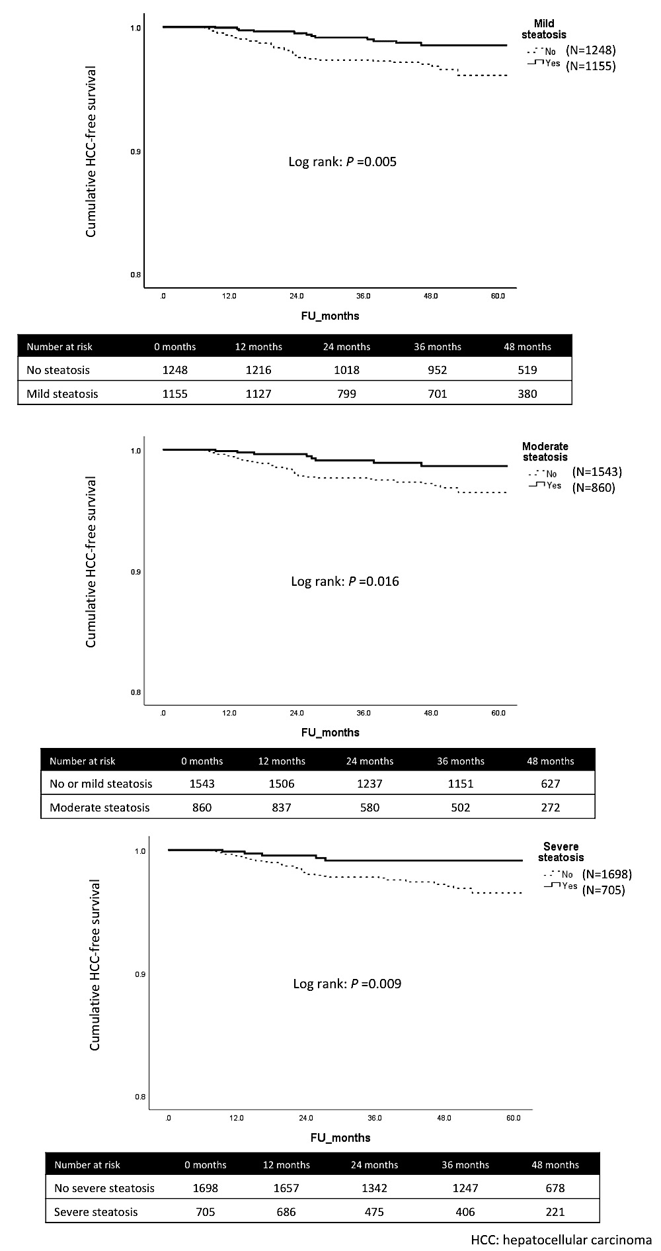
Supplementary figure 2. Cumulative HCC-free survival stratified by the severity of hepatic steatosis in NA-treated patients
Supplementary figure 3. Cumulative HCC-free survival stratified by different degrees of hepatic steatosis in NA-treated patients
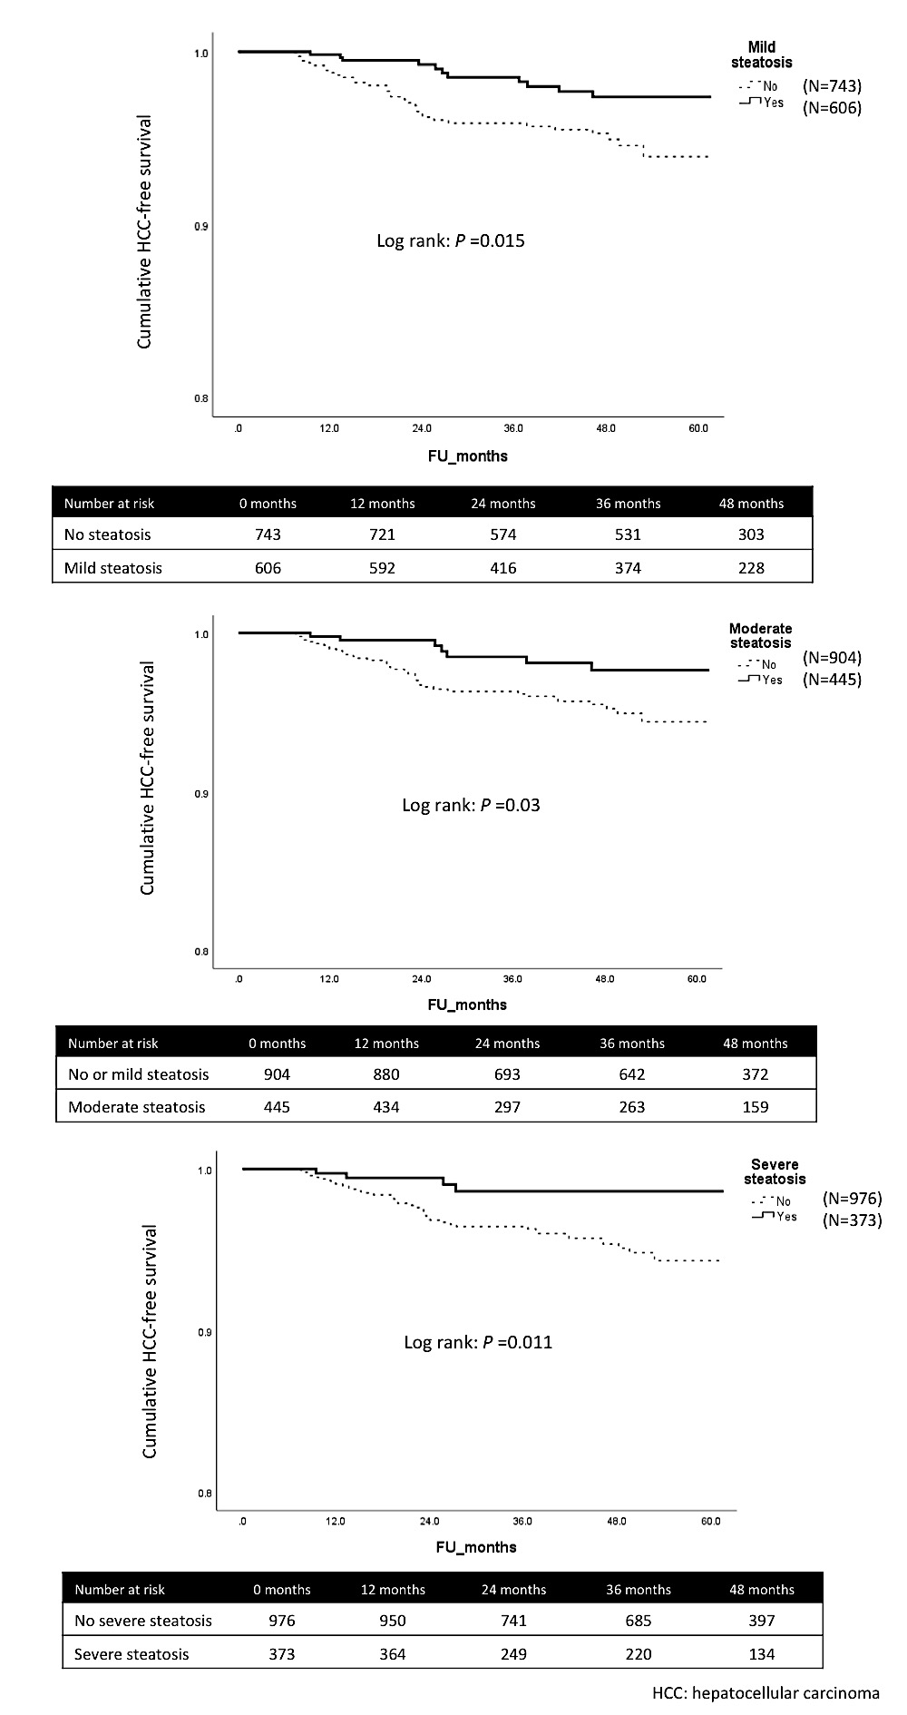
Supplementary Figure 4. Potential link between hepatic fat, fibrosis and hepatocellular carcinoma

