a
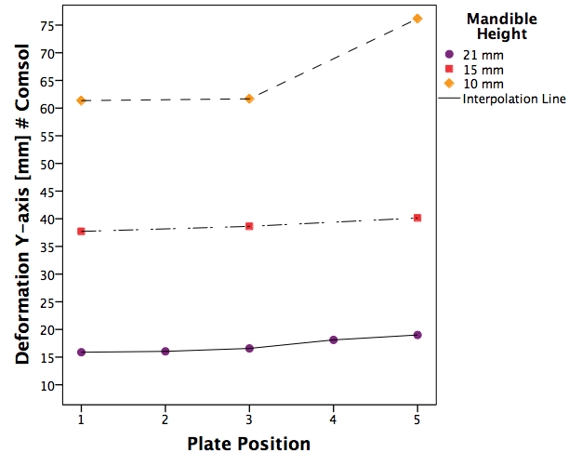

b
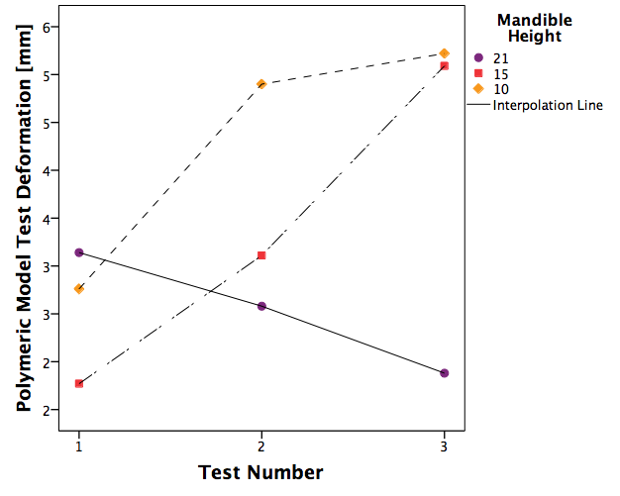

Supplementary Figure 1. (a) FEM deformation in the Y-axis in mm based on the outcomes from table 1. (b) Polymeric model testing deformation in mm at 150 N force from table 2.

