***Supplementary Information***

**Acoustic non-Hermitian skin effect from twisted winding topology**

Li Zhang1,2,#, Yihao Yang1,2,#*, Yong Ge3,#, Yi-jun Guan3, Qiaolu Chen1,2, Qinghui Yan1,2, Fujia Chen1,2, Rui Xi1,2, Yuanzhen Li1,2, Ding Jia3, Shou-qi Yuan3, Hong-xiang Sun3,*, Hongsheng Chen1,2,* and Baile Zhang4,5,*

1Interdisciplinary Center for Quantum Information, State Key Laboratory of Modern Optical Instrumentation, College of Information Science and Electronic Engineering, Zhejiang University, Hangzhou 310027, China.

2ZJU-Hangzhou Global Science and Technology Innovation Center, Key Lab. of Advanced Micro/Nano Electronic Devices & Smart Systems of Zhejiang, ZJU-UIUC Institute, Zhejiang University, Hangzhou 310027, China.

3Research Center of Fluid Machinery Engineering and Technology, School of Physics and Electronic Engineering, Jiangsu University, Zhenjiang 212013, China.

4Division of Physics and Applied Physics, School of Physical and Mathematical Sciences, Nanyang Technological University, 21 Nanyang Link, Singapore 637371, Singapore.

5Centre for Disruptive Photonic Technologies, The Photonics Institute, Nanyang Technological University, 50 Nanyang Avenue, Singapore 639798, Singapore.

# These authors contributed equally

\**yangyihao@zju.edu.cn* (Yihao Yang); *jsdxshx@ujs.edu.cn* (Hong-xiang Sun); *hansomchen@zju.edu.cn* (Hongsheng Chen); [*blzhang@ntu.edu.sg*](mailto:blzhang@ntu.edu.sg)(Baile Zhang)

**S1: More complex unconventional topological windings**

Our acoustic platform can generate more complex unconventional topological windings, as the nonreciprocity can be applied between arbitrary two sites. Here, we present two models. As shown in Fig. S1(a), the first example has reciprocal nearest-neighbor coupling *κ*1 = 6 Hz (yellow line) and unidirectional next-nearest-neighbor coupling = -11 + 3.9i Hz (blue line). The corresponding lattice Hamiltonian is . This model is similar to the counterpart in Fig. 4b, except for the strength of the reciprocal coupling that can be tuned by changing the cross-linked waveguide sizes. One can see that the complex energy plane is divided into four parts, including three regions with *v* = -1 (yellow shading) and one region with *v* = -2 (Fig. S1b).

As presented in Fig. S1c, the second model has reciprocal nearest-neighbour coupling *κ*1 (yellow line), forward positive coupling  (blue line), and backward negative coupling  (red line). The unidirectional coupling sign can be modified by adding a π phase shifter to the active component. Here, we set *κ*1 = 24 Hz and  = -11 + 3.9i Hz. The extracted complex energy spectrum encloses four areas with a winding number *v* = -1, +1, -1, +1 from left to right, respectively, as shown in Fig. S1d.

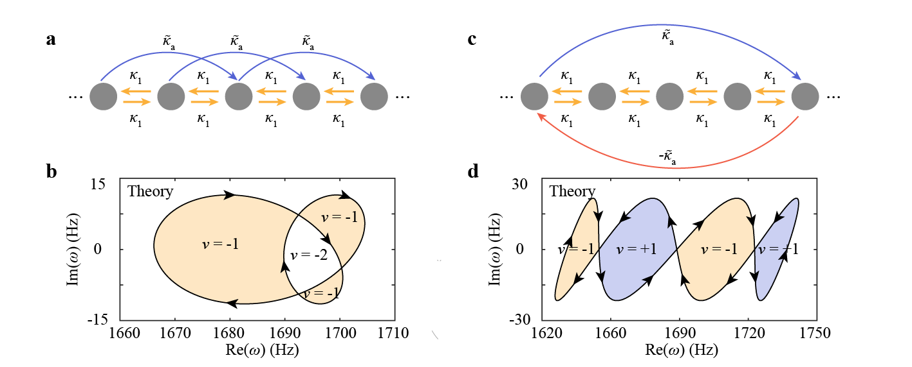

**Supplementary Figure 1|** More complex unconventional spectral windings. **a,** Schematic of the non-Hermitian model 1. The yellow lines and blue lines denote the reciprocal and non-reciprocal next-nearest neighbour couplings, respectively. **b**, Analytically-calculated complex energy spectrum. Light yellow shading denotes winding number *v* = -1 and the enclosed region implies winding number *v* = -2. **c,** Schematic of the non-Hermitian model 2. The yellow lines and blue/red lines denote the reciprocal and unidirectional couplings, respectively. **d**, Analytically-calculated complex energy spectrum. Light yellow (blue) shading denotes a winding number *v* = -1(+1).

**S2: Coupled-mode theory (CMT) for two-resonator model**

As shown in Fig. 2(a) in the main text, the two-resonator model is composed of two acoustic cavities connected via dual crossed waveguides, an active component amplifying the sound from cavity 1 to cavity 2 unidirectionally, a source, and a detector. The two cavities have the same resonance frequency *ω*0 and intrinsic loss , and two crossed waveguides provide the reciprocal coupling coefficient *κ*1. The source and the detector are inserted into the cavities with the same coupling strength *γ*1 (considering the source tube and the detector tube have the same size). The active component provides complex unidirectional coupling . According to the CMT1, when the wave is incident to cavity 1 (Fig. S2), the dynamic equation can be described as

, (*1*)

where *a*1 (*a*2) is the mode in cavity 1 (2), *s*1+ represents the incident wave from cavity 1. For the case when the wave is incident to cavity 2, change  to , where *s*2+ represents the wave incident to cavity 2.

The corresponding effective Hamiltonian is,

. (*2*)

It can be seen that in this Hamiltonian, the Hermiticity, time-reversal symmetry, and reciprocity are broken simultaneously2.

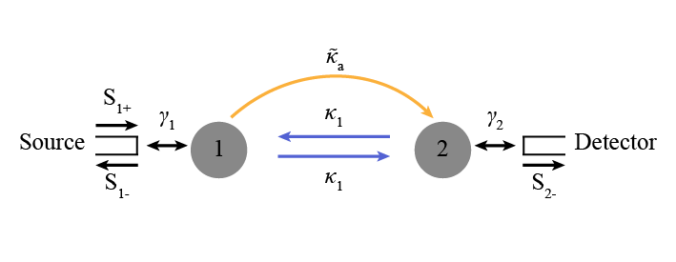

**Supplementary Figure 2|** The CMT model for the two-resonator model.

**S3: Transmission coefficients for the two-resonator model**

According to Eq. 1, the transmission coefficients are

. (*3*)

In the reciprocal model without the unidirectional coupling, the transmission coefficients are

. (*4*)

We use Eq. (3) and Eq. (4) to fit the three measured transmission spectra and retrieve the resonance frequency = 1706 Hz, the reciprocal coupling *κ*1= 24 Hz, the unidirectional coupling = -11 + 3.9i Hz, the intrinsic loss = 2.13 Hz, and the coupling strength =1.77 Hz.

**S4: Details of the two coupled acoustic cavities**

Figure S3 displays the model of the two coupled acoustic resonators. Each cavity has length *l* = 9.2 cm, width *w* = 7.2 cm, and height *h* = 11.2 cm. The distance between two resonators is *s* = 2.4 cm, and two waveguides have the same width *d* = 3.4 cm.

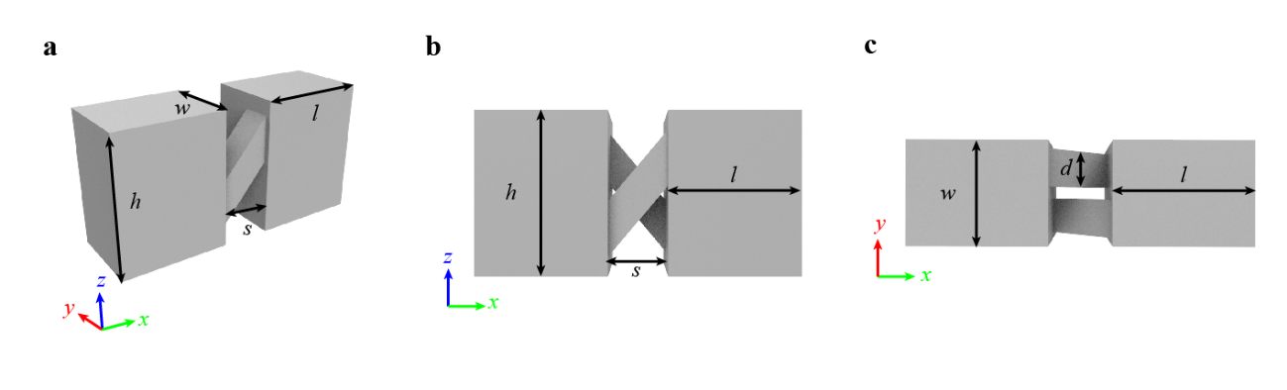

**Supplementary Figure 3|** Details of the two coupled acoustic cavities. **a,** 3D view. **b,** Front view. **c,** Top view.

**S5: Active acoustic component**

Figure S4a displays a photograph of the active component, where the standard non-inverting amplifier and the electrical circuit are fabricated with the printed circuit board (PCB) technique. The active amplifier component consists of a power amplifier and two highpass filters, as depicted in Fig. S4b. The input and output signal has a phase difference due to the resistances and capacitances in the amplifier and the filters.

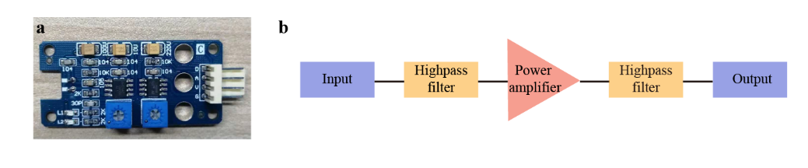

**Supplementary Figure 4|** Active acoustic component. **a,** Photograph of the active component. **b,** Schematic of the active component.

**S6: Experimental results of the reciprocal acoustic crystal**

To probe the field distribution, we place the source at site 10 and detect the response at each site of the chain (the same sample shown in Fig. 3(a) and the active components are not in operation). As shown in Fig. S5(a), the wave is concentrated on the input site 10 and propagates toward both directions with almost identical amplitude at *ω* = 1713 Hz. By applying Fourier transform to the measured field distributions in the chain, we obtain the dispersion, as depicted in Fig. S5(b).

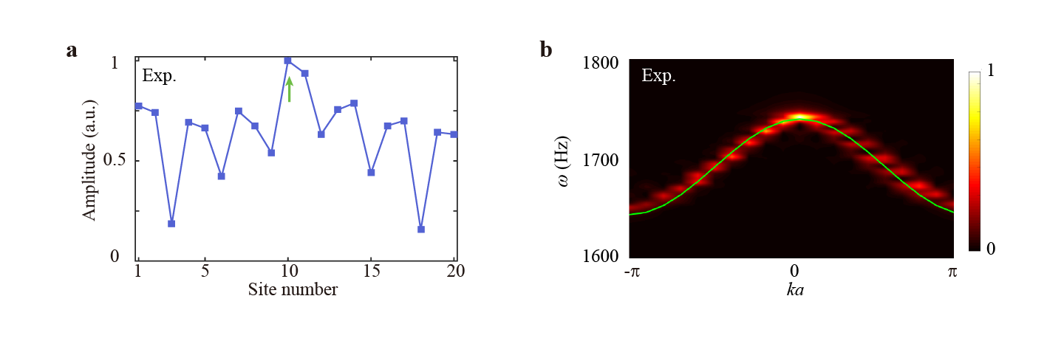

**Supplementary Figure 5|** **Experimental results of the reciprocal acoustic crystal**. **a,** Field distribution at frequency *ω* = 1713 Hz. **b,** Measured dispersion. The green line denotes the numerically fitted dispersion.

**S7: Topological robustness of the non-Hermitian skin effect (NHSE)**

To test the robustness of the NHSE, we introduce a uniformly distributed disorder () to the amplitude *κ*a (phase *φ*) of the unidirectional coupling *iκ*aei*φ*. We calculate the first spatial moment of every eigenstate , which is defined as3,

, (5)

with *n* being the position of the site. For each set of the first spatial moment, we calculate the averaged standard deviation *σ*m1. The lattice size is *N* =100, and each calculation is averaged over 1000 realizations. As shown in Fig. S6(a) and Fig. S7(a), the averaged standard deviation starts from 0 and converges at the large disorder strength, indicating the transition from the NHSE to the Anderson localization. We also show the eigenstates at different disorder strengths [see Figs. S6(b)-6(d) and S7(b)-7(d)]. One can see that at small disorder strength, the NHSE survives3.

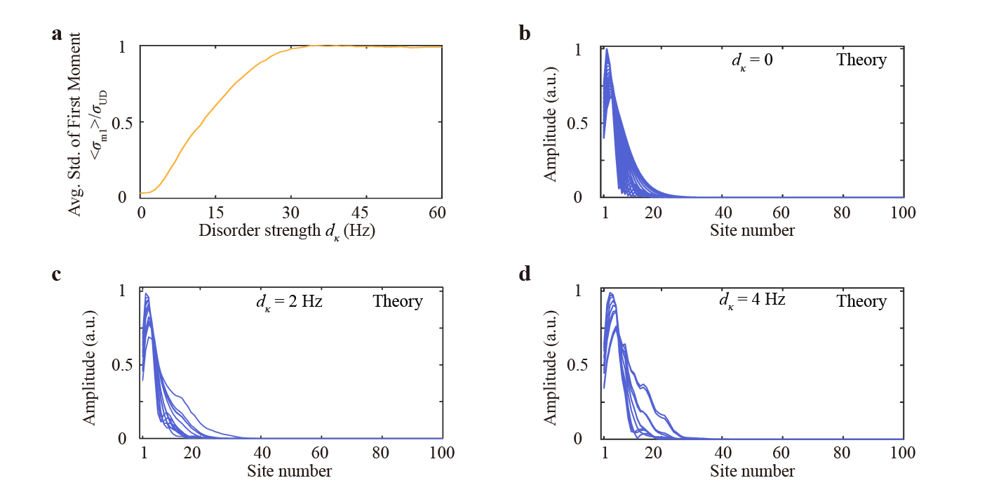

**Supplementary Figure 6|** Robustness of the NHSE. **a,** The averaged standard deviation of the first spatial moment versus the disorder strength *dκ*. **b-d,** Superposition of analytically-calculated field distributions of eigenstates at a disorder strength of 0 Hz (b), 2 Hz (c), and 4 Hz (d), respectively.

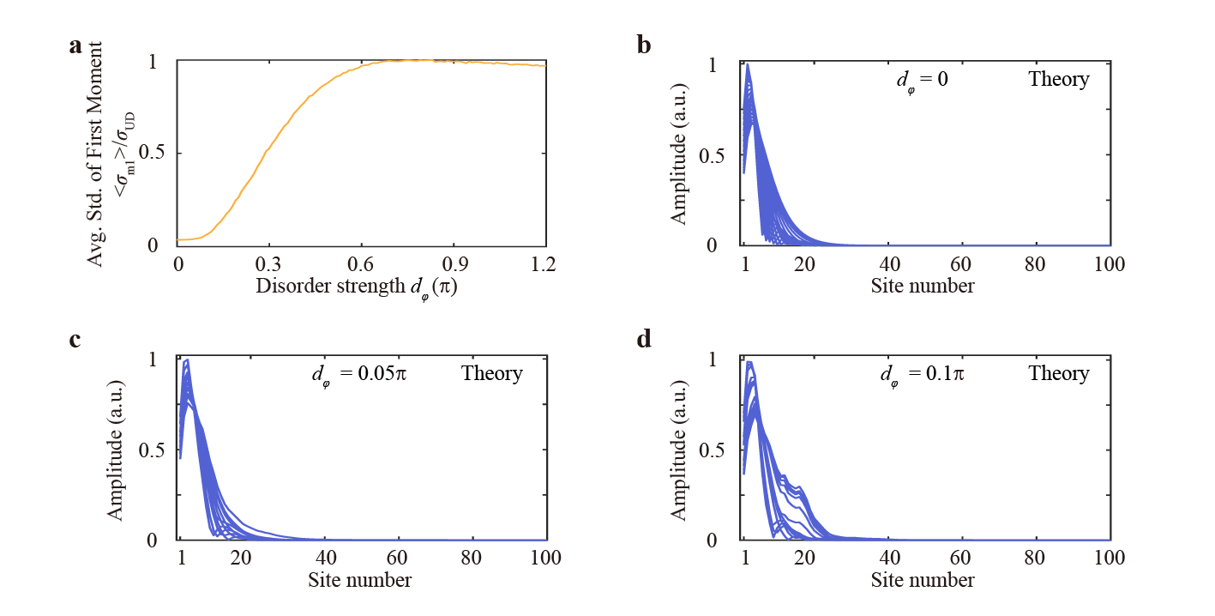

**Supplementary Figure 7|** Robustness of the NHSE. **a,** The averaged standard deviation of the first spatial moment versus the disorder strength *dφ*. **b-d,** Superposition of analytically-calculated field distributions of eigenstates at a disorder strength of 0 (b), 0.05π (c), and 0.1π (d), respectively.

**S8: Robustness of the** **Bloch-wave-like extended eigenstate**

The Bloch-wave-like extended eigenstate at the Bloch point is also robust against moderate disorder. To test its robustness, we introduce a uniformly distributed disorder () to the amplitude *κ*a (phase *φ*) of the unidirectional coupling *iκ*aei*φ*. The lattice size is *N* =100, and the model has reciprocal nearest-neighbor coupling *κ*1 and unidirectional next-nearest-neighbor coupling . We plot all the eigenstates as a function of eigenfrequencies4. As shown in Fig. S8 and S9, most eigenstates are localized at the left or right boundary, and a Bloch-wave-like extended eigenstate exists at the frequency between the left and right localized states.

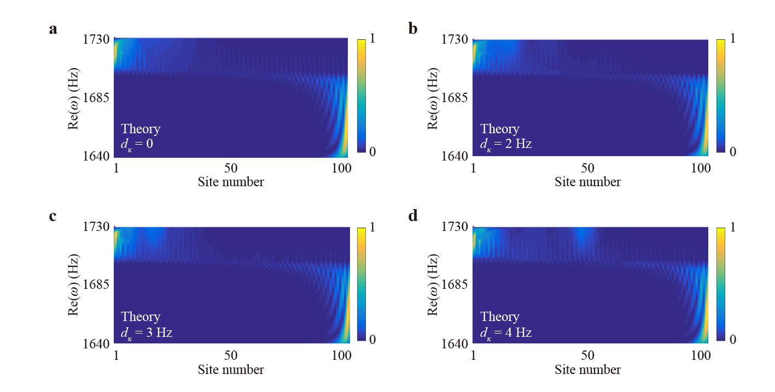

**Supplementary Figure 8|** Robustness of the Bloch-wave-like extended eigenstate. **a-d,** Analytically calculated energy of all eigenstates plotted as a function of eigenfrequencies and site number at different disorder strengths *σκ* of 0 Hz (a), 2 Hz (b), 3 Hz (c), and 4 Hz (d), respectively. Eigenstate profiles are normalized to have a maximum value 1.

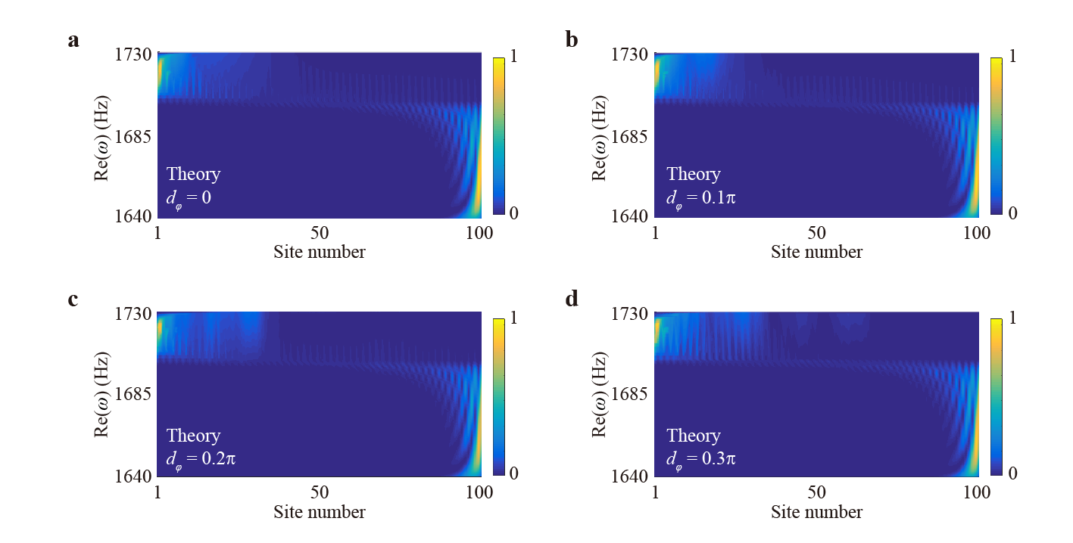

**Supplementary Figure 9|** Robustness of the Bloch-wave-like extended eigenstate. **a-d,** Analytically calculated energy of all eigenstates plotted as a function of eigenfrequencies and site number at different disorder strengths *σφ* of 0 (a), 0.1π (b), 0.2π (c), and 0.3π (d), respectively. Eigenstate profiles are normalized to have a maximum value 1.

**References**

1. Haus, H. *Waves and Fields in Optoelectronics* (Pretice Hall, 1984).

2. Helbig, T. et al. Generalized bulk–boundary correspondence in non-Hermitian topolectrical circuits. *Nat. Phys.* **16**, 747-750 (2020).

3. Weidemann, S. *et al.* Topological funneling of light. *Science* **368**, 311-314 (2020).

4. Song, F., Yao, S. & Wang, Z. Non-Hermitian topological invariants in real space. *Phys. Rev.*

*Lett.* **123**, 246801 (2019).