Participant Information Sheet for People with Dementia
Final Version 3.0 6th March 2020

IRAS Project ID: 256110
Title of Study: Pilot Randomised Evaluation of Singing in Dementia
Name of Chief Investigators: Professor Justine Schneider and Professor Martin Orrell
Local Researcher(s): Becky Dowson

We would like to invite you to take part in our research study. Before you decide we would like you to understand why the research is being done and what it would involve for you. One of our team will go through the information sheet with you and answer any questions you have. Talk to others about the study if you wish. Ask us if there is anything that is not clear.

What is the purpose of the study?
The purpose of the study is to investigate whether group singing has benefits for people with dementia and their carers. This is a feasibility study, which means that the data we collect will be used to plan a larger-scale study in the future. We want to find out whether this study design will work in the real world.

Why have I been invited?
We are inviting you to take part because you have been diagnosed with dementia, and you have a carer who can attend singing group sessions with you. We are inviting 80 participants like you to take part, along with their carers.

Do I have to take part?
It is up to you to decide whether or not to take part. A researcher will visit you at a convenient location for you to talk about the implications of taking part. If you do decide to take part we shall give you this information sheet to keep and ask you to sign a consent form. You can either sign the consent form straight away or take some time to decide, and return the form by post. If you don’t return the form, a researcher will give you a call to see whether we should collect the form in person, or if you prefer not to take part. If you decide to take part you are still free to withdraw at any time and without giving a reason. This would not affect your legal rights. You do not have to have any experience of singing to take part in this study and you will not be judged on your voice or musical abilities.

What will happen to me if I take part?
If you decide to take part, a researcher will arrange to come and visit you at a time that is convenient to you. The researcher will collect some information about you, such as your age and diagnosis. The researcher will also ask you to complete some questionnaires about things like your quality of life, mood, memory, and your ability to do everyday activities. These will be completed at a pace that suits you, with time for breaks if you need them. In total this visit will take approximately two hours.
Everyone who takes part in the study will be invited to attend a singing group once a week for 10 weeks. You will either be invited to attend a singing group straight away, or you will be asked to wait for 12 weeks before starting. Whether you attend straight away or wait will be decided randomly, so you will not get to choose. If you are asked to wait for 12 weeks, we will also ask you not to go to any other organised singing activities during that time (with the exception of religious services or meetings).
The singing group sessions will be free to attend and will take place weekly. Each session will last approximately two hours, but not all of this time will be spent singing as there will be time for refreshments and socialising. The sessions will be led by someone who has a lot of experience of leading similar groups. You will have the chance to join in singing familiar songs as well as new ones, and to suggest songs you would like to sing. You can take part in whatever way suits you, and join in as much or as little as you like.
Although every effort will be made to hold the singing groups in places and at times which are convenient for participants, there is a possibility that coming to the group will not be convenient for everyone.

If you can’t attend one of the sessions for some reason (for example, you are unwell or have another appointment) that’s fine, just come to the session the next time you are able to. The researcher may ask you why you couldn’t attend but you do not have to say if you don’t want to. Once you have attended the singing group for 10 weeks, you and your carer do not have to keep on attending but you both can if you want to.
You will receive two more visits from a researcher, three months and six months after the first visit. The researcher will ask you to complete the same questionnaires as at the first visit. Each of these visits will also last approximately two hours. Additionally, we will interview some of the people who take part about their experiences in the group. You do not have to be interviewed if you don’t want to be. If you agree to be interviewed, the interview will last approximately 45 minutes and will take place at a location and time convenient to you. We will ask for your permission to audio-record the interview.
The flowchart below shows what will happen during the study.

Flowchart of participant timeline in the study
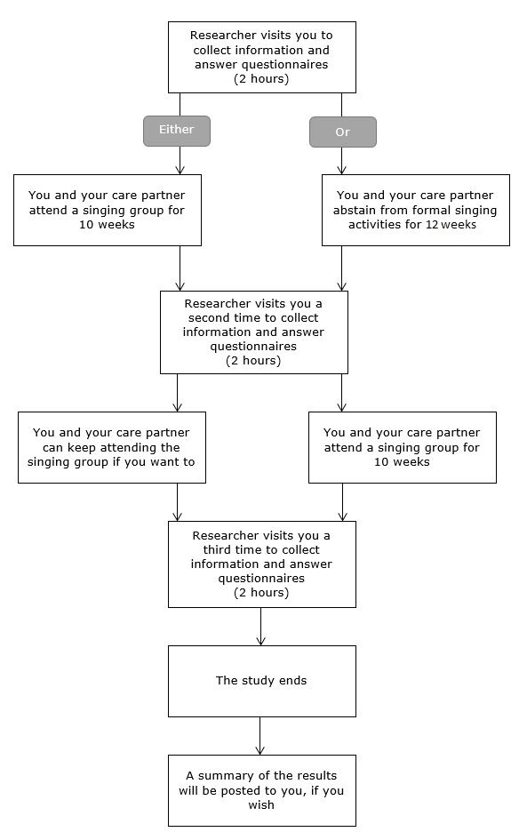

Expenses and payments
You will not be paid to participate in the study. The singing groups will be free to attend during the study.

What are the possible benefits of taking part?
We cannot promise the study will help you but the information we get from this study may help us to understand the benefits which singing has for people with dementia. This will contribute to making singing more accessible to other people with dementia in the future.

Many people find that singing is a fun and enjoyable activity, and research has shown that coming to a singing group may have benefits for the mood and cognition of people with dementia. There is also evidence that group singing strengthens the relationship between people with dementia and carers.

What are the possible disadvantages and risks of taking part?
The questionnaires which will be used in the study can be time-consuming, which you may find burdensome or inconvenient. Some people find that answering certain kinds of question causes distress, especially questions about memory problems and dementia.

Some people will attend the singing group immediately, and others will wait for 12 weeks before attending. This means that if you are in the waiting group, you will not experience any potential benefits of singing as soon as those who attend straight away. However, everyone who participates in the study will eventually have the opportunity to attend a singing group.

People respond to singing in different ways, and there is a possibility that you may find the singing group disagreeable. For example, you might find it overstimulating or have a strong emotional response to the singing. You are free to leave the group at any time during the session should this be the case, and we will try to provide a quiet space for this purpose.

What happens when the research study stops?
After you have attended the singing group for 10 weeks, you are free to stop coming if you wish or to continue to attend for a second set of 10 weekly sessions. Although we cannot continue to fund them we aspire to keep the singing groups running after the study so that so that those who wish to keep on coming may do so. However, the continuation of the groups is not guaranteed. If you consent to us holding your contact information until the study is complete, we will send you a summary of the study results by post. Please tell us if you do not want us to retain your contact information for this purpose.

What if there is a problem?
If you have a concern about any aspect of this study, you should ask to speak to the researchers who will do their best to answer your questions. The researchers’ contact details are given at the end of this information sheet. If you remain unhappy and wish to complain formally, you can do this by contacting the Patient Experience Team (PALs):

Patient Experience Team (PALs)
Moorgreen House
Highbury Hospital
Highbury Vale
Bulwell
Nottingham
NG6 9DR

Tel: 0115 9934542
Mon – Friday 8.30am – 4.30pm (excluding bank holidays)

Email: complaints@nottshc.nhs.uk

In the event that something does go wrong and you are harmed during the research and this is due to someone's negligence then you may have grounds for a legal action for compensation against the University of Nottingham but you may have to pay your legal costs.

Will my taking part in the study be kept confidential?
We will follow ethical and legal practice and all information about you will be handled in confidence.

If you join the study, we will use information collected from you during the course of the research. This information will be kept strictly confidential, stored in a secure and locked office, and on a password protected database at the University of Nottingham. Under UK Data Protection laws the University is the Data Controller (legally responsible for the data security) and the Chief Investigator of this study (Justine Schneider) is the Data Custodian (manages access to the data). This means we are responsible for looking after your information and using it properly. Your rights to access, change or move your information are limited as we need to manage your information in specific ways to comply with certain laws and for the research to be reliable and accurate. To safeguard your rights we will use the minimum possible personally – identifiable information.

You can find out more about how we use your information and to read our privacy notice at:

https://www.nottingham.ac.uk/utilities/privacy.aspx.

What will happen to my data which is collected during the study?
The data collected for the study will be looked at and stored by authorised persons from the University of Nottingham who are organising the research. They may also be looked at by authorised people from regulatory organisations to check that the study is being carried out correctly. All will have a duty of confidentiality to you as a research participant and we will do our utmost to meet this duty.

Your contact information will be kept by the University of Nottingham for one year after the end of the study so that we are able to contact you about the findings of the study and possible follow-up studies (unless you advise us that you do not wish to be contacted). This information will be kept separately from the research data collected and only those who need to will have access to it. All other data (research data) will be kept securely for 7 years. After this time your data will be disposed of securely. During this time all precautions will be taken by all those involved to maintain your confidentiality, only members of the research team given permission by the Data Custodian will have access to your personal data.

As part of the study we will be video recording some of the singing group sessions. We will ask for your permission to be recorded at the start of the session. It will not be possible to anonymise video recorded material. All video recordings will be kept securely on University of Nottingham servers and will only be viewed by members of the research team.

Will you share my data with anyone else?
In accordance with the University of Nottingham’s, the Government’s and our funders’ policies we may share our research data with researchers in other Universities and organisations, including those in other countries, for research in health and social care. Sharing research data is important to allow peer scrutiny, re-use (and therefore avoiding duplication of research) and to understand the bigger picture in particular areas of research. Data sharing in this way is usually anonymised (so that you cannot be identified) but if we need to share identifiable information we will seek your consent for this and ensure it is secure. You will be made aware if the data is to be shared with countries whose data protection laws differ to those of the UK and how we will protect your confidentiality. Please be aware that the groups will be taking place in a public space where people outside of the research team may see you and the group.

The University of Nottingham is committed to safeguarding the wellbeing of research participants. Everything you say/report is confidential unless you tell us something that indicates you or someone else is at risk of harm. We would discuss this with you before telling anyone else. Although what you say to us is confidential, should you disclose anything to us which we feel puts you or anyone else at any risk, we may feel it necessary to report this to the appropriate persons, such as your GP.

What will happen if I don’t want to carry on with the study?
Your participation is voluntary and you are free to withdraw at any time, without giving any reason, and without your legal rights being affected. If you withdraw we will no longer collect any information about you or from you but we will keep the information about you that we have already obtained as we are not allowed to tamper with study records and this information may have already been used in some analyses and may still be used in the final study analyses. To safeguard your rights, we will use the minimum personally-identifiable information possible.

Involvement of the General Practitioner/Family doctor (GP)
We do not need to inform your GP about your participation in this study. The only reason we would contact your GP would be if we believed that there was a risk of harm to you or someone else.

Who is organising and funding the research?
This research is being organised by the University of Nottingham and is being funded by The Alzheimer’s Society (Grant reference: 400).

Who has reviewed the study?
All research in healthcare is looked at by an independent group of people, called a Research Ethics Committee, to protect your interests. This study has been reviewed and given favourable opinion by the Social Care Research Ethics Committee (reference number: 19/IEC08/0056).

Further information and contact details
Study email address: Preside.Research@nottingham.ac.uk

Research associate:
Becky Dowson
D Floor, Institute of Mental Health
University of Nottingham
Triumph Road
Nottingham
NG7 2TU
Email: Becky.Dowson@nottingham.ac.uk
Tel: 0115 74 84315

Chief investigators:
Justine Schneider
Professor of Mental Health and Social Care
School of Sociology & Social Policy and Institute of Mental Health
University of Nottingham
Law & Social Sciences Building
University Park
Nottingham
NG7 2RD
Email: Justine.Schneider@nottingham.ac.uk
Tel: 0115 846 7307

Professor Martin Orrell
Room D07 Institute of Mental Health
Innovation Park
Triumph Road
Nottingham
NG7 2TU
Email: M.Orrell@nottingham.ac.uk
Tel: 0115 8231291

