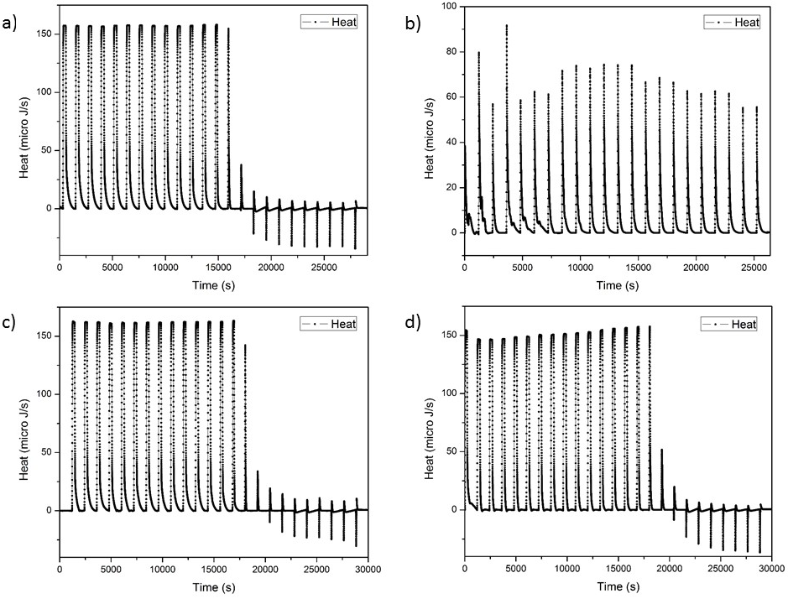
Heat aggregation of extracted collagen by isotherm titration calorimetry (Nano ITC) sensed from the injection of: a) the base solution over the acid, b) the acid solution over collagen, c) the base solution over the acid collagen solution, d) the base solution over the collagen gelatin, obtained from Wistar Hannover rat tail

