Ultrafast charge transfer dynamics in 2D Covalent Organic Frameworks/Re-complex hybrid photocatalyst for CO₂ reduction: hot electrons vs. cold electrons

Qinying Pan,^{a#} Mohamed Abdellah,^{b,c#} Yuehan Cao,^{d} Yang Liu,^{d} Weihua Lin,^{b} Jie Meng,ª Quan Zhou,^{e} Zonglong Li, ^{f} Hao Cui, ^{f} David Ackland Tanner,ª Mahmoud Abdel-hafiez,^{g} Ying Zhou ^{d},Tonu Pullerits,^{b} Sophie E. Canton, ^{h} Hong Xu,^{*f} and Kaibo Zheng,^{*a,b}
ª Department of Chemistry, Technical University of Denmark, DK-2800 Kongens Lyngby, Denmark.
^{b} Chemical Physics and NanoLund, Lund University, Box 124, 22100, Lund, Sweden
^{c} Department of Chemistry, Qena Faculty of Science, South Valley University, 83523, Qena, Egypt
^{d} State Key Laboratory of Oil and Gas Reservoir Geology and Exploitation, Southwest Petroleum University, Chengdu, 610500, China.
^{e} Department of Energy Conversion and Storage, Technical University of Denmark, DK-2800 Kongens Lyngby, Denmark.
^{f} Institute of Nuclear and New Energy Technology, Tsinghua University, Beijing 100084, China
g Uppsala University, Department of Physics and Astronomy, Box 516, SE-751 20 Uppsala, Sweden
^{h} European XFEL, Holzkoppel 4, 22869 Schenefeld, Germany

Supplementary Information
Table of Contents
Materials and methods 2
Computational methods 3
Characterization 3
Supplementary Figures 6
Supplementary Table 11

Materials and methods
5,5′-diamino-2,2′-bipyridine (95%, Yuhao Chemical), Pentacarbonylchlororhenium (98%, Sigma-Aldrich), 2,2′-bipyridine (≥ 99%, Sigma-Aldrich), Triformylphloroglucinol (95%, Yuhao Chemical), Mesitylene (98%, Sigma-Aldrich), 1,4- Dioxane (anhydrous, 99.8%, Sigma-Aldrich), glacial acetic acid (ACS reagent, Aldrich), Nafion (10 wt% in H₂O), 1-Propanol ( for HPLC, ≥ 99.9%, Sigma-Aldrich), Toluene (for HPLC, VWR Chemicals), Methanol (for HPLC, VWR Chemicals), Tetrahydrofuran (for HPLC, VWR Chemicals).
Synthesis of Re(bpy)(CO)₃Cl. This complex was prepared with slight modifications to literature methods^{1,2}. Re(CO)₅Cl (0.3020 g, 0.83 mmol) was dissolved in 50 mL of hot toluene, then 2,2-bipyridine (0.130 g, 0.83 mmol) was added, the mixture was stirred and reflux for 1h to get yellow product. Upon cooling, the product was filtered, washed with methanol for 3 times, dried under vacuum at 60 °C overnight and used without further purification. ¹H NMR (δ, 400 MHz, DMSO-d₆): 9.02 (d, 1H), 8.77 (d, 1H), 8.34(t, 1H), 7.76(t, 1H).
Synthesis of TpBpy. TpBpy was prepared according to literature methods with a little modification³. A Pyrex tube (o.d. × i.d. = 10 × 8 mm² and length 25 cm)) was charged with triformylphloroglucinol (Tp) (21 mg, 0.10 mmol), 5,5′- diamino-2,2′- bipyridine (Bpy) (27.9 mg, 0.15 mmol), 0.5 mL 1,4-dioxane, 0.5 mL mesitylene, 0.1mL 6 M aqueous acetic acid. This mixture was sonicated for 20 min in order to get a homogeneous dispersion. The tube was flash-frozen in a liquid nitrogen bath, evacuated to an internal pressure of ca.0.15 mmHg and flame-sealed. The tube was placed in an oven at 120 °C for 5 days upon warming to room temperature to afford an orange-red precipitate. The precipitate was isolated by filtration over a medium glass frit and washed with anhydrous tetrahydrofuran (THF, 20.0 mL). The product was immersed in anhydrous THF (20.0 mL) for 8 h, during which the activation solvent was decanted and freshly replenished four times. The solvent was removed by filtration and the precipitate dried under vacuum at 60 °C overnight to afford TpBpy (42 mg, 86%).
Synthesis of Re-TpBpy. The process of synthesis Re-TpBpy was similar to that of Re-Bpy. Re(CO)₅Cl (10 mg, 0.025 mmol) were dispersed in 10 mL hot toluene, then TpBpy (25 mg) was added, the mixture was refluxed 40 min while stirring. The orange products were filtered, washed with methanol for 3 times, dried under vacuum at 60 °C overnight, and used without further purification.
Photocatalytic Reduction of CO₂. The method of photocatalytic reduction of CO₂ was carried out according to literature methods with a little modification. Re-TpBpy (1 mg) was dispersed in 3 mL of CH₃CN, and 0.2 mL of TEOA (triethanolamine) in 11 mL septum-sealed glass vials. The mixture was purged with Ar for 5 min and CO₂ for 15 min first, then irradiated by a LED lamp with 520 nm and 440 wavelengths for 8 h and kept stirring during the photocatalytic reaction. The amount of CO generated was quantified using Shimadzu gas chromatography (GC-2010) by analyzing 500 μL of the headspace.

Computational methods
To investigate the relationship of the optical properties with molecular structures and electronic structures, we used a triformylphloroglucinol (Tp) terminated bipyridine (Bpy) molecular fragment (Fig. S10) to represent the COF structure. An implicit solvent model was used to reflect the solvation environment, and implemented using SMD solvation model⁴ in Gaussian 16 package⁵. Considering the transition metal complex in the fragment, M06-L^{6–11} was selected as the functional and def 2-TZVP^{12,13} was selected as the basis set for DFT calculations. Water and n-propanol parameters were used to represent the solvents in the SMD models¹⁴. Time-dependent density functional theory (TD-DFT) calculations were also performed using these parameters. The UV-vis absorption spectra and electron excitations were analyzed using the Multiwfn program¹⁵.

Characterization
PXRD data were collected by using Rigaku Miniflex600 at room temperature with Cu Kα1 source (λ = 1.5418 Å) over the range of 2θ = 3.0−40.0° with a step size of 0.02° and a counting time of 1 s per step. Fourier-Transformed Infrared Spectroscopy (FT-IR) data were obtained by using ALPHA P FT-IR spectrometer (Bruker). The sample material just has to be brought into contact with the measurement interface. X-ray photoelectron spectroscopy (XPS) data were obtained by using XPS-ThermoScientific with Al Kα (1486 eV) as the excitation X-ray source. The peak of C 1s at about 284.8 eV was used to calibrate the energy scale. The pressure of the analysis chamber was maintained at 2×10⁻¹⁰ mbar during measurement. The sample material was prepared by dispersing it in ethanol and then dripping it onto a silicon wafer sprayed with 39.7 nm gold by Quorum Coater, then dried in air. The XPS data were performed to analyze the valence band maximum (VBM) position corresponding to the Fermi level and compositions of samples. The absorption spectra were measured in a UV-Vis absorption spectrophotometer from Agilent Technologies (Santa Clara, USA). Photoluminescence (PL) was performed via Spex Fluorolog 1681 standard spectrofluorometer. Time-correlated single-photon counting (TCSPC) was performed triggered externally at 2.5 MHz to excite the sample at 438 nm. The emitted photons were detected by a fast avalanche photodiode (SPAD, Micro Photon Device) with a response time less than 50 ps after passing through a 470 nm long bandpass filter. The Time-resolved Photoluminescence (TRPL) measurements were performed by time-correlated single-photon counting (Picoharp) using a pulsed diode laser (Wavelength: 438 nm; Frequency: 2.5 MHz; Pulse duration: 40 ps; A long-pass filter from 450 nm) and a fast avalanche photodiode. It is important to note that during all photophysical measurements, the sample material was dispersed in Nafion (5% w/w in water and 1-propanol), except Tp was dispersed in acetonitrile.
Scanning electron microscopy (SEM) images were obtained by using AFEG 250 Analytical ESEM at an accelerating voltage of 20.0 kV shown in Figure S4. Transmission electron microscopy (TEM) images and Energy dispersive X-ray (EDX) mapping images were obtained with a Tecnai G2 T20 TEM shown in Figure S5 and Figure S6, respectively. Compared the SEM image of Re-TpBpy with the original TpBpy, the Re-modified TpBpy did not observe any significant changes in morphology (see Figure S4). In addition, the TEM image did not show the presence of any metal oxide particles in the COF matrix (see Figure S5). However, TEM-EDX mapping reveals a uniform distribution of Re content in Re-TpBpy (see Figure S6).
Nuclear Magnetic Resonance (NMR) spectroscopy were acquired on Bruker AVANCE 400 MHz spectrometer with a 5 mm CryoProbe Prodigy using approximately 1 mg sample dissolved in 2 mL of deuterated dimethyl sulfoxide (DMSO-d₆).
Transient absorption (TA) spectroscopy measurements. Time-resolved experiments were carried out on laser-based spectroscopy, with laser pulse fluence as low as 2×10¹³ ph/cm². Samples for transient absorption experiments were kept in dark between each measurement. A Coherent Legend Ti: Sapphire amplifier (800 nm,100 fs pulse length, 3 kHz repetition rate) was used. The output is split to pump and probe beams. Excitation pulses at the wavelength of 400 and 530 nm were acquired using an optical parametric amplifier (Topas C, Light Conversion). The probe pulses (a broad supercontinuum spectrum) were generated from the 800-nm pulses in a CaF₂ crystal and split by a beam splitter into a probe pulse and a reference pulse. The probe pulse and the reference pulse were dispersed in a spectrograph and detected by a diode array. Instrumental response time is ∼ 100 fs. Global SVD analysis was performed with the Glotaran software package (http://glotaran.org).
Transient Mid-IR Absorption Spectroscopy. A frequency-doubled Q-switched Nd:YAG laser (Quanta-Ray ProSeries, Spectra- Physics) was employed to obtain 400 nm and 530 nm pump light, 10 mJ/pulse with a FWHM of 100 fs. The 400 nm and 530 nm pump light was generated through the MOPO to pump the sample. Probing was done with the continuous wave quantum cascade (QC) IR laser with a tuning capability between 1960 and 2150 cm⁻¹ (Daylight Solutions). For IR detection, a liquid nitrogen-cooled mercurycadmium- telluride (MCT) detector (KMPV10-1-J2, Kolmar Technologies, Inc.) was used. The IR probe light was overlapped with the pump beam in a quasi-co-linear arrangement at 25° angle. Transient absorption traces were acquired with a Tektronix TDS 3052 500 MHz (5GS/s) oscilloscope in connection with the L900 software (Edinburgh Instruments) and processed using Origin 9 software ^{16,17}. Samples were kept in a modified Omni cell (Specac) with with O-ring sealed CaF2 windows and a path length of 1 mm. All samples were prepared in an Ar-filled glove box (Unilab, MBraun), and Nafion (5% w/w in water and 1-propanol) was used as a solvent in all experiments. All acids were dried overnight under a vacuum before use.

Supplementary Figures
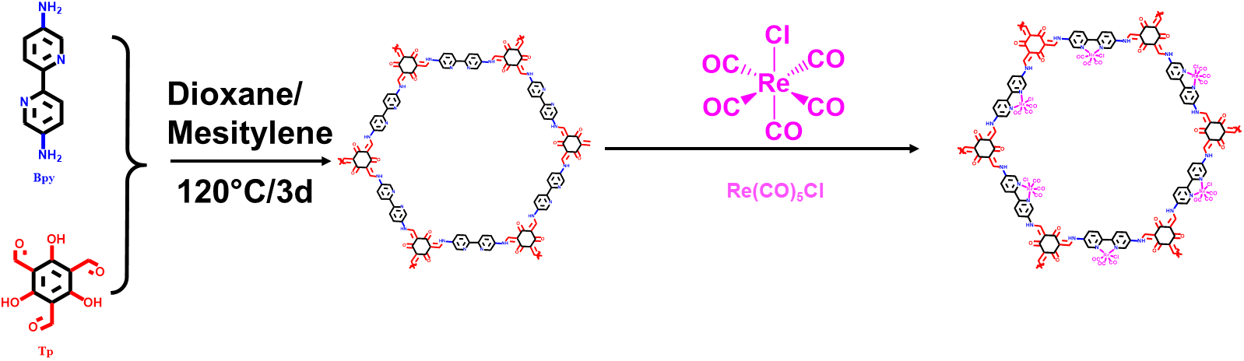
Supplementary Figure 1：Synthesis scheme for TpBpy and Re-TpBpy.

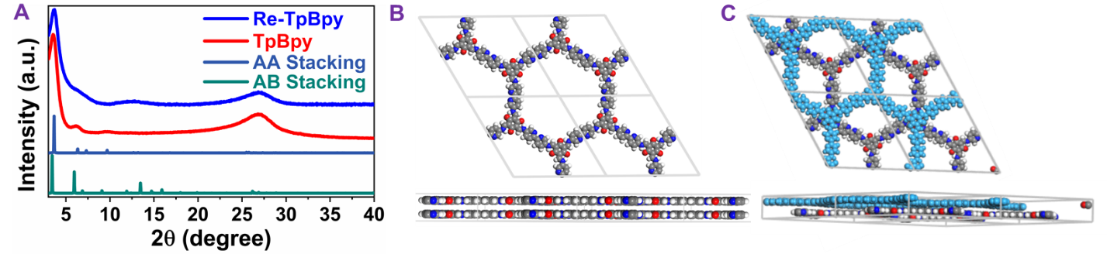
Supplementary Figure 2：A, PXRD of TpBpy (red curve), Re-TpBpy (blue curve), simulated AA
stacking modeand (Dark blue curve) and simulated AB stacking mode (Dark green curve). Simulated structure of AA (B) and AB stacking (C) using Materials Studio software package¹⁸.

The powder X-ray diffraction (PXRD) patterns of both TpBpy and Re-TpBpy in Fig. 1b match well with the simulated AA stacking structure of COFs in the hexagonal space group (P6). The pronounced peak at 2θ of 3.6° of both samples can be assigned to the (100) plane of the TpBpy, which demonstrates that the crystalline structure of TpBpy is unchanged after Re-complex incorporation. The broad peak between 2θ = 25.1°-28.1° is attributed to the π-π stacking interlayers along the (001) plane¹⁹.
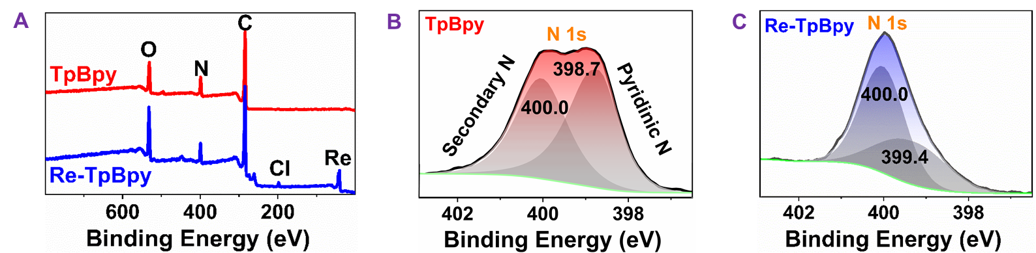 Supplementary Figure 3：A, overview XPS spectrum of TpBpy and Re-TpBpy, (B) and (C) correspond to the XPS N 1s core level spectra of TpBpy and Re-TpBpy, respectively.

The overview spectrum of Re-TpBpy displays the existence of Re and Cl elements in addition to C, O, N in pristine TpBpy, suggesting the acyual incorporation of the Re-complex in the host COF. More importantly (Figure 3A), the two N 1S bands observed at 400.03 eV and 398.71 eV can be ascribed to the secondary nitrogen and pyridinic nitrogen in TpBpy, respectively^{20,21}. In Re-TpBpy, the pyridinic nitrogen band is shifted to higher binding every (i.e. from 398.71 eV to 399.39 eV), while the peak position of the secondary nitrogen (Fig. B and C) remains unchanged. This indicates that the Re-complex is anchored to the TpBpy only through its bipyridinic units²².

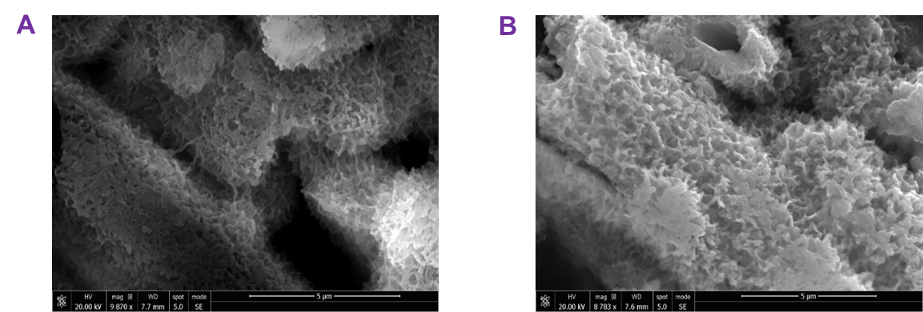Supplementary Figure 4: SEM imange of TpBpy (A) and Re-TpBpy (B).
Supplementary Figure 5: HR-TEM image of TpBpy (A) and Re-TpBpy (B).

Supplementary Figure 6: Emission spectra of TpBpy and Re-TpBpy calibrated by the absorption at the 400 nm excitation wavelength.

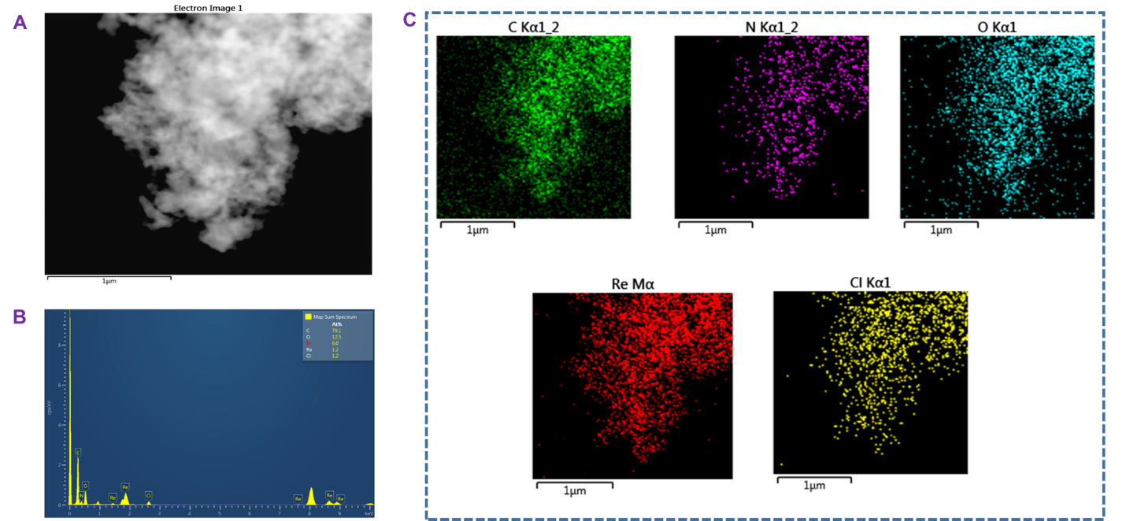
Supplementary Figure 7: TEM imange of Re-TpBpy (A), EDX Spectrum of Re-TpBpy (B). The element analysis results of Re-TpBpy.
Supplementary Figure 8: Two-dimensional transient absorption (TA) spectra under 530 nm excitation 500 uW of TpBpy (A). TA kinetics at B1 535 nm for TpBpy excited with two different excitation intensities. A clear faster decay can be observed at high excitation intensity, indicating the existence of high order recombination process.
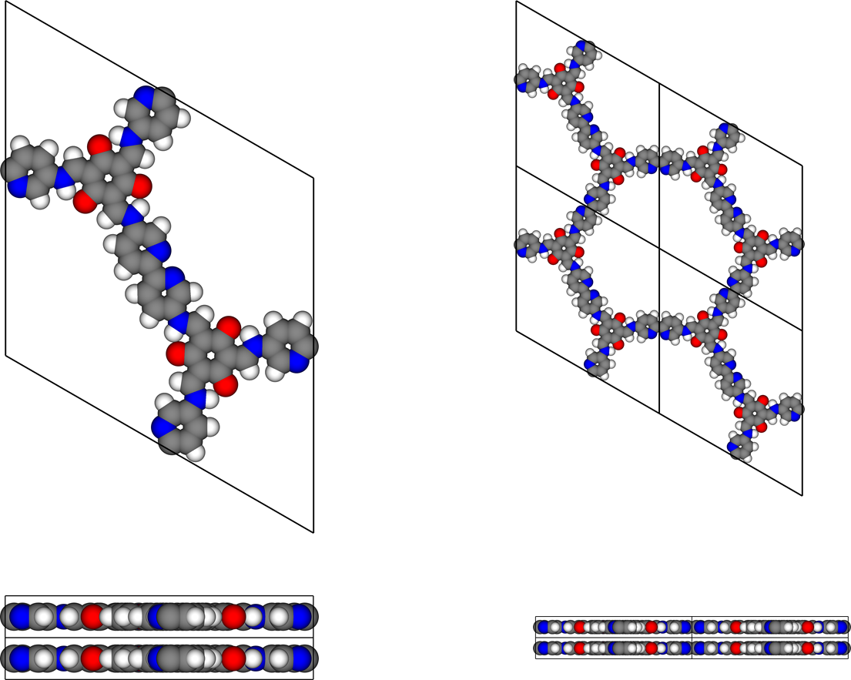
Supplementary Figure 9: Crystalline Structures of TpBpy, top-view and side-view.

Supplementary Table
Supplementary Table 1: Calculated DFT energy levels of TpBpy fragment.
Orbital Name | Orobital Number | Energy (eV) | iso-surface images
LUMO+12 | 240 | -0.96886231 | 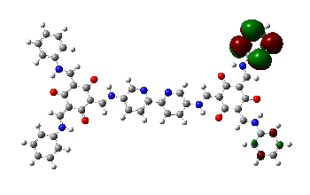
LUMO+11 | 239 | -0.969700086 | 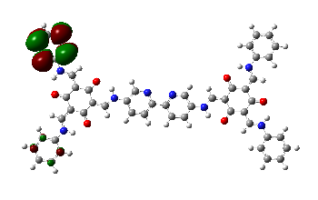
LUMO+10 | 238 | -0.972883907 | 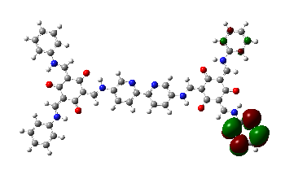
LUMO+9 | 237 | -0.973715102 | 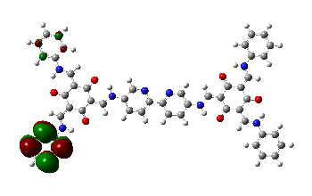
LUMO+8 | 236 | -1.068732822 | 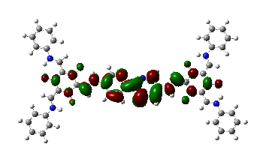
LUMO+7 | 235 | -1.333214011 | 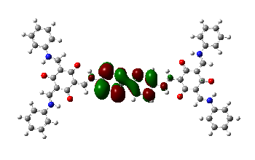
LUMO+6 | 234 | -1.621848404 | 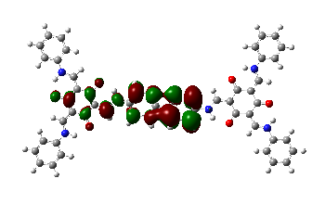
LUMO+5 | 233 | -1.995218628 | 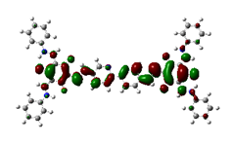
LUMO+4 | 232 | -2.034934733 | 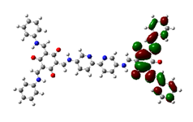
LUMO+3 | 231 | -2.035340048 | 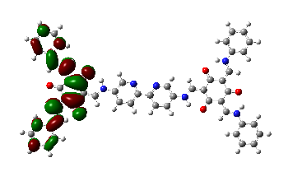
LUMO+2 | 230 | -2.237486536 | 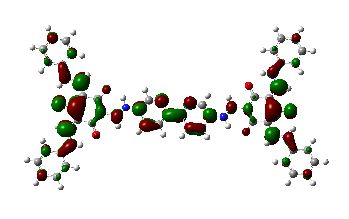
LUMO+1 | 229 | -2.576204276 | 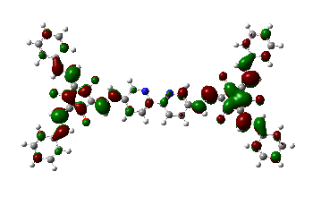
LUMO | 228 | -2.799618969 | 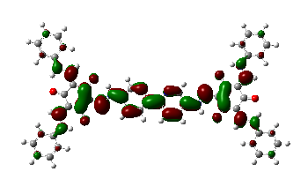
HOMO | 227 | -5.045478166 | 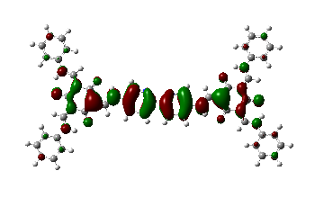
HOMO-1 | 226 | -5.172556295 | 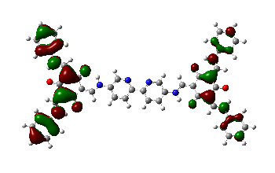
HOMO-2 | 225 | -5.172573899 | 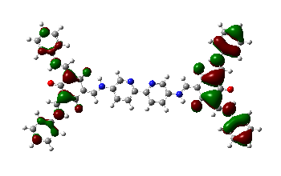
HOMO-3 | 224 | -5.365218278 | 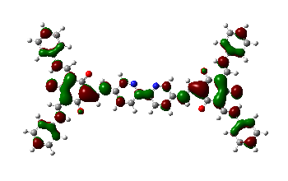
HOMO-4 | 223 | -5.670073594 | 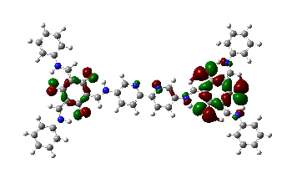
HOMO-5 | 222 | -5.676649 | 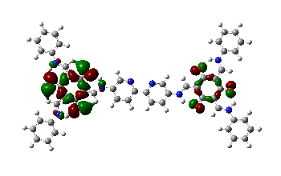
HOMO-6 | 221 | -5.718600616 | 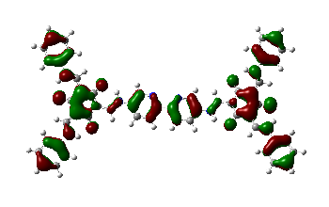
HOMO-7 | 220 | -5.940760198 | 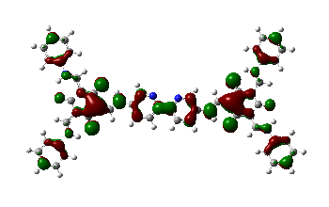
HOMO-8 | 219 | -6.053834645 | 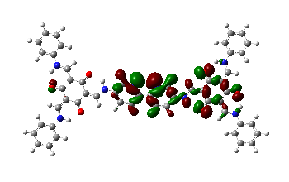
HOMO-9 | 218 | -6.200828562 | 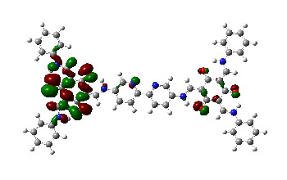
HOMO-10 | 217 | -6.205291056 | 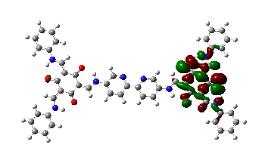
HOMO-11 | 216 | -6.22438551 | 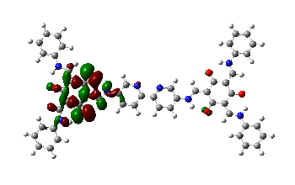
HOMO-12 | 215 | -6.279711603 | 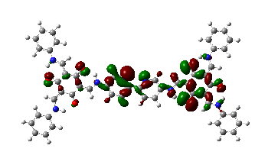

Supplementary Table 2: Calculated DFT energy levels of Re-TpBpy fragment.
Orbital Name | Orobital Number | Energy (eV) | iso-surface images
LUMO+12 | 277 | -0.98413959 | 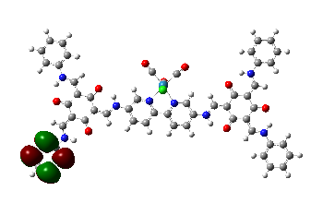
LUMO+11 | 276 | -0.986257352 | 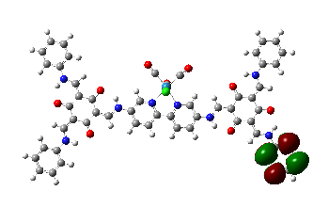
LUMO+10 | 275 | -1.078184819 | 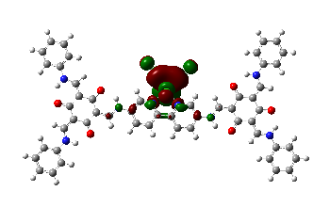
LUMO+9 | 274 | -1.283727355 | 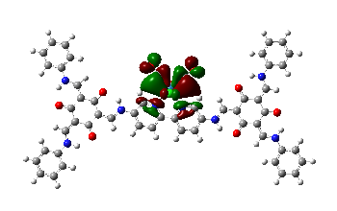
LUMO+8 | 273 | -1.402089054 | 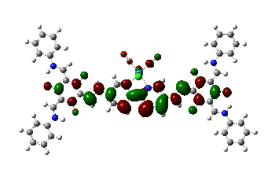
LUMO+7 | 272 | -1.867455072 | 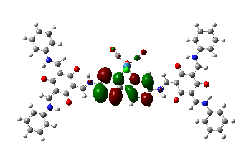
LUMO+6 | 271 | -1.993478502 | 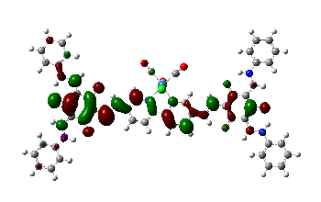
LUMO+5 | 270 | -2.067937563 | 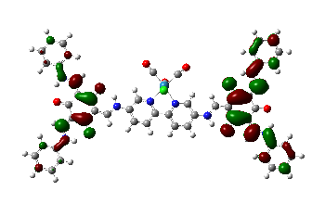
LUMO+4 | 269 | -2.068107788 | 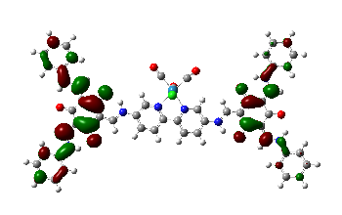
LUMO+3 | 268 | -2.196090793 | 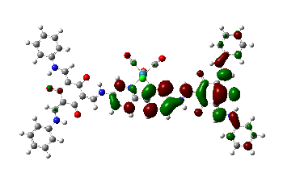
LUMO+2 | 267 | -2.455782405 | 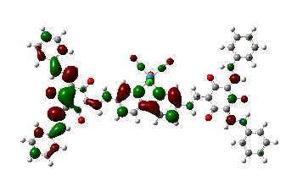
LUMO+1 | 266 | -2.655408515 | 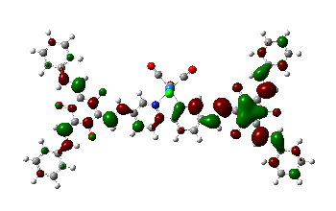
LUMO | 265 | -3.092359577 | 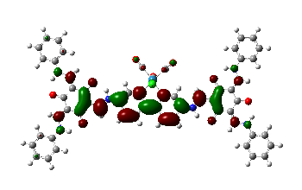
HOMO | 264 | -5.197598202 | 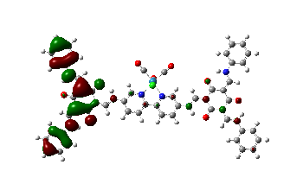
HOMO-1 | 263 | -5.19983685 | 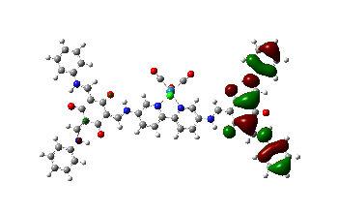
HOMO-2 | 262 | -5.206329891 | 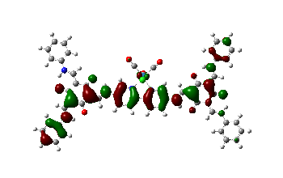
HOMO-3 | 261 | -5.429726984 | 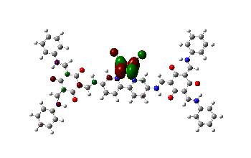
HOMO-4 | 260 | -5.450935274 | 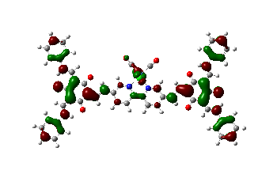
HOMO-5 | 259 | -5.529614132 | 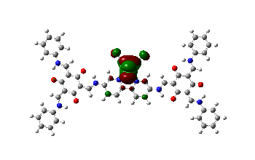
HOMO-6 | 258 | -5.724384074 | 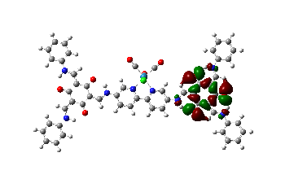
HOMO-7 | 257 | -5.72505861 | 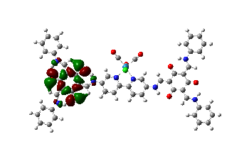
HOMO-8 | 256 | -5.811185661 | 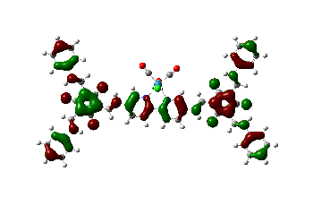
HOMO-9 | 255 | -5.893560943 | 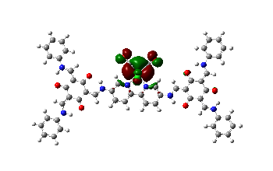
HOMO-10 | 254 | -6.051646689 | 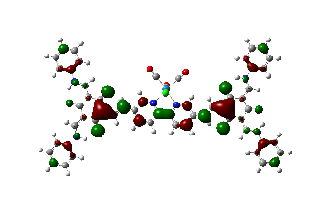
HOMO-11 | 253 | -6.242005536 | 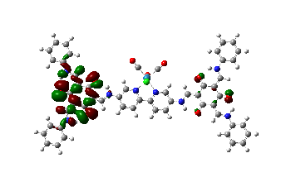
HOMO-12 | 252 | -6.242635938 | 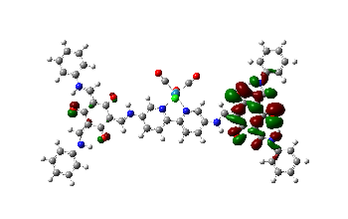

Table S3 | Atomistic coordinates of TpBp-n-propanol.

Atom | x/a | y/b | z/c
C | 12.82607 | 8.28556 | 2.55511
C | 13.45496 | 7.06020 | 2.78772
C | 14.82914 | 6.98689 | 2.77993
C | 15.57025 | 8.13988 | 2.53708
C | 14.86423 | 9.32363 | 2.31420
N | 13.54423 | 9.39525 | 2.32468
N | 16.95759 | 8.05678 | 2.53155
C | 17.82925 | 9.04245 | 2.34057
C | 19.20221 | 8.90143 | 2.34951
C | 19.83544 | 7.61748 | 2.57592
O | 19.41644 | 11.21299 | 1.93258
H | 17.39390 | 7.14591 | 2.69329
C | 11.35888 | 8.41665 | 2.55693
N | 10.84719 | 9.64553 | 2.72987
C | 9.53595 | 9.79424 | 2.73398
C | 8.63153 | 8.74398 | 2.56386
C | 9.15480 | 7.46825 | 2.37948
C | 10.52345 | 7.31106 | 2.37884
N | 7.27541 | 9.04021 | 2.58461
C | 6.26091 | 8.19419 | 2.43942
C | 4.92571 | 8.54401 | 2.45996
C | 4.50097 | 9.91679 | 2.65064
O | 4.35359 | 6.28294 | 2.11228
H | 6.98782 | 10.01278 | 2.71924
H | 12.87726 | 6.17008 | 2.99502
H | 15.33747 | 6.04880 | 2.96769
H | 15.38984 | 10.25146 | 2.11454
H | 17.43134 | 10.03433 | 2.16596
H | 9.15278 | 10.80138 | 2.88183
H | 8.51277 | 6.61066 | 2.23157
H | 10.93942 | 6.32606 | 2.21804
H | 6.50186 | 7.14816 | 2.29282
C | 25.17733 | 2.46452 | 3.50020
C | 25.86933 | 3.63980 | 3.24436
C | 25.18371 | 4.82098 | 3.02469
C | 23.78974 | 4.83829 | 3.05894
C | 23.09088 | 3.66029 | 3.31675
C | 23.78958 | 2.48538 | 3.53452
N | 23.15734 | 6.06423 | 2.82988
C | 21.85689 | 6.31513 | 2.79629
C | 21.28822 | 7.55687 | 2.57191
C | 22.09939 | 8.73511 | 2.34742
O | 19.14747 | 6.58811 | 2.77095
H | 23.74065 | 6.88773 | 2.66708
H | 26.95160 | 3.64009 | 3.21484
H | 25.71928 | 5.74115 | 2.82398
H | 22.01009 | 3.65359 | 3.35105
H | 21.18355 | 5.48187 | 2.95679
C | 0.04363 | 15.87067 | 3.39866
C | -0.82902 | 14.80996 | 3.20089
C | -0.34174 | 13.52688 | 3.02797
C | 1.03246 | 13.29143 | 3.05180
C | 1.91247 | 14.35353 | 3.25108
C | 1.41123 | 15.63239 | 3.42207
N | 1.46192 | 11.97301 | 2.87193
C | 2.70732 | 11.52291 | 2.83768
C | 3.07493 | 10.20092 | 2.65645
C | 2.08920 | 9.15531 | 2.48019
O | 5.34182 | 10.83295 | 2.80681
H | 0.75538 | 11.24494 | 2.74837
H | -1.01779 | 12.69466 | 2.87235
H | 2.98116 | 14.18948 | 3.27422
H | 2.10149 | 16.45222 | 3.57633
H | 3.50218 | 12.24865 | 2.96017
C | -0.88193 | 2.37933 | 1.39553
C | 0.48865 | 2.16471 | 1.36233
C | 1.36591 | 3.21891 | 1.54322
C | 0.87717 | 4.50677 | 1.76077
C | -0.49874 | 4.72642 | 1.79675
C | -1.36508 | 3.66256 | 1.61334
N | 1.81513 | 5.52899 | 1.93622
C | 1.58419 | 6.82018 | 2.12301
C | 2.55698 | 7.78994 | 2.29141
C | 3.96579 | 7.46304 | 2.27749
O | 0.86382 | 9.41825 | 2.48944
H | 2.80732 | 5.28467 | 1.92048
H | 2.43699 | 3.05690 | 1.51728
H | -0.89682 | 5.71716 | 1.96830
H | -2.43249 | 3.84183 | 1.64282
H | 0.55064 | 7.14407 | 2.14429
C | 23.98050 | 15.84298 | 0.99744
C | 22.59505 | 15.86256 | 1.07404
C | 21.89144 | 14.69437 | 1.30601
C | 22.57163 | 13.48768 | 1.46447
C | 23.96270 | 13.46287 | 1.38593
C | 24.65440 | 14.63928 | 1.15440
N | 21.80353 | 12.34220 | 1.69475
C | 22.23372 | 11.10816 | 1.91167
C | 21.42496 | 10.00536 | 2.12426
C | 19.98252 | 10.11167 | 2.12301
O | 23.35077 | 8.66340 | 2.34530
H | 20.78577 | 12.43383 | 1.70162
H | 22.05530 | 16.79321 | 0.95291
H | 20.80989 | 14.70286 | 1.36812
H | 24.50650 | 12.53533 | 1.50045
H | 23.30532 | 10.94997 | 1.92505
H | 25.71343 | 1.54035 | 3.67234
H | 23.23899 | 1.57478 | 3.73477
H | -0.33747 | 16.87448 | 3.53368
H | -1.89803 | 14.98007 | 3.18032
H | -1.56841 | 1.55483 | 1.25402
H | 0.88091 | 1.16969 | 1.19436
H | 24.53110 | 16.75672 | 0.81572
H | 25.73515 | 14.61171 | 1.09417

Table S4 | Atomistic coordinates of Re-TpBpy-n-propanol.

Atom | x/a | y/b | z/c
Re | 11.90630 | 11.62434 | 2.51252
C | 13.34728 | 12.87699 | 2.65634
C | 10.70622 | 13.11024 | 2.63530
Cl | 11.85313 | 11.15375 | 5.00108
C | 11.93848 | 11.86514 | 0.62711
O | 14.22872 | 13.62434 | 2.73320
O | 11.95970 | 12.03195 | -0.52248
C | 12.36680 | 8.57097 | 2.46530
C | 13.03362 | 7.34795 | 2.47652
C | 14.40565 | 7.31227 | 2.47218
C | 15.12441 | 8.50731 | 2.45467
C | 14.40366 | 9.69781 | 2.44060
N | 13.07256 | 9.72446 | 2.44783
N | 16.50632 | 8.45742 | 2.44959
C | 17.36165 | 9.48123 | 2.46355
C | 18.73202 | 9.35907 | 2.44970
C | 19.38389 | 8.06148 | 2.41564
O | 18.91614 | 11.71015 | 2.50207
H | 16.96229 | 7.54094 | 2.43391
C | 10.91775 | 8.69992 | 2.46339
N | 10.42593 | 9.96032 | 2.43986
C | 9.11168 | 10.15747 | 2.43069
C | 8.19155 | 9.11228 | 2.44498
C | 8.68571 | 7.80901 | 2.47030
C | 10.04599 | 7.61402 | 2.47873
N | 6.84848 | 9.43816 | 2.43322
C | 5.81511 | 8.59586 | 2.46421
C | 4.49171 | 8.97248 | 2.45092
C | 4.09511 | 10.36854 | 2.39502
O | 3.87220 | 6.69893 | 2.54400
H | 6.57596 | 10.42454 | 2.39973
H | 12.47678 | 6.42289 | 2.48958
H | 14.93470 | 6.36784 | 2.48236
H | 14.89880 | 10.65805 | 2.42199
H | 16.94924 | 10.48225 | 2.48916
H | 8.76698 | 11.18404 | 2.41323
H | 8.02260 | 6.95584 | 2.48210
H | 10.43444 | 6.60660 | 2.49837
H | 6.03485 | 7.53606 | 2.50520
C | 24.76904 | 2.88971 | 2.22634
C | 25.45391 | 4.09655 | 2.22124
C | 24.76135 | 5.29355 | 2.25852
C | 23.36784 | 5.29346 | 2.30188
C | 22.67577 | 4.08401 | 2.30785
C | 23.38128 | 2.89383 | 2.26999
N | 22.72415 | 6.53444 | 2.33863
C | 21.42157 | 6.76927 | 2.36306
C | 20.83528 | 8.02333 | 2.39733
C | 21.63021 | 9.23375 | 2.41268
O | 18.70857 | 7.00644 | 2.40184
H | 23.29750 | 7.38084 | 2.34571
H | 26.53596 | 4.10934 | 2.18779
H | 25.29117 | 6.23856 | 2.25418
H | 21.59506 | 4.06587 | 2.34335
H | 20.76148 | 5.91038 | 2.35454
C | -0.27387 | 16.43984 | 2.20549
C | -1.15916 | 15.37166 | 2.23481
C | -0.68537 | 14.07275 | 2.27584
C | 0.68756 | 13.82876 | 2.28802
C | 1.58038 | 14.89849 | 2.25971
C | 1.09234 | 16.19315 | 2.21842
N | 1.09932 | 12.49278 | 2.32993
C | 2.33579 | 12.02015 | 2.34076
C | 2.67653 | 10.67841 | 2.38929
C | 1.66925 | 9.63901 | 2.43575
O | 4.95686 | 11.27640 | 2.35245
H | 0.38072 | 11.76636 | 2.35888
H | -1.37126 | 13.23425 | 2.29864
H | 2.64848 | 14.73007 | 2.27035
H | 1.79204 | 17.01917 | 2.19666
H | 3.14639 | 12.73816 | 2.31010
C | -1.45038 | 2.85445 | 2.82253
C | -0.08566 | 2.60513 | 2.79391
C | 0.81477 | 3.65284 | 2.72234
C | 0.35515 | 4.96856 | 2.67863
C | -1.01454 | 5.22371 | 2.70831
C | -1.90435 | 4.16581 | 2.77945
N | 1.31579 | 5.98285 | 2.60783
C | 1.11268 | 7.29001 | 2.54923
C | 2.10711 | 8.25181 | 2.49334
C | 3.50695 | 7.89552 | 2.49855
O | 0.44952 | 9.92515 | 2.42745
H | 2.30196 | 5.71531 | 2.60432
H | 1.88145 | 3.46366 | 2.69980
H | -1.38992 | 6.23739 | 2.67764
H | -2.96700 | 4.37220 | 2.80223
H | 0.08613 | 7.63581 | 2.54630
C | 23.44139 | 16.48300 | 2.58323
C | 22.05455 | 16.47459 | 2.62818
C | 21.36202 | 15.27737 | 2.60302
C | 22.05485 | 14.06960 | 2.53203
C | 23.44789 | 14.07316 | 2.48661
C | 24.12811 | 15.27837 | 2.51294
N | 21.29573 | 12.89447 | 2.50883
C | 21.73675 | 11.64677 | 2.46992
C | 20.93991 | 10.51475 | 2.45098
C | 19.49817 | 10.60264 | 2.47005
O | 22.88169 | 9.17994 | 2.39436
H | 20.27761 | 12.97604 | 2.52581
H | 21.50479 | 17.40559 | 2.68345
H | 20.27934 | 15.26388 | 2.63921
H | 24.00313 | 13.14681 | 2.42971
H | 22.80950 | 11.49906 | 2.45347
H | 25.31104 | 1.95352 | 2.19736
H | 22.83649 | 1.95816 | 2.27540
H | -0.64407 | 17.45620 | 2.17330
H | -2.22727 | 15.54817 | 2.22568
H | -2.15491 | 2.03494 | 2.87864
H | 0.28373 | 1.58804 | 2.82746
H | 23.98364 | 17.41931 | 2.60267
H | 25.21026 | 15.27308 | 2.47690
O | 9.96839 | 14.00103 | 2.69623

References
1. Schneider, T. W., Ertem, M. Z., Muckerman, J. T. & Angeles-Boza, A. M. Mechanism of Photocatalytic Reduction of CO2 by Re(bpy)(CO)3Cl from Differences in Carbon Isotope Discrimination. ACS Catal. 6, 5473–5481 (2016).
2. Yang, S. et al. 2D Covalent Organic Frameworks as Intrinsic Photocatalysts for Visible Light-Driven CO2 Reduction. J. Am. Chem. Soc. 140, 14614–14618 (2018).
3. Zhong, W. et al. A Covalent Organic Framework Bearing Single Ni Sites as a Synergistic Photocatalyst for Selective Photoreduction of CO2 to CO. J. Am. Chem. Soc. 141, 7615–7621 (2019).
4. Marenich, A. V, Cramer, C. J. & Truhlar, D. G. Universal Solvation Model Based on Solute Electron Density and on a Continuum Model of the Solvent Defined by the Bulk Dielectric Constant and Atomic Surface Tensions. J. Phys. Chem. B 113, 6378–6396 (2009).
5. Frisch, M. J. et al. G16_C01. Gaussian 16, Revision C.01, Gaussian, Inc., Wallin (2016).
6. Zhao, Y. & Truhlar, D. G. A new local density functional for main-group thermochemistry, transition metal bonding, thermochemical kinetics, and noncovalent interactions. J. Chem. Phys. 125, 194101 (2006).
7. Zhao, Y. & Truhlar, D. G. The M06 suite of density functionals for main group thermochemistry, thermochemical kinetics, noncovalent interactions, excited states, and transition elements: two new functionals and systematic testing of four M06-class functionals and 12 other function. Theor. Chem. Acc. 120, 215–241 (2008).
8. Tao, Y., Zou, W., Luo, G.-G. & Kraka, E. Describing Polytopal Rearrangement Processes of Octacoordinate Structures. I. Renewed Insights into Fluxionality of the Rhenium Polyhydride Complex ReH5(PPh3)2(Pyridine). Inorg. Chem. 60, 2492–2502 (2021).
9. Agarwal, J., Fujita, E., Schaefer, H. F. & Muckerman, J. T. Mechanisms for CO Production from CO2 Using Reduced Rhenium Tricarbonyl Catalysts. J. Am. Chem. Soc. 134, 5180–5186 (2012).
10. Dürr, A. B., Fisher, H. C., Kalvet, I., Truong, K.-N. & Schoenebeck, F. Divergent Reactivity of a Dinuclear (NHC)Nickel(I) Catalyst versus Nickel(0) Enables Chemoselective Trifluoromethylselenolation. Angew. Chem. Int. Ed. Engl. 56, 13431–13435 (2017).
11. Cammarota, R. C. et al. A Bimetallic Nickel–Gallium Complex Catalyzes CO2 Hydrogenation via the Intermediacy of an Anionic d10 Nickel Hydride. J. Am. Chem. Soc. 139, 14244–14250 (2017).
12. Weigend, F. & Ahlrichs, R. Balanced basis sets of split valence, triple zeta valence and quadruple zeta valence quality for H to Rn: Design and assessment of accuracy. Phys. Chem. Chem. Phys. 7, 3297–3305 (2005).
13. Weigend, F. Accurate Coulomb-fitting basis sets for H to Rn. Phys. Chem. Chem. Phys. 8, 1057–1065 (2006).
14. Borodin, O., Behl, W. & Jow, T. R. Oxidative Stability and Initial Decomposition Reactions of Carbonate, Sulfone, and Alkyl Phosphate-Based Electrolytes. J. Phys. Chem. C 117, 8661–8682 (2013).
15. Lu, T. & Chen, F. Multiwfn: A multifunctional wavefunction analyzer. J. Comput. Chem. 33, 580–592 (2012).
16. Mirmohades, M. et al. Direct Observation of Key Catalytic Intermediates in a Photoinduced Proton Reduction Cycle with a Diiron Carbonyl Complex. J. Am. Chem. Soc. 136, 17366–17369 (2014).
17. Mirmohades, M. et al. Following [FeFe] Hydrogenase Active Site Intermediates by Time-Resolved Mid-IR Spectroscopy. J. Phys. Chem. Lett. 7, 3290–3293 (2016).
18. Shinde, D. B. et al. A mechanochemically synthesized covalent organic framework as a proton-conducting solid electrolyte. J. Mater. Chem. A 4, 2682–2690 (2016).
19. Chandra, S. et al. Chemically Stable Multilayered Covalent Organic Nanosheets from Covalent Organic Frameworks via Mechanical Delamination. J. Am. Chem. Soc. 135, 17853–17861 (2013).
20. Aiyappa, H. B., Thote, J., Shinde, D. B., Banerjee, R. & Kurungot, S. Cobalt-Modified Covalent Organic Framework as a Robust Water Oxidation Electrocatalyst. Chem. Mater. 28, 4375–4379 (2016).
21. Chandra, S. et al. Interplaying Intrinsic and Extrinsic Proton Conductivities in Covalent Organic Frameworks. Chem. Mater. 28, 1489–1494 (2016).
22. Li, S.-Y. et al. Rhenium-functionalized covalent organic framework photocatalyst for efficient CO2 reduction under visible light. Microporous Mesoporous Mater. 285, 195–201 (2019).

