Dielectric nanohole array metasurface for high-resolution near-field sensing and imaging

Donato Conteduca^{1*}, Isabel Barth¹, Giampaolo Pitruzzello¹, Christopher P. Reardon¹, Emiliano R. Martins², Thomas F. Krauss¹
1. Photonics Group, Department of Physics, University of York, Heslington, York YO10 5DD, UK
2. São Carlos School of Engineering, Department of Electrical and Computer Engineering, University of São Paulo, São Carlos-SP, Brazil

*e-mail: donato.conteduca@york.ac.uk

Supplementary informations

- Design and experimental results of the nanohole array
The nanohole array is designed as a triangular lattice (α = 60⁰) of period Λ_{x} = 480 nm realized in a-SiOx:H (n = 2.45 and k < 10⁻³ @ λ = 700 nm) with a thickness t = 110 nm on a glass substrate (Figure S1). The optical properties of the material are determined with an ellipsometer. Each hole has a diameter D = 120 nm. The COMSOL® Multiphysics finite element method is used to simulate the optical response of the device. The unit cell is shown in Figure S1a and periodic boundary conditions are used. A plane wave is launched in normal direction to the plane of the array to replicate the experimental conditions. Perfectly matched layers (PMLs) are used at the top and bottom of the computational domain to prevent spurious reflections. The resulting reflection spectrum including both the TM and the TE modes is shown in Figure S1b. The numerical results show a Q-factor = 550 for the TM mode with a resonance wavelength at λ = 665 nm and Q = 400 for the TE mode with a reflection peak at λ = 734 nm. The experimental spectrum of Fig. 1b (main manuscript) is superimposed to highlight the excellent agreement with the simulation.
Both modes provide a sharp Fano resonance confirmed by the low values of the damping parameter and resonance asymmetry [17], that we associate with the transparency of the dielectric material, obtaining a relevant improvement compared to Fano resonances in plasmonic devices. Furthermore, an evident increase of both parameters has been observed by increasing the optical losses of the material, as expected, with a consequent fast decrease of Q-factor and smaller dynamic range.

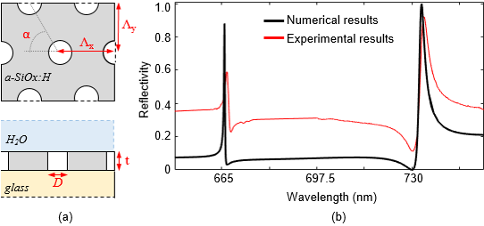
Figure S1. (a) Top view (top) and cross-section (bottom) of the nanohole array with a triangular lattice and (b) reflection spectrum calculated using COMSOL® Multiphysics (black line) and experimental results (red curve).

- Design optimization of the dielectric nanohole array

A rigorous design of the dielectric nanohole array has been carried out to optimize the performance of both resonant modes concurrently. We have investigated a parametric analysis on the period, hole radius and slab thickness to quantify the Q-factor and the dynamic range for the TE and TM mode.
The optimized structure should provide a high Q-factor and wide dynamic range DR for the TM mode used for sensing application, while extremely high dynamic range and strongly localized energy confinement are required for the TE mode for imaging applications. A strong Fano-shaped resonance improves the performance of both modes for the target applications.
We have chosen a triangular lattice compared to a square lattice because it provides slightly higher values of Q-factor and DR for both TM and TE mode. We have chosen Λ = 480nm and R = 60nm as the optimized configuration, because it represents the best compromise between high DR and high Q-factor. In particular, the Q-factor increases with a larger lattice period Λ and a smaller hole radius for both resonant modes (Figure S2a and S2c). However, as the hole radius decreases, the DR decreases as well, which is counterproductive (Figure S2b and S2d). We note that other work, driven by the SQ figure of merit alone, tends to ignore this trade-off. We have therefore chosen a radius of 60 nm as a good compromise, which is also technologically feasible with our lithography and dry etching process. The choice of the thickness t = 110 nm is justified by the fact that a lower thickness provides a higher Q-factor but at the expense of a fast decrease of DR (Figure S2e), so it presents a similar trade-off as the hole radius.
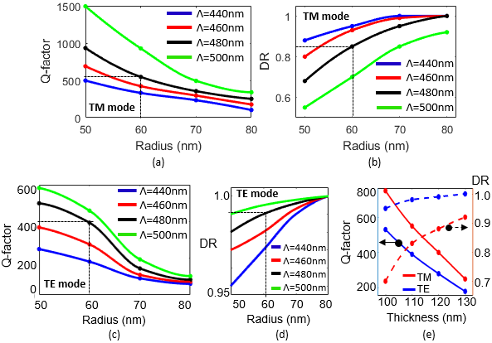
Figure S2. Parametric analysis on the hole radius R and period Λ in the dielectric nanohole array. (a) Q-factor and (b) DR vs. radius for different lattice periods for the TM mode. (c) Q-factor and (d) DR vs. radius for the TE mode. The black dotted line represents the optimized configuration used in the experiments with R=60nm, t=110nm and Λ=480nm. (e) Q-factor and DR vs. thickness of the dielectric slab for the TM mode and TE mode.

- Comparison of the performance of dielectric nanoholes with the state-of-the-art of label-free measurements with comparable structures
In Table S3, we compare the performance of the dielectric nanohole array with the State-of-the-Art of different configurations used for sensing in the visible and in the near-infrared wavelength range. We compare the dynamic range (DR) together with the signal-to-noise ratio (SNR), the figure of merit FOM = SQ, where Q is the Q-factor and S the surface sensitivity of the sensor and LOD, as the minimum detectable concentration for biosensing. While the dielectric nanohole array offers a lower surface sensitivity than some of the other configurations, the Q-factor is typically higher, which yields a higher FOM overall. We also note that the 1D-GMR of [28] is comparable to our results in terms of the FOM, but it operates using a very distributed mode, which consequently has poor spatial resolution. A higher value of SQ has been obtained in [31] with a dielectric nanohole array exploiting the BIC modes. However, we note that our nanohole array provides a significant enhancement of the SNR for both modes, which plays an important role in the optimization of the imaging and sensing resolution, as described in detail below.
Since spatial resolution is not mentioned in most papers, it has not been included here, but we note that the dielectric nanohole array offers a very favourable combination of sensing and imaging performance.

Table S3. Comparison of the performance of dielectric nanoholes with the state-of-the-art of label free-biosensors with comparable structures
 | DR | SNR | Q | Ss (nm/RIU) | FOM = SQ (nm/RIU) | LOD  (fM) (pg/ml)
Plasmonic nanohole array [23] | 0.2 | / | 40 | 30 | 1.2x10³ | 5x10^{3 [16]} | 145 ^{[16]}
1D GMR [28]  2D GMR [46] | 0.8  0.8 | /  / | 240  130 | 31  / | 7.4x10³  / | 3x10⁹  1.7x10⁴ | 5x10⁸*  10³
Dielectric metasurface [9] | 0.6 | ~20 | 90 | 40 | 3.6x10³ | 8.5x10⁴ | 4x10⁴
Dielectric metasurface [31] | 0.2 | ~20 | 1300 | 53** | 6.9x10⁴ | 6.6 x10^{7 [39]} | /
This work TE mode | 0.8 | 160 | 300 | 20 | 6x10³ | ~60 | ~10
This work TM mode | 0.4 | 78 | 450 | 20 | 9x10³ | 6.6 | 1

* The experiment has been conducted only with the reported concentration of analyte and/or the signal to noise ratio is still over the 3σ threshold, therefore the actual LOD could be potentially smaller than the reported value.
** This is a simulated value reported in [31].

- Bulk sensitivity and limit of detection of the chirped nanohole array
We determine the bulk sensitivity of the chirped nanohole array by changing the refractive index of the solution in the channels; different refractive indices are obtained via different concentrations of glucose in DI water (Figure S4a). We observe a linear shift of the resonance position as a function of refractive index in the range from Δn = 0.001 to Δn = 0.023 with a minimum shift of 5.73 µm for Δn = 0.001 compared to DI water (n_{H20} = 1.3329). We use these results to obtain the sensitivity of 3960 µm/RIU (Figure S4b) stated in the main manuscript. In order to translate this figure to the more commonly used sensitivity in nm/RIU, we also measured the bulk sensitivity of the array by compensating the shift due to refractive index with a change in illumination wavelength. For the maximum refractive index change of Δn=0.023, we require a wavelength change of Δλ = 3.37 nm, corresponding to a bulk sensitivity S = 140 nm/RIU. This value is in good agreement with the sensitivity obtained from a non-chirped array of the same period. In order to determine the noise limit, we measure for 30 minutes in DI water and obtain a value 3σ = 0.183 µm (3 times the standard deviation) (Figure S4c). Together with the 3960 μm/RIU, this corresponds to a limit of detection of LOD = 4.6x10⁻⁵ RIU.
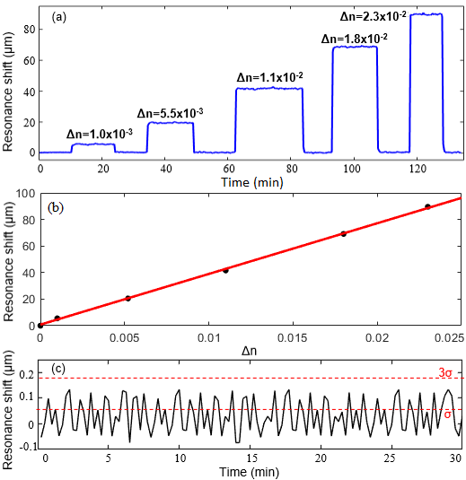
Figure S4. (a) Resonance shift over time with different values of refractive index of the solution (b) Resonance shift (black dots) and corresponding linear fit (red curve) as a function of refractive index change of the solution. (c) Measurement of the noise limit in water for 30 min with 3σ = 0.183 µm.

- Comparison of sensitivity of the TE and TM modes for biosensing

We have also studied the optical response of both optical modes for biosensing applications. A comparison of the binding curves in the presence of 10 pg/mL of IgG is shown in Figure S5. The resonance shift observed with this concentration is almost the same for both modes. However, the noise for the TM mode is much lower (3σ = 0.78 µm), i.e. approximately 2 times lower than for the TE mode in the same measurement. We believe that this difference can be explained with the higher Q-factor of the TM mode which affords more accurate tracking of the resonance. Moreover, the TM mode distribution is much more suitable for surface sensing than that of the TE mode, which is mainly confined to the holes (Figure 1c, d in the main manuscript). The field of the TM mode offers a larger area for interaction with surface-bound molecules, which makes for a more reliable measurement. In contrast, the TE mode mainly interacts with molecules having diffused into the holes, which tends to be more erratic; as a result, we have observed less consistency with TE mode measurements on multiple repeats of the experiment. Nevertheless, the fact that the TE mode exhibits similar performance as the TM mode makes it very suitable for measurements that require a combination of strong localisation and high sensitivity, as e.g. for the studies of bacteria.

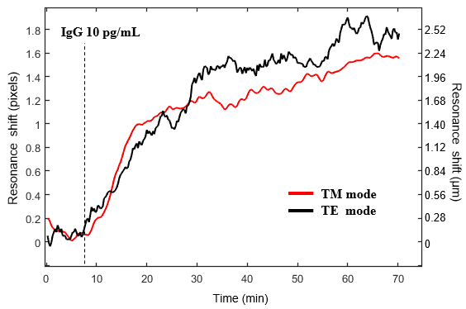
Figure S5. Binding assay with chirped nanohole array for the TE (black curve) and TM (red curve) with 10 pg/mL of IgG.

- Resolution of hyperspectral imaging

We evaluate the spatial resolution of the nanohole array by lithographically defining blocks of different refractive index on the surface (Figure S6a). We then use hyperspectral imaging to resolve the size and the position of the blocks by analysing the spectral information exploiting the TE mode.
As explained in the Methods, multiple images are obtained at different wavelengths in order to construct a hyperspectral cube (Figure S6b and Figure S6c). The higher refractive index of the blocks causes a resonance shift in the block region. In order to determine the spatial resolution of this resonance shift, we made a symmetric structure consisting of squared blocks of SiO₂ with a width of 5 µm and a gap size of 0.9 µm, 1.4µm, 2.9µm (Fig. S6a). The experimental results confirm that a gap size of 0.9µm can still be resolved in both directions, which shows that a spatial resolution less than 1µm is obtained. (Figure S6d and Figure S6e). This result compares favourably to previous results in 1-D GMRs, which exhibit a spatial resolution of 2-6µm depending on orientation [Refs. 20, 21, 34 in the manuscript].
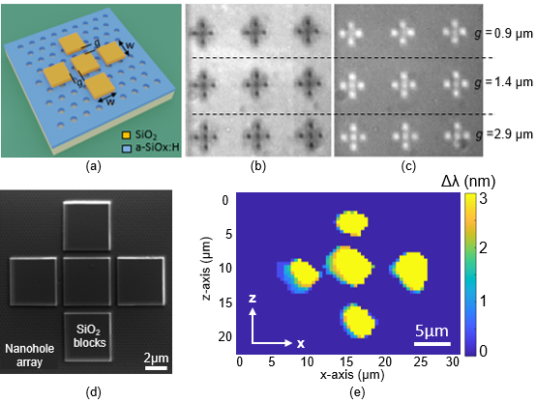
Figure S6. (a) Schematic of SiO₂ blocks placed on top of the nanohole array with a width w = 5 µm and varying gap. (b,c) Images taken at the wavelength of the resonance peak of (b) the background and (c) the blocks. The separate blocks are clearly resolved, indicating a spatial resolution of better than 1µm; (d) SEM micrograph of the structure with blocks of gap g = 0.9 µm and (e) hyperspectral image of the same structure.

- Study of the spatial resolution for both resonant modes with hyperspectral imaging
We have evaluated the spatial resolution with the nanohole array for both resonant modes (Figure S7). The high dynamic range obtained with the TE mode provides a strong image contrast with the blocks on resonance (Figure S7f), which together with its stronger confinement, enables resolving the blocks and the gap between them with higher accuracy than the TM mode. While the spatial resolution for the TE mode is around 1 µm in both directions (Fig. S7a), the TM mode does not achieve such high resolution, due its more distributed confinement and its lower dynamic range (Figure S7c, S7d). Correspondingly, for the TM mode, we note a spatial resolution of approximately 3 µm (Figure S7e).
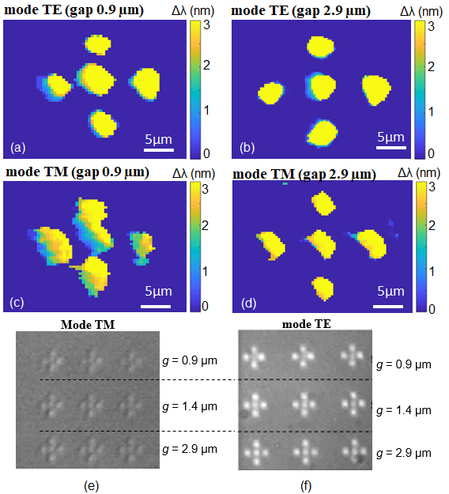
Figure S7. Hyperspectral imaging of the blocks structure with the TE mode (a,b) and TM mode (c,d) with a blocks width of 5 µm and a gap size of 0.9 µm and 2.9 µm, respectively. Camera images taken at the resonance peak of the blocks for (e) the TM mode and (f) the TE mode.

- Optical response of single bacteria

Figure S8 shows a comparison between the resonance behaviour for a bacterium binding to the surface and the background without bacteria. We observe a clear shift of the resonance (Δλ = 3.4 nm) for the bacterium on the sensor surface, which allows us to resolve the size and position of the bacterium. The observed shift is remarkably higher than the threshold value of 0.5 nm, which we have assumed as a baseline in the hyperspectral analysis (in order to consider possible inhomogeneity in the surface chemistry and experimental errors), and which provides a clear and high-resolution hyperspectral map for the detection of individual bacteria.
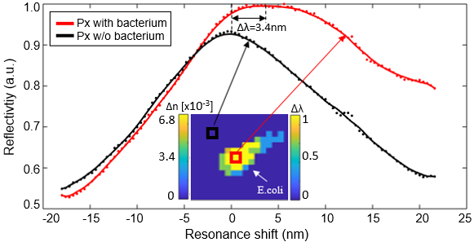
Figure S8. Comparison of the resonance shift of two pixels (px) in the presence of a bacterium (red curve) and for the bare nanohole array without bacteria (black curve). The pixel size is 0.45 µm.

- Hyperspectral imaging for the monitoring of the bacteria growth on the nanohole array

The nanohole array with a resolution down to 1µm and a field of view up to few mm² is suitable for the monitoring of the growth of bacteria. Figure S9 shows the time evolution of the hyperspectral map for studying bacterial growth in a region of interest of 50 µm x 50 µm of the nanohole array. The presence of a first colony (A) is evident in the region of interest after 1 h and further covering occurs over time. A similar behaviour is observed for the growth of different colonies (B) and (C) in different regions and time frames with a faster growth rate after 4h due to the stronger interaction between different colonies. A control experiment with the nanohole array in LB medium without bacteria for the same time scale demonstrates negligible change in the hyperspectral map, confirming that the resonance change is actually due to the presence of bacteria on the sensor.

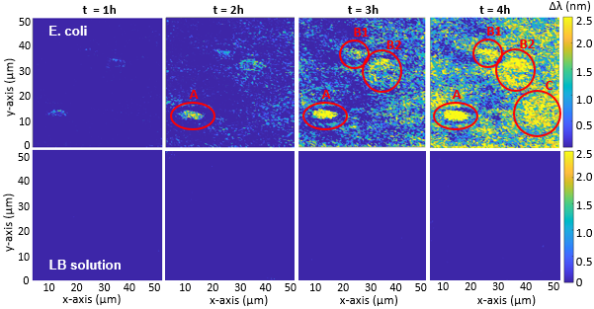
Figure S9. Time dependence of the hyperspectral map of an area of 50 µm x 50 µm of the nanoholes array to monitor the growth of E.coli over time (top) compared to the control experiment with only LB medium without bacteria (bottom). A magnification of 20x is used to take each brightfield image.

