Supplementary Data: Figures S2

Premature differentiation of nephron progenitors and dysregulation of gene pathways critical to kidney development in a model of preterm birth

Aleksandra Cwiek¹, Masako Suzuki³, Kim deRonde¹, Mark Conaway⁴ ⁵, Kevin M. Bennett⁶, Samir El Dahr⁷, Kimberly Reidy^{2#}, Jennifer R Charlton^{1#}*

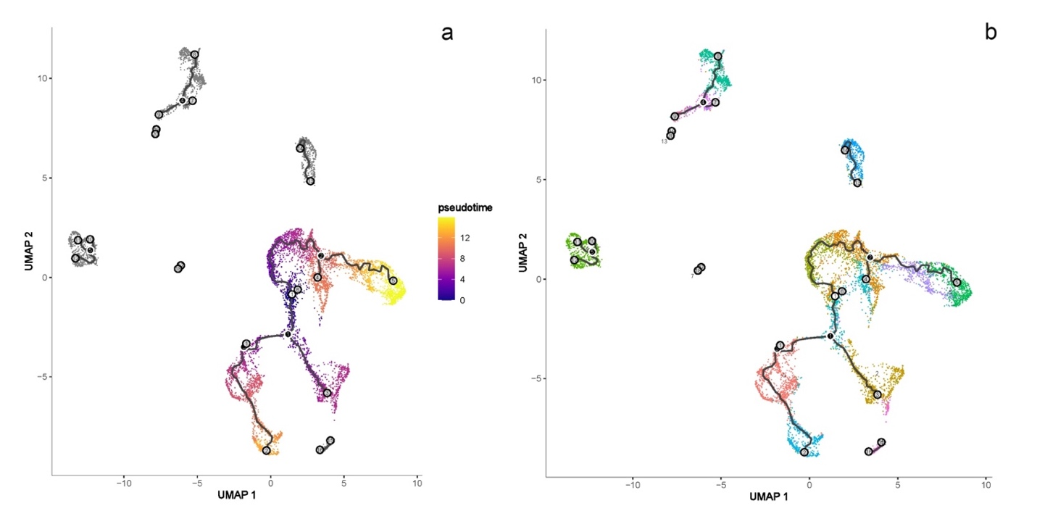
Supplementary Fig. S2. Pseudotime analysis. Using data from preterm and term mouse kidneys a 20 dpc, cell expression profiles (marked with single points) were generated in a two-dimensional independent component space. The edges of the minimum spanning tree (MST) created by the Monocle algorithm are indicated by the connected dots. Solid grey line shows the main diameter path of the MST and provides the backbone of Monocle's algorithm pseudotime ordering of the cells. (a) Pseudotime analysis result overlapped with the results from clustering of each cell type (b).

