Three-Dimensional Hierarchical Porous Carbon Derived from Natural Resources for Highly Efficient Treatment of Polluted Water
Jiaxin Li,ª Rudolf Holze,^{b,c,d} Simbarashe Moyoª, Song Wang^{e}*, Sanxi Li,^{e} Tao Tang,^{f}* Xuecheng Chen^{a,e}*
ª Faculty of Chemical Technology and Engineering, West Pomeranian University of Technology, Szczecin, Piastów Ave. 42, Szczecin 71-065, Poland.
^{b} Chemnitz University of Technology, Institut für Chemie, AG Elektrochemie, 09107, Chemnitz, Germany.
^{c} Saint Petersburg State University, Institute of Chemistry, St. Petersburg, 199034, Russia.
^{d} State Key Laboratory of Materials-oriented Chemical Engineering, School of Energy Science and Engineering, Nanjing Tech University, Nanjing, 211816, Jiangsu Province, China.
^{e} School of Environment and Chemical Engineering, Shenyang University of Technology, Shenyang 110870, China.
^{f} Changchun Institute of Applied Chemistry, Chinese Academy of Sciences, Changchun 130022, China.
Corresponding author: wangsong@sut.edu.cn; xchen@zut.edu.pl; ttang@ciac.ac.cn;

Figure S1. Photo of the MB solutions before and after adsorption by the PC-500-6.
The optical photographs were taken before and after MB adsorption (Figure S1). For example, after the adsorption of MB with an initial concentration of 300 mg/l on PC-500-6, the polluted water became clear and colorless, which further revealed the efficient adsorption and distinct discoloration for wastewater using PC-500-6.

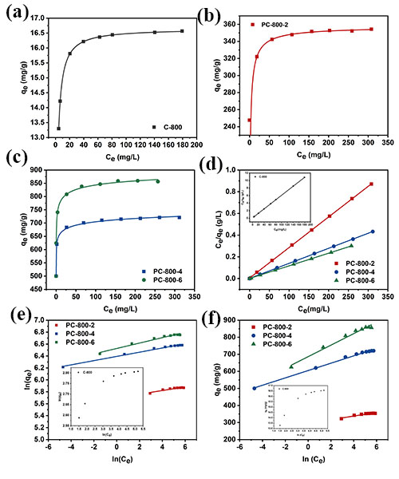
Figure S2. Equilibrium adsorption isotherms of (a) C-800 (b) PC-800-2 (c) PC-800-4 and PC-800-6; and (d) Langmuir, (e) Freundlich and (f) Temkin isotherms of MB on C-800 and PC-800-Y. (20 mg of C-800, PC-800-2 or PC-800-4/6 added to a 50 mL MB solution (10-80 mg/L, 100-500 mg/L or150-550 mg/L) at a designated concentration after stirring for 12 h.)

Table S1 Langmuir, Freundlich and Temkin isotherm parameters of C-800 and PC-800-Y for MB.
Isotherm | Parameter | Adsorbent
 |  | C-800 | PC-800-2 | PC-800-4 | PC-800-6
Langmuir | q_{m} (mg/g) | 16.66 | 354.61 | 724.64 | 862.07
 | K_{L} (L/mg) | 0.8883 | 0.6845 | 0.902 | 1.3143
 | R² | 0.99999 | 0.99995 | 0.99996 | 0.99994
Freundlich | 1/n | - | 0.03074 | 0.03534 | 0.04534
 | K_{F} (mg/g(L/mg)1/n) | - | 109.346 | 149.572 | 157.931
 | R² | - | 0.25472 | 0.99003 | 0.97274
Temkin | B_{T} | - | 10.4196 | 21.5372 | 33.7500
 | K_{T} (L/mg) | - | 8.41*10³ | 8.14*10³ | 3.40*10³
 | R² | - | 0.90715 | 0.99538 | 0.98245

Table S2 Comparison table of adsorption capacities of MB on different adsorbents.
Entry | Adsorbent | Adsorption capacity (mg/g) | Ref.
1 | Activated carbon from coconut husk | 418.15 | [1]
2 | Activated carbon from coconut shells | 526 | [2]
3 | Activated carbon from date stones | 316 | [3]
4 | Activated carbon from cashew nut shell | 476 | [4]
5 | Porous carbon nanotubes | 319.1 | [5]
6 | CNF aerogel | 800.0 | [6]
7 | Activated CNT | 400 | [7]
8 | Porous carbon sheets | 769.2 | [8]
9 | ZIF-derived nitrogen-doped porous carbons | 791.3 | [9]
10 | Activated carbon membranes | 235.2 | [10]
11 | Agar/graphene oxide composite aerogel | 578 | [11]
12 | Boron doped carbon nitride nanoscrolls | 250 | [12]
13 | Magnetic halloysite nanotube | 714.29 | [13]

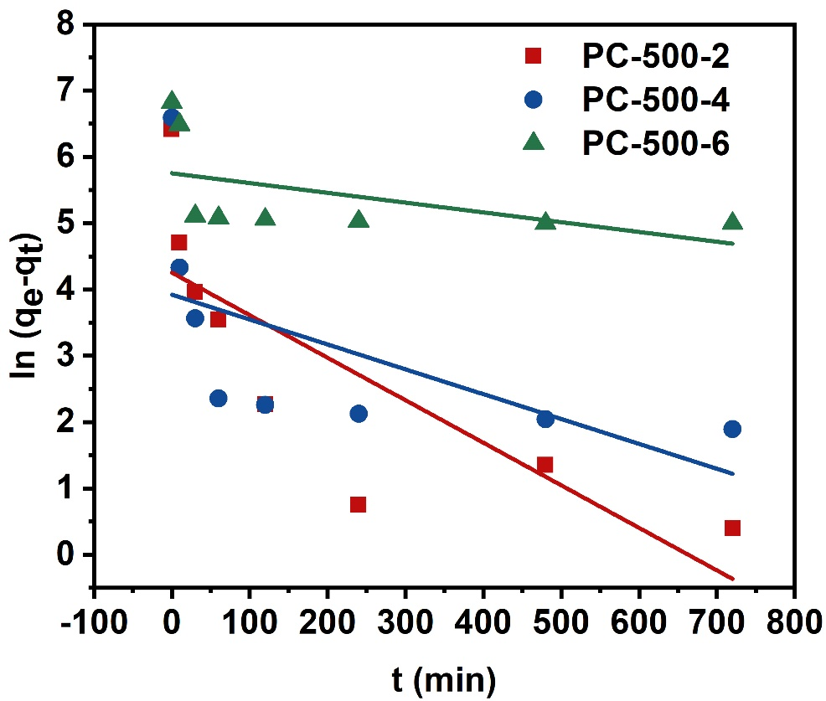
Figure S3. The pseudo first-order kinetic model of PC-500-Y for the adsorption of MB. (Experimental conditions: MB concentration = 250 mg/L for PC-500-2, 300 mg/L for PC-500-4 and PC-500-6 and adsorbent concentration = 20 mg/L).

Table S3. Kinetic parameters of the pseudo first-order kinetic model for MB on the PC-500-Y.
Absorbent | C₀ (mg/L) | q_{e},exp (mg/g) | q_{e,}cal (mg/g) | k₁  (min⁻¹) | R²
PC-500-2 | 150 | 360.94 | 70.07 | 0.00642 | 0.6430
PC-500-4 | 250 | 718.30 | 50.37 | 0.00375 | 0.3625
PC-500-6 | 300 | 861.18 | 314.00 | 0.00147 | 0.2648

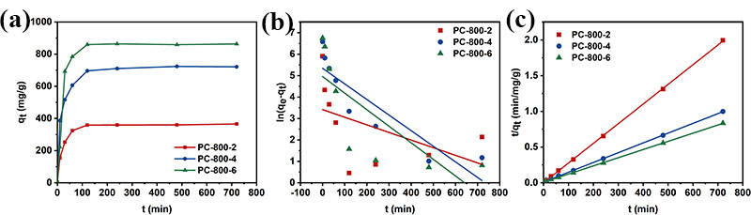
Figure S4. Kinetic curves (a) and the pseudo second-order kinetic model (b) of PC-800-Y for the adsorption of MB. (Experimental conditions: MB concentration was 250 mg/L for PC-800-2, 300 mg/L for PC-800-4 and PC-800-6 and adsorbent concentration was 20 mg/L).

Table S4. Kinetic parameters of the pseudo second-order kinetic model for MB on the PC-800-Y.
Adsorbent | C₀  (mg/L) | qe,exp  (mg/g) | Pseudo first-order model |  |  | Pseudo second-order model
 |  |  | k₁  (min)-1 | qe,cal  (mg/g) | R² | k₂  (min⁻¹) | h  (mg/g/min) | R²
PC-800-2 | 150 | 365.62 | 0.00356 | 29.95 | 0.2468 | 8.75*10⁻⁹ | 0.00102 | 0.9998
PC-800-4 | 250 | 714.29 | 0.00728 | 93.67 | 0.8106 | 2.01*10⁻⁸ | 0.0103 | 0.9999
PC-800-6 | 300 | 862.07 | 0.00773 | 66.28 | 0.6100 | 1.18*10⁻⁸ | 0.0082 | 0.9994

Reference
[1] Foo K Y, Hameed B H (2012) Coconut husk derived activated carbon via microwave induced activation: Effects of activation agents, preparation parameters and adsorption performance. Chem Eng J 184: 57-65.
[2] Jain A, Jayaraman S, Balasubramanian R, Srinivasan M P (2014) Hydrothermal pre-treatment for mesoporous carbon synthesis: enhancement of chemical activation. J. Mater. Chem. A 2: 520-528.
[3] Foo K Y, Hameed B H (2011) Preparation of activated carbon from date stones by microwave induced chemical activation: Application for methylene blue adsorption. Chem Eng J 170: 338-341.
[4] Spagnoli A A, Giannakoudakis D A, Bashkova S (2017) Adsorption of methylene blue on cashew nut shell based carbons activated with zinc chloride: The role of surface and structural parameters. Journal of Molecular Liquids 229: 465-471.
[5] Gong J, Liu J, Jiang Z, Wen X, Mijowska E, Tang T, Chen X (2015) A facile approach to prepare porous cup-stacked carbon nanotube with high performance in adsorption of methylene blue. J Colloid Interface Sci 445: 195-204.
[6] Liang H W, Guan Q F, Chen L F, Zhu Z, Zhang W J, Yu S H (2012) Macroscopic-scale template synthesis of robust carbonaceous nanofiber hydrogels and aerogels and their applications. Angew Chem Int Ed Engl 51: 5101-5.
[7] Ma J, Yu F, Zhou L, Jin L, Yang M, Luan J, Tang Y, Fan H, Yuan Z, Chen J (2012) Enhanced adsorptive removal of methyl orange and methylene blue from aqueous solution by alkali-activated multiwalled carbon nanotubes. ACS Appl Mater Interfaces 4: 5749-60.
[8] Gong J, Liu J, Chen X, Jiang Z, Wen X, Mijowska E, Tang T (2015) Converting real-world mixed waste plastics into porous carbon nanosheets with excellent performance in the adsorption of an organic dye from wastewater. J Mater Chem A 3: 341-351.
[9] Xu S, Lv Y, Zeng X, Cao D (2017) ZIF-derived nitrogen-doped porous carbons as highly efficient adsorbents for removal of organic compounds from wastewater. Chem Eng J 323: 502-511.
[10] Yang K, Zhu X, Chen B (2017) Facile fabrication of freestanding all-carbon activated carbon membranes for high-performance and universal pollutant management. J Mater Chem A 5: 20316-20326.
[11] Chen L, Li Y, Du Q, Wang Z, Xia Y, Yedinak E, Lou J, Ci L (2017) High performance agar/graphene oxide composite aerogel for methylene blue removal. Carbohydr Polym 155: 345-353.
[12] Wang J, Hao J, Liu D, Qin S, Chen C, Yang C, Liu Y, Yang T, Fan Y, Chen Y, Lei W (2017) Flower stamen-like porous boron carbon nitride nanoscrolls for water cleaning. Nanoscale 9: 9787-9791.
[13] Wan X, Zhan Y, Long Z, Zeng G, He Y (2017) Core@double-shell structured magnetic halloysite nanotube nano-hybrid as efficient recyclable adsorbent for methylene blue removal. Chem Eng J 330: 491-504.

