The combination of UHPLC-HRMS and molecular networking improving discovery efficiency of chemical components in Chinese Classical Formula
Xiaoxia Xue ^{1,2,#}, Qishu Jiao ^{1,#}, Runa Jin ¹, Xueyuan Wang ³, Shougang Shi ⁴, Zhengjun Huang ⁴, Yuntao Dai ^{1,2,}*, and Shilin Chen ¹

Author information
¹ Institute of Chinese Materia Medica, China Academy of Chinese Medical Sciences, 100700, Beijing, China; xxxue1003@163.com (XX); qs_jiao1108@bucm.edu.cn (QJ); jrn11330@163.com (RJ); slchen@icmm.ac.cn (CS)
² Shanxi University of Chinese Medicine, 030619, Shanxi, China
³ Modern Research Center for Traditional Chinese Medicine, Shanxi University, Taiyuan 030006, China; 774740773@qq.com (XW)
⁴ Sunflower Pharmaceutical Group (Xiangyang) Longzhong Co.Ltd, 441003, Hubei, China; 497869216@qq.com (SS); xfhzj2007@163.com (ZH)
# Co-first author
* Correspondence: ytdai@icmm.ac.cn (YD)
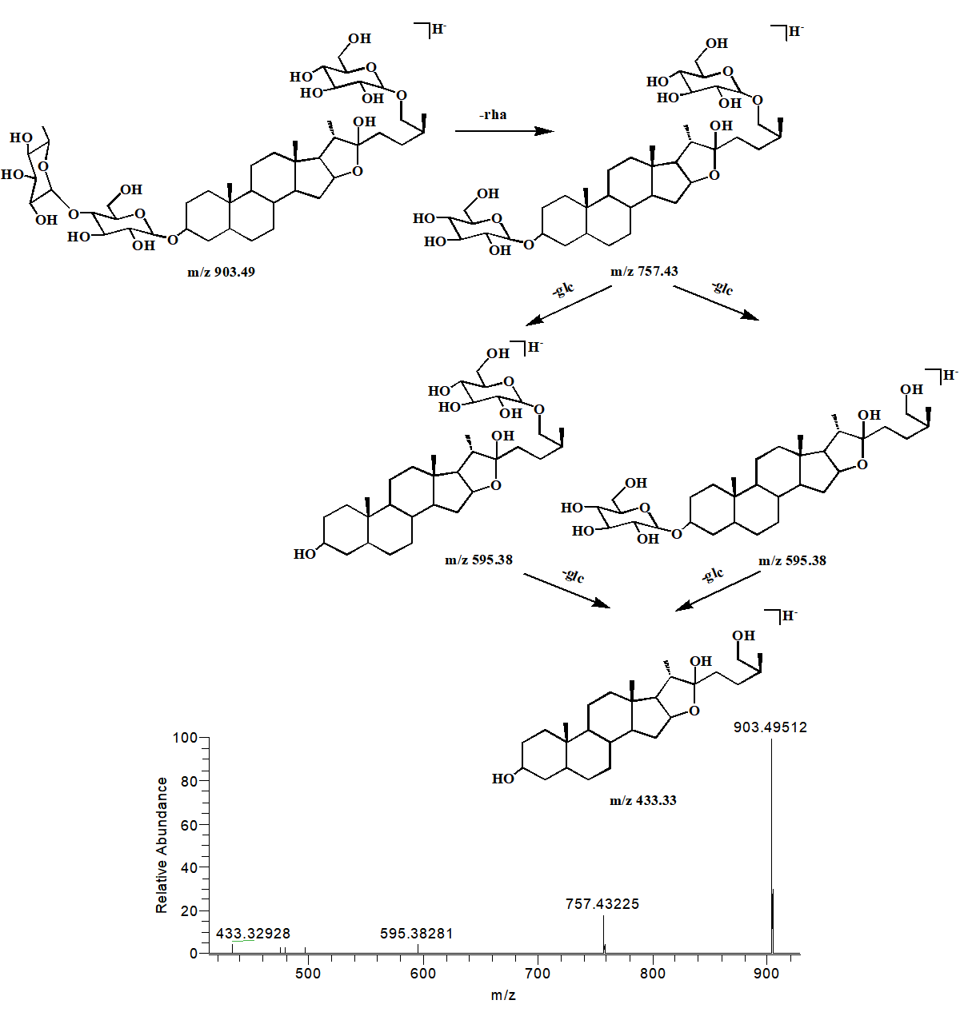
Figure S1. The proposed fragmentation pathways and the MS/MS spectra for aspacochioside A in the negative mode.
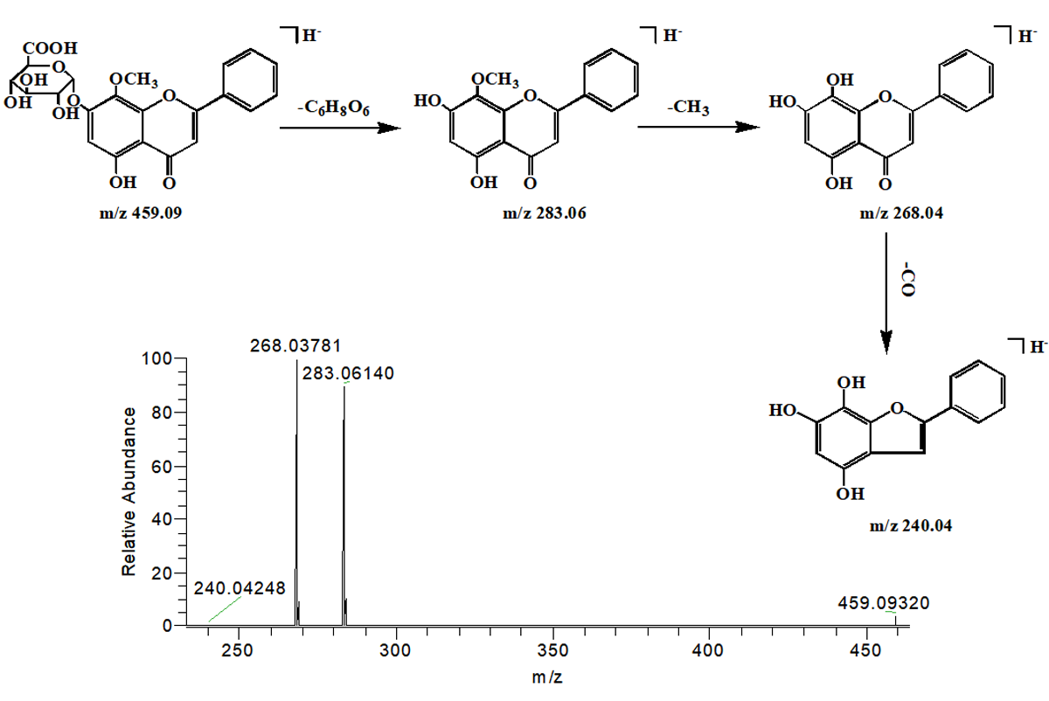
Figure S2. The proposed fragmentation pathways and the MS/MS spectra for wogonoside in the negative mode.
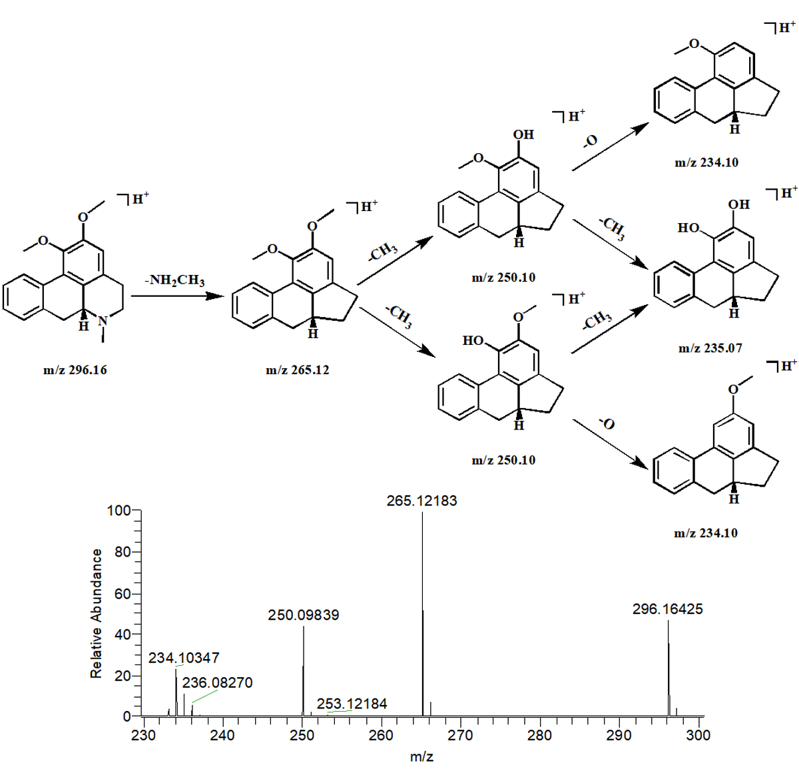
Figure S3. The proposed fragmentation pathways and the MS/MS spectra for nuciferine in the positive mode.

