## **Additional file 6 Calibration plots**

**Supplementary Figure 6 Calibration plots of DIVERT per country for outcome ED visits**



**Supplementary Figure 7 Calibration plots of CARS per country for outcome hospital admissions**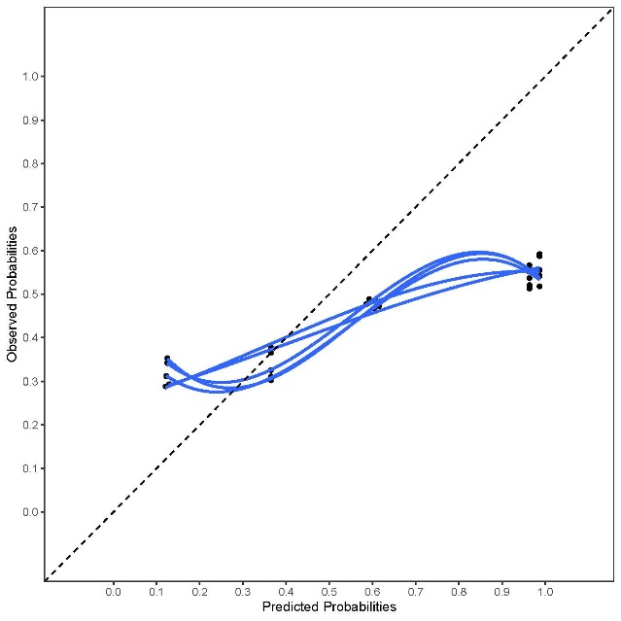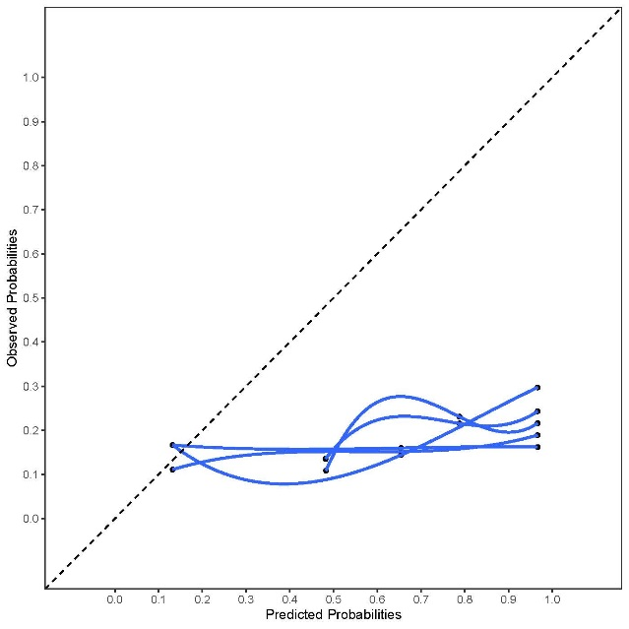

Italy

Iceland

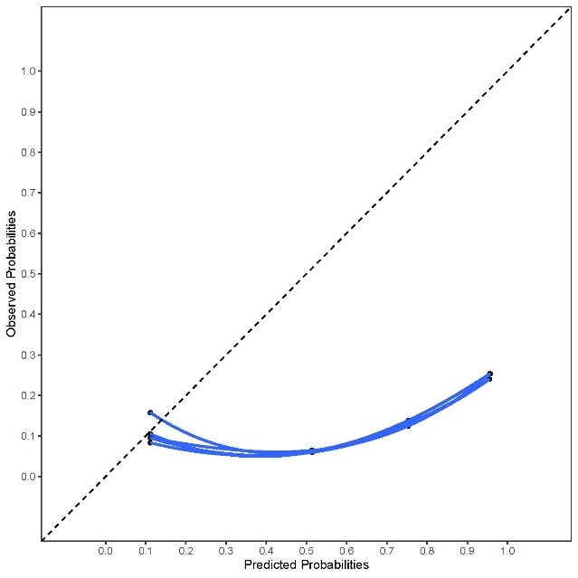

Germany

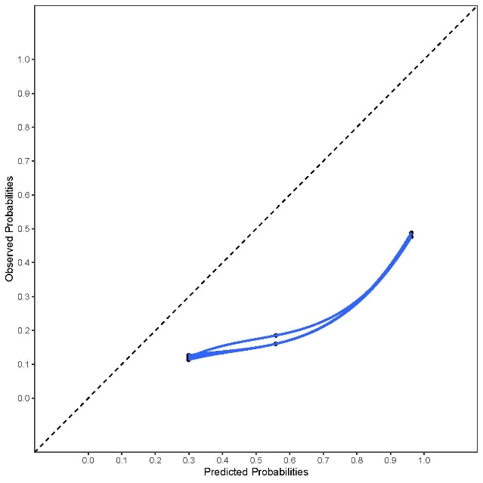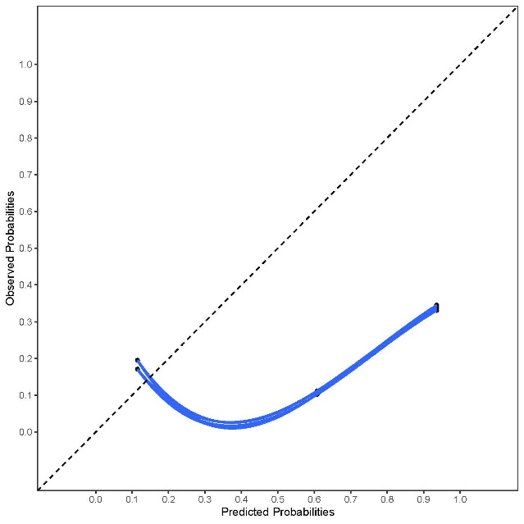

Finland

Netherlands

**Supplementary Figure 8 Calibration plots of CARS per country for outcome ED visits**

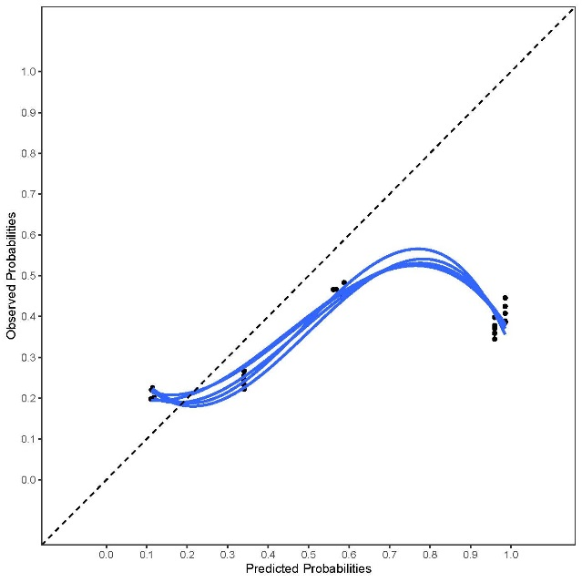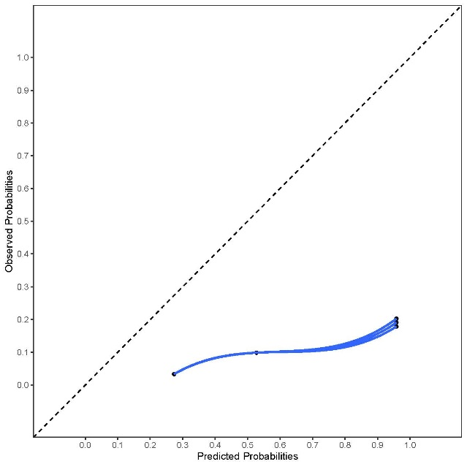

Iceland

Italy

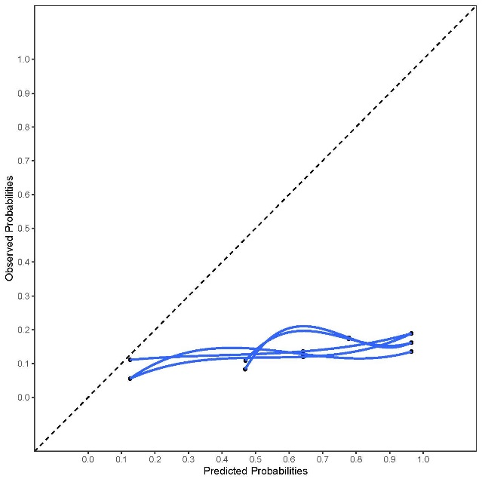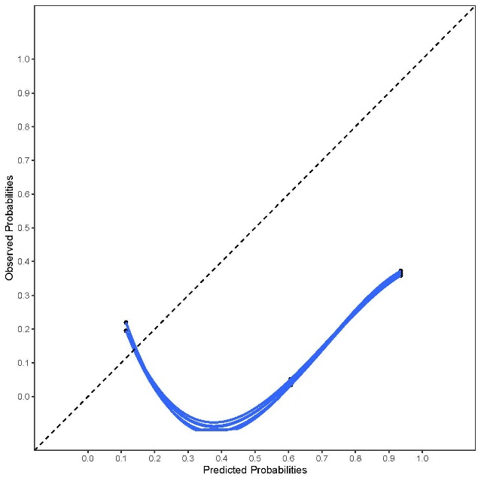

Finland

Netherlands

**Supplementary Figure 9 Calibration plots of CARS per country for outcome any unplanned hospital visit**

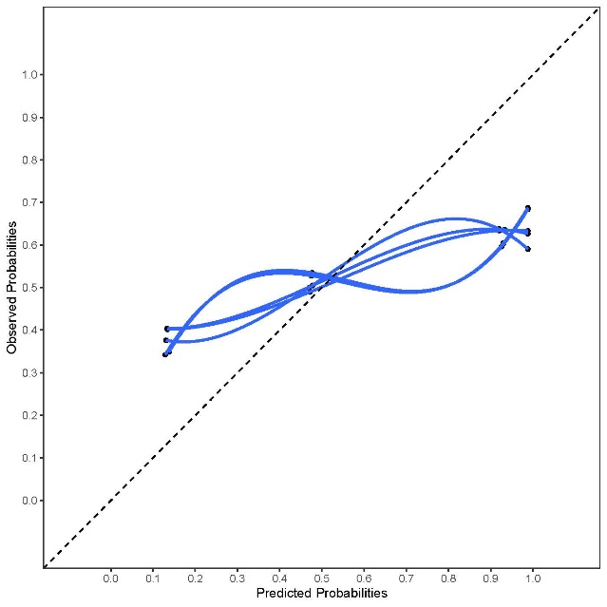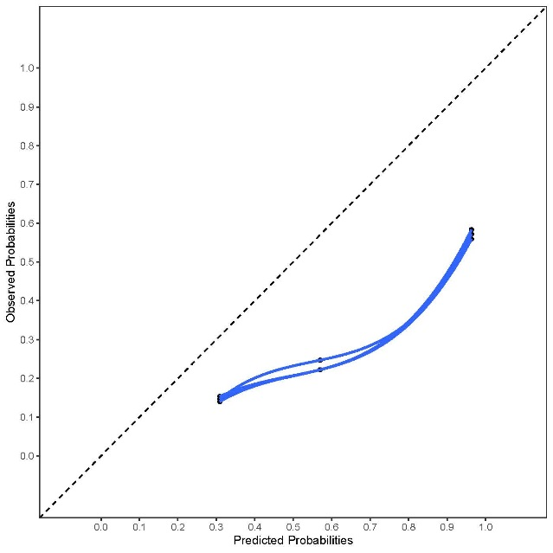

Finland

Iceland

Italy

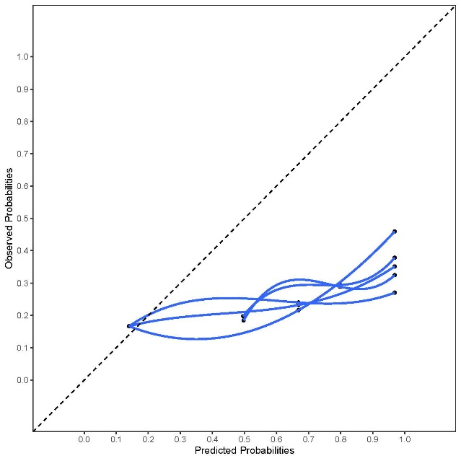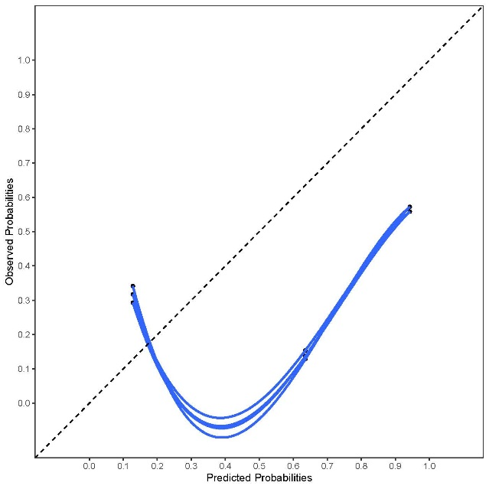

Netherlands

**Supplementary Figure 10 Calibration plots of EARLI per country for outcome hospital admissions**

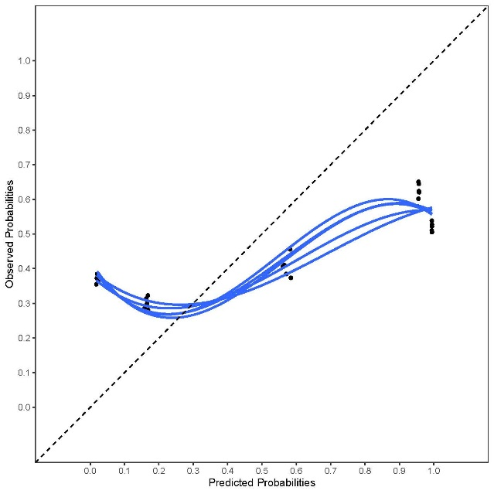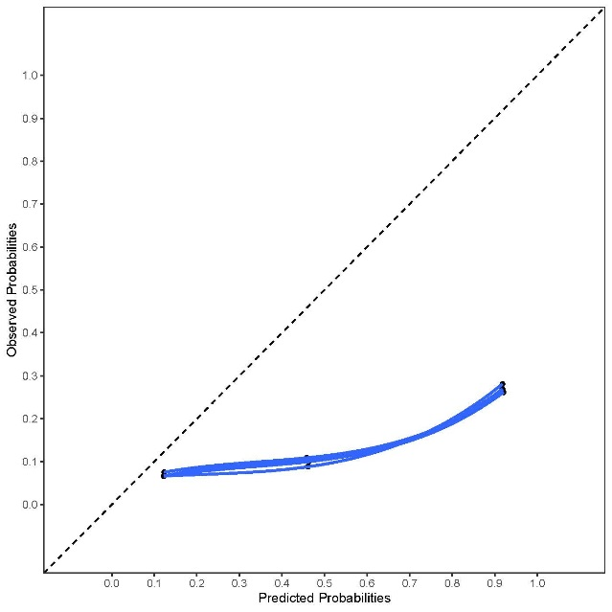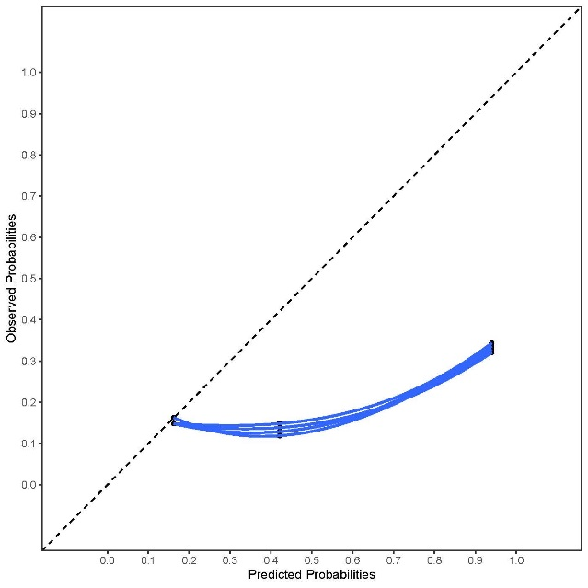

Finland

Iceland

Belgium

Netherlands

Italy

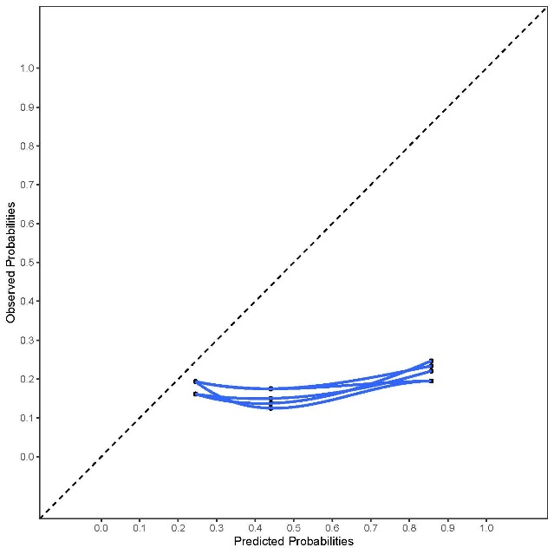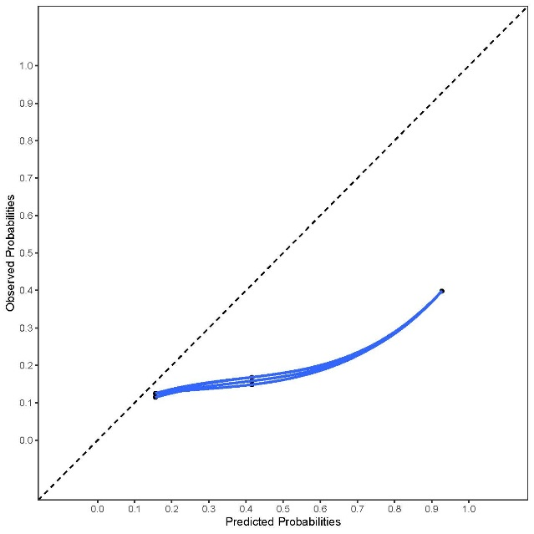

**Supplementary Figure 11 Calibration plots of EARLI per country for outcome ED visits**

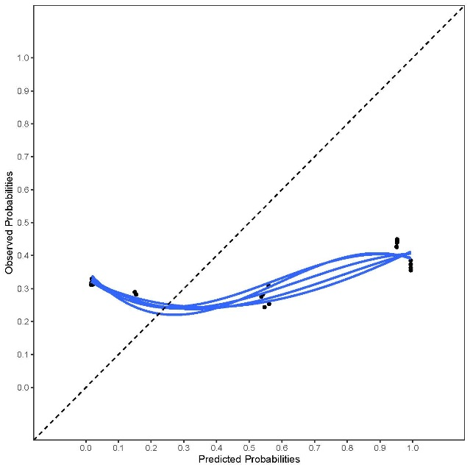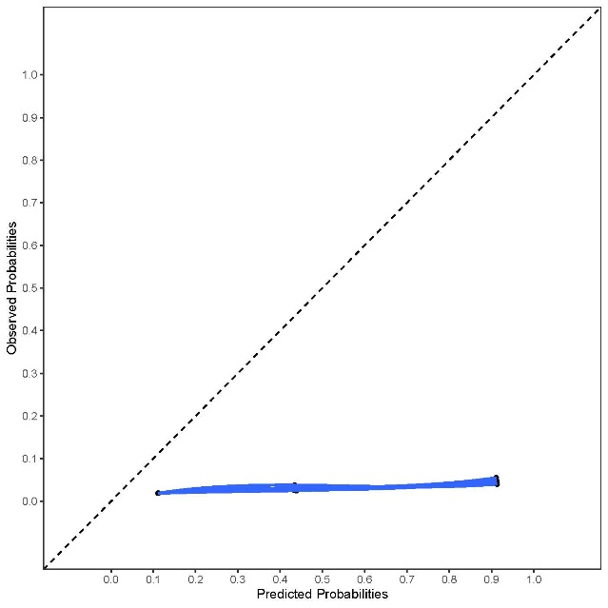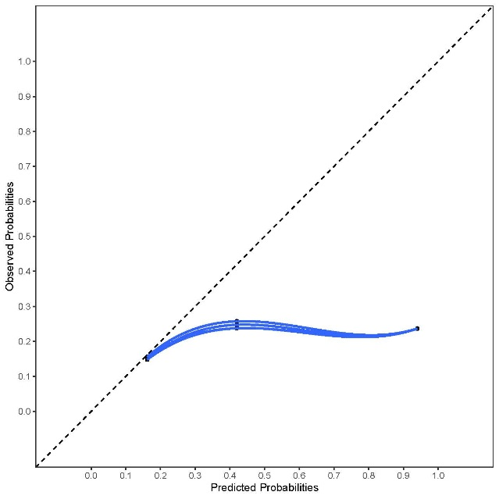

Finland

Iceland

Belgium

Netherlands

Italy

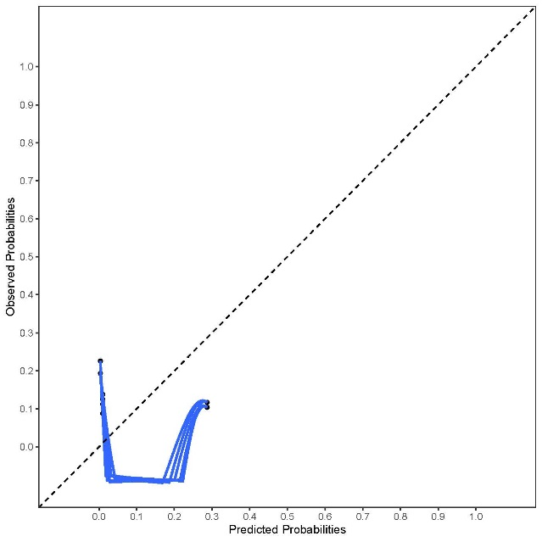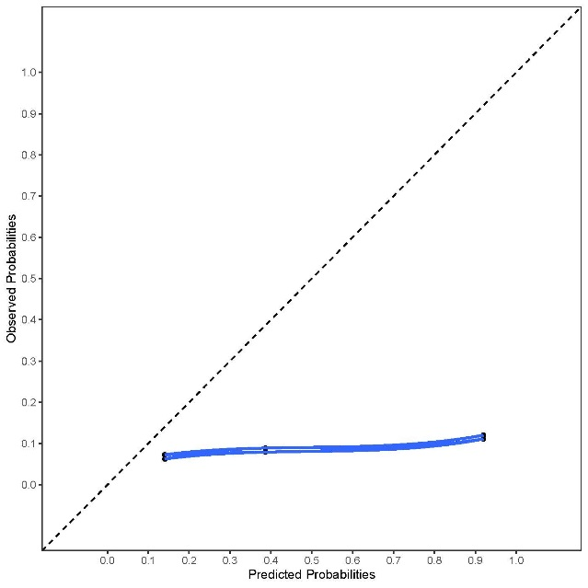

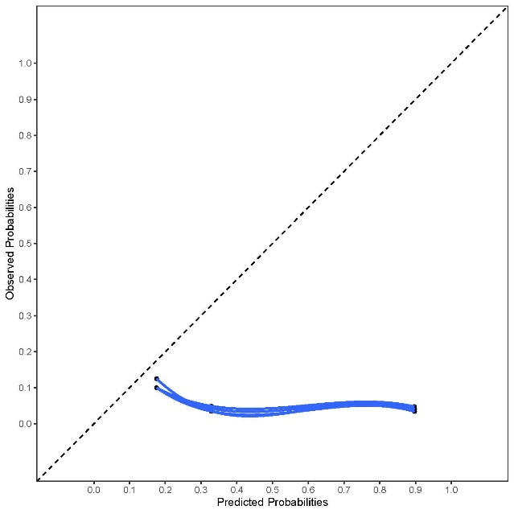

Germany

**Supplementary Figure 12 Calibration plots of EARLI per country for outcome any hospital visit** 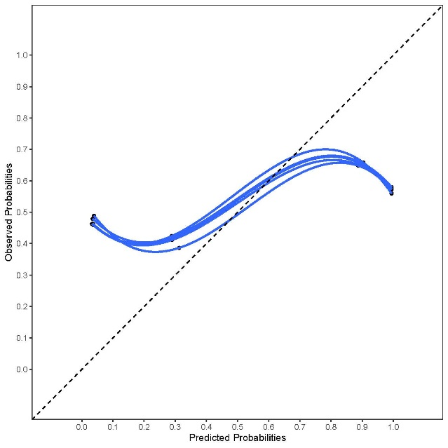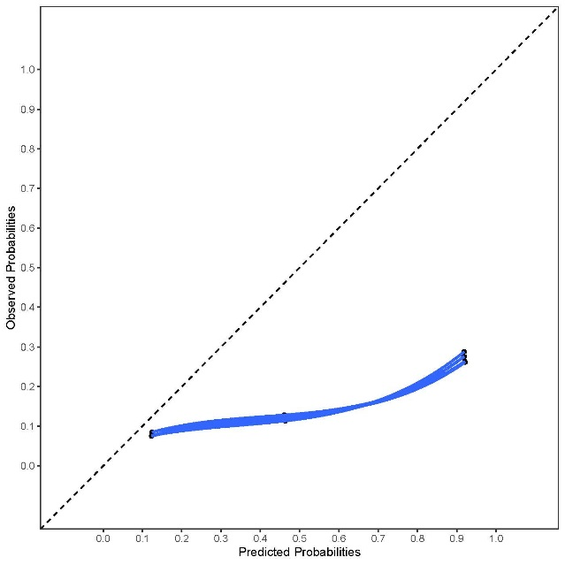

Italy

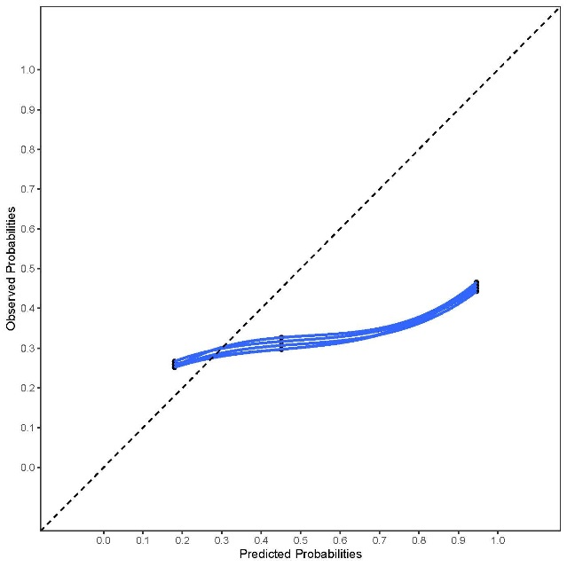

Finland

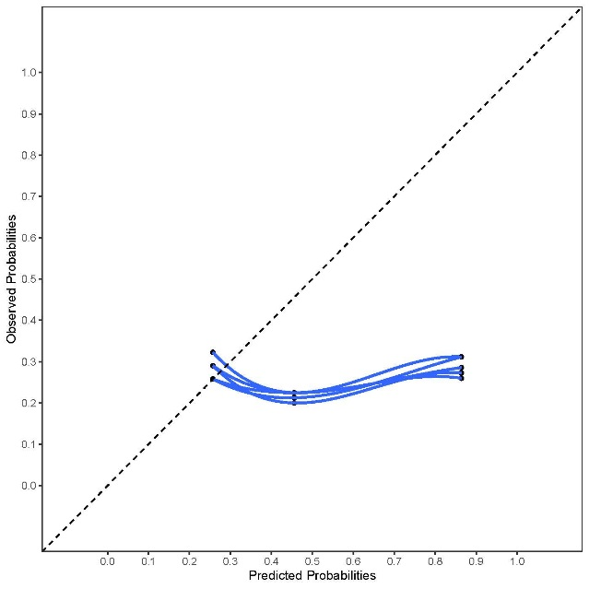

Belgium

Netherlands

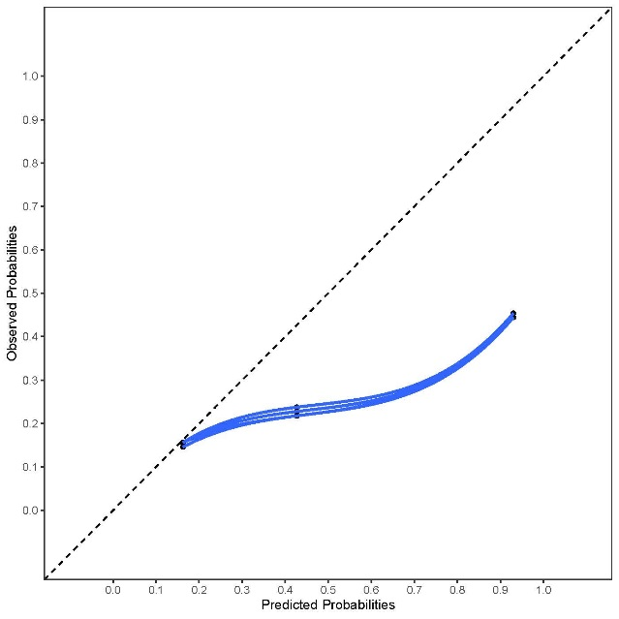

Iceland

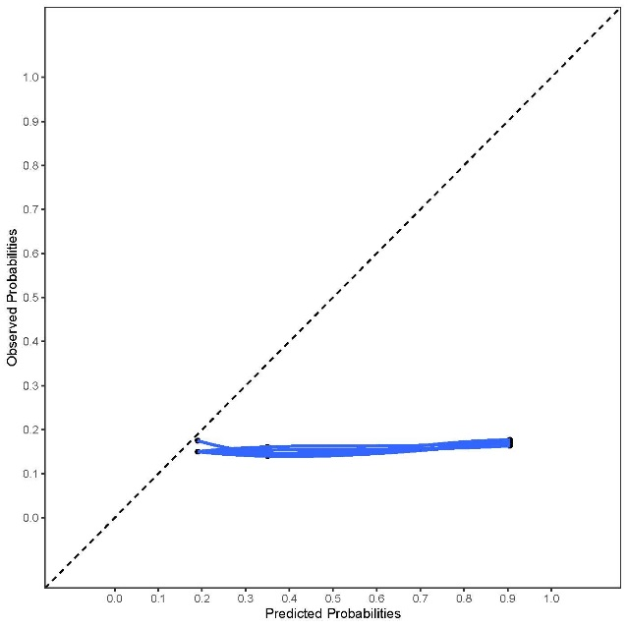

Germany

**Supplementary Figure 13 Calibration plots of PAA per country for all outcomes**





**Supplementary Figure 14 Calibration plots of CHESS per country for outcome hospital admissions**

