Supplemental information
Figure S1 |The developmental sequence of Jinia rosettea gen. et sp. nov. A, GRCP 14002, the Jinia rosettea at early developmental stage. B, GRCP 14003a, the J. rosettea at later developmental stages. C, GRCP 14003b, SEM images show the thickness of the cuticle. D, zoom in of the plate of E. E, the morphology of the rings of GRCP 14001. F, the morphology of the rings of GRCP 14003b. G, the morphology of the rings of the developed specimen GRCP 14004. Scale bars：A-C 1 mm；D 10 μm; E-G 200 μm. Abbreviation: bc: boundary cell; p: plate; po: polygon; pt: platelet.

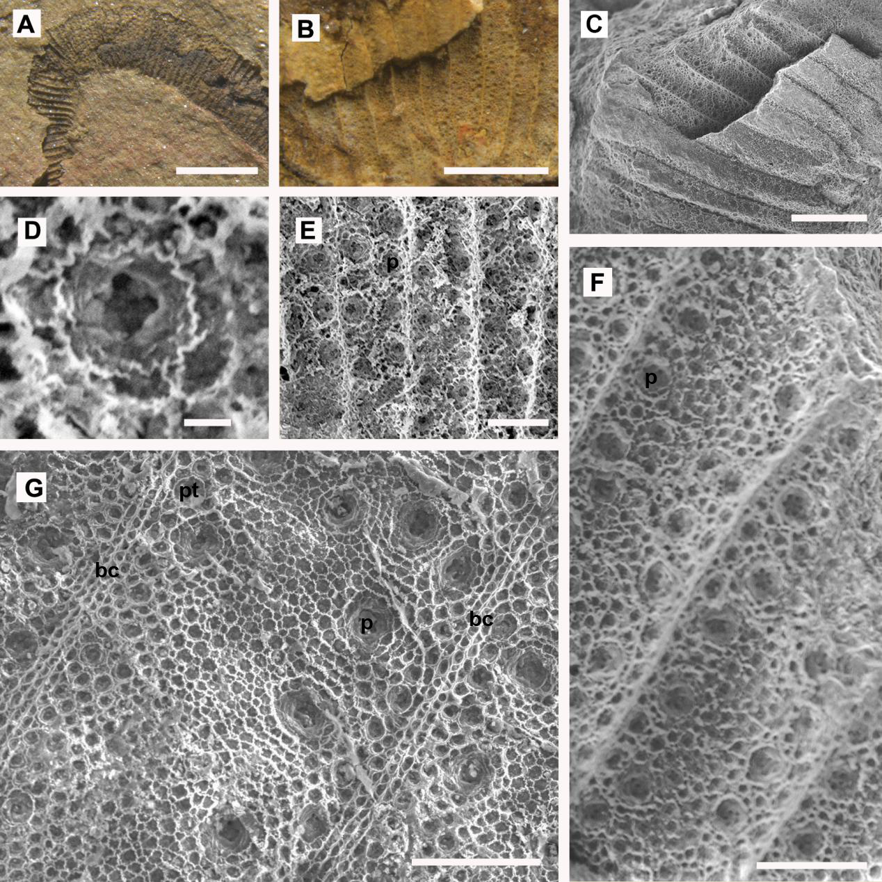Figure S1 related to Figure 1

