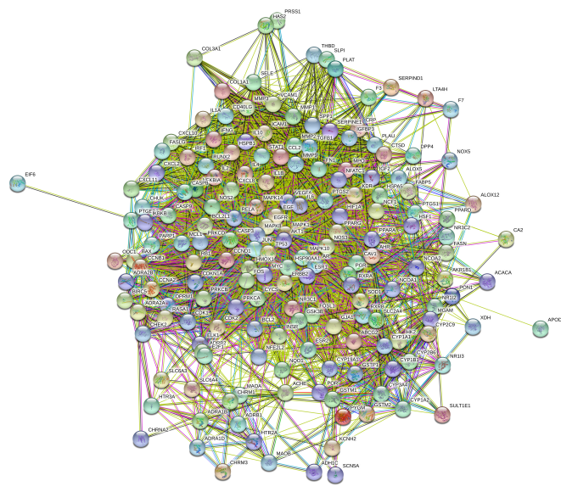
Supplementary Figure1.PPI Analysis Network of 175 Targets

