Supplementary information
Yuxin Liu et al. Multi-channel NIR/SWIR Lanthanide Nanoprobe for Forensic Gender Identification of Fingerprints

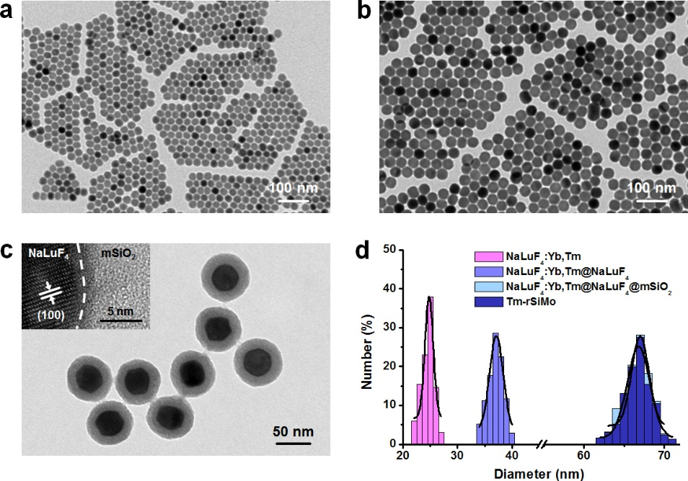
Supplementary figure 1. TEM images of NaLuF₄:Yb,Tm a), NaLuF₄:Yb,Tm@NaLuF₄ b) and NaLuF₄:Yb,Tm@NaLuF₄@mSiO₂ c). HR-TEM image of NaLuF₄:Yb,Tm@NaLuF₄@mSiO₂ is inserted. d) Diameter distribution of NaLuF₄:Yb,Tm, NaLuF₄:Yb,Tm@NaLuF₄, NaLuF₄:Yb,Tm@NaLuF₄@mSiO₂ and Tm-rSiMo.

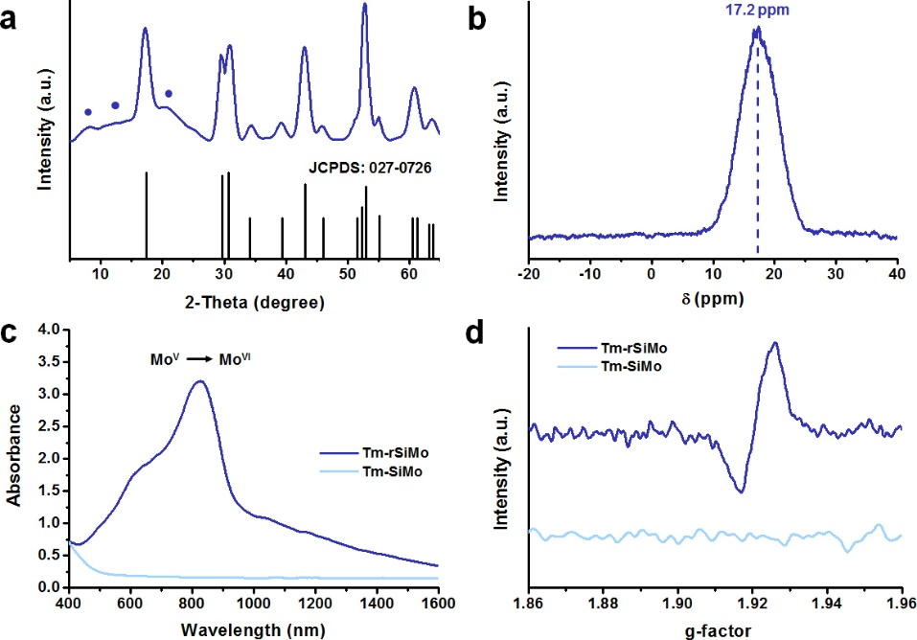
Supplementary figure 2. XRD pattern a) and ⁹⁵Mo NMR spectrum b) of Tm-SiMo. The standard pattern on bottom is assigned to hexagonal phase NaLuF₄ (JCPDS: 027-0726). The sphere-marked peaks in XRD pattern is contributed to SiMo (JCPDS: 79-2426). The δ at 17.2 ppm in ⁹⁵Mo NMR spectrum is contributed to Mo atom in α-keggin SiMo. UV-vis-NIR c) and EPR d) spectra of Tm-SiMo and Tm-rSiMo. The g-factor at ~1.92 in EPR spectrum is contributed to Mo^{V} in Tm-rSiMo.

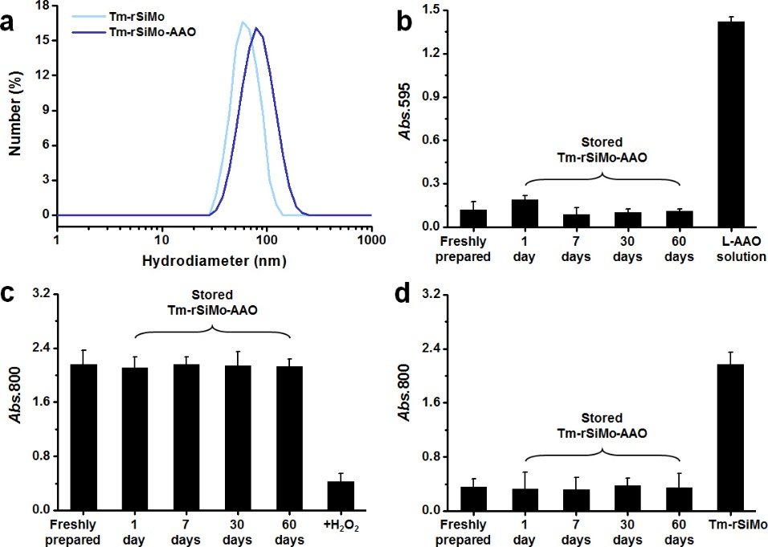
Supplementary figure 3. a) DLS of Tm-rSiMo with and without L-AAO modification. b) Detached L-AAO in supernatant of Tm-rSiMo-AAO dispersion after various storage periods. Abs.595 of ninhydrin is used as an indicator and free L-AAO solution is used as a positive control group. c) Oxidation level of Tm-rSiMo-AAO dispersion after various storage periods. Abs.800 of rSiMo is used as an indicator and H₂O₂-added Tm-rSiMo-AAO dispersion is used as a positive control group. d) Enzymatic activity of Tm-rSiMo-AAO dispersion after various storage periods. All samples are pre-treated with mimic L-AA working solution. Abs.800 of rSiMo is used as an indicator and Tm-rSiMo dispersion is used as a positive control group. Freshly prepared Tm-rSiMo-AAO dispersion is used as a negative control group. Data are represented as mean ± SD.

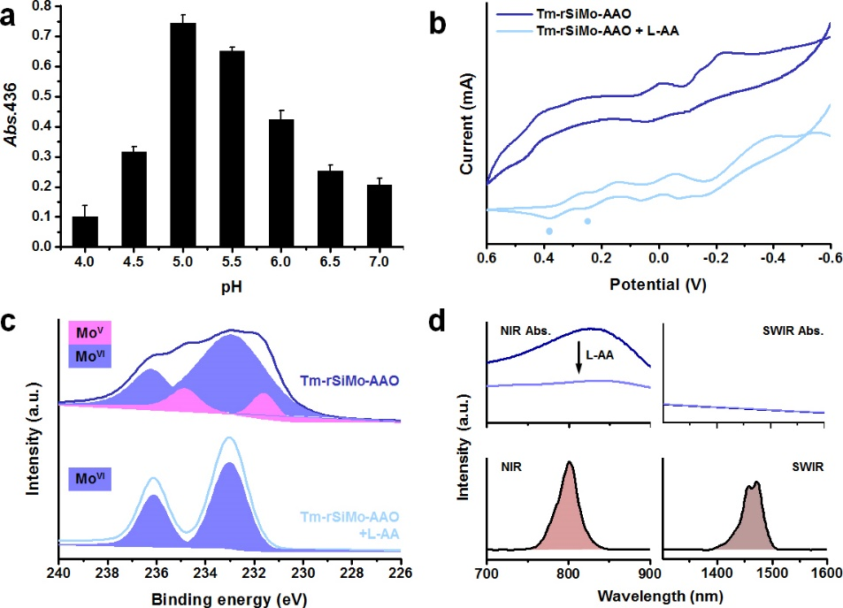
Supplementary figure 4. a) Enzymatic activity of L-AAO in various pH conditions. CV curves b) and Mo_{2p} XPS spectra c) of Tm-rSiMo-AAO in absence and presence of L-AA. The two sphere-marked peaks in CV curves are corresponded to SiMo. d) Absorbance (up) and luminescence (bottom) of Tm-rSiMo in same NIR and SWIR spectral range. Data are represented as mean ± SD.
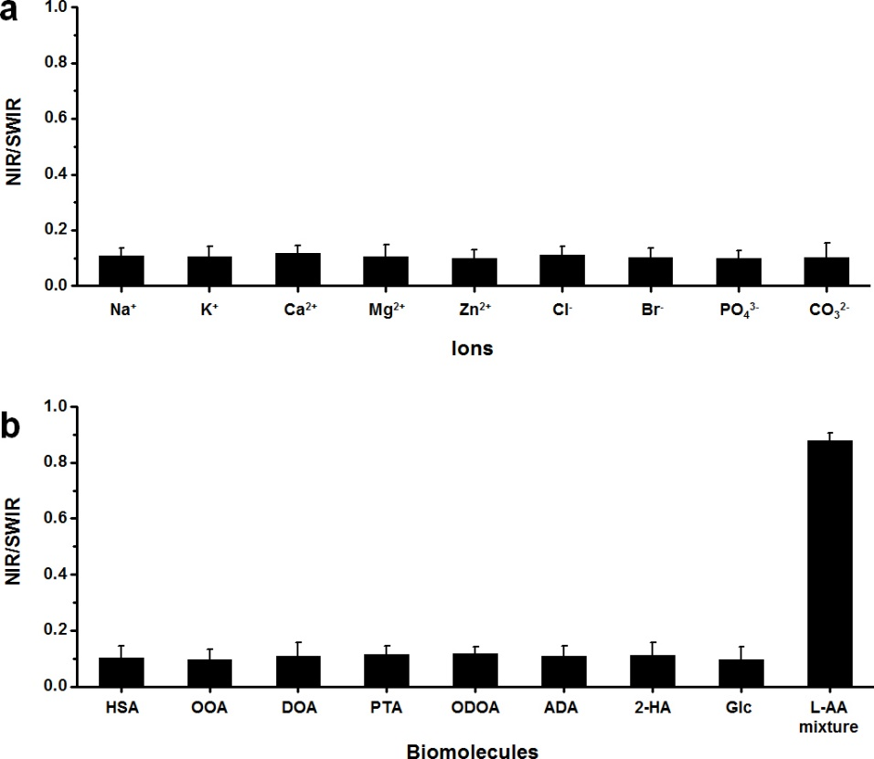
Supplementary figure 5. NIR/SWIR of Tm-rSiMo-AAO in addition with various typical ions a) and biomolecules b) in fingerprints. The biomolecule mainly refer to albumin, fatty acids and other small molecules, including human serum albumin (HSA), octanoic acid (OOA), decanoic acid (DOA), palmitic acid (PTA), octadecanoic acid (ODOA), arachidic acid (ADA) 2-hydroxypropanoic acid (2-HA) and glucose (Glc). Data are represented as mean ± SD.

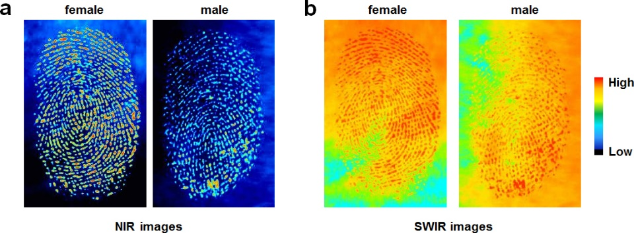
Supplementary figure 6. NIR a) and SWIR b) images of fingerprints of female and male.

Supplementary table 1. Average L-AA concentration (mM) values for males and females derived from fingerprints.
L-AA | Female | Male | Female/Male ratio
Thr | 0.2090 | 0.1121 | 1.8644
Ser | 0.9840 | 0.5208 | 1.8894
Glu | 0.1780 | 0.1109 | 1.6050
Gly | 0.6463 | 0.3418 | 1.8909
Ala | 0.3870 | 0.1968 | 1.9665
Cit | 0.1967 | 0.1267 | 1.5525
Asp | 0.1196 | 0.0638 | 1.8746
Asn | 0.0380 | 0.0161 | 2.3602
Gln | 0.0178 | 0.0120 | 1.4833
Pro | 0.0728 | 0.0349 | 2.0860
Val | 0.0919 | 0.0459 | 2.0022
Cys | 0.0012 | 0.0009 | 1.3333
Met | 0.0085 | 0.0034 | 2.5000
Iso | 0.0494 | 0.0229 | 2.1572
Leu | 0.0625 | 0.0324 | 1.9290
Tyr | 0.0559 | 0.0303 | 1.8449
Phe | 0.0378 | 0.0172 | 2.1977
β-ala | 0.0128 | 0.0034 | 3.7647
Orn | 0.1361 | 0.0684 | 1.9898
Lys | 0.0528 | 0.0285 | 1.8526
Trp | 0.0151 | 0.0071 | 2.1268
His | 0.1790 | 0.0804 | 2.2264
Arg | 0.0948 | 0.0540 | 1.7556
Total | 3.6470 | 1.9307 | 1.8889

