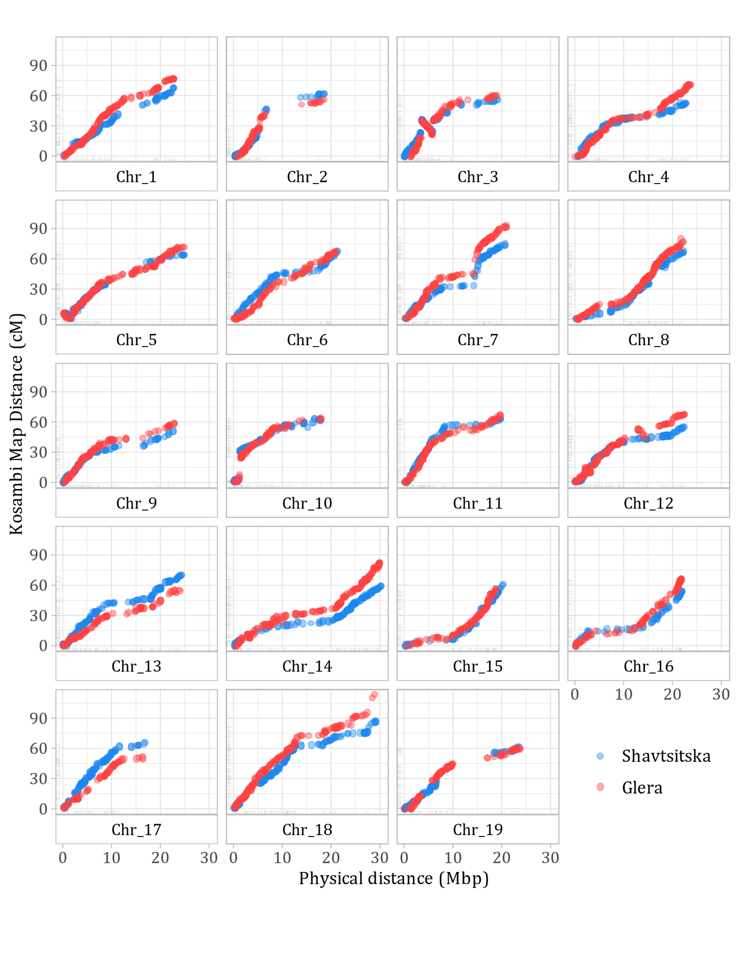
Figure S4. Dot plot for SNP markers utilized for the development of the parental linkage maps of ‘Shavtsitska’ (blue) and ‘Glera’ (red). On the x axis the SNP physical distances on grape reference genome ‘PN40024’ while on y axis the SNP genetic distances.

