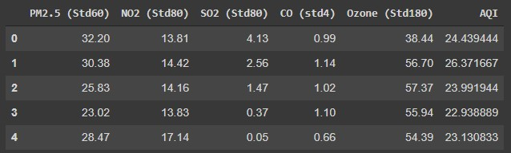
Fig. S1. The first 5 rows of the dataset
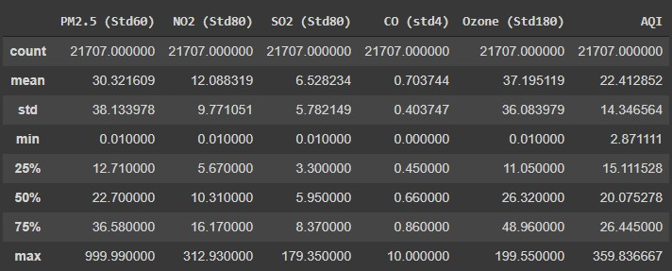
Fig. S2. Descriptive statistics about the dataset
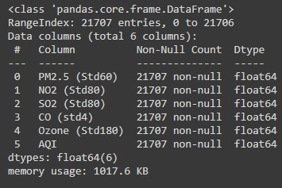
Fig. S3. Information about the dataset
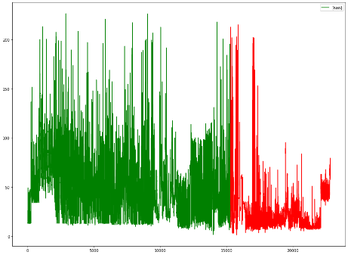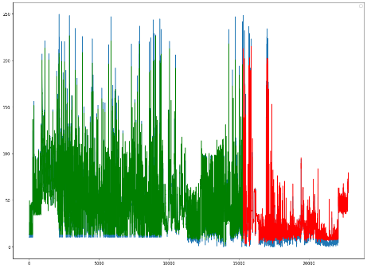
Fig. S4. (a) PM2.5 values vs Time (b) Comparison of observed vs predicted PM 2.5 values trained for 100 epochs
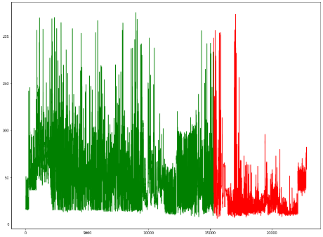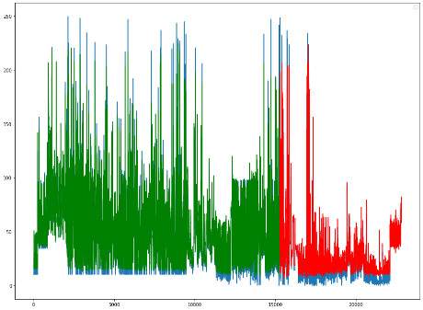
Fig. S5. (a) PM2.5 values vs Time (b) Comparison of observed vs predicted PM 2.5 values trained for 1000 epochs
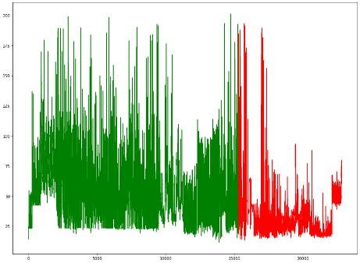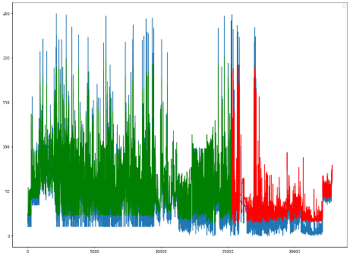
Fig. S6. (a) PM2.5 values vs Time (b) Comparison of observed vs predicted PM 2.5 values trained for 100 epochs
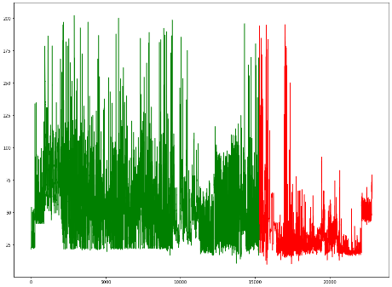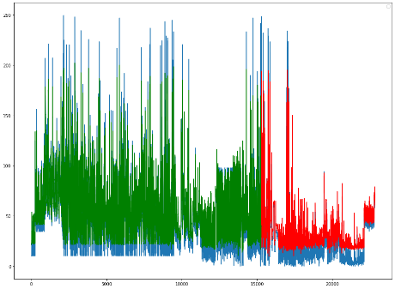
Fig. S7. (a) PM2.5 values vs Time (b) Comparison of observed vs predicted PM 2.5 values trained for 1000 epochs
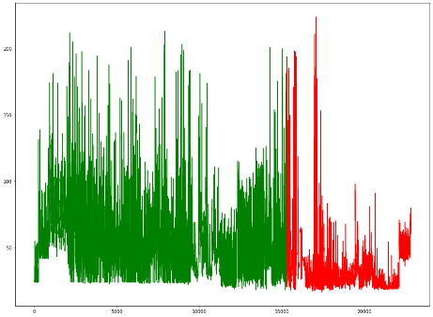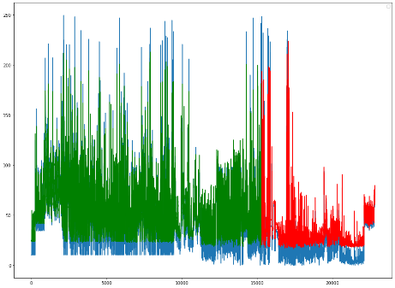
Fig. S8. (a) PM2.5 values vs Time (b) Comparison of observed vs predicted PM 2.5 values trained for 100 epochs
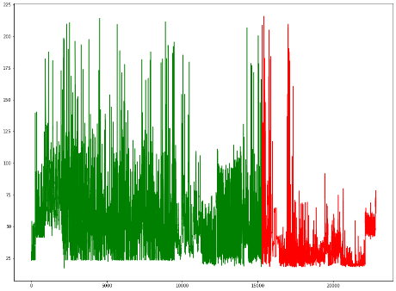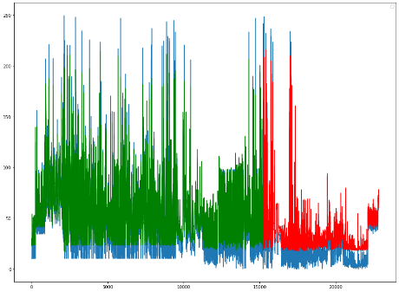
Fig. S9. (a) PM2.5 values vs Time (b) Comparison of observed vs predicted PM 2.5 values trained for 1000 epochs

