Figure S1. Phenotypes of case 103 who carries heterozygous mutations in the RP1 gene.
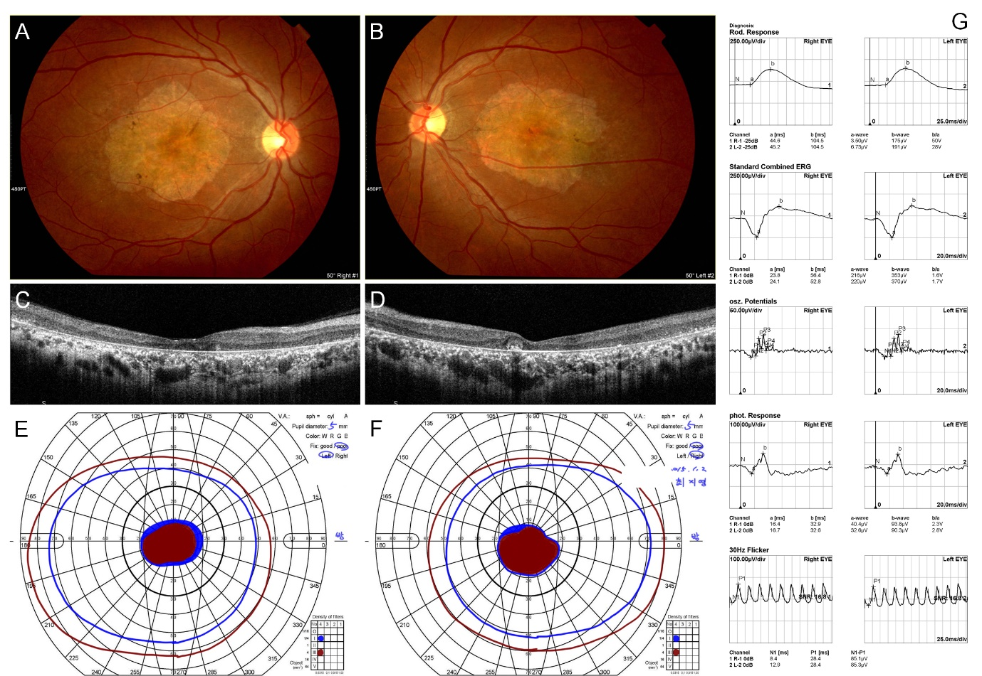
(A,B) Color fundus photograph. (C,D) Optical coherence tomography images. (E,F) Vision field diagram. (G) ERG recording.

