Supplementary files

Table S1 The culture media for callus induction, somatic embryogenesis and regeneration of G. arboreum used in this experiment
Medium | Basic medium ingredients | PGR | Amino acid
MS₀ | 1/2MS+1.5% (w/v) glucose  + 0.25% (w/v) phytagel
MS₁ | MSB+0.25% (w/v) phytagel  + 3% (w/v) glucose | 0.09 µM 2, 4-D, 2.32 µM KT
MS₂ | MSB+0.25% (w/v) phytagel  + 3% (w/v) glucose | 0.045 µM 2, 4-D, 1.476 µM IBA,  2.32 µM KT
MS₃ | MSB+0.25% (w/v) phytagel  + 3% (w/v) glucose | 2.46 µM IBA, 0.93 µM KT | 6.8 Mm Gln  3.8 Mm Asn
MS₄ | MSB+0.1g/L NaCl+0.1g/L KCl+0.1g/L CuSO₄ + 3% (w/v) glucose
MS₅ | MSB+0.25% (w/v) phytagel+37.59 mM KNO₃+62.47 µM NH₄NO₃ + 3% (w/v) glucose |  | 6.8 mM Gln  3.8 mM Asn
MSB: MS salts (Murashige and Skoog 1962) and B₅ vitamins (Gamborg et al. 1968), 555 µM myo-inositol; Gln: glutamine; Asn: asparagines; IBA: Indole-3-butyric acid; KT: kinetin

Table S2 Plant growth regulators (PGRs) used for somatic embryogenesis in G. arboreum on MS₅ medium
 | Combination of PGR
G1 | 0.45 µM 2, 4-D，0.93 µM KT
G2 | 0.226 µM 2, 4-D，0.465 µM KT
G3 | 0.113 µM 2,4-D，0.23 µM KT
G4 | 0.045 µM 2, 4-D, 2.46 µM IBA, 0.465 µM KT
G5 | 2.46 µM IBA, 0.93 µM KT
G6 | no PGRs served as control

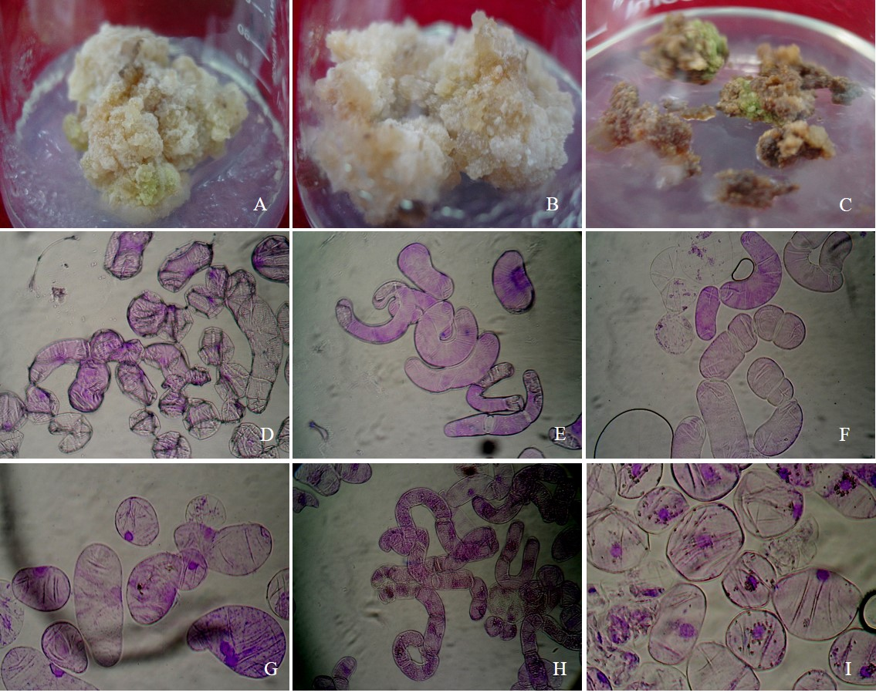
Fig. S1 Callus induction and cell phenotype from callus of G.arboreum through solid and alternate solid-liquid culture.
A, B, C：initial callus (C1) from hypocotyls, roots and cotyledons proliferated on MS₂ medium; D: The cell phenotypes of initial callus from hypocotyls; E: the cell phenotypes of new callus (SC1) formed from the one cycle suspension culture of C1 callus in MS₄ medium; F: The cell phenotypes of SC1 callus proliferated on solid MS₃ medium; G: The cell phenotype of new callus (SC2) formed on MS₃ medium from the suspension culture in liquid MS₄ medium; H: The cell phenotype of proliferated SC2 callus on MS₃ medium; I: The cell phenotype of new SC3 callus formed on MS₃ medium from 2-3 cycles of alternate solid-liquid cultures

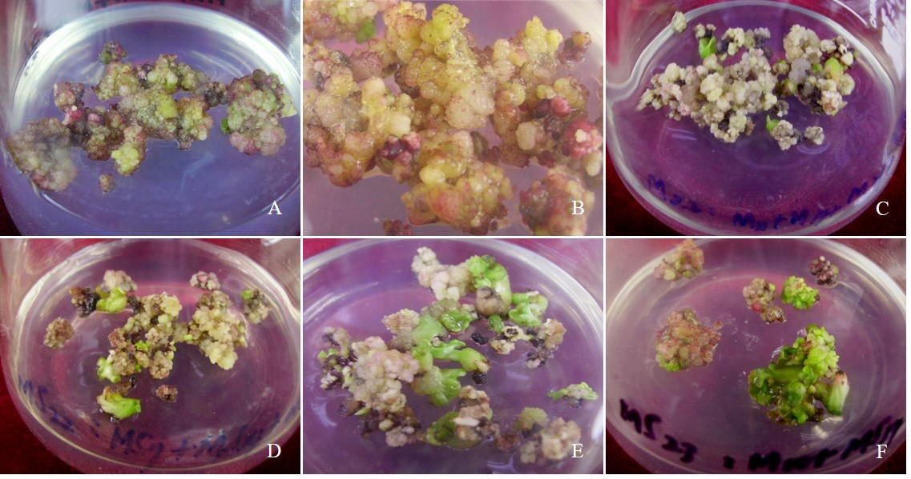
Fig S2 Somatic embryogenesis on MS₅ medium with different PGRs
A: embryogenic callus cultured on MS₅ medium with G1 PGR; B: embryogenic callus cultured on MS₅ medium with G3 PGR; C: embryogenic callus cultured on MS₅ medium with G6 PGR (No PGRs supplemented in medium); D: somatic embryogenesis on MS₅ medium with G1; E: somatic embryogenesis on MS₅ medium with G2 PGR; F: somatic embryogenesis on MS₅ medium with G3 PGR.

