Supporting Information
Biosensor-enabled on-site therapeutic drug monitoring of antibiotics
H. Ceren Ates^{1,2}, Hasti Mohsenin³, Christin Wenzel⁴, Regina Glatz^{1,2}, Hanna J. Wagner^{3,5}, Richard Bruch², Nico Höfflin³, Sashko Spassov⁴, Lea Streicher⁴, Sara Lozano-Zahonero⁴, Bernd Flamm⁴, Maja Köhn³, Johannes Schmidt⁴, Stefan Schumann⁴, Gerald A. Urban^{1,6}, Wilfried Weber³, Can Dincer^{1,2, *}

H. Ceren Ates, Regina Glatz, Can Dincer
University of Freiburg, Freiburg Center for Interactive Materials and Bioinspired Technologies (FIT), Georges-Koehler-Allee 105, 79110 Freiburg, Germany
E-mail: dincer@imtek.de

H. Ceren Ates, Regina Glatz, Richard Bruch, Gerald A. Urban, Can Dincer
University of Freiburg, Department of Microsystems Engineering (IMTEK), Laboratory for Sensors, 79110 Freiburg, Germany

Hasti Mohsenin, Hanna J. Wagner, Nico Höfflin, Maja Köhn, Wilfried Weber
University of Freiburg, Faculty of Biology and Signalling Research Centres BIOSS and CIBSS, Schaenzlestrasse 18, 79104 Freiburg, Germany

Hanna J. Wagner
ETH Zurich, Department of Biosystems Science and Engineering, Mattenstrasse 26, 4058 Basel, Switzerland

Christin Wenzel, Sashko Spassov, Lea Streicher, Sara Lozano-Zahonero, Bernd Flamm, Johannes Schmidt, Stefan Schumann
University of Freiburg, Department of Anesthesiology and Critical Care, Medical Center -, Faculty of Medicine, 79085 Freiburg, Germany

Gerald A. Urban
University of Freiburg, Freiburg Materials Research Centre (FMF), 79104 Freiburg, Germany

  - Chip design and fabrication
A polyimide foil, Pyralux® AP8525R (DuPont, USA) was utilized after 1 h of copper etching as a substrate material for the biosensor fabrication¹. The platinum (Pt) electrode structures were prepared by using lift-off technology. The negative tone photoresist, ma-N 1420 (Micro Resist Technology, Germany), was spin coated onto the substrate at 3,000 rpm for 30 s, exposed to UV (ultraviolet) light on an exposure unit (Hellas, Bungard Elektronik, Germany) and developed. Pt electrodes (200 nm) were deposited via physical vapour deposition in a cleanroom environment. SU-8 3005 (MicroChem Corp., USA) layer (5 µm thick) was applied by spin coating at 4,000 rpm for 30 s to (i) precisely define the electrode areas, (ii) electrically isolate electrodes, (iii) realize small wells to implement stopping barriers later on. After UV light exposure and development steps, the SU-8 coated wafer was hard-baked in an oven (Binder, Germany) for 3 h at 150 °C.
After hard-bake, in order to remove possible SU-8 residues on the Pt electrodes, a low frequency oxygen plasma (Tetra-30-LF-PC, Diener, Germany) was applied for 3 min at 300 W at room temperature. Ag/AgCl on-chip reference electrode was realized by galvanic deposition in an Arguna S solution (Umicore Galvanotechnik, Germany) employing a constant current of −0.2524 mA for 20 min with a silver wire as counter electrode. After chlorination of the silver layer in a 0.1 M Potassium chloride (KCl) solution employing a constant current of +135.44 µA for 10 min, the reference electrode was finalized.
The microfluidic channels were realized by stacking dry film photoresist layers, Pyralux® PC1025 (DuPont, USA), on the platinum patterned polyimide substrate. DFR layers were first exposed for 50 s to UV light and then developed in a 1% sodium carbonate (Na₂CO₃) solution at 42 °C in an ultrasonic bath (Sonorex Super 10 P, Bandelin, Germany). To prevent any over-development, DFR layers were subsequently immersed into a 1% HCl bath for 1 min.
Hydrophobic stopping barrier which separates the electrochemical cell from the immobilization area, small drops of 3% Teflon® (AF 1600, DuPont, USA) were dispensed into small SU-8 wells. Finally, the developed layers were aligned on the substrate and fixed using a laminator (HRL 350, Ozatec). After lamination, the wafer was diced into individual biosensor chips and hard-baked at 160 °C for 3 h with a ramp function.

  - Cost estimation of the biosensor used in this study
Fabrication- and functionalization-related costs of the biosensor, were calculated by using the in-house used container sizes and prices of each step. As these prices are based on relatively small container sizes, the price will strongly vary, depending on the quantity of manufactured biosensor chips. Calculations were made with a batch of 4 wafers, each containing 130 biosensors².

Table S1: Estimation of the costs for the fabrication and functionalization of a single biosensor.
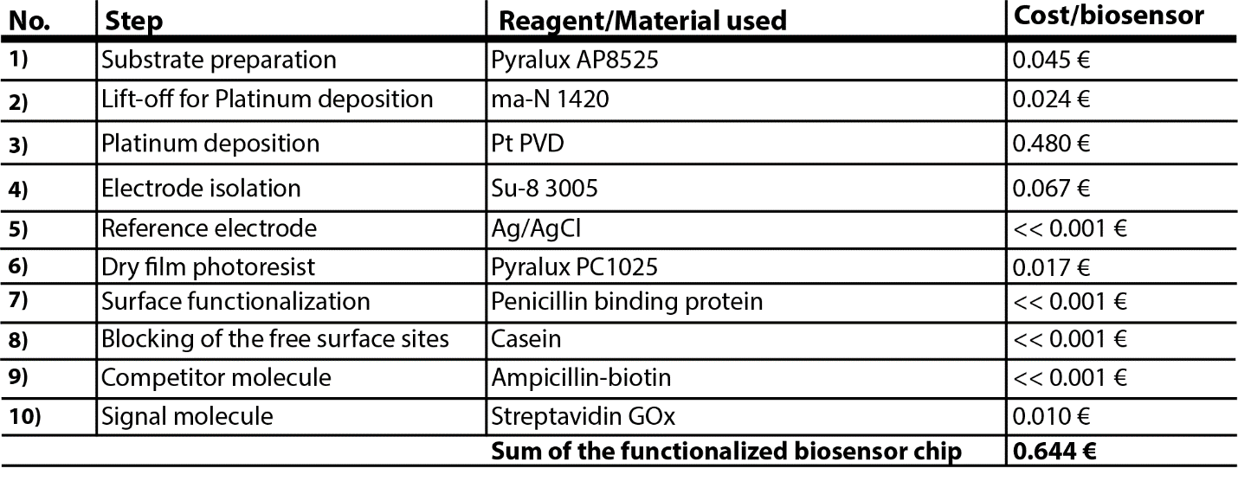

  - Production and purification of the penicillin-binding protein 3 (PBP-3)
The PBP-3 bacterial expression vector was transformed into E. coli BL21 (DE3) pLysS (Invitrogen).³ Bacteria were grown in LB medium (Roth) containing 100 µg m$L^{-1}$ampicillin (Roth) and 36 µg m$L^{-1}$chloramphenicol (Roth) at 37 °C, 150 rpm. Once OD600 = 0.6 was reached, protein production was induced with 1 mM isopropyl ß-D-1-thiogalactopyranoside (IPTG) for 14 h at 20 °C. Cells were harvested by centrifugation at 6,000 $×$ g for 10 min and the bacterial pellets were resuspended in Ni-Lysis buffer (50 mM NaH₂PO₄, 300 mM NaCl, 10 mM imidazole, pH 8.0) and lysed by sonication (60% amplitude, 0.5 s/1 s pulse/pause intervals using a Bandelin Sonoplus HD 3100 homogenizer, Germany, for 10 min on ice). Cellular debris was removed by centrifugation at 30,000 $×$ g for 30 min at 4 °C and the supernatant was purified by gravity flow Ni²⁺-NTA chromatography using superflow agarose (QIAGEN, Germany) following the manufacturer’s instructions. The buffer of the purified proteins was exchanged by dialysis against 5 L Ni-Lysis buffer without imidazole overnight, using SnakeSkin dialysis tubes with 3.5k MWCO (Thermo Fisher Scientific, USA). The purified protein was analysed by SDS-PAGE (12% (w/v) gels) and Coomassie brilliant blue staining (Figure S1). The protein concentration was determined by Bradford method (Bio-Rad, USA) with bovine serum albumin (Carl Roth GmbH + Co. KG, Germany) as standard. Proteins were supplemented with 10% glycerol and concentrated to a final concentration of 10 mg m$L^{-1}$ using Spin-X UF 6 (10k MWCO, Corning Inc.,USA). Aliquots were stored at –80 °C and thawed for each experiment.

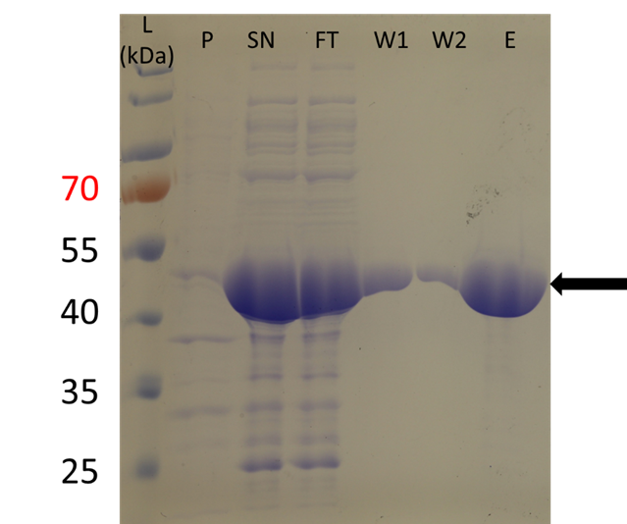
Figure S1: (a) Chemical reaction of NHS-(PEG)24-biotin with ampicillin. (b) Analysis of PBP-3 purification by SDS-PAGE. 6 µL of PageRuler Prestained Protein Ladder (Thermo Fischer Scientific, USA, lane 1) and 10 µL of samples were separated on a 12% (w/v) SDS-gel. P, pellet; SN, supernatant; FT, flow-through; W1, wash fraction 1; W2, wash fraction 2; E, elution. The arrow indicates the purified PBP-3 protein (expected size: 42 kDa).

  - Synthesis of the ampicillin-biotin conjugate
1 mg ampicillin sodium salt (Carl Roth GmbH + Co. KG, Germany) was dissolved in 842 µl dried ethanol (max. 0.01% H₂O, Merck KGaA, Germany). NHS-PEG₂₄-biotin (Sigma-Aldrich, Germany, QBD10774) was dissolved in anhydrous DMSO (Sigma-Aldrich, Germany) under continuous Argon flow in a desiccator to a final concentration of 50 mg m$L^{-1}$. 158 µL NHS-PEG₂₄-biotin solution (5.4 µmol) was mixed with 842 µL ampicillin solution (2.7 µmol) and incubated at RT for 3 h while shaking (400 rpm)³. The reaction characterization was carried out by MALDI-MS. Conjugates were aliquoted under argon flow and stored at –80 °C. The product was used without further purification as the non-reacted NHS-PEG₂₄-biotin was eliminated by washing after binding of the ampicillin-biotin conjugate to PBP-3 on the biosensor.

  - Characterization of the biomolecules
Samples were dissolved in acetonitrile (HPLC grade, Sigma-Aldrich, Germany). 5 µl of the sample solution was mixed with 5 µl of a saturated solution of α-cyano-4-hydroxycinnamic acid matrix for MALDI-MS (Sigma-Aldrich, Germany) in acetonitrile. 1.5 µl of the latter mixture was applied to the MALDI target and let dry. Analysis was carried out on a Microflex MALDI mass spectrometer (Bruker, USA) and data was processed via mMass software.⁴

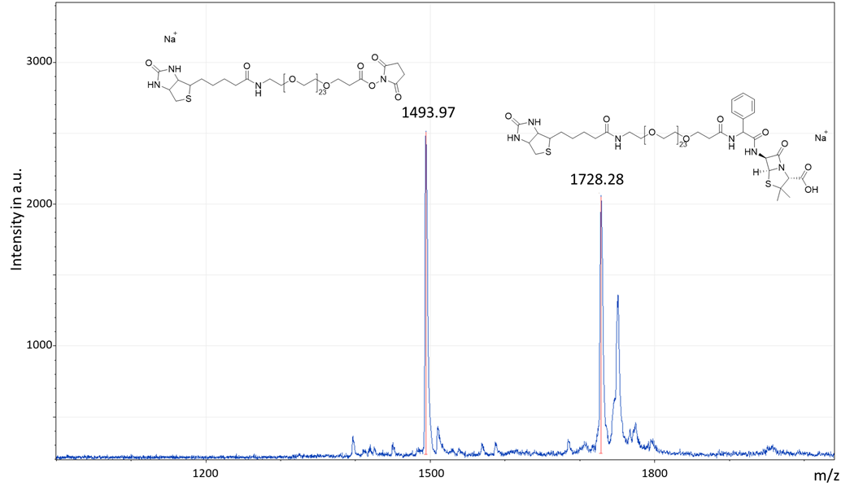
Figure S2: Time-of-flight MALDI spectra analysis. The marked left peak corresponds to the excess amount of reactant (NHS (PEG)24-biotin) with an expected molecular weight of ~1493 g mol^{–1}. The marked right peak corresponds to final product (ampicillin-(PEG)24-biotin) with an expected molecular weight of ~172 g mol^{–1}.

  - Animal studies
The study was approved by the review board of local ethical committee (Regierungspräsidium Freiburg; Ref.-No. G-20/45) and performed in accordance with the European and German law on protection of animals used for scientific purposes. With the intention to reduce animal experiments, this and another study regarding respiratory system mechanics during mechanical ventilation, not interfering with each other were conducted with the same animals.
German Landrace hybrid pigs with a weight of 43 ± 3 kg (6 males, 3 females) were used for this study. After a fasting period of 12 h, animals were premedicated with an intramuscular injection of ketamine (20 mg kg^{–1}) and midazolam (0.5 mg kg^{–1}). Anaesthesia was induced intravenously (i.v.) with propofol and maintained with a continuous infusion of midazolam (0.3 mg kg^{–1} h^{–1}), ketamine (10 mg kg^{–1} h^{–1}) and dexmedetomidine (1-5 µg kg^{–1} h^{–1}). To prevent dehydration during ventilation Ringer solution (10 ml kg^{–1} h^{–1}; B. Braun Melsungen AG, Germany) was infused intravenously. The pigs were tracheally intubated with a standard endotracheal tube with an inner diameter of 7.5 mm and ventilated with an intensive care ventilator (Evita V500, Draeger Medical, Germany) with a tidal volume of 7 ml kg^{–1}, inspiratory oxygen fraction of 0.3 and a positive end-expiratory pressure of 5 cm H₂O. Respiratory rate was adjusted to achieve an End-Tidal CO₂ of 35-45 mm Hg. An arterial catheter (4F, Pulsion Medical Systems, Germany) was placed in the femoral artery for taking blood samples. A urinary catheter was inserted into the bladder for taking urine samples. Following surgical intervention and a stabilization phase of 15 min and randomization, piperacillin/tazobactam was injected intravenously with either 200%, 100% or 50% of standard dose (4 g piperacillin/tazobactam 0.5 g).
Samples of blood and urine were taken before (ST), and 5 (BL), 30, 60, 120, 180 and 240 min after injection of antibiotics. Additionally, saliva probes were drawn via an intravenous cannula (Vasofix 14G, B. Braun Melsungen AG, Germany) before (ST), 5 (BL) 30, 60, 120 and 180 min after injection of antibiotics.
To collect exhaled breath condensate (EBC), expiratory gas was drawn at a flow rate of 180 ml min^{–1} using a flow generator (Vamos, Dräger Medical, Lübeck, Germany) from the airway’s mainstream measurement for 30 min. The gas was cooled down for condensation at -7.5 °C. EBC samples were taken before injection of antibiotics and after 30, 60, 120 and 180 minutes.
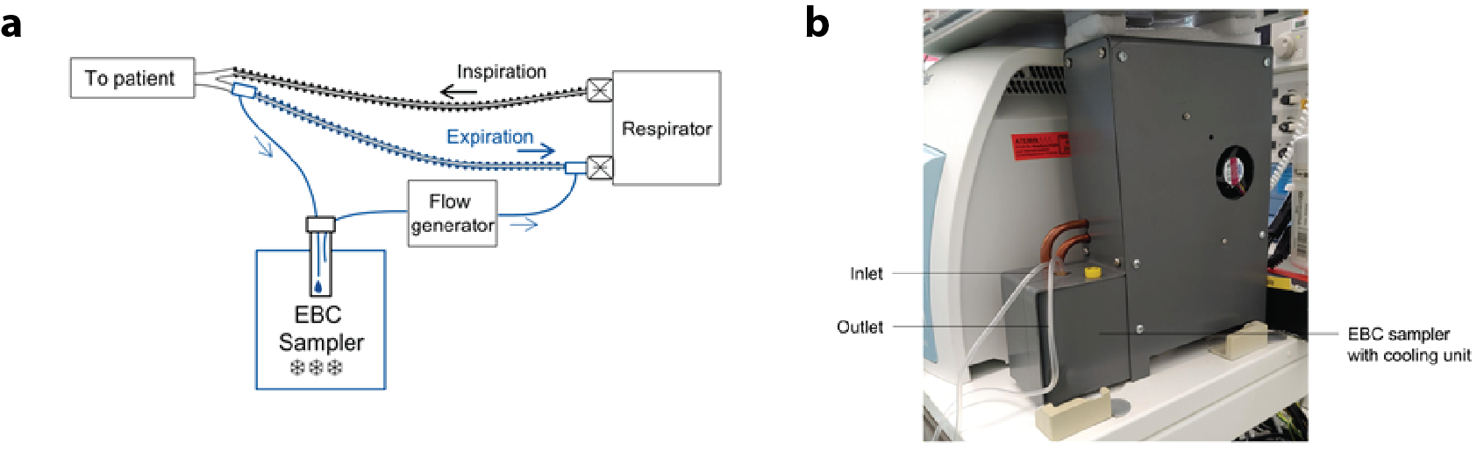
Figure S3: (a) Schematic drawing of setup to measure exhaled breath condensate (EBC). Via side stream measurement 180 ml min^{–1} were continuously drawn from patients’ exhaled air using a flow generator (Vamos, Dräger Medical, Lübeck, Germany) and cooled down for condensation at –7.5 °C. (b) Illustration of the device for sampling EBC from patients’ exhaled air using side stream measuring.

  - Statistical analysis and calculation of limit of detection
All data were expressed as mean ± standard error with n = 4. For the calculation of the limit of detection (LOD), the fitted calibration curve was used to determine the signal response from the sensor at the LOD, using the following equation 1:
$y={LOD}_{signal}={Signal}_{blank}-1.654*{SD}_{blank}-1.654*{SD}_{lowest_measured_concentration}$ (Eq. 1)
To calculate the responding concentration of the obtained ${LOD}_{signal}$, the equation of the 4-parametric logistic fit is needed; equation 2:
$y=A_{min}+\frac{A_{max}-A_{min}}{1+{(\frac{x}{x_{0}})}^{p}}$ (Eq. 2)
where $A_{min}$ is equal to the lower saturation plateau for higher concentrations, $A_{max}$ corresponds to the higher saturation plateau for very low concentrations. $x_{0}$ describes the concentration value for which 50% of the signal is present and $p$ is the slope of the fitting curve in the dynamic region. By placing the obtained ${LOD}_{signal}$ of equation 1 into equation 2, the LOD can be calculated:
${LOD}_{concentration}=x_{0}*({\frac{{LOD}_{signal }-A_{max}}{A_{min}-{LOD}_{signal }})}^{\frac{1}{p}}$ (Eq. 3)
These calculations were performed for every calibration curve, shown in this publication.
  - On-chip assay optimization
On-chip incubation started with PBP-3 adsorption by 1-hour incubation of the channel surface with 250 µg ml^{–1} PBP-3 (Table S2). Then, active surface sites were blocked with biotin-free casein for 20 minutes. The third step of the assay relied on the competitive binding of piperacillin in the sample solutions with different concentrations and 0.2 µg ml^{–1} biotinylated ampicillin to the PBP-3. Finally, 10 µg ml^{–1} Streptavidin-glucose oxidase was utilized with a 15-minute incubation for the signal generation. After each incubation step, a washing protocol was employed, where the microchannel was flushed with wash buffer (50 μl of 0.05% TWEEN 20 in 10 mM PBS). Unbound biomolecules were removed by applying a vacuum to the channel inlet, without contaminating the measurement cell. Conversion of glucose to hydrogen peroxide by streptavidin-glucose oxidase resulted in an electrical current through the measurement of H₂O₂ in the electrochemical cell, followed by the signal readout.

Table S2: Incubation protocol of all assay components employed for the on-chip antibiotic assay.
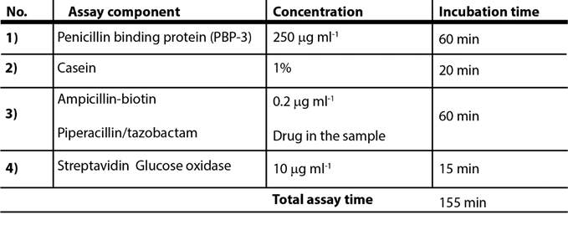
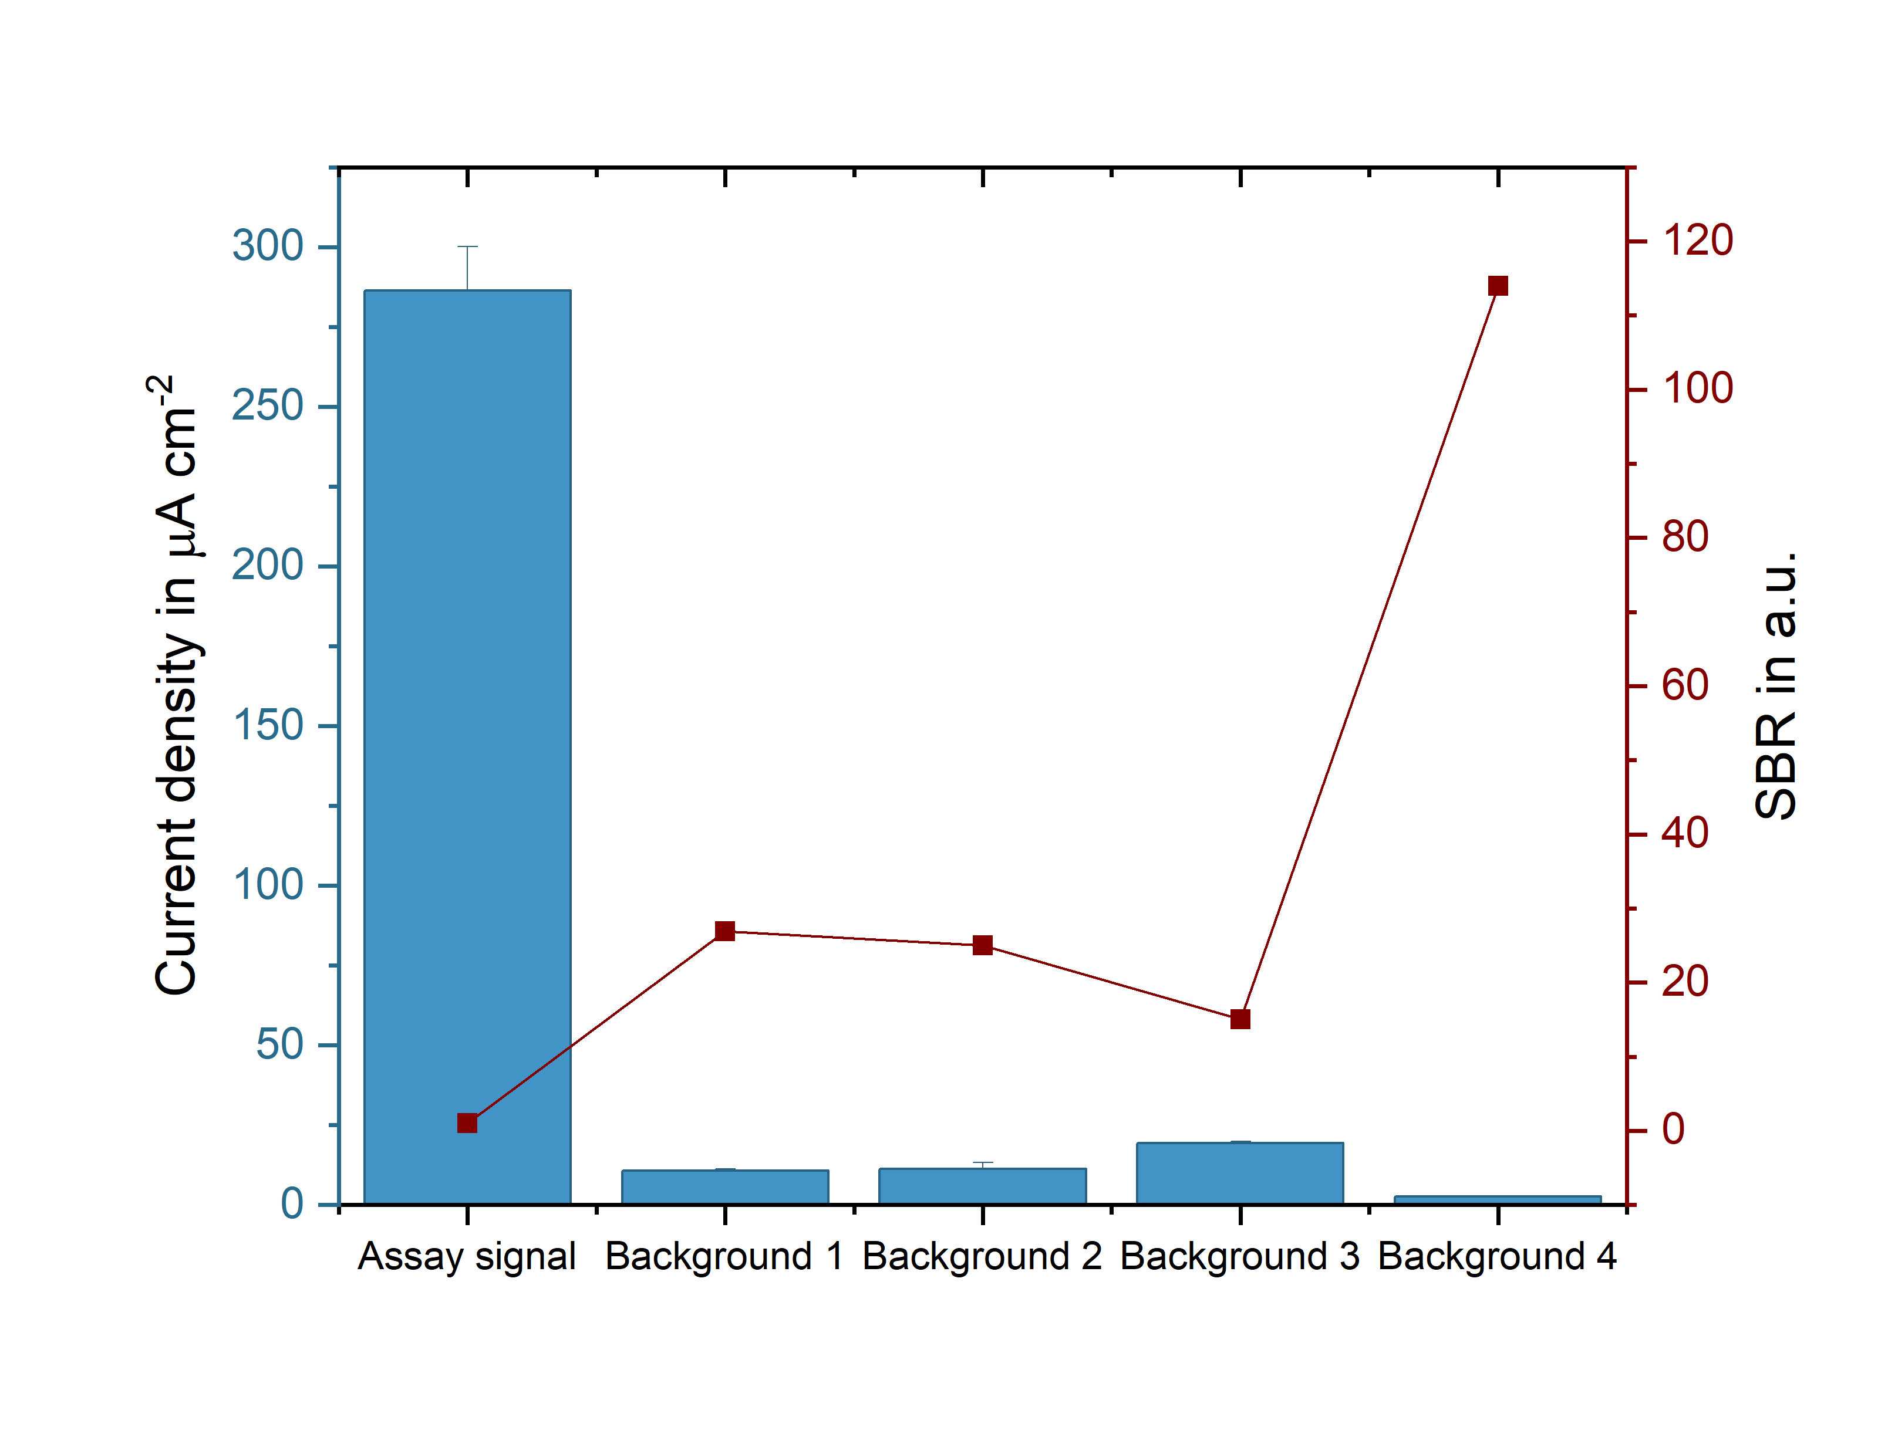
Figure S4: Determination of non-specific binding of assay components. Background 1: The signal obtained by 10 µg ml^{–1} Streptavidin-GO_{x} immobilized on the surface blocked with casein. Background 2: The signal obtained by the channel functionalized with 250 µg ml^{–1} PBP-3, blocked with casein and incubated with 10 µg ml^{–1} Streptavidin-GO_{x}. Background 3: The signal obtained by the channel blocked with casein, and incubated with 10 µg ml^{–1} ampicillin-biotin and 10 µg ml^{–1} Streptavidin-GO_{x}. Background 4: The signal obtained by the channel functionalized with 250 µg ml^{–1} PBP-3, blocked with casein and incubated with 10 µg ml^{–1} ampicillin-biotin. The signal to background ratio (SBR) was calculated by dividing the individual mean values of the signal by the mean values of the individual backgrounds. Error bars represent ± SD of n = 4 replicates.

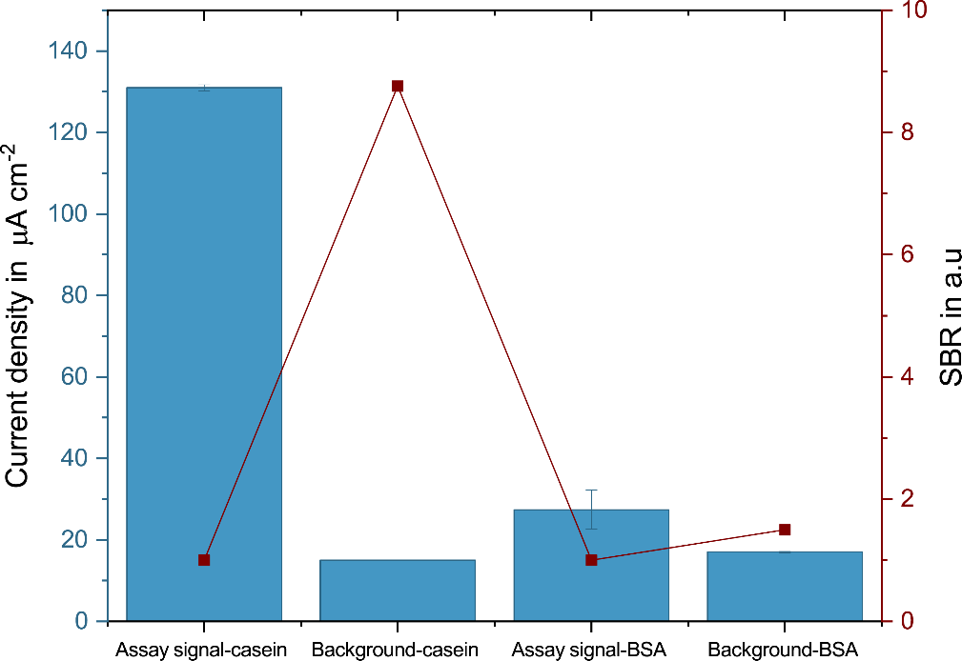
Figure S5: Comparison of two different blocking strategies. The signal to background ratio was calculated by dividing the mean values of the signal by the mean values of the individual backgrounds of casein and BSA. Error bars represent ± SD of n = 4 replicates.

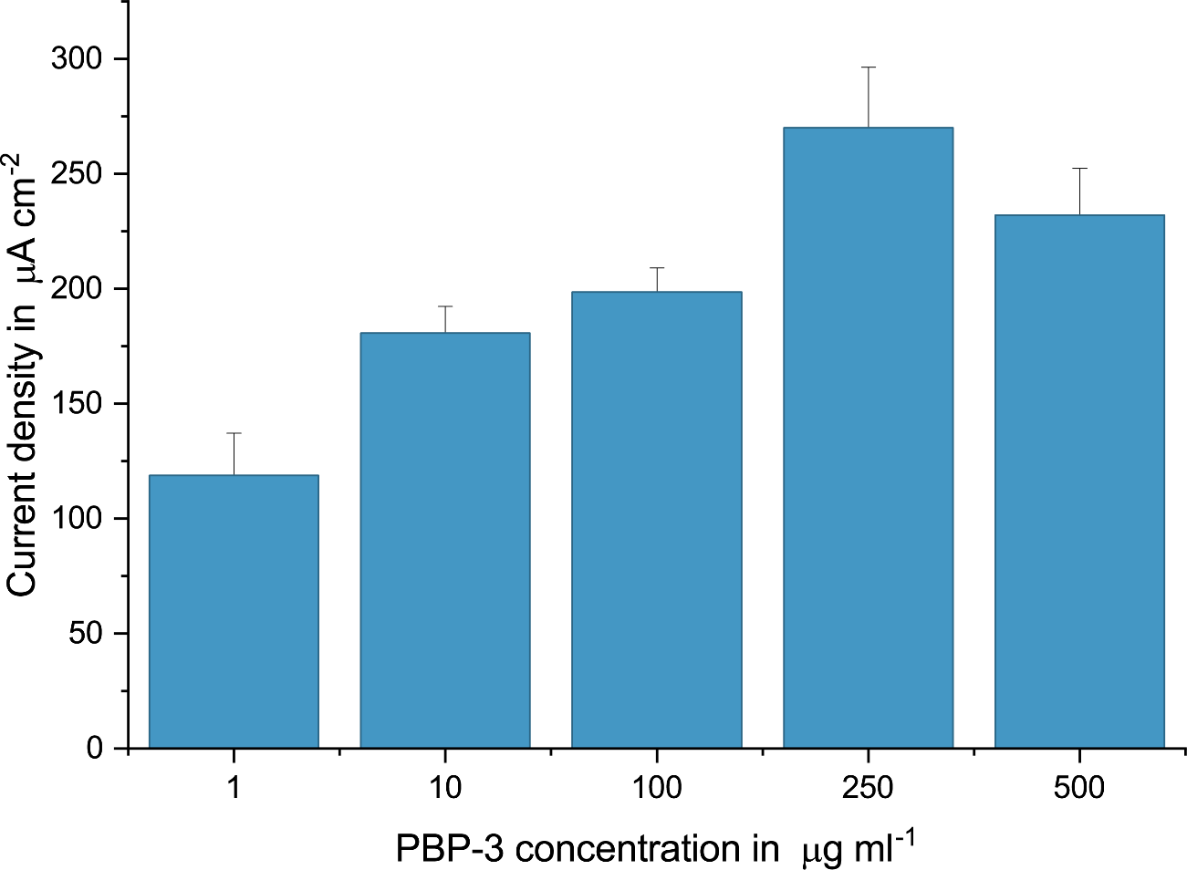
Figure S6: Comparison of different PBP-3 concentrations to functionalize the surface of the chip. For ß-lactam measurements, unless otherwise stated, the concentration of PBP-3 was selected as 250 µg ml^{–1}. Error bars represent ± SD of n = 4 replicates.

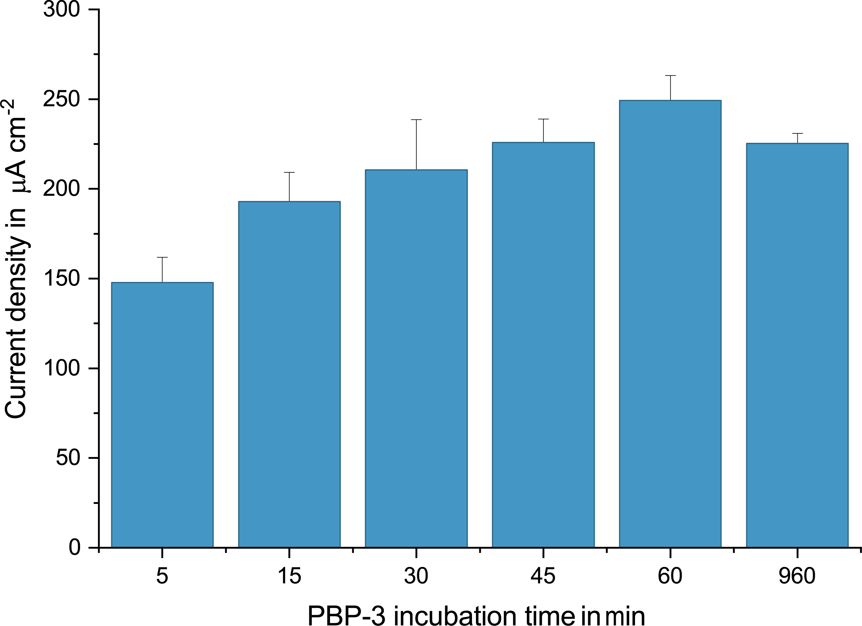
Figure S7: Comparison of different PBP-3 (250 µg ml^{–1}) incubation times for the functionalization of the chip surface. For ß-lactam measurements, unless otherwise stated, the incubation time with PBP-3 was selected as 1 hour. Error bars represent ± SD of n = 4 replicates.

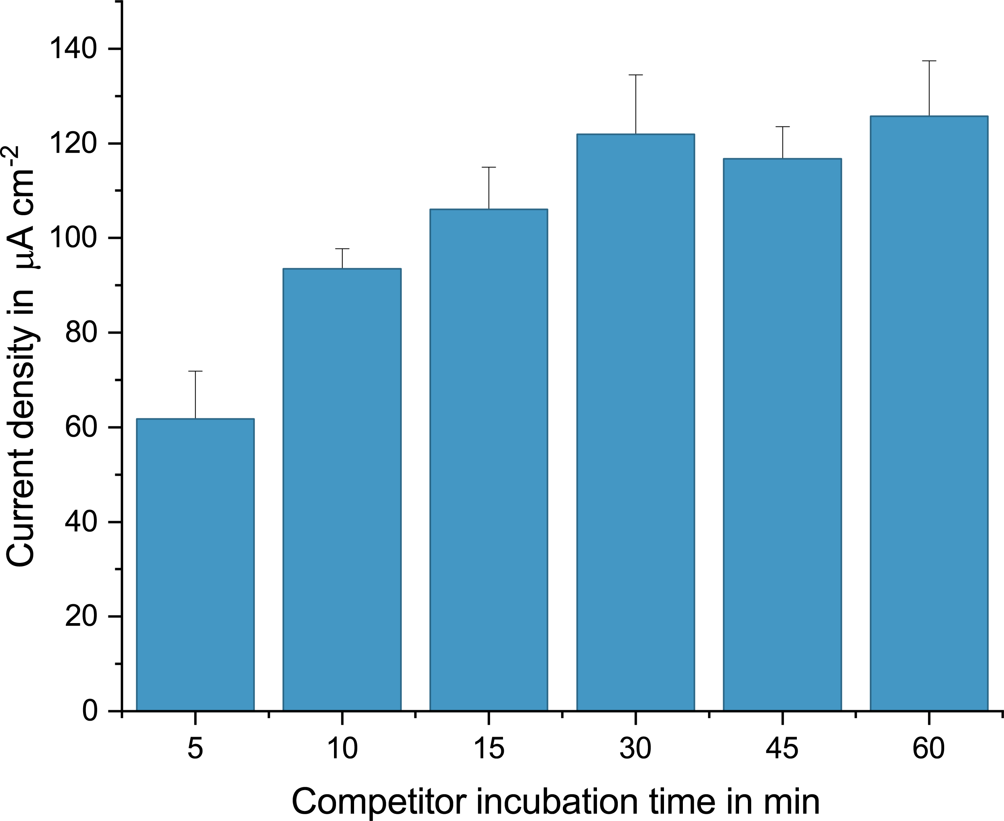
Figure S8: Comparison of different ampicillin-biotin (10 µg ml^{–1}) incubation times. For assay measurements, unless otherwise stated, the competitor incubation time was selected as 1 hour. Error bars represent ± SD of n = 4 replicates.

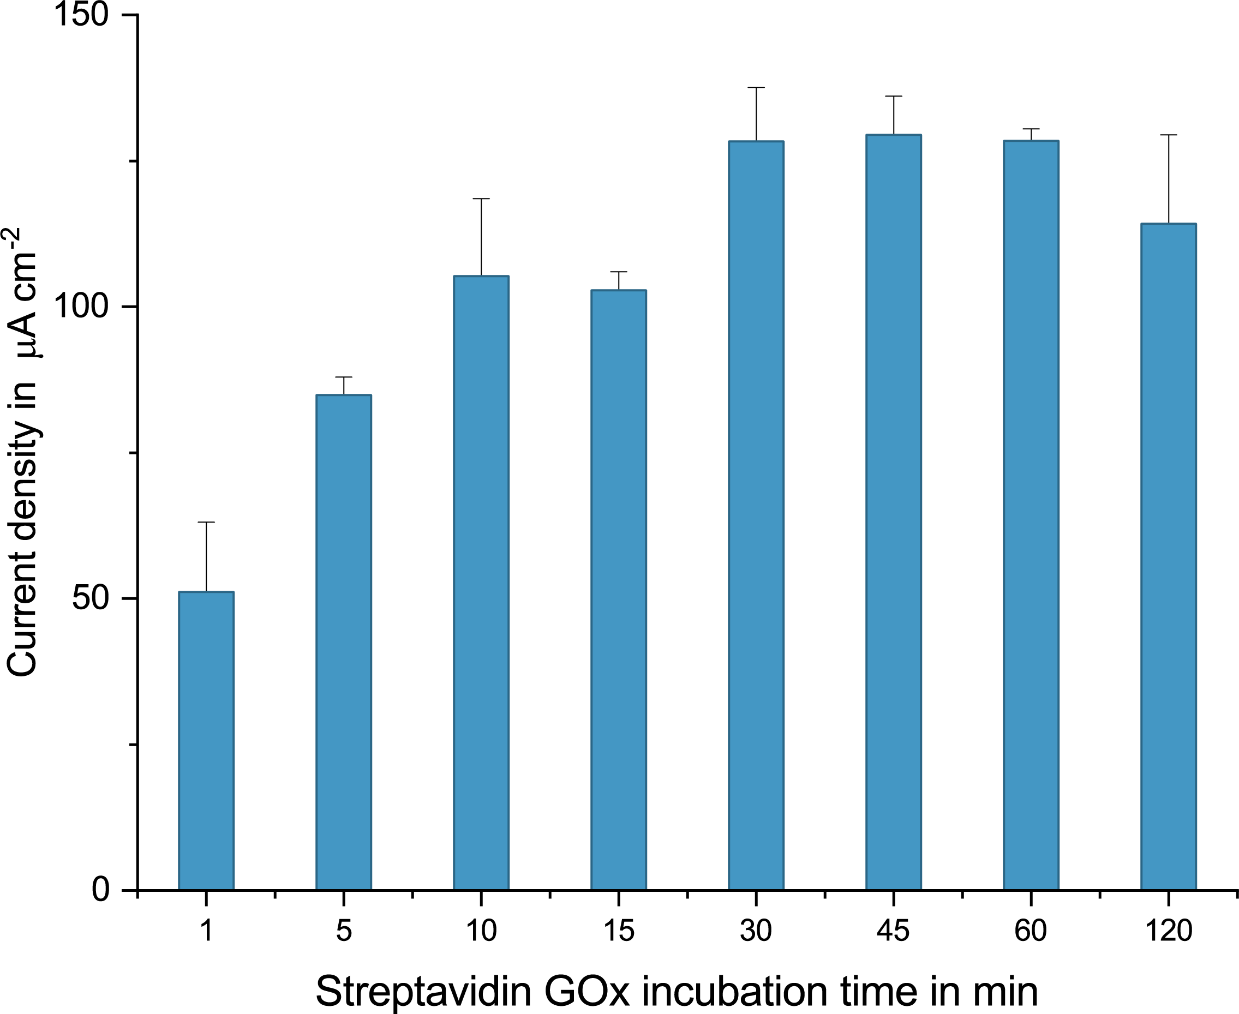
Figure S9: Comparison of different Streptavidin-GOx (10 µg ml^{–1}) incubation times. For ß-lactam measurements, unless otherwise stated, incubation time of Str-GOx was selected as 15 minutes. Error bars represent ± SD of n = 4 replicates.

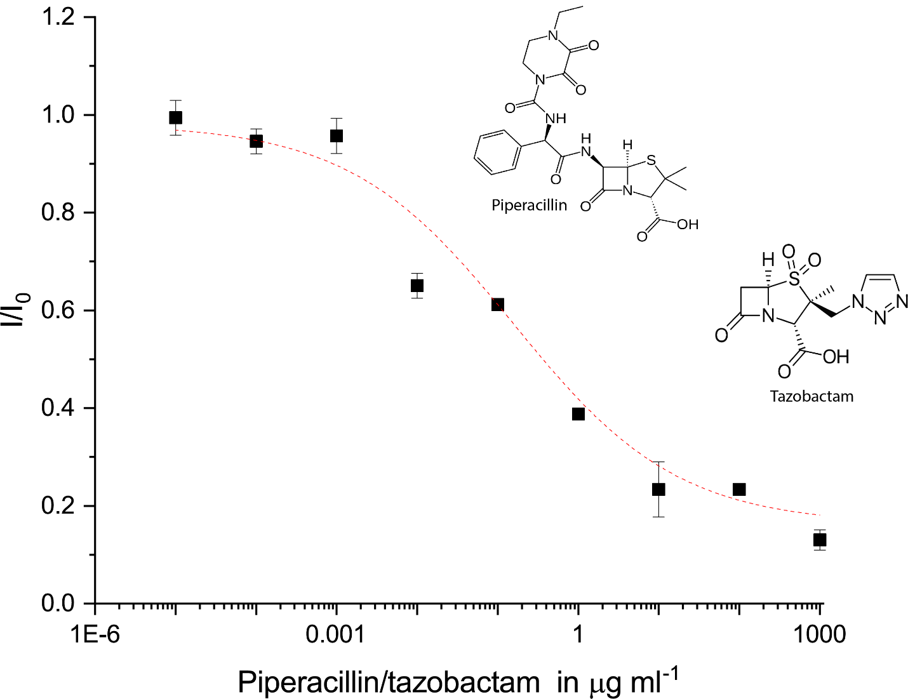
Figure S10: Calibration curve of the piperacillin/tazobactam in physiological PBS. The results were fitted with a 4-parametric logistic fit, resulting in a limit of detection of 0.056 µg ml^{–1}. Having high sensitivity, the optimized assay enables working with very diluted samples (up to 1,000 times) and detecting antibiotic concentration in these diluted samples. Accordingly, using only one calibration curve, drug concentrations in different samples can be calculated. All error bars represent ± SD of n = 4 replicates.

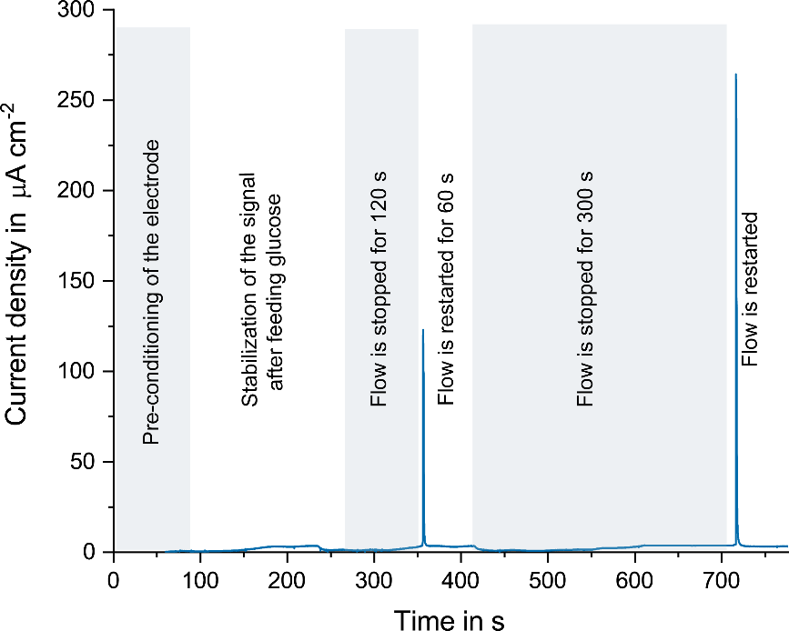
Figure S11: Readout procedure of the amperometric biosensor. After the preconditioning step of the working electrode (60 seconds), the 40 mM-glucose solution is introduced, and the signal stabilizes over the next couple of minutes. The flow of the glucose solution is stopped for 2 minutes, resulting in a first measurement peak and then restarted, followed by second stop for 5 minutes, resulting in the final measurement peak.

  - Sample pre-processing and dilution integrity
The first critical step was to determine the correct dilution factor for each sample type. Selection of the dilution factor as well as the dilution integrity for the plasma samples diluted at different rates were demonstrated. After optimization studies dilution factors were found to be: 1:500 for plasma, 1:750 for urine and 1:100 for saliva. For EBC measurements, since the expected concentration is already small, and dilution was performed to increase salt content as 9:10.

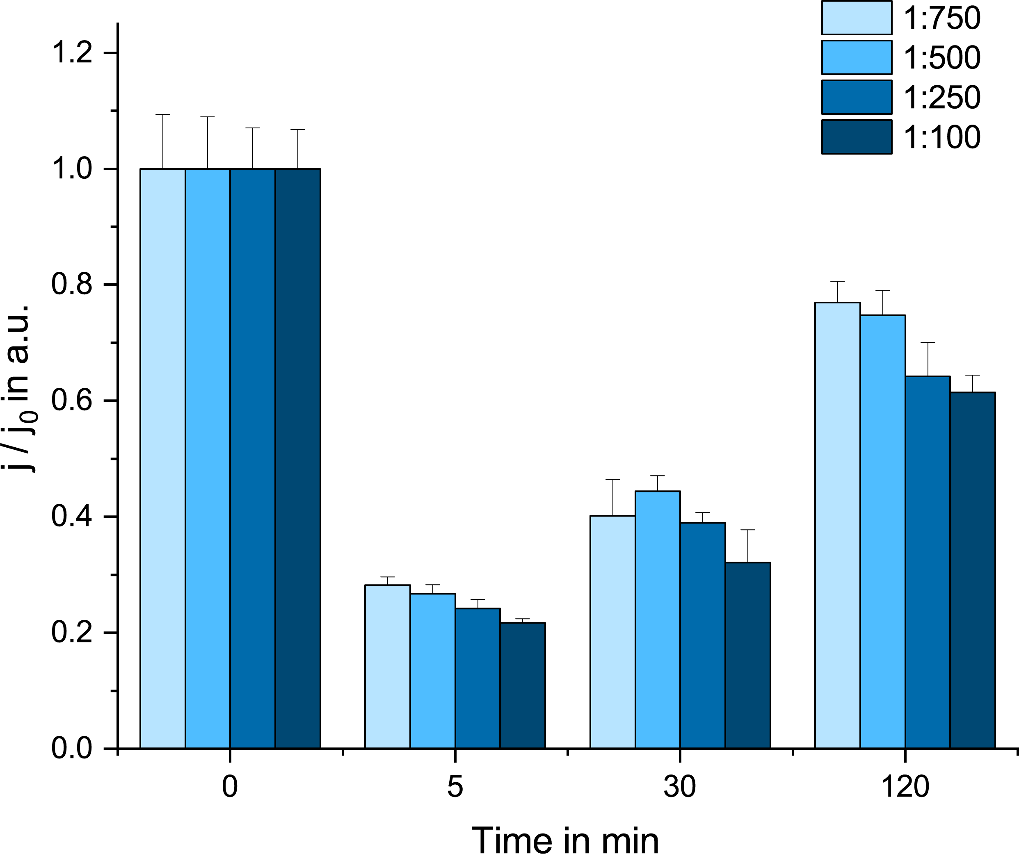
Figure S12: Demonstration of the dilution integrity for plasma samples taken from the animal given overdose antibiotics over a time period of 120 minutes. The same clearance effect was observed regardless of the dilution factor. For further measurements, dilution factor for the plasma samples of overdosed animals was selected as 1:500. Error bars represent ± SD of n = 4 replicates.
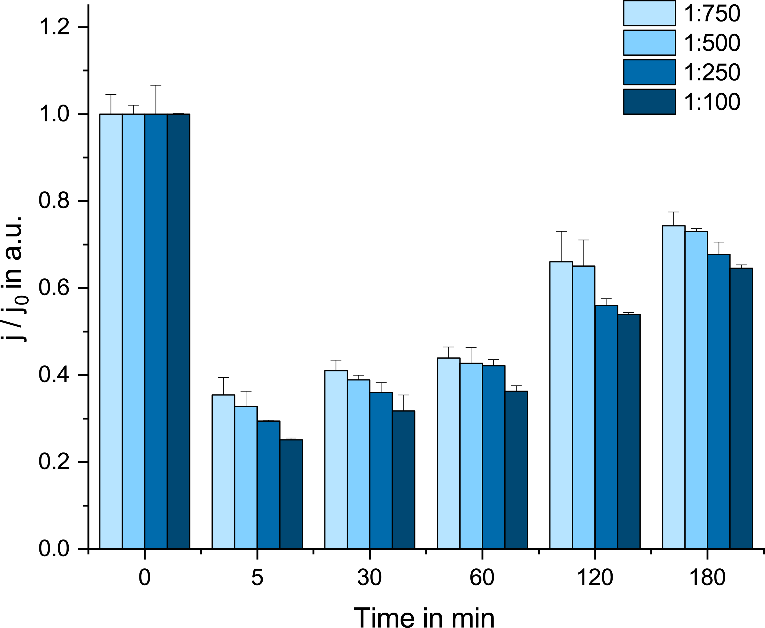
Figure S13: Study of the dilution integrity for plasma samples taken from the animal given normal-dose antibiotics over a time period of 180 minutes. The same clearance effect was observed regardless of the dilution factor. For further measurements, dilution factor for the plasma samples of normal-dosed animals was selected as 1:500. Error bars represent ± SD of n = 4 replicates.

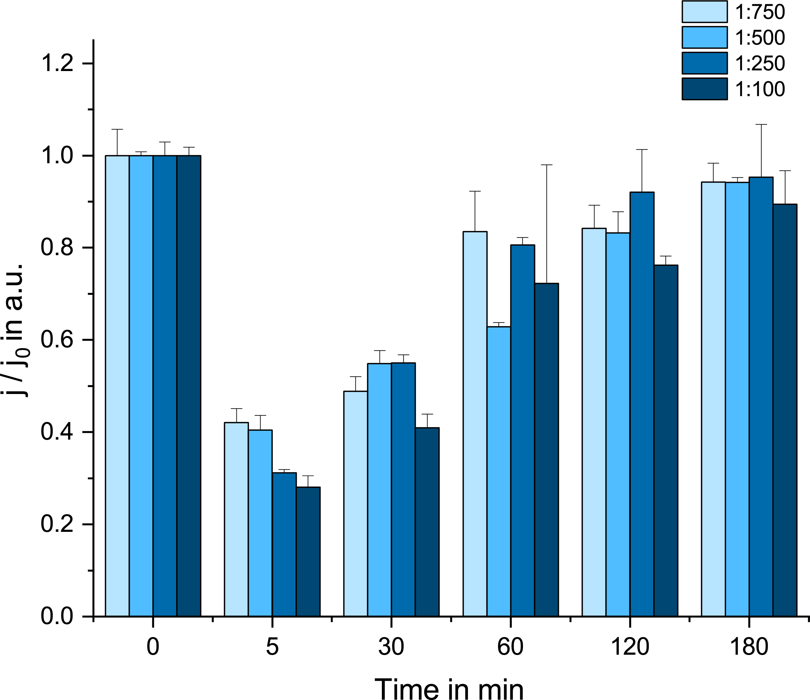
Figure S14: Comparison of the dilution integrity for plasma samples taken from the animal given underdose antibiotics over a time period of 180 minutes. The same clearance effect was observed regardless of the dilution factor. For further measurements, dilution factor for the plasma samples of underdosed animals was selected as 1:500. Error bars represent ± SD of n = 4 replicates.

  - Effect of an external drug on the measured signal
During the on-site animal experiments, drug concentrations followed the dosage regimen quantitatively. Nonetheless, during the concentration measurements, one anomaly was observed in the 120-minute-sample of the normal-dosed pig. In order to understand the source of this deviation, the animal’s experiment log-book was checked, which revealed an emergency dosage of propofol (an anesthetic drug) to maintain anesthesia. This possibility was then confirmed with an in vitro test, where a similar concentration of propofol was spiked in a whole blood sample.

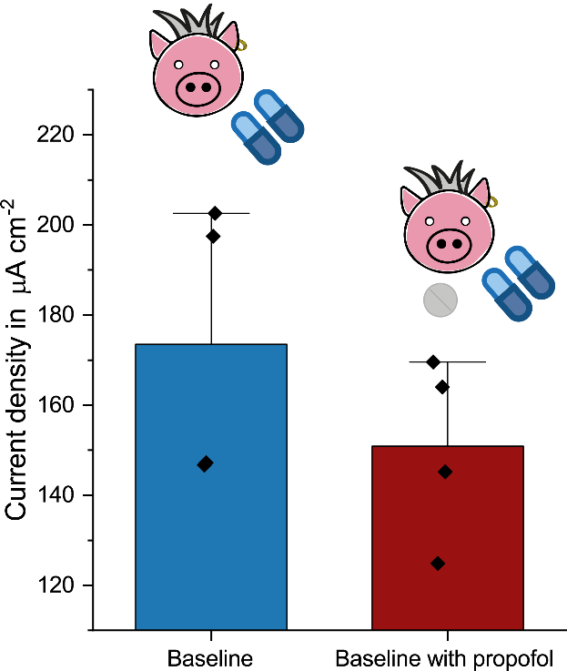

Figure S15: Demonstration of the external drug effects on the antibiotic measurement. Whole blood samples were taken from normal-dosed animal spiked with stimulated dosage of propofol. A short-term interference was caused by the presence of propofol. In the normal experimental setting, samples were taking from the animals following surgical intervention and a stabilization phase of 15 min, which eliminates the risk of interference of anaesthetics. Box and whisker plot for n = 4 replicates. Error bars represent the outlier range.
References
1. Bruch, R., Kling, A., Urban, G. A. & Dincer, C. Dry Film Photoresist-based Electrochemical Microfluidic Biosensor Platform: Device Fabrication, On-chip Assay Preparation, and System Operation. J. Vis. Exp. e56105 (2017). doi:10.3791/56105
2. Bruch, R. et al. CRISPR/Cas13a-Powered Electrochemical Microfluidic Biosensor for Nucleic Acid Amplification-Free miRNA Diagnostics. Adv. Mater. (2019). doi:10.1002/adma.201905311
3. Bruch, R. et al. Clinical on-site monitoring of ß-lactam antibiotics for a personalized antibiotherapy. Sci. Rep. 7, 1–10 (2017).
4. Niedermeyer, T. H. J. & Strohalm, M. mMass as a Software Tool for the Annotation of Cyclic Peptide Tandem Mass Spectra. PLoS One (2012). doi:10.1371/journal.pone.0044913

