**Supplementary Materials**

**A lightweight strain-glass alloy showing nearly temperature-independent low modulus and high strength**

Chang Liu1, Jingxian Tang1, Yuanchao Ji1,2,*, Kazuhiro Otsuka3, Yu Wang2, Mengrui Hou1, Yanshuang Hao1, Shuai Ren4, Xiaobing Ren1,3,*

*1 Frontier Institute of Science and Technology, and State Key Laboratory for Mechanical Behaviour of Materials,* *Xi’an Jiaotong University, Xi’an 710049, China*

*2 MOE Key Laboratory for Nonequilibrium Synthesis and Modulation of Condensed Matter, Xi’an Jiaotong University, Xi’an 710049, China*

*3 Center for Functional Materials, National Institute for Materials Science, Tsukuba, 305-0047, Ibaraki, Japan*

*4 College of Mechatronics and Control Engineering, Shenzhen University, Shenzhen 518060, China*

Email: [jyc.xjtu@xjtu.edu.cn](mailto:jyc.xjtu@xjtu.edu.cn); [Ren.Xiaobing@nims.go.jp](mailto:Ren.Xiaobing@nims.go.jp)

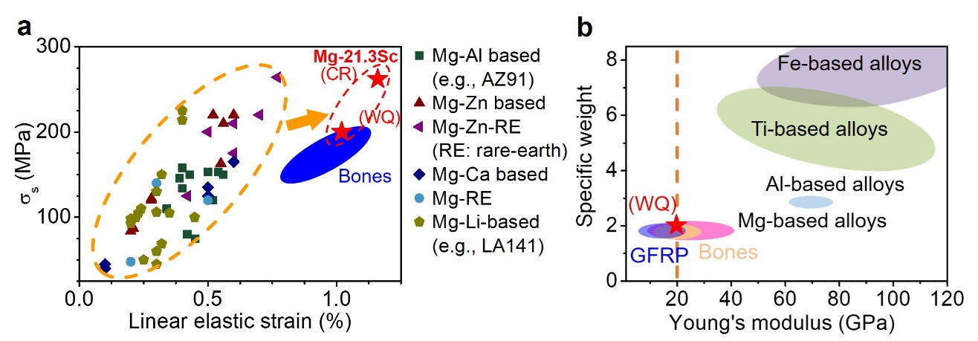

**Fig. S1.** (a)Comparison of maximum elastic strain vs. yield strength between Mg-21.3Sc and other Mg-alloys14-26. (b) Comparison of Young’s modulus vs. specific weight (the ratio of the density of material to the density of water) among Mg-21.3Sc alloy, GFRP，natural bone, Fe-based, Ti-based and Al-based alloys6-8,29-33.

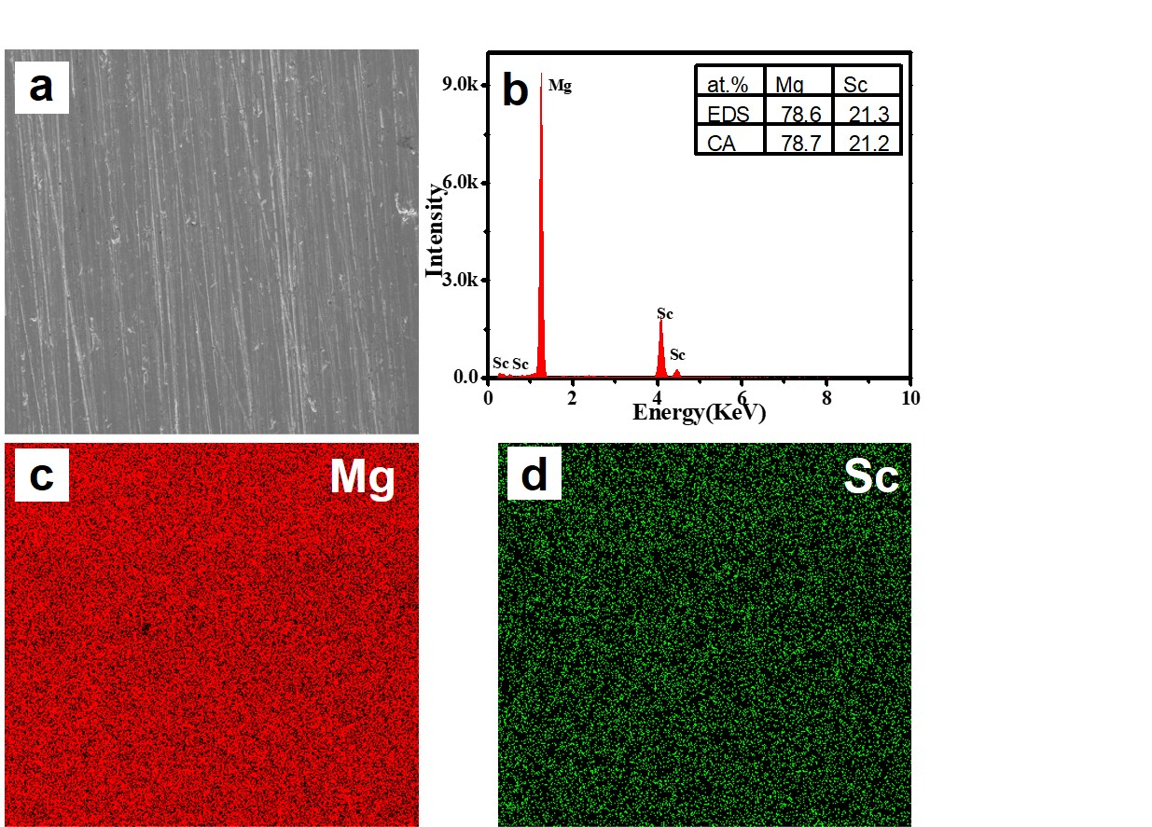

**Fig. S2.** Scanning electron micrographs and EDS mapping images of the Mg-21.3Sc alloy, which show the homogeneous distribution of elements. (b) shows the composition analysis results by EDS and chemical analysis (CA).

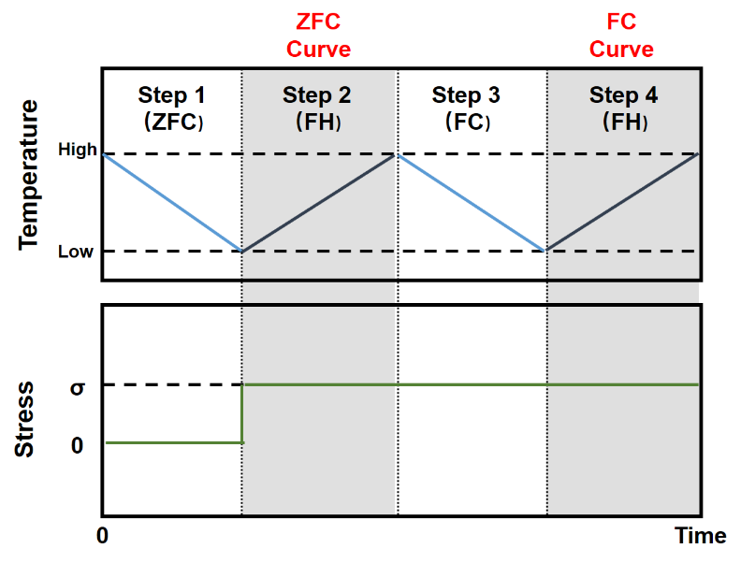

**Fig. S3.** A well-known experimental method for detecting the nonergodicity is the so-called zero-field-cooling (ZFC)/field-cooling (FC) measurement29. The strain glass sample was first cooled to a low temperature well below the glass transition temperature Tg under zero stress (ZFC, process 1). then loaded (stress σ = 40 MPa) and heated up to far above Tg under this stress (field heating or FH, process 2). Thereafter, the sample was cooled to low temperature again with the stress (FC, process 3) and then heated to high temperature again at the same stress (FH, process 4). The static strain curves that measured in process 2 and process 4 are called the ZFC curve and the FC curve, respectively, and their deviation is a signature for nonergodicity.

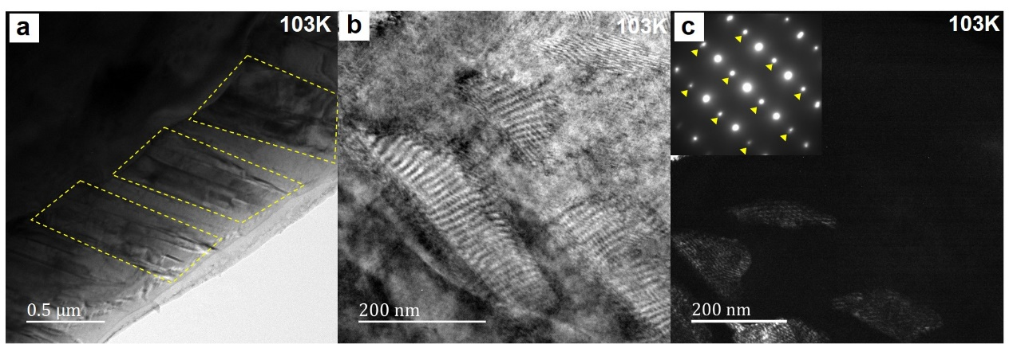

**Fig. S4. a**, TEM bright field image of Mg-19.5Sc alloy at 103 K shows large martensitic domains, which contrasts with the nano-domains in Mg-21.3Sc strain glass alloy. **b** and **c,** TEM bright field and dark field images of Mg-19.5Sc alloy at 103K along [111]β zone axis, the large martensitic domains in the dark field image are corresponding to the 1/2(112) superlattice spots which marked by yellow triangles. The 1/2(112) spots locale the same position with our Mg-21.3Sc strain glass nano-domains in Fig. 4b.

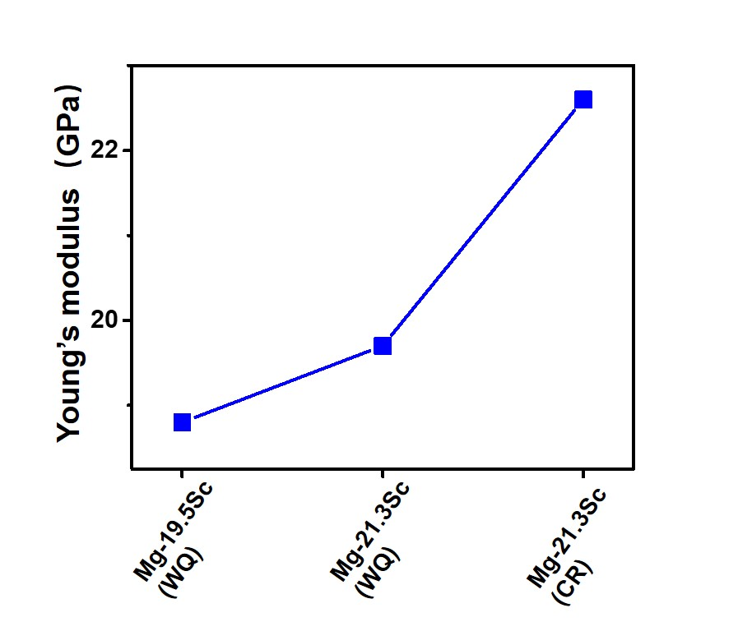

**Fig. S5.** The modulus increases in a sequence of Mg-19.5Sc (WQ), Mg-21.3Sc (WQ), and Mg-21.3Sc (CR).

**Table. S1** Young’s modulus and yield strength of Mg-21.3Sc and current main families of Mg-based alloys (experimental data in Fig. 1b).

