Supplementary Materials

Anti-inflammatory components isolated from Atractylodes macrocephala in LPS-induced RAW264.7 macrophages and BV2 microglia

Hong-Guang Jin^{1,2,a}, Kwan-Woo Kim^{1,3,a}, Jing Li^{1,4,a}, Dae Young Lee³, Dahye Yoon³, Jin Tae Jeong³, Geum-Soog Kim³, Hyuncheol Oh¹, Ren-Bo An^{5,*}, Youn-Chul Kim^{1,*}
¹Institute of Pharmaceutical Research and Development, College of Pharmacy, Wonkwang University, Iksan 54538, Republic of Korea
²School of Pharmacy and Life Sciences, Jiujiang University, Jiujiang 332005, Jiangxi, China
³Deparment of Herbal Crop Research, National Institute of Horticultural and Herbal Science, RDA, Eumseong, 27709, Republic of Korea
⁴Deparment of Pharmacy, Jiujiang University Hospital, Jiujiang 332000, Jiangxi, China
⁵College of Pharmacy, Yanbian University, Yanji, Jilin 133002, China

^{a.}Hong-Quang Jin, Kwan-Woo Kim, and Jing Li contributed equally to this work.

Corresponding authors
Ren-Bo An: College of Pharmacy, Yanbian University, Yanji, Jilin 133002, China, E-mail: anrb@ybu.edu.cn;
Youn-Chul Kim: Institute of Pharmaceutical Research and Development, College of Pharmacy, Wonkwang University, Iksan 54538, Republic of Korea, E-mail: yckim@wku.ac.kr

Spectroscopic data of compounds 1 and 5
Compound 1 (9α-hydroxyatractylenolide) - ¹H-NMR (400 MHz, CDCl₃) δ: 4.98 (1H, d, J = 2.0 Hz, H-8β), 4.88 (1H, d, J = 1.6 Hz, H-15b), 4.60 (1H, d, J = 1.6 Hz, H-15a), 3.88 (1H, d, J = 3.6 Hz, H-9β), 2.67 (1H, dd, J = 12.8, 3.2 Hz, H-6α), 2.38 (1H, m, H-5α), 2.35 (1H, m, H-3β), 2.31 (1H, m, H-6β), 2.06 (1H, dt, J = 13.6, 4.4 Hz, H-1α), 1.95 (1H, m, H-3α), 1.83 (3H, t, J = 1.6 Hz, H-13), 1.60 (2H, m, H-2), 1.33 (H, m, H-1β), 0.89 (3H, s, H-14); ¹³C-NMR (100 MHz, CDCl₃) δ: 175.1 (C-12), 159.1 (C-7), 148.9 (C-4), 121.9 (C-11), 107.3 (C-15), 79.9 (C-8), 75.4 (C-9), 42.2 (C-5), 41.0 (C-10), 36.3 (C-3), 34.6 (C-1), 25.6 (C-6), 18.9 (C-2), 15.7 (C-14), 8.4 (C-13).
Compound 5 (atractylenolide II) - ¹H-NMR (400 MHz, CDCl₃) δ: 4.83 (1H, d, J = 1.2 Hz, H-15b), 4.80 (1H, t, J = 6.4 Hz, H-8), 4.57 (1H, d, J = 1.2 Hz, H-15a), 2.68 (1H, dd, J = 13.6, 3.6 Hz, H -6α), 2.23-2.36 (3H, m, H-3β, 6β, 9β), 1.94 (1H, td, J = 13.2, 6.0 Hz, H-3α), 1.80 (1H, m, H-5α), 1.78 (3H, d, J = 1.6 Hz, H-13), 1.52-1.62 (3H, m, H-1β, 2α, 2β), 1.27 (1H, m, H-1α), 1.09 (1H, t, J = 12.0 Hz, H-9α), 0.86 (3H, s, H-14);¹³C-NMR (100 MHz, CDCl₃) δ: 174.8 (C-12), 162.6 (C-7), 148.5 (C-4), 120.2 (C-11), 107.0 (C-15), 78.1 (C-8), 50.0 (C-5), 47.6 (C-9), 40.9 (C-1), 37.1 (C-10), 36.3 (C-3), 25.8 (C-6), 22.4 (C-2), 16.5 (C-14), 8.3 (C-13).

Fig. S1. ¹H-NMR spectrum of compound 1 in CDCl₃
Fig. S2. ¹³C-NMR spectrum of compound 1 in CDCl₃

Fig. S3. HMBC spectrum of compound 1 in CDCl₃
Fig. S4. NOESY spectrum of compound 1 in CDCl₃

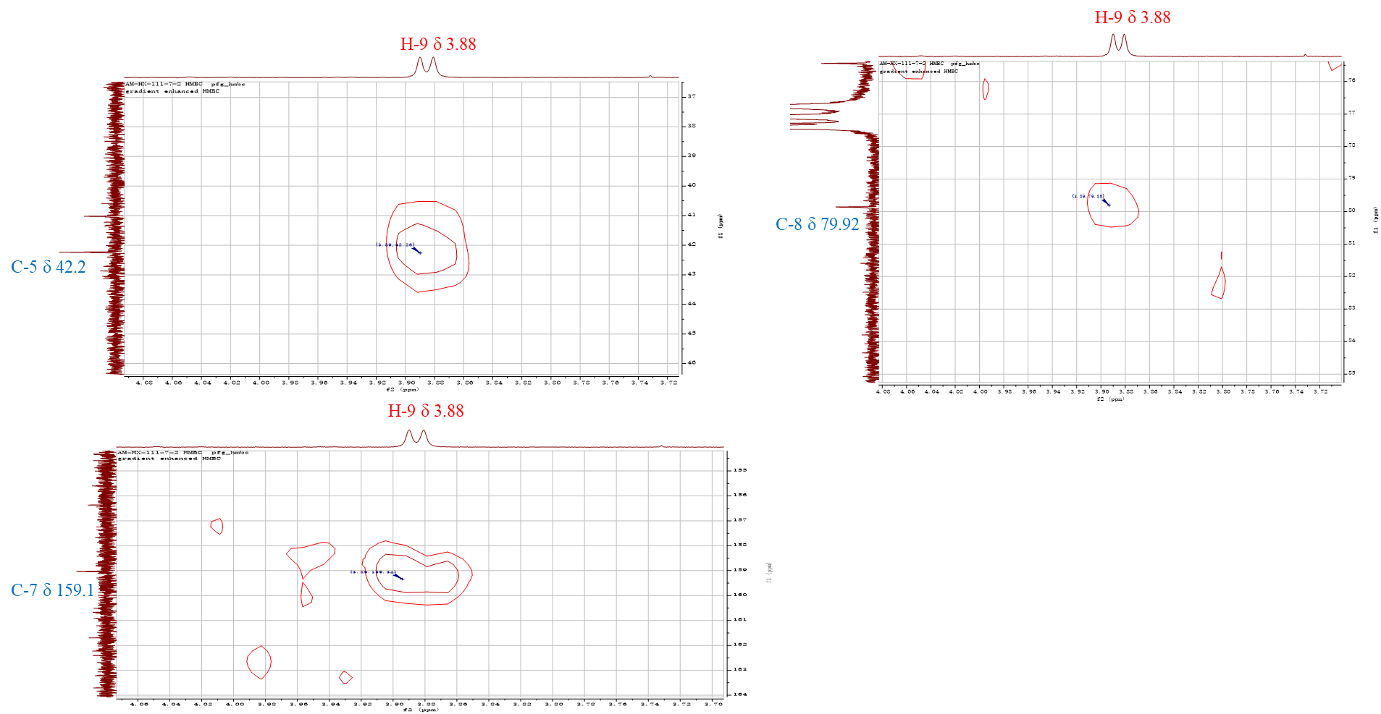
Fig. S5. The key HMBC correlation of compound 1

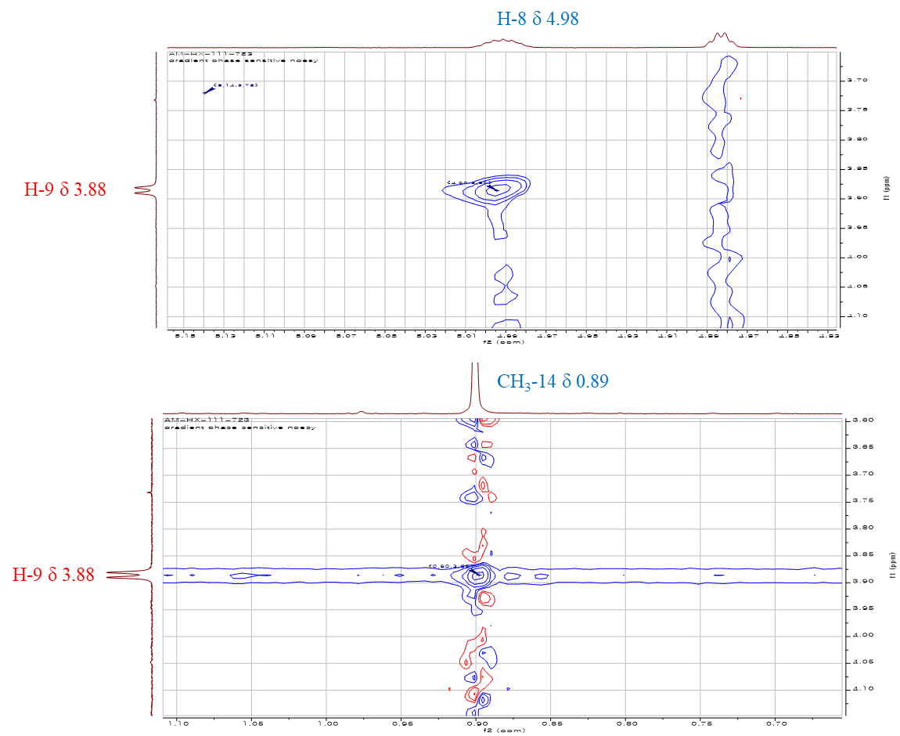
Fig. S6. The key NOESY correlation of compound 1

